* Block Diagram of the Project:

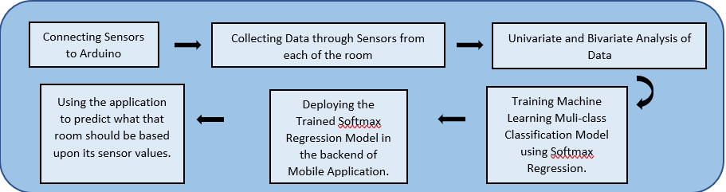

* Connection of Sensors used

1. Gas Sensor
2. Temperature Sensor
3. Light Intensity Sensor

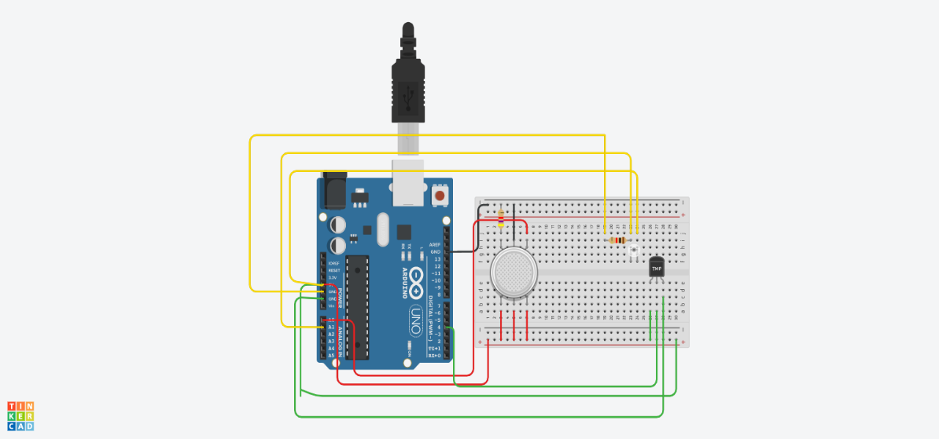

|  |  |  |
| --- | --- | --- |
| S No. | Gas Sensor Pin | Arduino Pin |
| 1. | A1, H1 A2 | Vcc, 5V |
| 2. | Terminal 2 | Gnd |
| 3. | H2 | Gnd |
| 4. | B1 | Ao |

*Table 1.1 Connections of Gas Sensor*

|  |  |  |
| --- | --- | --- |
| S No. | TMP36 Pin | Arduino Pin |
| 1. | Power | Vcc, 5V |
| 2. | GND | GND |
| 3. | Vout | 4(digital signal) |

*Table 1.0 Connections of Temperature and Humidity Sensor*

|  |  |  |
| --- | --- | --- |
| S No. | Ambient Light Sensor Pin | Arduino Pin |
| 1. | Collector | Vcc, 5V |
| 2. | Emitter | A1 |

*Table 1.2 Connections of Ambient Light Sensor*

* Collection of Data from each Room:

1. Collected Data from each room

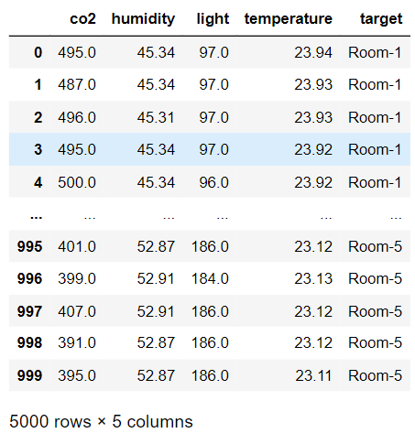

1. CO­2 Concentration of each room

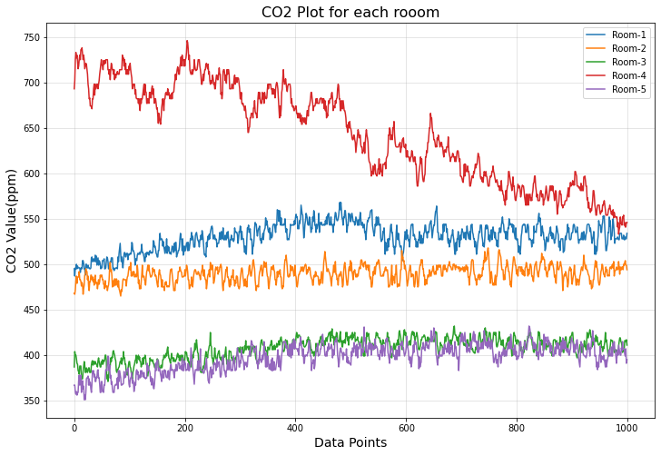

* Bivariate Analysis of Features with respect to Carbon Dioxide:

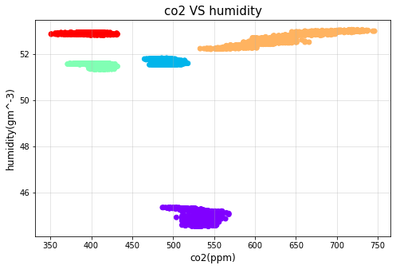

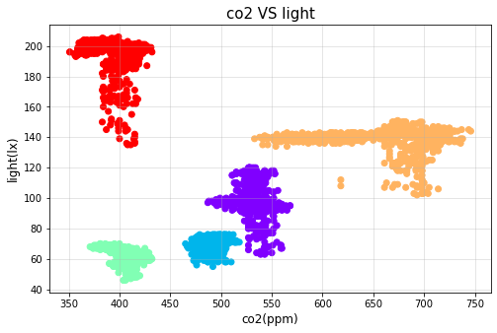

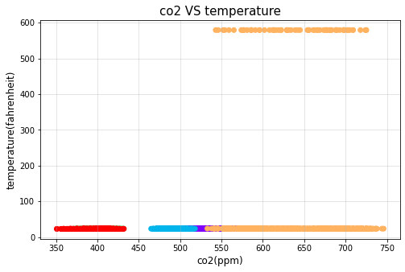

* Training Machine Learning Model:

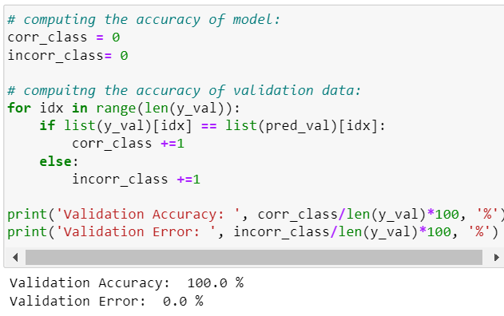

* Deploying Mobile Application using Kivy:
  1. Prediction Result of Mobile Application:

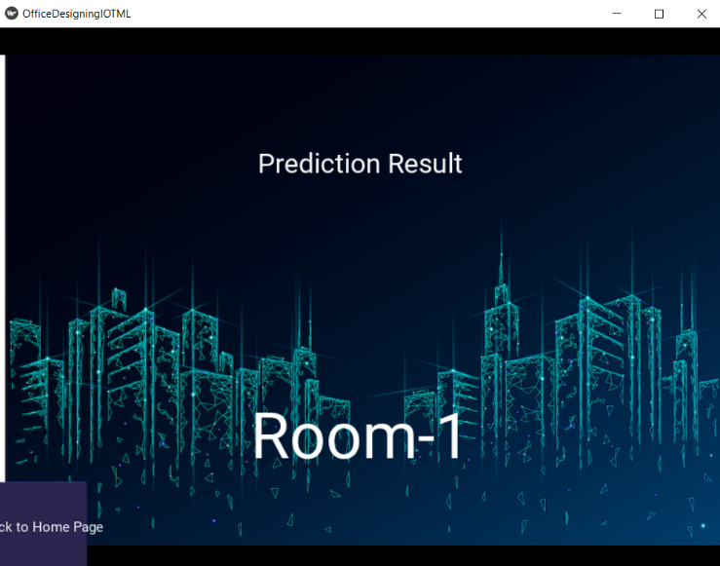

* 1. Mobile Application Interface:

