PROJECT REPORT:

Chapter 1: INTRODUCTION

* 1. Project Scope: The evolution of workplaces and homes over a past few years has been enormous. The smart building of all sorts of shelters has worked to get the most out of that space. Deployment of IoT algorithms and machine learning in smart building to increase work efficiency, predictive maintenance, save the environment and minimize energy waste, track activities and build health and safety against environmental changes have expanded boundaries of the emerging technology. Our model can be used by architects and engineers while working on sites to measure the humidity, temperature, CO2 andlight intensity to predict the suitability of locating a particular section of the building or a house at the piece of land. This escalates the scope of smart construction and let us consider major but highly ignored factors while constructing a new place.
  2. We have used the two top-most burning technologies in current era i.e. Internet of Things (IOT) and Machine Learning (ML/AI). The idea of the project is as follows: Collecting the data using various IOT-sensors, further analysing it using Python, drawing some very important insights from the data, training a machine learning model on the very same data. We also have evaluated the trained model to generalize pretty well on the unseen instances and thus avoiding the problem of Overfitting and Underfitting of Models. The trained model is then deployed at the backend of the mobile phone application, where the data will be given by the user and the machine learning model would predict something which would be displayed in the prediction page.

Figure 1.0 Mobile Application Interface

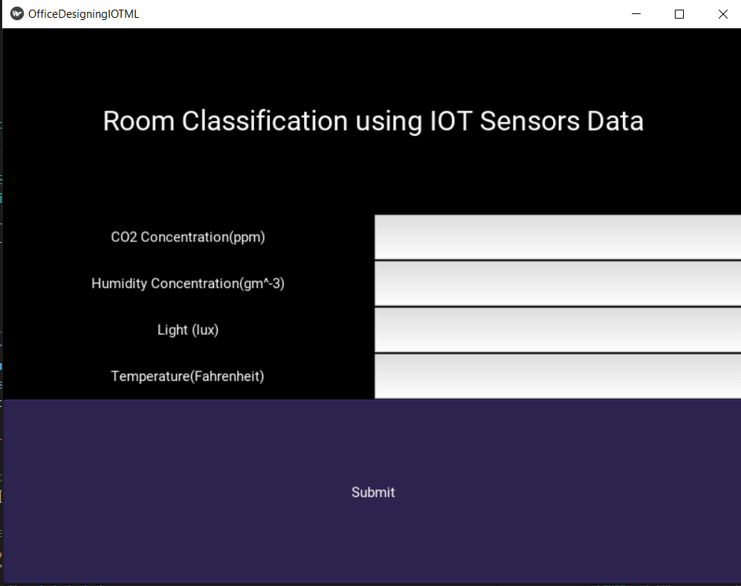

* 1. We have simply visited 5 rooms and collected data using DHT11 sensor which gives us the temperature and humidity readings for that room, Ambient Light Sensor which gives us the intensity of light in that room in lux (unit for measuring light) and MQ-135 sensor which computes the co2 concentration in the room. Thus, we visited each of the 5 rooms and collected data using all of the sensors above mentioned and after collecting the whole of data, it looks like as described in Figure 1.0.
  2. After the data has been compl

1.2 Project Objective: The objective of building a “Smart Location Pointer” is to contribute in the designing of homes, offices, restaurants and all other accommodations and workplaces differently according to their unique needs. Hence, we have created a mobile application where the user needs to enter the data of each of the feature i.e. co2, humidity, light, temperature and based upon these values, the model would suggest which room it should be. Hence, we have deployed the machine learning model trained using Softmax Regression which does multi-class classification and based upon the values obtained by each of the IOT-sensor, it would suggest the best possible room it should be. Now, the data on which we have Our model is trained using a set of data of five rooms. The application can be used at construction sites or prospective places for construction to predict the suitability of locating a particular room like washroom, bedroom, conference room etc.

**1.3 Block Diagram:**

The block diagram clearly shows how the whole project has been implemented and what steps have been performed to completely and successfully achieve the desired project:

Figure 1.1, Block Diagram of the Project:

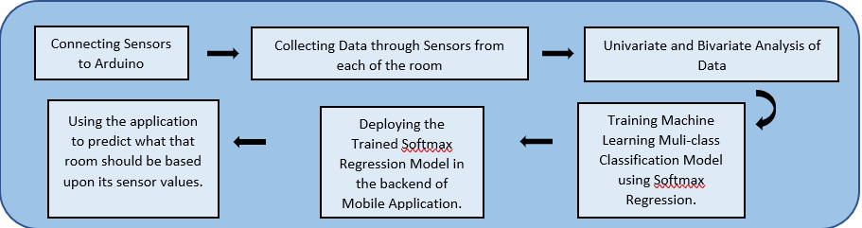

Figure 1.1 shows the complete demonstration of the project and is well explained. Some basic understanding of the block diagram has also been explained in the previous page.

Chapter 3: Project Plan

3.1 Project Cost Estimation: 1800/-

3.2 Project Execution:

Brief Introduction on the components and sensors which we have used in our project:

1. Arduino UNO

Arduino Uno is a microcontroller board based on the ATmega328P ([datasheet](http://ww1.microchip.com/downloads/en/DeviceDoc/Atmel-7810-Automotive-Microcontrollers-ATmega328P_Datasheet.pdf)). It has 14 digital input/output pins (of which 6 can be used as PWM outputs), 6 analogue inputs, a 16 MHz ceramic resonator (CSTCE16M0V53-R0), a USB connection, a power jack, an ICSP header and a reset button. It contains everything needed to support the microcontroller; simply connect it to a computer with a USB cable or power it with a AC-to-DC adapter or battery to get started.

"Uno" means one in Italian and was chosen to mark the release of Arduino Software (IDE) 1.0. The Uno board and version 1.0 of Arduino Software (IDE) were the reference versions of Arduino, now evolved to newer releases. The Uno board is the first in a series of USB Arduino boards, and the reference model for the Arduino platform; for an extensive list of current, past or outdated boards see the Arduino index of boards.

1. Temperature Sensor:

A temperature sensor is an electronic device that measures the temperature of its environment and converts the input data into electronic data to record, monitor, or signal temperature changes. There are many different types of temperature sensors. Some temperature sensors require [direct contact](https://www.electronics-tutorials.ws/io/io_3.html) with the physical object that is being monitored (contact temperature sensors), while others indirectly measure the temperature of an object (non-contact temperature sensors). We have used DHT11 sensor to record the temperature and humidity values from the environment in Fahrenheit.

1. CO2 Gas Sensor:

A carbon dioxide sensor or CO2 sensor is an instrument for the measurement of carbon dioxide gas. ... Measuring carbon dioxide is important in monitoring indoor air quality, the function of the lungs in the form of a capnograph device, and many industrial processes. We have used MQ-135 sensor for recording the concentration of CO2 in parts-per-million.

1. Humidity Sensor:

A humidity sensor is an electronic device that measures the humidity in its environment and converts its findings into a corresponding electrical signal. ... Relative humidity is calculated by comparing the live humidity reading at a given temperature to the maximum amount of humidity for air at the same temperature. As discussed above, we have used DHT11 sensor for recording humidity concentration in the environment in gram-per-meter-cube.

1. Light Intensity Sensor:

Light Sensors. The light sensor is a passive device that converts the light energy into an electrical signal output. ... Phototransistors, photoresistors, and photodiodes are some of the more common type of light intensity sensors. Photoelectric sensors use a beam of light to detect the presence or absence of an object. We have used ambient light sensor for recording the intensity of light in the environment in lux.

**Execution and Implementation Details:**

Figure 1.2 Connections of Sensors

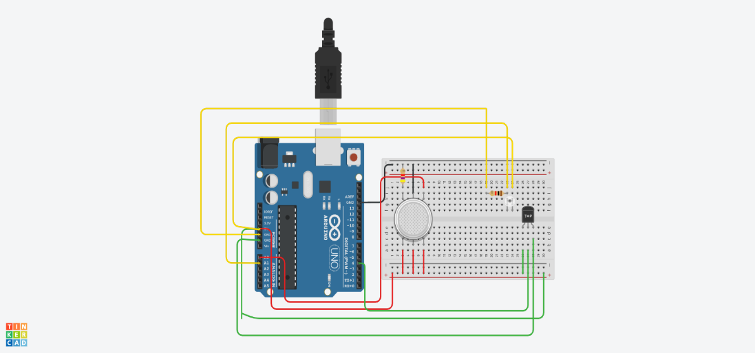

* *Connecting Sensors to Arduino*:

The connections of the hardware to collect data are described in Figure 1.2. We have Arduino UNO where each of the sensor is connected to the pins of the Arduino as described briefly below:

1) **Temperature and Humidity Sensor:**

The temperature sensor consists of three pins out of which the one on the extreme left named Power is connected to the 5V pin of the Arduino Uno. Followed by the centre pin i.e., Vout pin connected to the A1 pin of the Arduino. The extreme right pin i.e., Ground, is connected to the ground of Arduino Uno.

|  |  |  |
| --- | --- | --- |
| S No. | TMP36 Pin | Arduino Pin |
| 1. | Power | Vcc, 5V |
| 2. | GND | GND |
| 3. | Vout | 4(digital signal) |

*Table 1.0 Connections of Temperature and Humidity Sensor*

2) **Gas Sensor:**

The Gas Sensor consists of total of six terminals with the Arduino Uno. The A1 H1 and A2 terminals are together connected to the voltage supply (5V) of the Arduino.

|  |  |  |
| --- | --- | --- |
| S No. | Gas Sensor Pin | Arduino Pin |
| 1. | A1, H1 A2 | Vcc, 5V |
| 2. | Terminal 2 | Gnd |
| 3. | H2 | Gnd |
| 4. | B1 | Ao |

*Table 1.1 Connections of Gas Sensor*

And the H2 terminal is connected to ground along with the Terminal 2. The B1 terminal is attached to the A0 port of the Arduino to obtain an analogue. output.

3) **Ambient Light Sensor:**

Light Sensor has two terminals, Emitter and Collector and they are connected as follows:

|  |  |  |
| --- | --- | --- |
| S No. | Ambient Light Sensor Pin | Arduino Pin |
| 1. | Collector | Vcc, 5V |
| 2. | Emitter | A1 |

*Table 1.2 Connections of Ambient Light Sensor*

The Collector terminal is connected with a resistor of 1K and then to the 5V supply of the Arduino.

And the Emitter is connected to the Ground.

* *Collecting Data From Sensors:*

After connecting all the sensors perfectly, we visit five different rooms of an office where we start reading data from each of the sensor for 2 hours and then we go to another room and perform the same operation, we go on until data for each of the 5 rooms is collected and at the end of the experiment, we have 5 different columns/features i.e. 'co2', 'humidity', 'light', 'temperature', 'room', where 'room' refers to the room from which data has been collected. The data looks as shown in the Figure 1.3.

Figure 1.3 Data Collected for each Room

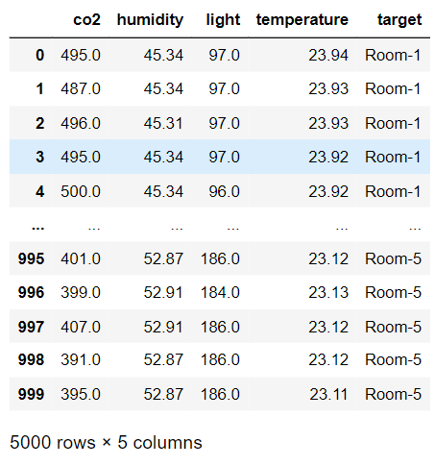

* *Analysing Data:*

After Collecting data, we perform univariate and bivariate analysis on data. Univariate Analysis refers to analyzing each of the column's data individually whereas bivariate analysis refers to analyzing relationships between two features in data.

In Figure 1.4, the univariate analysis of CO2-concentration in each of the rooms can be observed. It can be seen that co2 concentration of Room-3 and Room-5 is quite similar whereas the CO2 concentration of Room-4 seems to be the highest. Further, the co2 concentration of Room-3 and Room-5 are increasing as time increases and then they become constant whereas if we observe the co2 concentration of Room-4, it seems to be decreasing with time. The co2 concentration of Room-1 and Room-2 also seems to be quite same in nature and also sort of remains constant with time. In, this way, we can simply analyze rest of the univariate feature.

Figure 1.4 CO2 Concentration of Each Room

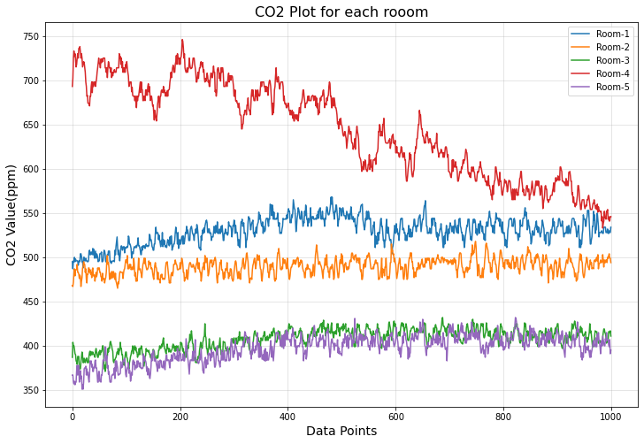

From Figure 1.5, we can observe that we can clearly distinguish the rooms using co2 and humidity. Each cluster represents the room from which its data has been observed. Since, there seems to be no overlapping between data of co2 and temperature of all the 5 rooms, hence it means these wo features are quite good predictors for classifying the target feature. Further, some similar analysis could be observed from the Figure 1.6 which is plotted between co2 and light. This again means that light along with co2 are a nice predictors of Target feature. But from figure 1.7, we can observe overlapping of temperature among different rooms and this means that temperature is not as a good predictor for the target feature as co2, light and humidity are.

Hence, we derive a very important insight that the feature ‘temperature’ might not be able to distinguish among the rooms correctly and rest of the three feature have quite different data for each of the room hence perform so well in classifying the rooms. In this way, we perform Bivariate Analysis and draw some very important results from data.

Figure 1.7 CO2 VS Temperature

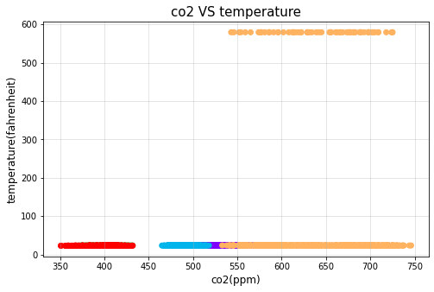

Figure 1.6 CO2 VS Light

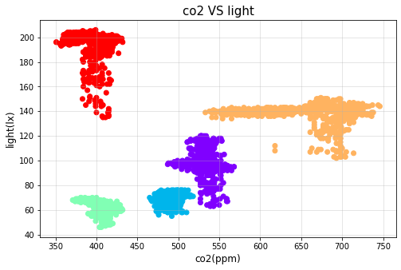

Figure 1.5 CO2 VS Humidity Plot

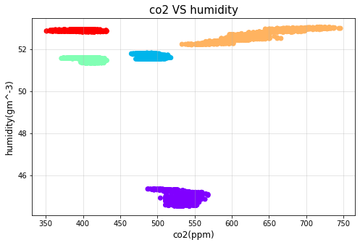

* *Training Machine Learning Model:*

I have used Softmax Regression (multi-class classification algorithm) for training a supervised Machine Learning Model which could be used in the backend of the mobile or web application where the trained model would classify what that room should be based upon the values entered for each of the features i.e. co2, humidity, light and temperature. After training the model, we also evaluate the performance of model on some unseen data and see if the trained model is generalizing well on the validation data, which takes us to an important conclusion that the model should not get overfitted on training data or underfitted. Hence, we should be getting the best fit of the model.

Figure 1.8 Evaluation of Model

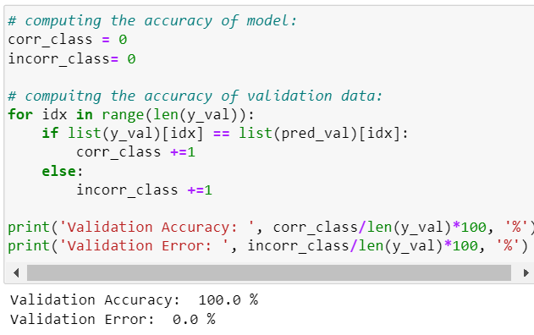

From Figure 1.8, it is clearly visible that the machine learning model performs quite well and has 100% accuracy for validation data. This is one of the best conclusions we can derive from the project. As discussed already, we explained that the features, ‘co2’, ‘humidity’ and ‘light’ were quite capable of distinguishing the rooms (i.e. target feature) based upon their values.

* *Developing Mobile Application using Kivy (Framework of Python):*

After training the model, we created a web-application where the user would enter the details of the values obtained from each of the 4 sensors and then based upon those values, the model which is deployed in the backend of the mobile application would classify that room to be either a bed-room, conference-room, store-room, etc.

Figure 2.0 Prediction Result of Mobile App.

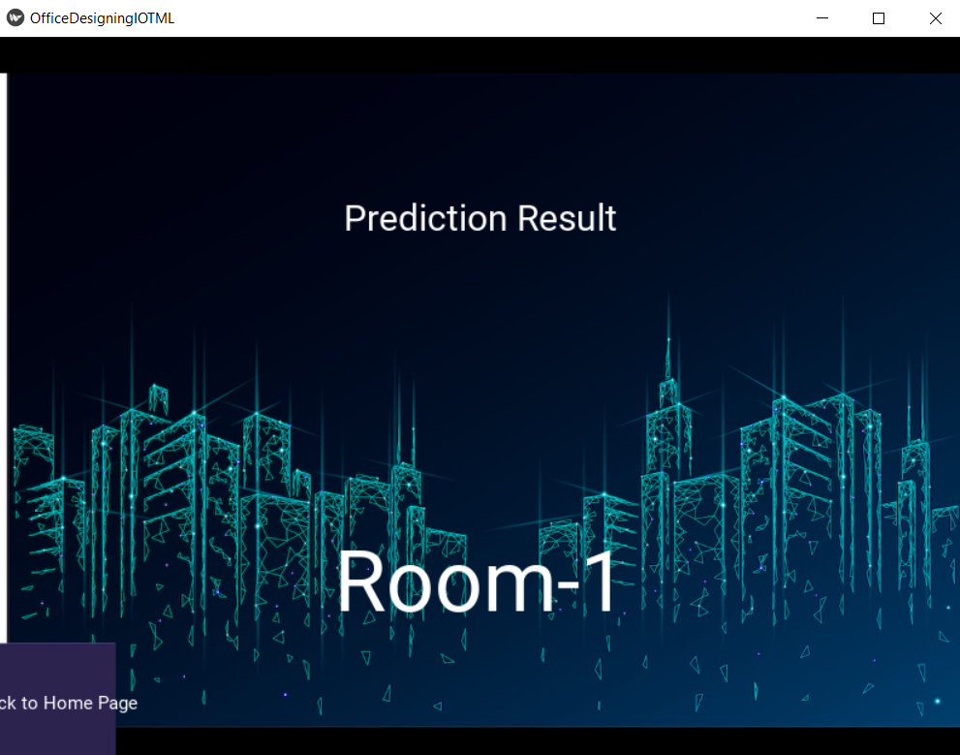

Figure 1.9 Interface of Mobile Application

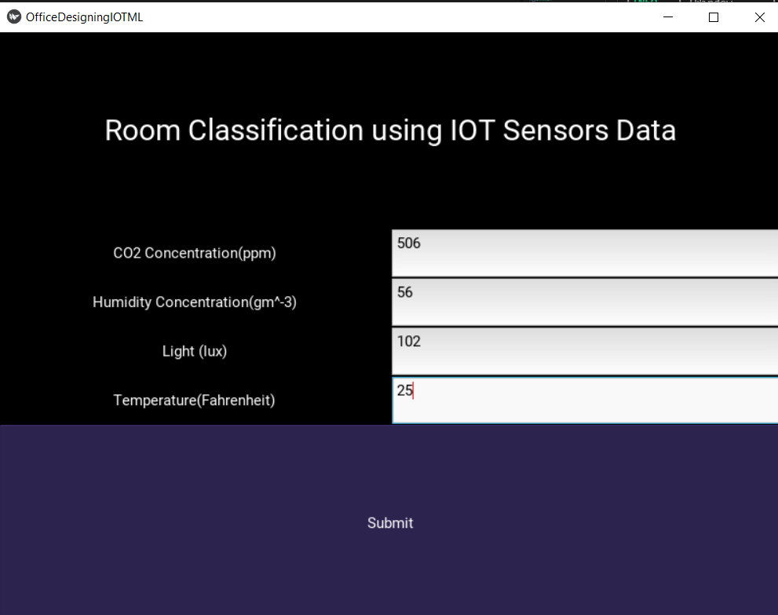

Chapter 4: Architecture

1. Arduino UNO

Arduino Uno is a microcontroller board based on the ATmega328P ([datasheet](http://ww1.microchip.com/downloads/en/DeviceDoc/Atmel-7810-Automotive-Microcontrollers-ATmega328P_Datasheet.pdf)). It has 14 digital input/output pins (of which 6 can be used as PWM outputs), 6 analogue inputs, a 16 MHz ceramic resonator (CSTCE16M0V53-R0), a USB connection, a power jack, an ICSP header and a reset button. It contains everything needed to support the microcontroller; simply connect it to a computer with a USB cable or power it with a AC-to-DC adapter or battery to get started.

"Uno" means one in Italian and was chosen to mark the release of Arduino Software (IDE) 1.0. The Uno board and version 1.0 of Arduino Software (IDE) were the reference versions of Arduino, now evolved to newer releases. The Uno board is the first in a series of USB Arduino boards, and the reference model for the Arduino platform; for an extensive list of current, past or outdated boards see the Arduino index of boards.

1. Temperature Sensor:

A temperature sensor is an electronic device that measures the temperature of its environment and converts the input data into electronic data to record, monitor, or signal temperature changes. There are many different types of temperature sensors. Some temperature sensors require [direct contact](https://www.electronics-tutorials.ws/io/io_3.html) with the physical object that is being monitored (contact temperature sensors), while others indirectly measure the temperature of an object (non-contact temperature sensors). We have used DHT11 sensor to record the temperature and humidity values from the environment in Fahrenheit.

1. CO2 Gas Sensor:

A carbon dioxide sensor or CO2 sensor is an instrument for the measurement of carbon dioxide gas. ... Measuring carbon dioxide is important in monitoring indoor air quality, the function of the lungs in the form of a capnograph device, and many industrial processes. We have used MQ-135 sensor for recording the concentration of CO2 in parts-per-million.

1. Humidity Sensor:

A humidity sensor is an electronic device that measures the humidity in its environment and converts its findings into a corresponding electrical signal. ... Relative humidity is calculated by comparing the live humidity reading at a given temperature to the maximum amount of humidity for air at the same temperature. As discussed above, we have used DHT11 sensor for recording humidity concentration in the environment in gram-per-meter-cube.

1. Light Intensity Sensor:

Light Sensors. The light sensor is a passive device that converts the light energy into an electrical signal output. ... Phototransistors, photoresistors, and photodiodes are some of the more common type of light intensity sensors. Photoelectric sensors use a beam of light to detect the presence or absence of an object. We have used ambient light sensor for recording the intensity of light in the environment in lux.

5.2 Hardware Assembly



Chapter 6

Result: The readings obtained using this model dovetailing the techniques of Machine learning and Internet of Things

Chapter 7

Conclusion: Hence, our project “Smart Location Director” helps the workers scrutinize the suitable location for each part of a building. This makes the place more liveable and convenient. E.g., It helps locating the study room at the corner which has the highest amount of light striking, a conference hall where less CO2 is detected and so on.

The prerequisites which are usually ignored while construction is covered up through this model.