Abstract
Mental Health Analysis for Company Employees
Kanupriya Sharma¹ and Vrushali Purushottam Gajare²
^{1,2}University of Texas at Dallas
^{1.}email: KXS220016@utdallas.edu
^{2.}email: VXG220058@utdallas.edu
In our project we find what are the most important factors involved for an employee who is working in a technical company seeking help for their mental health condition. This study will help employers improve their work environment for better wellbeing of their employees.
1 Introduction
We chose this dataset for our study since mental health is the most underappreciated health condition in our culture. We have practical tests for detecting diseases like diabetes, blood pressure, and even Covid-19, but mental health illnesses are influenced by various aspects that include social, economic, and personal factors. As a result, determining whether a person is mentally fit is a difficult topic to answer. In this project, we will attempt to determine which factors or features have most influence on a person’s mental well-being and whether that person will seek treatment for his/her condition. Our target audience in this dataset is primarily employee technical companies and the impact they have on their employee’s mental health.
2 Features of Our Dataset
There is total 24 features in our dataset. Following are their definitions:
- Age: Respondent’s age
- Gender: Respondent’s Gender
- Country: Respondent’s Country
- self_employed: Is the respondent self_employed?
- family_history: Does the respondent have a family history of mental illness?
- treatment: Has the respondent sought treatment for a mental health condition?
- work_interfere: If the respondent has a mental health condition, does he/she feel that it interferes with their work?
- remote_work: Does the respondent work remotely (outside of an office) at least 50% of the time?
- tech_company: Is the respondent's employer primarily a tech company?
- benefits: Does the respondent's employer provide mental health benefits?
- care_options: Does the respondent know the options for mental health care that their employer provides?
- respondent's employer ever discussed mental health as part of an employee wellness program?
- seek_help: Does the respondent's employer provide resources to learn more about mental health issues and how to seek help?
- anonymity: Is the respondent's anonymity protected if he/she chooses to take advantage of mental health or substance abuse treatment resources?
- leave: How easy is it for respondents to take medical leave for a mental health condition?
- mental_health_consequence: Does the respondent think that discussing a mental health issue with their employer would have negative consequences?
- Phys_health_consequences:the respondent think that discussing a physical health issue with their employer would have negative consequences?
- coworkers: Would he/she be willing to discuss a mental health issue with their coworkers?
- supervisor: Would he/she be willing to discuss a mental health issue with their direct supervisor(s)?
- mental_health_interview: Would he/she bring up a mental health issue with a potential employer in an interview?
- phys_health_interview:Would he/she bring up a physical health issue with a potential employer in an interview?
- mental_vs_physical: Does the respondent feel that their employer takes mental health as seriously as physical health?
- obs_consequence: Has the respondent heard of or observed negative consequences for coworkers with mental health conditions in their workplace?
- comments: Any additional notes or comments

3. Exploratory Data Analysis
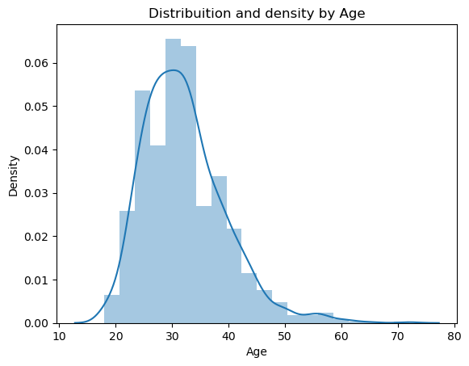
We see that most of our respondents age lie in between their 20s to 40s.
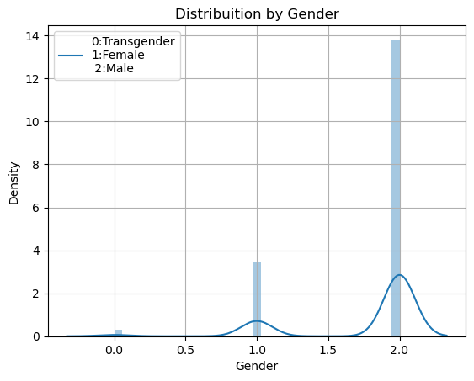

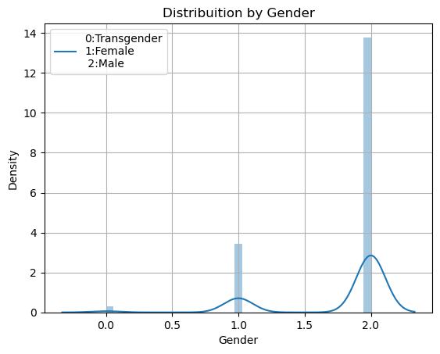
In our dataset most of the people are male followed by females.

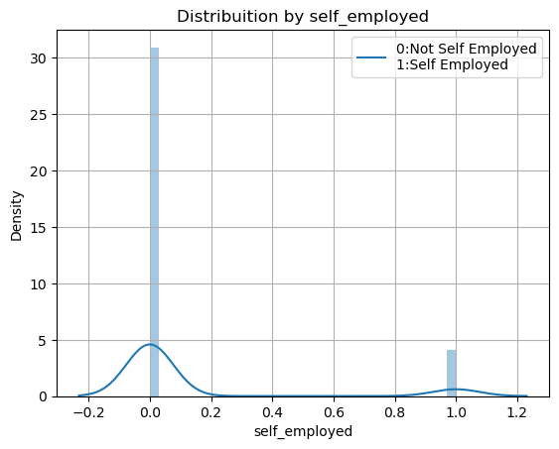
In our dataset 90% of the respondents are not self-employed.

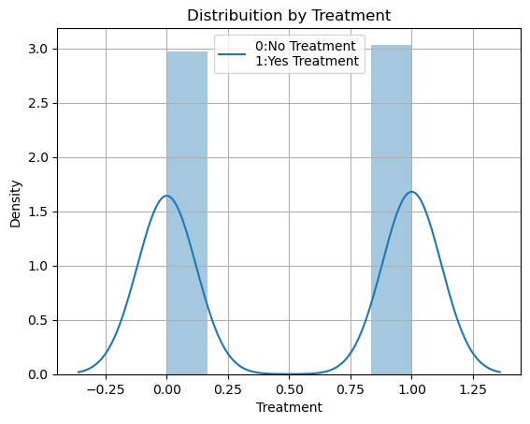
Our dataset is quite balanced as 50% seeked treatment and 50% did not seek help.

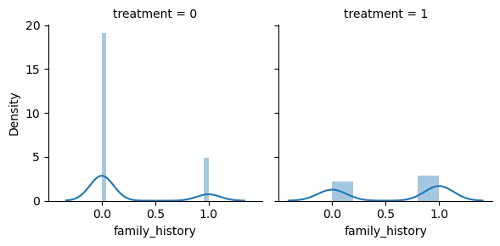
We observe that very less people had a family history and those who had very few seek treatment.

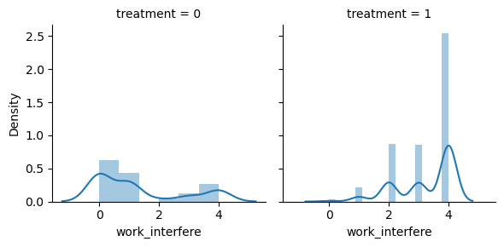
According to the data people who responded that their mental health sometimes got in the way of work had seek treatment and for those who never had any issue never sought any help.
0: No
1: Not Sure
2: Yes

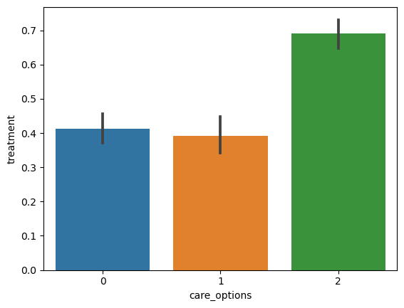
Those people who are aware of the care options of their company did seek treatment for their condition.

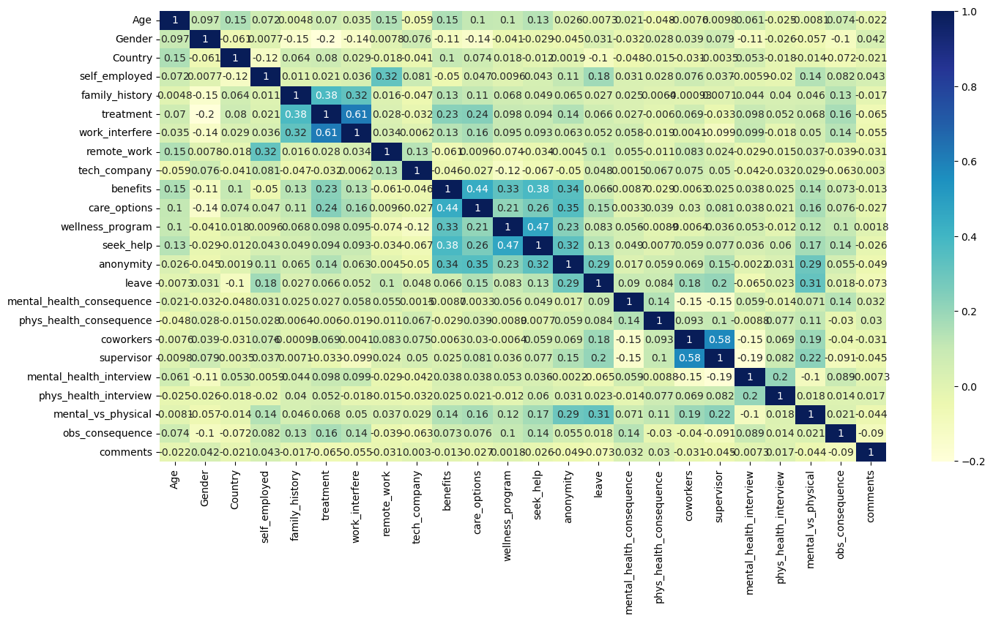
According to the heat map we see that the features that are maximum related to our lable treatment are as follow:
1.family_history 2. work_interference 3. benefits 4. care_options 5. anonymity 6.obs_consequences

Feature Importance

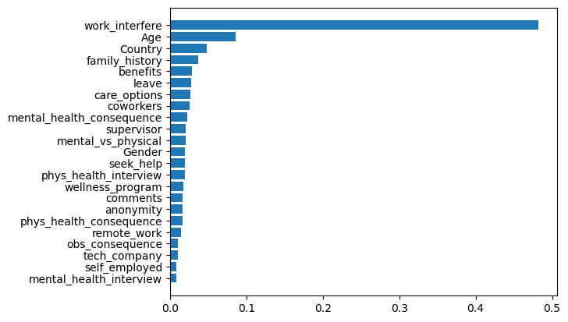

When we do feature importance according to random forest, we basically find the best features on the basis of information gain. According to the feature selection of random forest our most important features are denoted in the plot above are as follow:
- Work Interference
- Age
- Country
- Family History
- Leave
- Mental Health Consequences
- Care Options
- Coworkers
- Benefits
- Physical Health Interview
2.2 Model Evaluation
We started off with the simplest to the most complex algorithm. Since this is a classification problem, we used all the supervised learning models. We have used 7 different algorithms for our model evaluation in which we have recorded the results for area under the curve for our ROC curve, accuracy, precision and recall. We have also used cross validation using Stratified K Fold library for hyperparameter tunning our models.
2.2.1 Logistic Regression
The equation of logistic regression is given by the following equation:
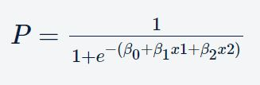

In the context of the business problem that we are going to solve, P denotes the probability of an employee seeking treatment. In logistic regression model, you choose a cutoff value c, say 0.5. In a binary classification task (y = 1|0), if P > c, then the predicted value is 1 else 0. According to our hyperparameter tuning the c value is 1.0 and the best auc corresponding to best c: 0.8 on cross validation set. The results are as follows:

 | With Cross Validation on test set | Without Cross Validation on test set
AUC | 0.7990842490842491 | 0.7965201465201466
Accuracy | 0.8010610079575596 | 0.7984084880636605
Precision | 0.780373831775701 | 0.7793427230046949
Recall | 0.8564102564102564 | 0.8512820512820513

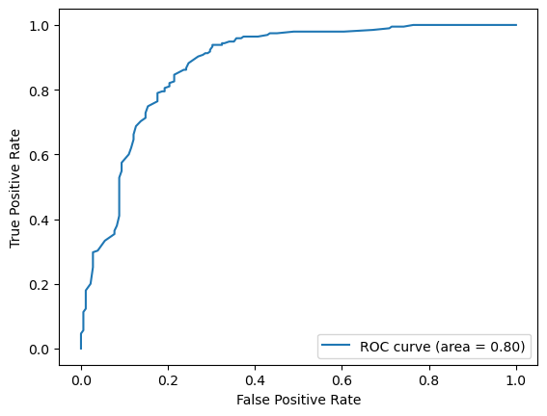
2.2.2 Decision Tree Classifier
Due to their great interpretability and clear approach, decision trees mimic the people make decisions and excel at dealing with categorical data. Unlike other methods such as logistic regression or SVMs, decision trees do not find a linear link between the independent and target variables. However, they can be used to model very nonlinear data.

When we do cross validation on decision tree, we get the best depth as 2, minimum sample leaves as 50 and minimum sample split as 50 and best corresponding mean auc is 0. 8754654610953031.The results are as follow:

 | With Cross Validation on test set | Without Cross Validation on test set
AUC | 0.8234432234432234 | 0.8152793614595211
Accuracy | 0.8275862068965517 | 0.8275862068965517
Precision | 0.773109243697479 | 0.773109243697479
Recall | 0.9435897435897436 | 0.9435897435897436

We see that decision tree better than Logistics regression which was expected. To sum up, there are several situations in which a linear regression model cannot be used to create predictions, such as when you want to partition the data set into many subgroups since each subset has an independent trend related to it. There, you utilize a decision tree model to create predictions since a tree regression model may partition the data into many sets and assign a linear regression model to each set independently.

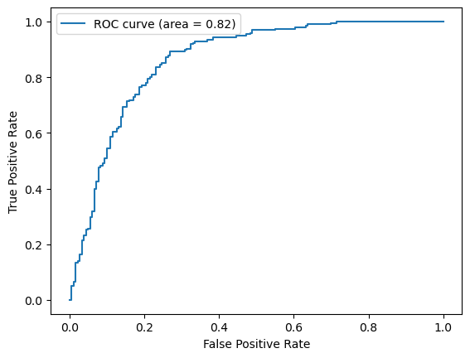
2.2.3 Random Forest Classifier
Random forests are by far the most successful bagging form of ensemble. They are essentially collections of decision trees. You build a large number of models (say, 100 decision trees), each of which is trained on a distinct bootstrap sample from the training set. To obtain the outcome, you must aggregate the decisions made by all of the trees in the ensemble.
From our cross validation set the best number of trees is 801 for our random forest classifier and best auc is 0.8963787960605827.

 | With Cross Validation on test set | Without Cross Validation on test set
AUC | 0.8141025641025641 | 0.8261904761904761
Accuracy | 0.8169761273209549 | 0.8275862068965517
Precision | 0.78125 | 0.8125
Recall | 0.8974358974358975 | 0.8666666666666667

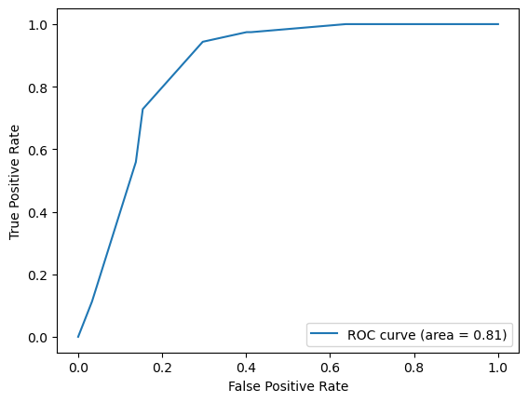

We observe that our auc is 81% with hyperparameter tuning as compared to 82% in decision tree model. These results are not expected as random various advantages as follow:
- Diversity happens because each tree is generated using some of the features, i.e. not all of the attributes. The attributes taken into account for each tree are picked at random. This assures that the trees are not mutually dependent.
- The fact that the responses of several trees balance out leads to stability. The model variance of a random forest is lower than that of a single tree.
- Resistance to the curse of dimensionality: Because each tree does not evaluate all of the characteristics, the feature space (the amount of features a model must consider) shrinks. As a result, the algorithm is immune to the curse of dimensionality. Computational and complexity challenges arise as a result of a huge feature space.
- Parallelizability: A forest necessitates many trees. Because two trees are formed individually based on distinctive data and properties, they can be built separately. This implies you can use your multi-core CPU to create random forests. Assume four cores and 100 trees are to be developed; each core can build 25 trees to form a forest.
2.2.4 Adaboost Classifier
The AdaBoost algorithm enhances performance by increasing the likelihood of some points while decreasing the likelihood of others. We used the hyperparameter tunning results of the decision tree as our weak learner for our algorithm and got an accuracy of 0.7904509283819628 on our test set. We believe that adaboost might not have done better than random forest because it is highly sensitive to outliers. Because AdaBoost tends to increase the probabilities of misclassified points, and there is a significant risk that outliers will be misclassified, it will continue to increase the probability of outliers and make progress difficult. The results are as follows:

Accuracy: 0. 7904509283819628
Precision: 0.7843137254901961
Recall: 0.8205128205128205
AUC Score: 0.7893772893772893

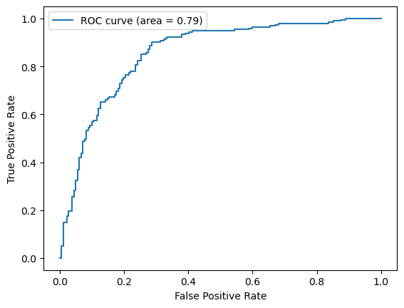
2.2.5 Gradient Boosting
In the gradient boosting process, the following two steps are repeated on each iteration:
1. Calculate the residual and apply a new model to it.
2. Combine the new and old models and go to the next iteration.
Our main goal is to minimize the loss function.Our gradient boosting results are as follows:
Accuracy: 0.830238726790451
Precision: 0.8075117370892019
Recall: 0.882051282051282
AUC Score: 0.8283882783882783

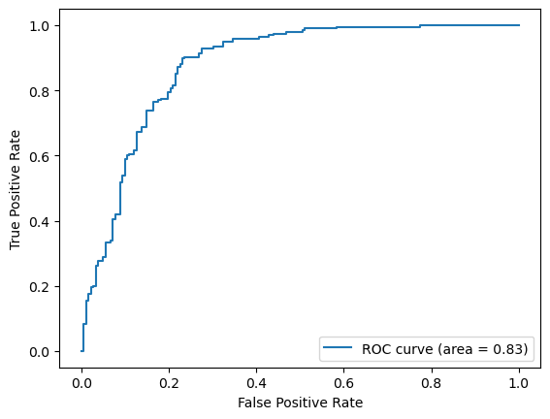
We see that our gradient boosting does equally better with random forest.
2.2.6 KNN Classifier
In nearest neighbors we can have a complex or simple decision boundary depending on the K hence we select K by using hyperparameter tuning. From the cross validation test we find that neighbor K is 29. The results are as follows:
 | With Cross Validation on test set | Without Cross Validation on test set
AUC | 0.7747252747252747 | 0.7794871794871795
Accuracy | 0.7771883289124668 | 0.7824933687002652
Precision | 0.7534246575342466 | 0.7511111111111111
Recall | 0.8461538461538461 | 0.7511111111111111

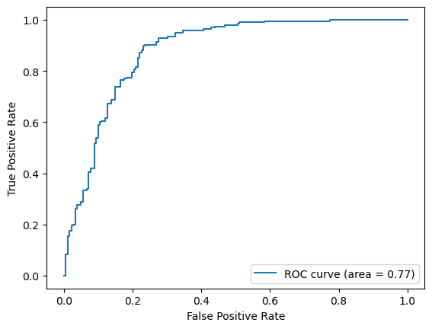
So far KNN has done the worst with our dataset. It may be overfitting, that is one possible reason for its bad performance.
2.2.7 SVM Classifier
SVMs, can deal with quite complex problems, where models such as logistic regression typically fail. SVMs have been widely employed to solve complicated classification issues like image recognition and voice detection.

The best C we get from cross validation is 1.0 and mean auc is 0. 8794732015051386.When we test our model we get following results:

 | With Cross Validation on test set | Without Cross Validation on test set
AUC | 0.8012820512820514 | 0.7985347985347985
Accuracy | 0.8037135278514589 | 0.8010610079575596
Precision | 0.776255707762557 | 0.7727272727272727
Recall | 0.8717948717948718 | 0.8717948717948718

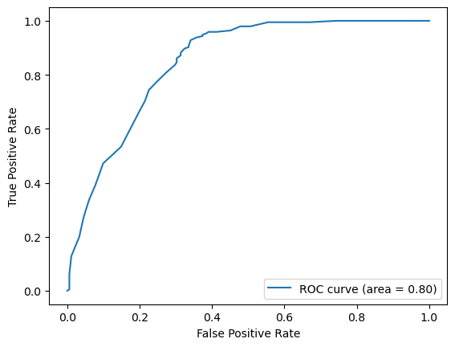
The auc is again not that great as compared to random forest because we used linear SVM model instead RBF or gaussian kernel which are capable of a much complex decision boundary.
2.3 Success of Models
Till now, we have learnt various machine learning models such as logistic regression, support vector machines, decision trees, and random forests. The question is, how do we choose which model(s) to apply to a given business problem? We plotted the auc for all our models including the scores with and without cross validation and the results are as followed:
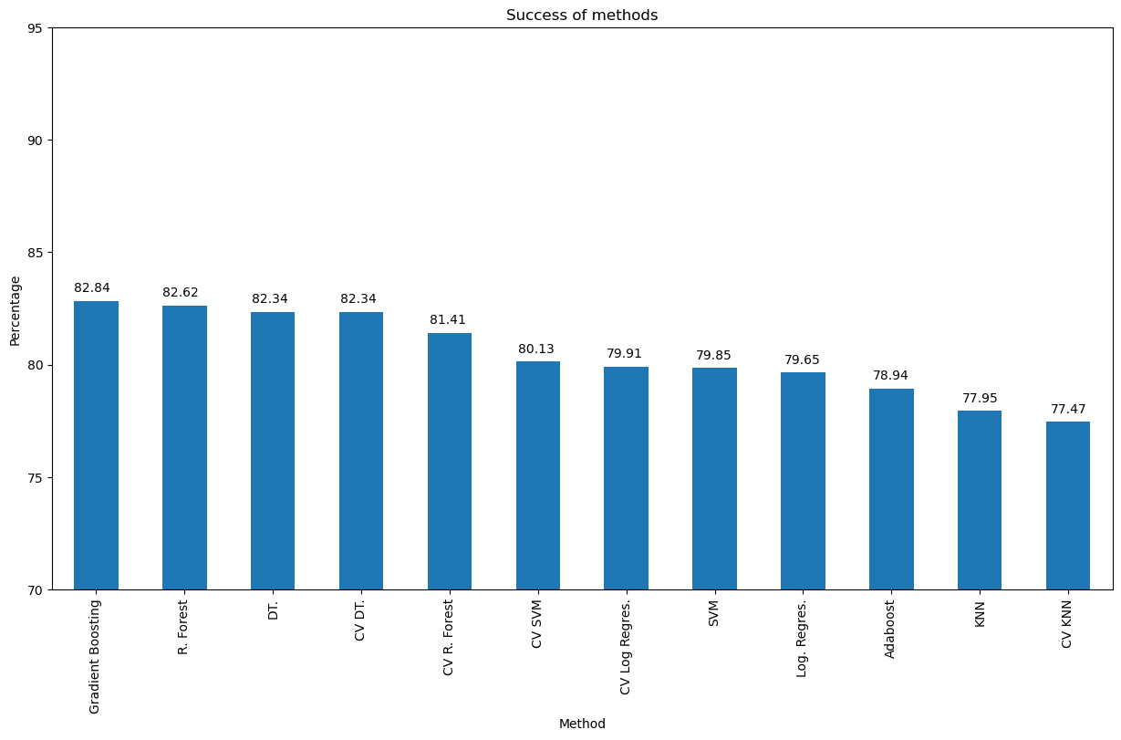

One option is to apply all the models and compare their
results: but is it always feasible to apply all the models? Sometimes, we won’t have enough time to try all the available options. More importantly, it is helpful to be able to identify some guiding principles behind the choice of models, rather than using a hit-and-trial approach. In our project we see that gradient boosting did best follow by random forest which did equally good. Decision tree also did the same. Also, Adaboost might have lost the race with gradient boosting because of the outliers as we didn’t check the data for the same. Moreover, with cross validation and hyperparameter tuning we got better results than without it in general. We also believe that SVM did not do better in this case because we used a linear SVM, so the complexity of our model was less, and the same reason is for the logistic regression model as well. Moreover, SVM didn’t do well because it is difficult to choose the right kernel for the given data and it has more computational cost when number of observations are large. KNN did poorly because we think it is overfitting the data.
2.9 Model Evaluation using Feature Selection
In this code segment we took all our trained models and tried to do some feature selection using RFE and compared how our models did after eliminating features which didn’t contribute much. We did find out the features from our random forest but this time we will do a backward selection approach and see if that helps in increasing the auc of our models.

We dropped the features based on their VIF score and only took the top 15 features. The VIF score and features are as follow:

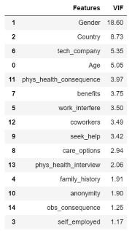

We compare all the models for the auc score and results are as follows:

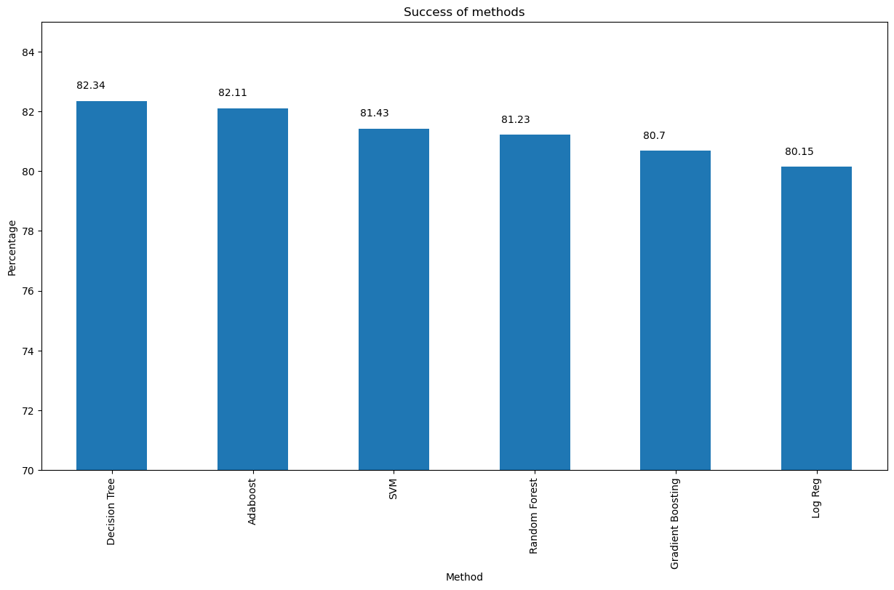
We further drop the features to 10 and then we compare our models again:

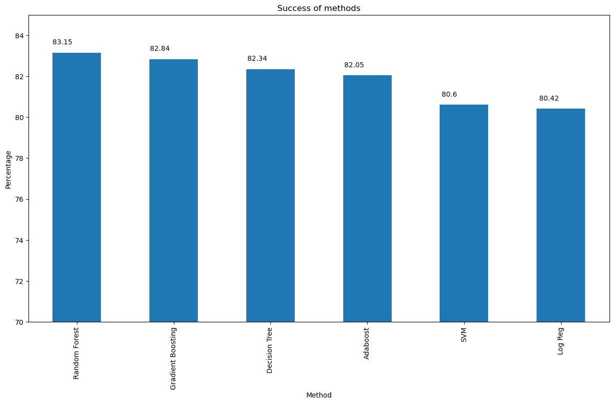

There has not been much change in auc scores except for 1% here and there so further reduced our features to 8 then again compared our models. The graph of the model comparisons is as follows:

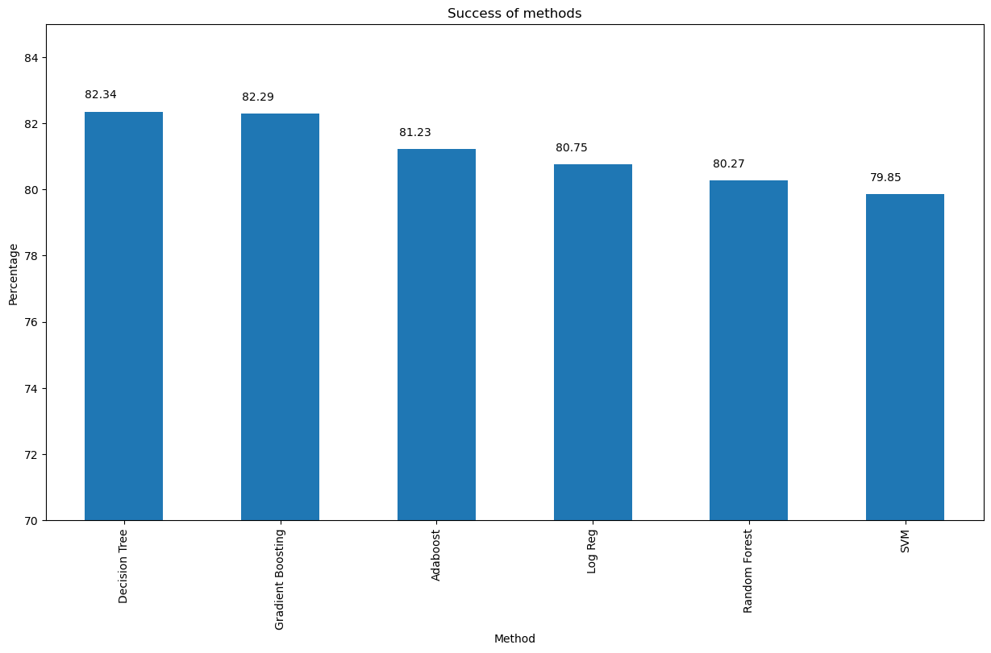

We observe that the auc score has started to reduce for random forest, logistic regression, Adaboost and SVM by 2% hence we put 10 features as the cutoff to get the maximum accuracy for our models.
Discussion
We have gradient boosting and random forest performing best for our data followed by decision tree. SVM didn’t do well because we didn’t find the right kernel for it and only linear was used and adaboost did bad because we didn’t remove the outliers properly. Lastly, logistic regression will not be good because our data is not linear. We didn’t consider precision and recall in our problem statement because our data is balanced hence accuracy and auc can be a good measure. Finally, our predicting features are as follows:
1. Gender
2. Country
3. Age
4. phys_health_consequence
5. work_interfere
6. coworkers
7. seek_help
8. benefits
9. family_history
10. obs_consequence

Our problem statement was to predict the people who will take treatment for their condition and the most influential features for them is gender, country, age, physical health consequences that is if someone discussed their health issues with their employer have a negative impact or not, work interference that is does their mental health condition interfere with their work, coworkers that is will the employee discuss their mental health condition with their coworkers, seek_help that is does the respondent's employer provide resources to learn more about mental health issues and how to seek help, benefits that is the respondent's employer provide mental health benefits ,then we have family history of the employee with any mental illness and lastly observed consequences that is has the respondent heard of or observed negative consequences for coworkers with mental health conditions in their workplace.

Acknowledgments
We would like to acknowledge Professor Sriraam Natarajan for providing us with this opportunity to work on this project. We would also like to acknowledge Nikhilesh Prabhakar, TA for CS6375 for helping us during our entire project.
References
- https://www.kaggle.com/code/kairosart/machine-learning-for-mental-health-1
- https://scikit-learn.org/stable/
- https://www.upgrad.com/blog/logistic-regression-for-machine-learning/
- https://towardsdatascience.com/id3-decision-tree-classifier-from-scratch-in-python-b38ef145fd90
- https://pub.towardsai.net/understanding-tree-models-d2a38a9dcd5b

