Task:2
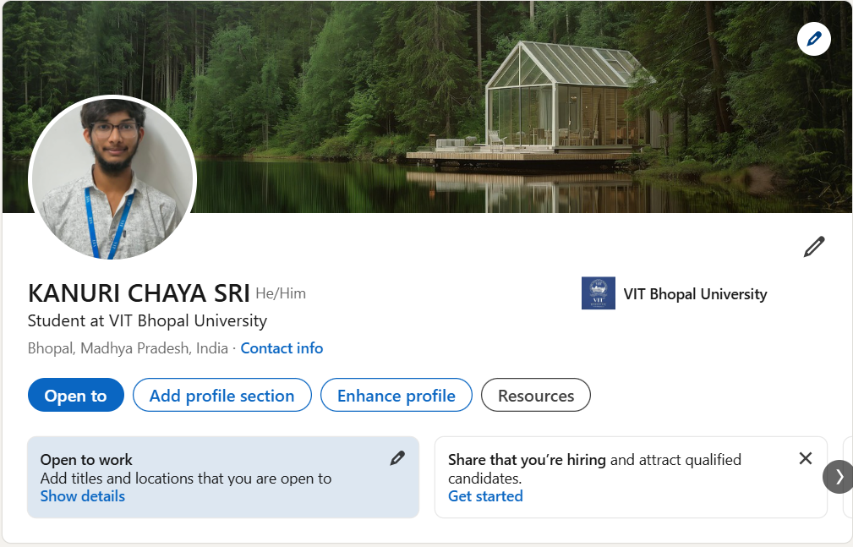
inkedIn Profile Reflection: Kanuri Chaya Sri
Current State: Strong professional presence with a high-quality headshot and a serene, aesthetic banner. Properly linked to VIT Bhopal University with the "Open to Work" feature enabled.
Key Optimizations
Elevate the Headline: "Student at VIT Bhopal University" is a bit generic. Since your GitHub highlights Aerospace Engineering and Sustainability, try:
“Aerospace Engineering Student at VIT Bhopal | Aspiring Data Analyst | Focus on Sustainable Transportation & Computational Engineering”.The "About" Section: This is currently blank. Write a brief summary (3-4 sentences) connecting your engineering background with your technical skills. Mention your projects in Sustainability and your proficiency in Python or problem-solving.Skill Endorsements: Add specific technical skills such as Aerospace Engineering, Python (Programming Language), Sustainable Development, and Data Analysis.Strategic Connections: Start following aerospace companies (like ISRO, Airbus, or Boeing) and sustainability startups. Engaging with their posts will put your profile in front of the right recruiters.
Goal: Bridge the gap between Engineering Theory and Practical Data Skills.
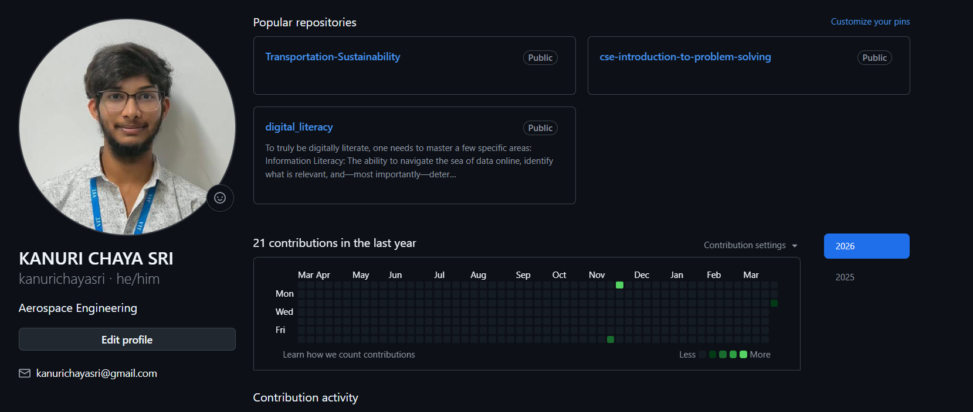
GitHub Profile Reflection: Kanuri Chaya Sri
Current State: Solid professional foundation with a focus on Aerospace Engineering. Pinned repos like Transportation-Sustainability show a great interest in large-scale engineering solutions.
Key Optimizations
The Interdisciplinary Bridge: Aerospace is increasingly data-driven. Use your README to highlight where Aerospace meets Computational Tools (e.g., Python for fluid dynamics or structural analysis).Project Context: Add descriptions to the Transportation-Sustainability and CSE repos. Briefly explain the tech stack used (e.g., "Python-based simulation" or "Problem-solving in C++").
Skill Showcase: Since you have a repo for Digital Literacy, consider adding a "Skills" section to your profile README covering CAD software, programming languages, or simulation tools.
Documentation: Ensure your repositories have a README.md file with a clear "Overview" and "How to Run" section. This is what transforms a student project into a professional portfolio.
Goal: Positioning yourself as a Modern Aerospace Engineer who is proficient in software and sustainability.
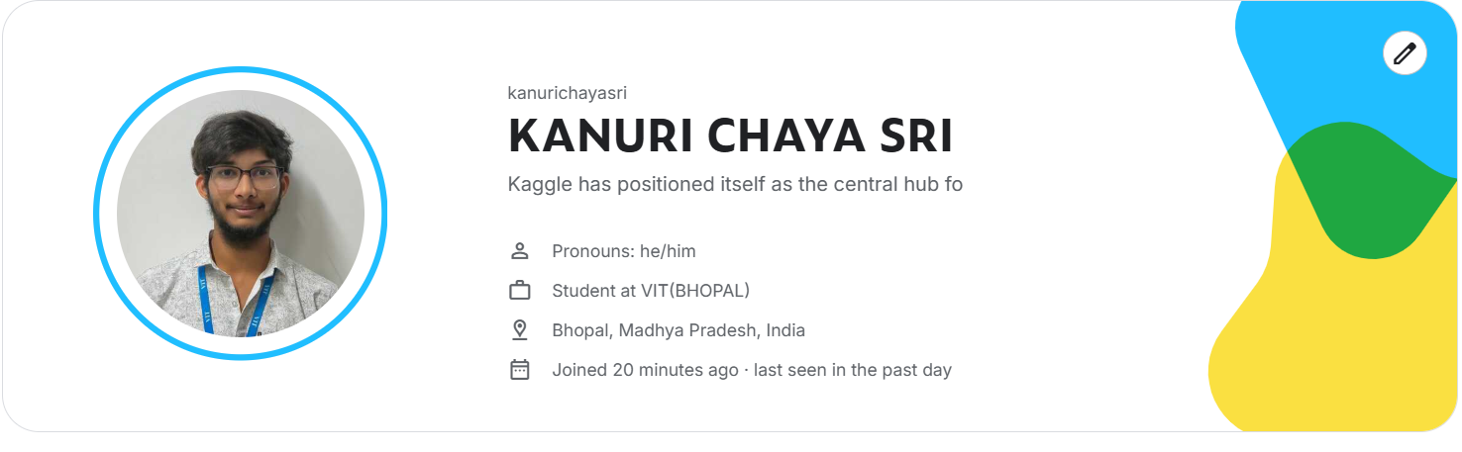
Kaggle Profile Reflection: Kanuri Chaya Sri
Current State: New profile with a clean photo and student affiliation at VIT Bhopal. The tagline seems to be a placeholder or cut off.
Key Optimizations
Fix the Tagline: Replace the current text with something that bridges Aerospace and Data. “Aerospace Engineering Student | Exploring Data Science in Aviation & Sustainability.”
The "About" Section: Mention your interest in Transportation Sustainability. Kaggle has great datasets on fuel efficiency and orbital mechanics that fit your major perfectly.
Skill Integration: Highlight your proficiency in Python or MATLAB if you use it for engineering simulations.
First Action: Find a dataset related to fluid dynamics or satellite data. Forking a simple notebook and adding your engineering perspective is the best way to get your first "Bronze Medal."
Goal: Establish yourself as a Data-Driven Aerospace Engineer.

