SPRING BOOT STUDENT MANAGEMENT SYSTEM

Name | K ANUSRI
Roll No. | 2520030432
Branch | CSE
Project | Student Management REST API
Technologies | Java, Spring Boot, MySQL, Postman
1. AIM
To develop and test a Student Management REST API using Java, Spring Boot, Spring Data JPA, MySQL and Postman, implementing CRUD operations for student records.
2. OBJECTIVES
- Create a Spring Boot project for student management.
- Configure MySQL database connectivity using Spring Data JPA.
- Create a Student entity with id, name, department and email fields.
- Implement repository and service layers.
- Create REST API endpoints for Create, Read, Update and Delete operations.
- Test the REST API using Postman.
- Verify the student data in the MySQL database.
3. SOFTWARE / TOOLS REQUIRED
- Java
- Spring Boot
- Maven
- Visual Studio Code
- MySQL / MySQL Workbench
- Postman
4. PROJECT STRUCTURE
student-management/
├── src/
│ ├── main/
│ │ ├── java/com/example/studentmanagement/
│ │ │ ├── controller/
│ │ │ │ └── StudentController.java
│ │ │ ├── entity/
│ │ │ │ └── Student.java
│ │ │ ├── repository/
│ │ │ │ └── StudentRepository.java
│ │ │ ├── service/
│ │ │ │ └── StudentService.java
│ │ │ └── StudentManagementApplication.java
│ │ └── resources/
│ │ └── application.properties
│ └── test/
├── pom.xml
├── mvnw
└── mvnw.cmd
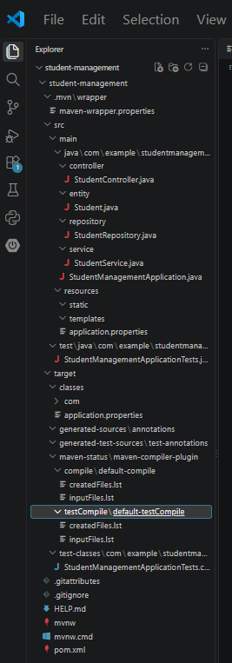
5. DATABASE CREATION
A MySQL database named studentdb was created for the Student Management application.
CREATE DATABASE studentdb;
USE studentdb;
SELECT DATABASE;
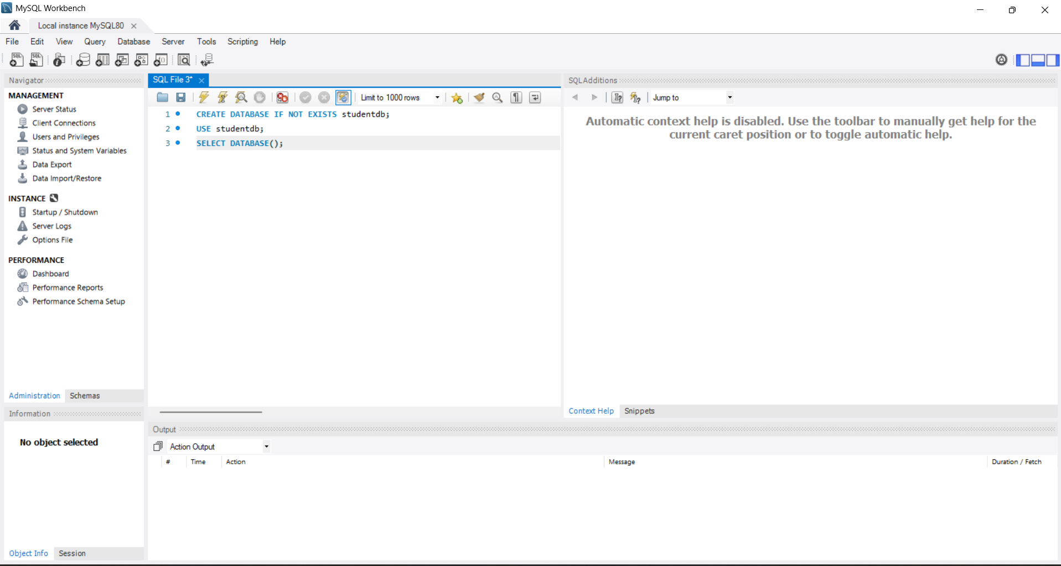
6. DATABASE CONFIGURATION
The Spring Boot application was configured to connect to the studentdb MySQL database. The JPA configuration was used to create/update the required database table automatically.
spring.application.name=student-management
spring.datasource.url=jdbc:mysql://localhost:3306/studentdb
spring.datasource.username=root
spring.datasource.password=YOUR_MYSQL_PASSWORD
spring.jpa.hibernate.ddl-auto=update
spring.jpa.show-sql=true
spring.jpa.properties.hibernate.format_sql=true
server.port=8080
Note: The actual database password should not be uploaded to a public GitHub repository.
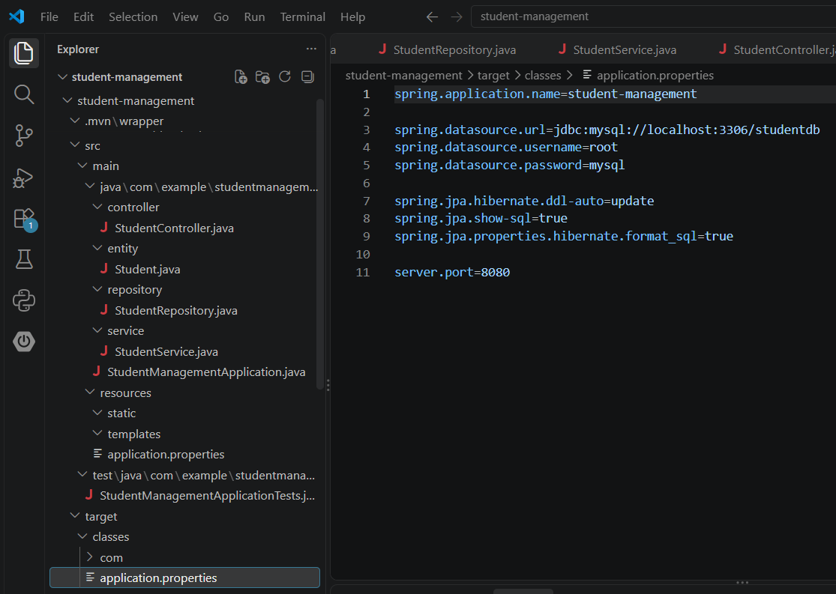
7. STUDENT ENTITY
The Student entity represents the student record stored in the database. It contains the following fields:
- id – Primary key and automatically generated.
- name – Student name.
- department – Student department.
- email – Student email address.
@Entity
public class Student {
@Id
@GeneratedValue(strategy = GenerationType.IDENTITY)
private Long id;
private String name;
private String department;
private String email;
}
[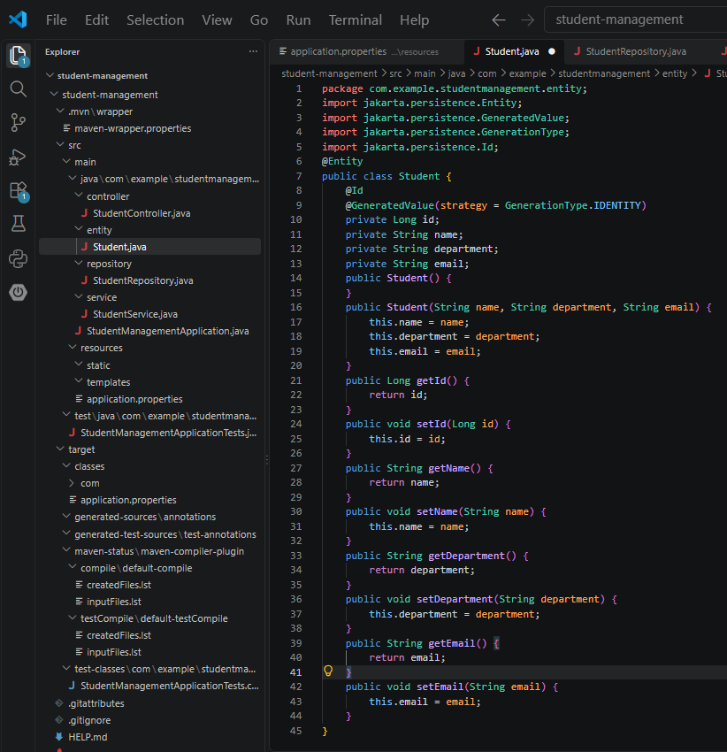
8. REPOSITORY LAYER
StudentRepository extends JpaRepository<Student, Long> and provides database CRUD operations through Spring Data JPA.
public interface StudentRepository
extends JpaRepository<Student, Long> {
}
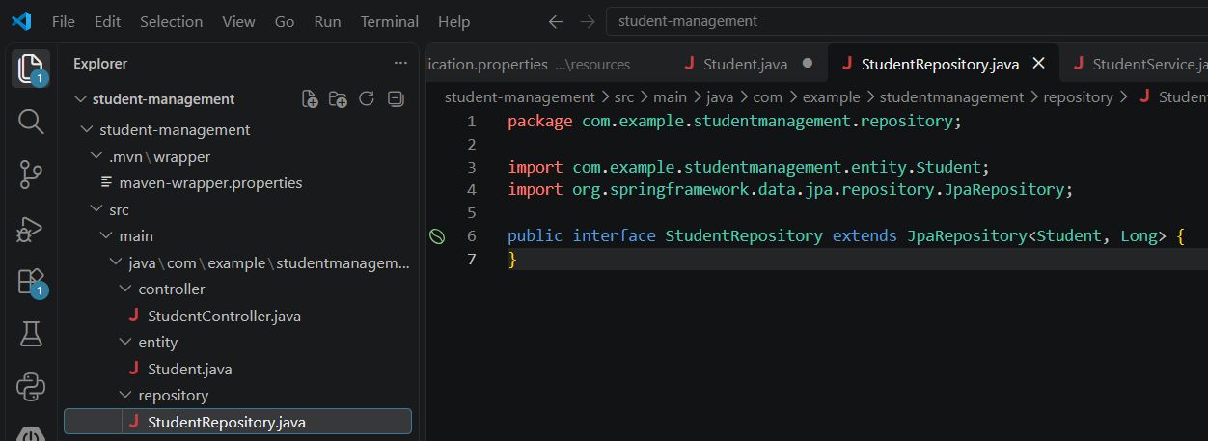
9. SERVICE LAYER
The service layer contains the application logic for saving, retrieving, updating and deleting student records.
public Student saveStudent(Student student)
public List<Student> getAllStudents()
public Optional<Student> getStudentById(Long id)
public Student updateStudent(Long id, Student student)
public void deleteStudent(Long id)
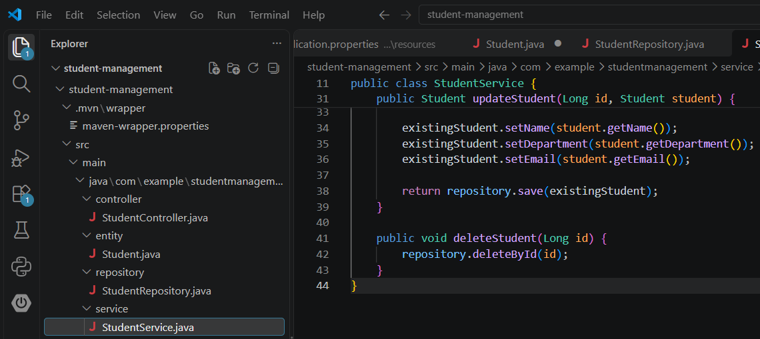
10. CONTROLLER LAYER
The StudentController exposes REST endpoints under the base URL /api/students.
Method | Endpoint | Operation
POST | /api/students | Create student
GET | /api/students | Get all students
GET | /api/students/{id} | Get student by ID
PUT | /api/students/{id} | Update student
DELETE | /api/students/{id} | Delete student
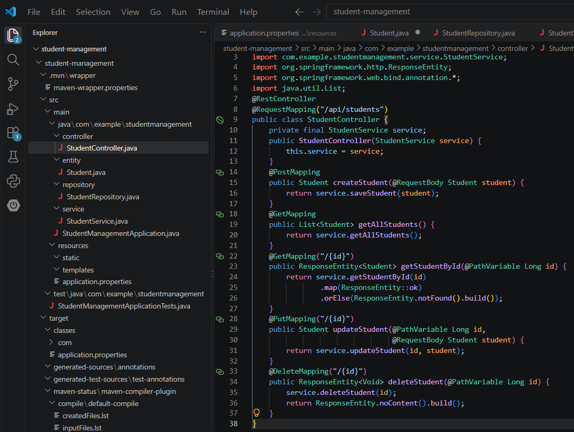
11. RUNNING THE APPLICATION
The Spring Boot application was started from the project directory using the Maven wrapper.
mvnw.cmd spring-boot:run
The application started successfully on port 8080 and connected to the studentdb MySQL database.
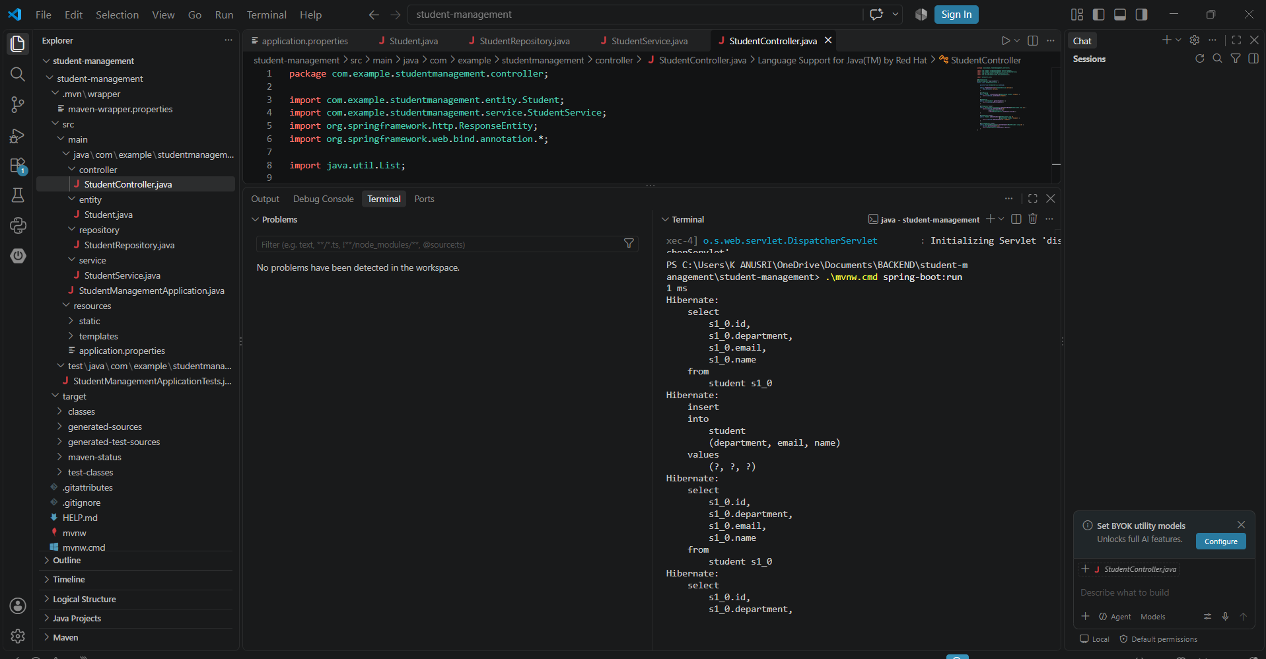
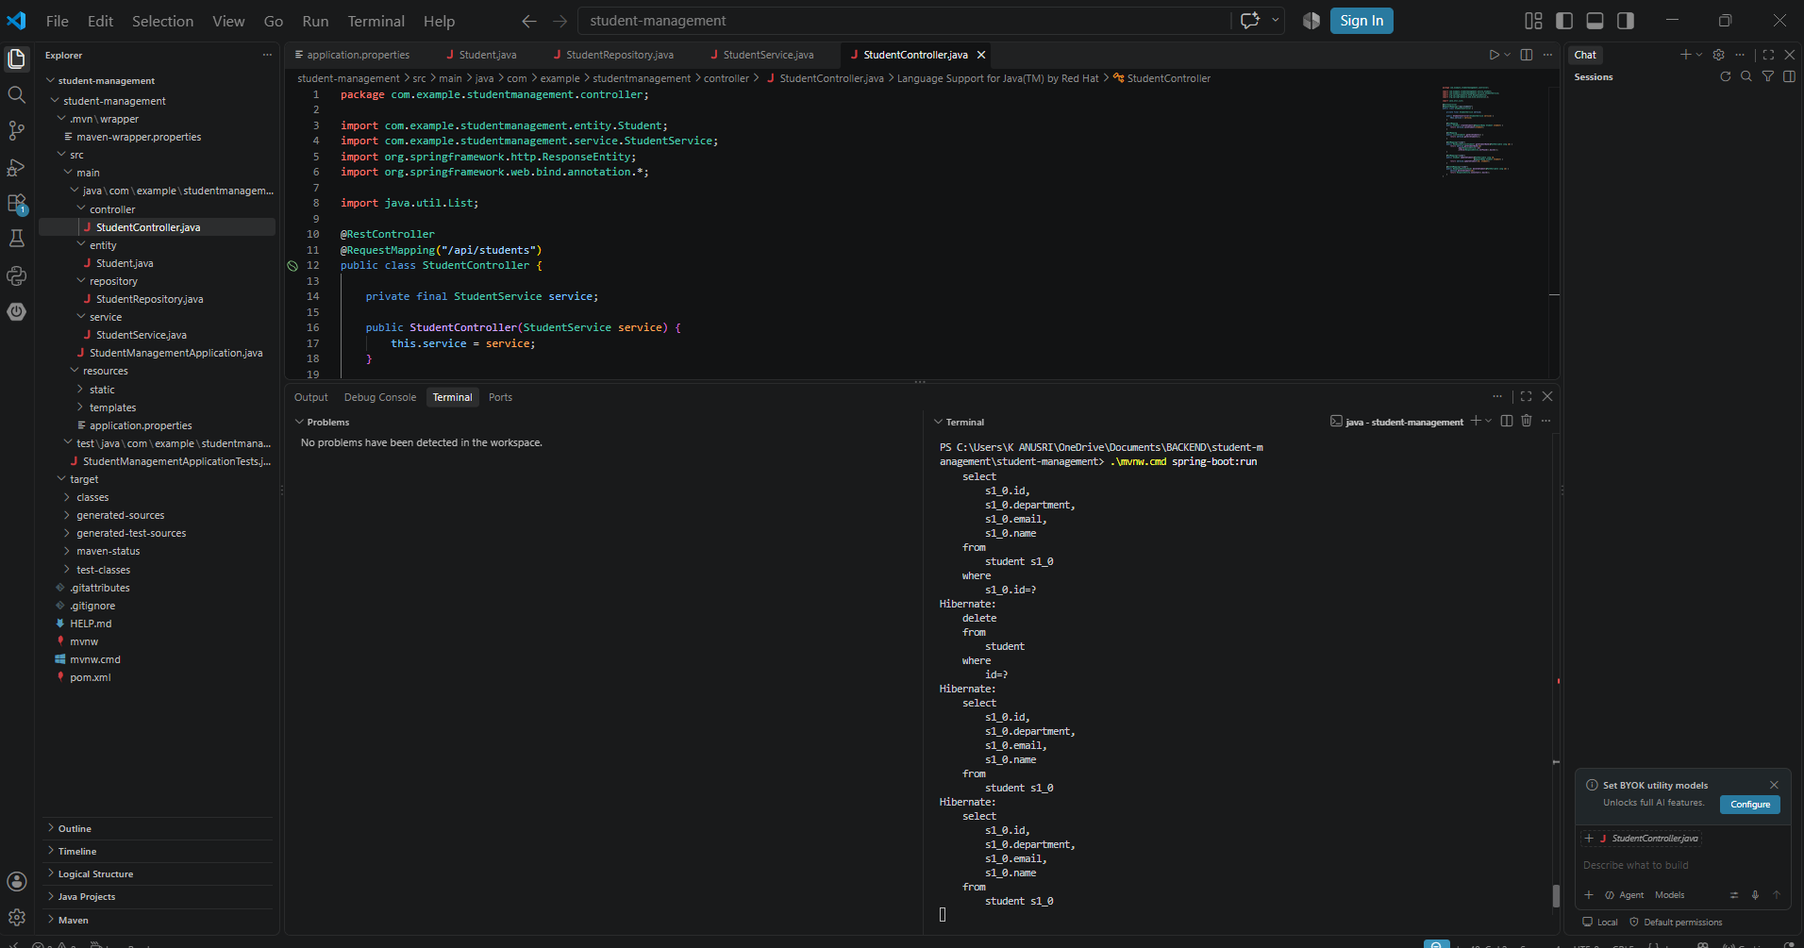

12. POSTMAN TESTING – CREATE STUDENT
A POST request was sent to create a new student.
POST http://localhost:8080/api/students
{
"name": "Anusri",
"department": "CSE",
"email": "anusri@example.com"
}
The API returned the newly created student record with an automatically generated ID.
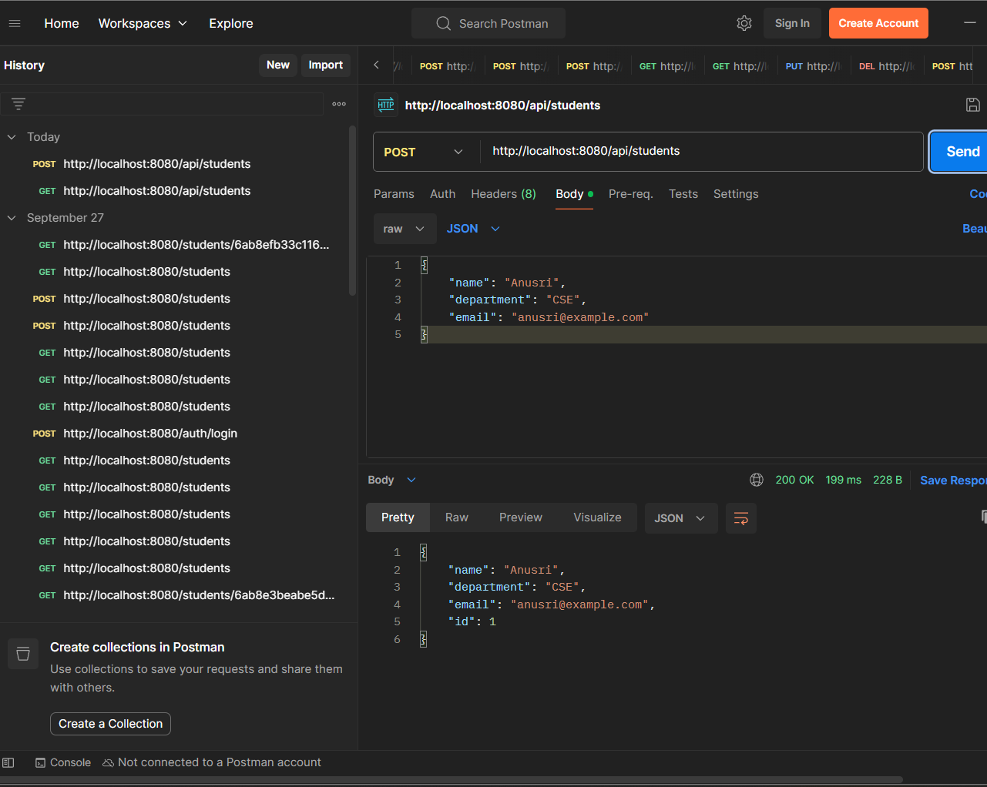

13. POSTMAN TESTING – GET ALL STUDENTS
GET http://localhost:8080/api/students
The GET request returned the list of students stored in the database.
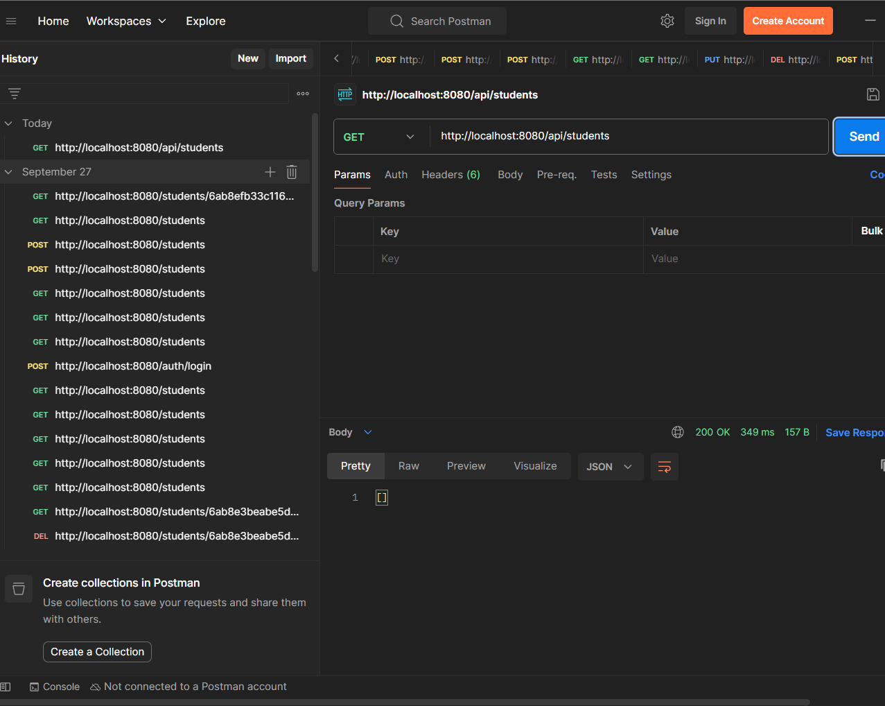

14. POSTMAN TESTING – GET STUDENT BY ID
GET http://localhost:8080/api/students/1
The API returned the student record corresponding to ID 1.
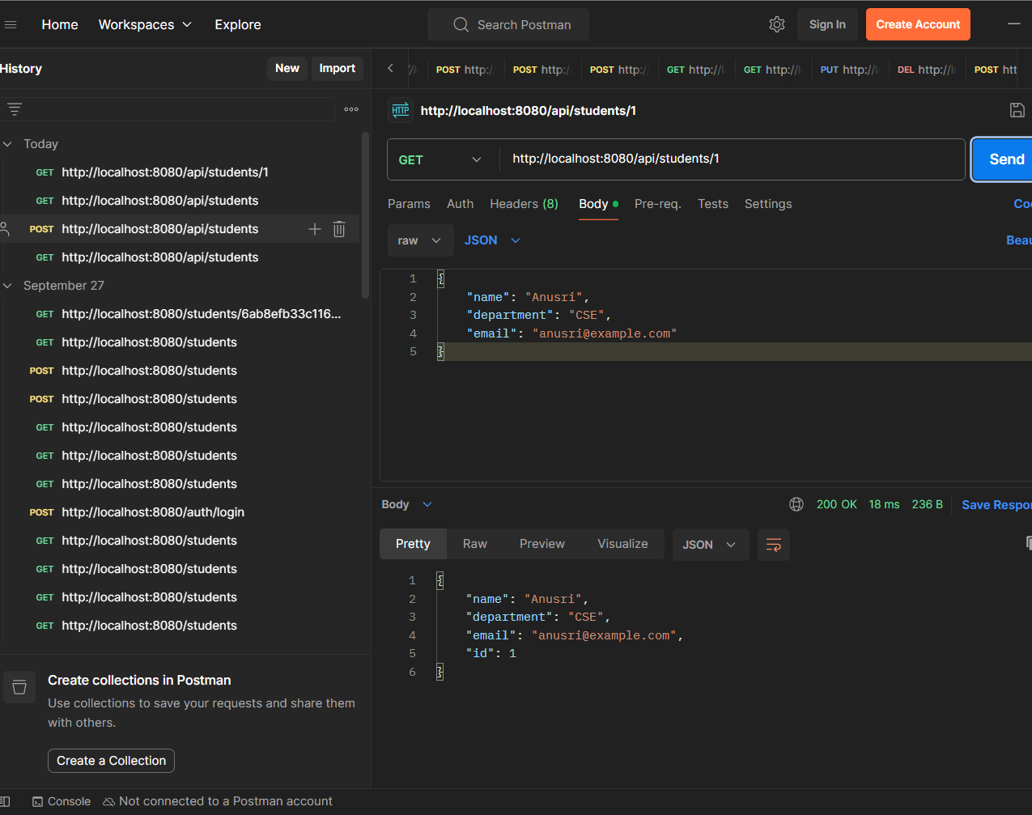

15. POSTMAN TESTING – UPDATE STUDENT
PUT http://localhost:8080/api/students/1
{
"name": "K Anusri",
"department": "Computer Science",
"email": "kanusri@example.com"
}
The PUT request updated the existing student record.
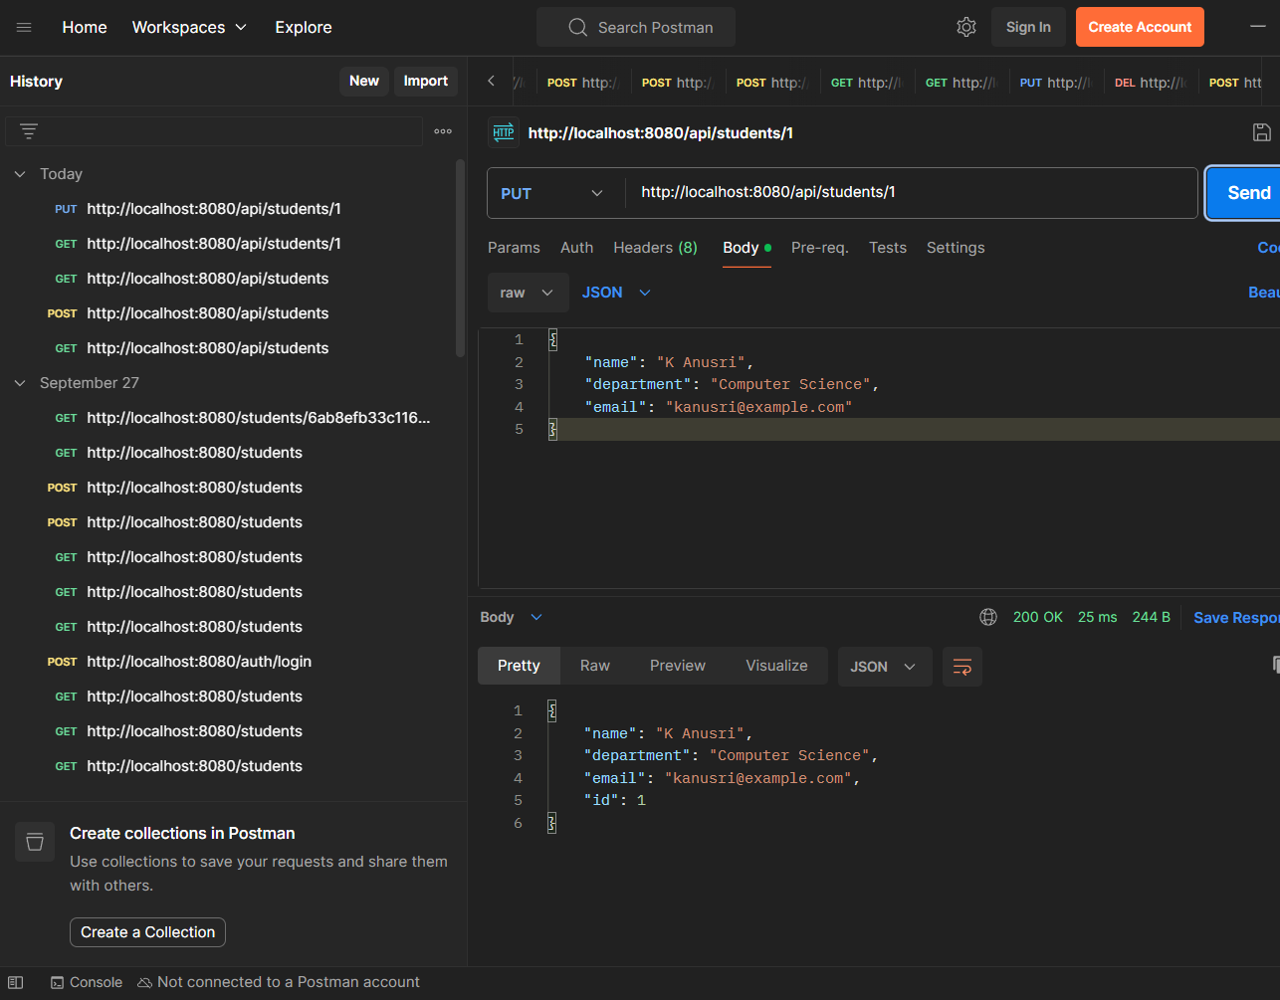

16. POSTMAN TESTING – DELETE STUDENT
DELETE http://localhost:8080/api/students/1
The DELETE request removed the student record and returned HTTP 204 No Content.
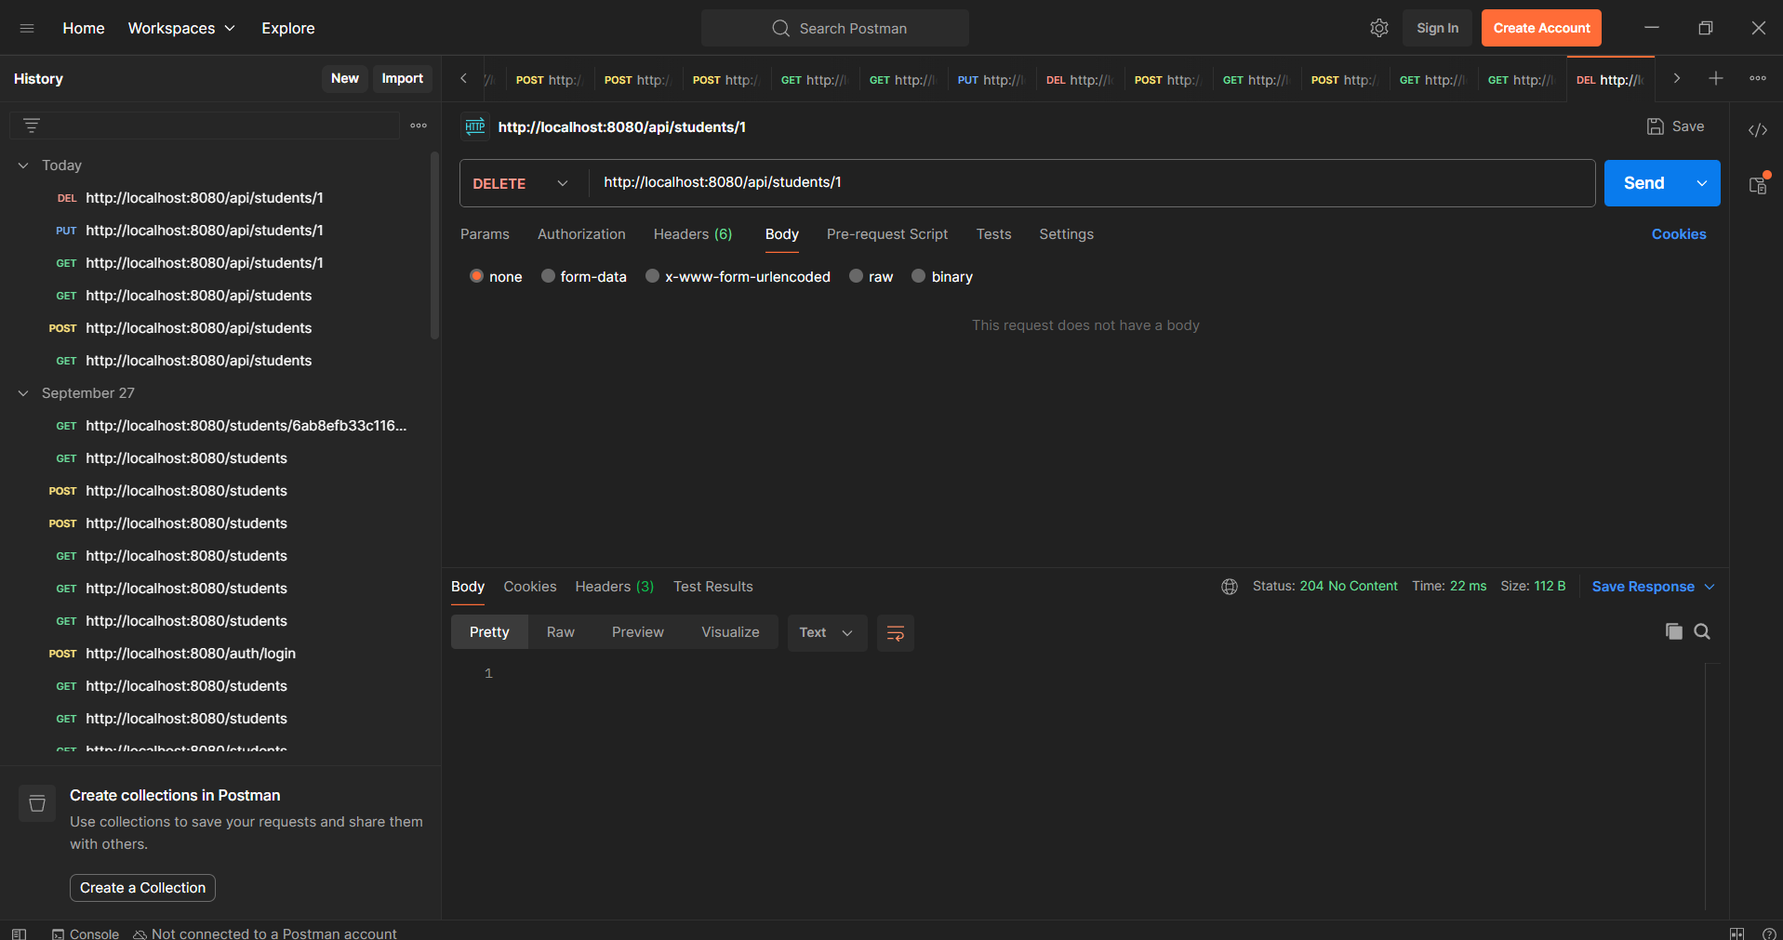
17. FINAL VERIFICATION
GET http://localhost:8080/api/students
After deletion, the GET request returned an empty list, confirming that the student record was successfully removed.
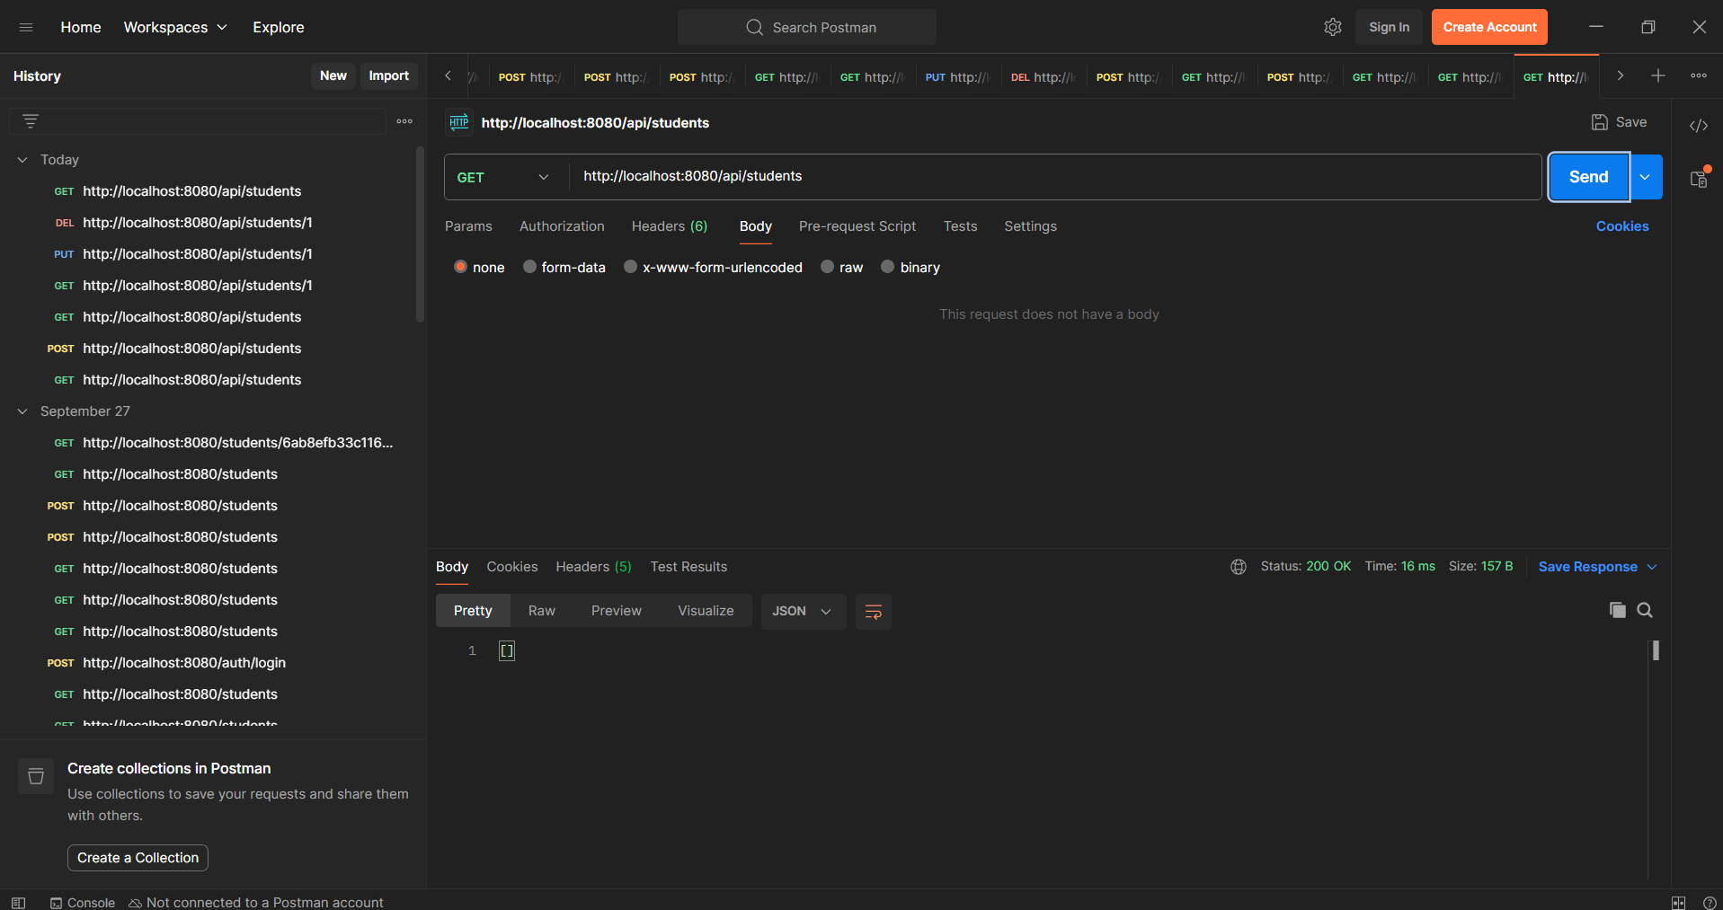
18. RESULT
The Student Management REST API was successfully developed using Java and Spring Boot with MySQL as the database. CRUD operations were implemented through REST endpoints and successfully tested using Postman.
19. CONCLUSION
The practical demonstrated the development of a layered Spring Boot REST application using Entity, Repository, Service and Controller components. MySQL database connectivity was configured using Spring Data JPA, and the REST API was verified using Postman.

