COMPUTER NETWORKS – SKILL 1
ENCAPSULATION BUILDER

Student Details | Information
Name | K ANUSRI
Roll Number | 2520030432
Section | 08
Subject | CNNP

1. Aim
To capture network packets and understand how Ethernet, IP, and TCP/UDP headers are added during data transmission.

2. Objective
To analyze the overhead introduced by protocol headers and determine how encapsulation affects network efficiency.

3. Software / Requirements
• Wireshark
• Computer with an active Wi-Fi or Ethernet network connection
• Web browser

4. Theory
Whenever data travels through a computer network, each protocol layer adds its own header to the data. These headers introduce overhead. In this experiment, Wireshark is used to capture network packets, examine Ethernet, IP and TCP/UDP headers, calculate total overhead, and determine how efficiently the network carries application data.

5. Procedure
1. Install Wireshark: Open a browser, download and install Wireshark using the default settings, and then open the application.
2. Select network interface: Select the active Wi-Fi or Ethernet interface. Double-click it to start packet capture.
3. Generate network traffic: While capturing, open a browser and visit websites such as https://www.google.com. Visit two or three websites, wait approximately 30 seconds, and stop the capture using the red Stop button.
4. Apply display filters: Enter the following filters separately in the display filter bar and observe the packets: tcp, udp, icmp, and tcp.len > 0.
5. Inspect packet headers: Select a TCP packet. Expand Frame, Ethernet II, Internet Protocol Version 4, and Transmission Control Protocol in the packet details pane. Record the required values. Repeat for one UDP packet.
6. Calculate header overhead: Use the captured packet values and the formulas given in the calculation section to determine overhead and payload efficiency.
7. Save the capture: Select File → Save As, choose a folder, enter a filename, retain the pcapng format, and click Save.

6. Display Filters
Filter | Purpose
tcp | Displays TCP packets
udp | Displays UDP packets
icmp | Displays ICMP packets
tcp.len > 0 | Displays TCP packets carrying data

7. Packet Header Details to Record
Parameter | Where to find it
Frame length | Frame
Ethernet header | Ethernet II
Source MAC address | Ethernet II
Destination MAC address | Ethernet II
IPv4 header length | Internet Protocol Version 4
IPv4 total length | Internet Protocol Version 4
TCP header length | Transmission Control Protocol
TCP segment length | Transmission Control Protocol
UDP header length | User Datagram Protocol
UDP length | User Datagram Protocol

8. Header Overhead Calculation
For a basic Ethernet + IPv4 + TCP packet without TCP options, the given values are:
Component | Size
Ethernet header | 14 bytes
IPv4 header | 20 bytes
TCP header | 20 bytes
Application data | 1500 bytes
FCS (if included) | 4 bytes

Total size including FCS = 14 + 20 + 20 + 1500 + 4 = 1558 bytes
Total overhead = 14 + 20 + 20 + 4 = 58 bytes
Payload efficiency = (Application data ÷ Total packet size) × 100
Substitution: (1500 ÷ 1558) × 100 = 96.28%
Note: Wireshark may not capture or display the Ethernet FCS. Use the actual captured packet fields when recording observations.

9. Observation Table
Parameter | TCP Packet | UDP Packet
Frame length | 55 Bytes | Bytes 84 Bytes
Ethernet header length | 14 Bytes | 14 Bytes
IP header length | 20 Bytes | 40 Bytes
Transport header length | 20 Bytes | 8 Bytes
IP total length | 41 Bytes | 270 Bytes
Payload length | 1 Bytes | 150 Bytes

10. Result
Network packets were captured and analyzed using Wireshark. The Ethernet, IP, and TCP/UDP headers were inspected, and the packet overhead and payload efficiency were determined.

11. Viva / Review Questions
1. What is encapsulation?
Answer: Encapsulation is the process of wrapping data from a higher networking layer with specific protocol control information (headers and trailers) as it moves down the OSI or TCP/IP model before transmission.
2. What is the purpose of the Ethernet header?
Answer: The Ethernet header identifies the source and destination physical MAC addresses on a local link and specifies the upper-layer protocol type to ensure data is delivered to the correct device interface.
3. What information is stored in the IP header?
Answer: The IP header stores source and destination IP addresses, packet length, time-to-live (TTL), protocol type (like TCP or UDP), fragmentation details, and header checksums for routing across networks.
4. What is the difference between TCP and UDP headers?
Answer: A TCP header is complex (minimum 20 bytes) and includes sequence numbers, acknowledgment numbers, window size, and connection-management flags for reliable delivery, whereas a UDP header is simple and fixed at 8 bytes, containing only source/destination ports, length, and checksum without connection tracking.
5. Why does each protocol add a header?
Answer: Each protocol adds a header to provide the specific control and routing instructions required by that layer—such as addressing, error checking, sequencing, or port identification—to ensure successful delivery.

6. What is packet overhead?
Answer: Packet overhead refers to the extra non-data bytes added by network protocols (headers and trailers) that are transmitted along with the actual application payload.
7. How does header overhead affect network efficiency?
Answer: Higher header overhead reduces network efficiency because a larger percentage of the transmitted bandwidth is consumed by control data rather than useful application payload.

13. Screenshots / Experimental Evidence
The following screenshots provide evidence of packet capture and the application of TCP and UDP display filters in Wireshark. Insert screenshots taken during your own experiment in the spaces provided.
Figure 1: Live Packet Capture
Start packet capture on the active Wi-Fi or Ethernet interface. Show packets appearing in the packet list.
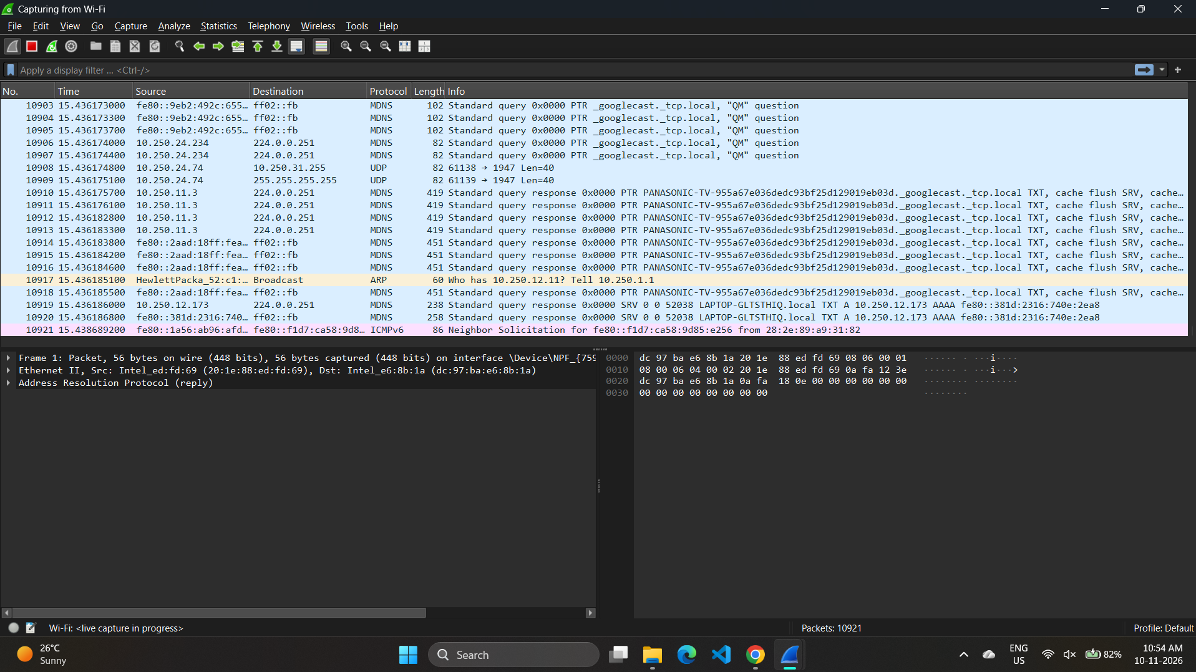

Figure 2: TCP Packets Using Display Filter
Enter tcp in the display filter bar and press Enter. Show the resulting TCP packets.
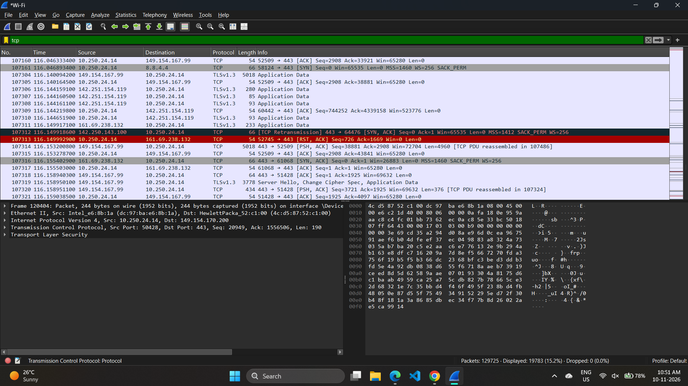

Figure 3: UDP Packets Using Display Filter
Enter udp in the display filter bar and press Enter. Show the resulting UDP packets.
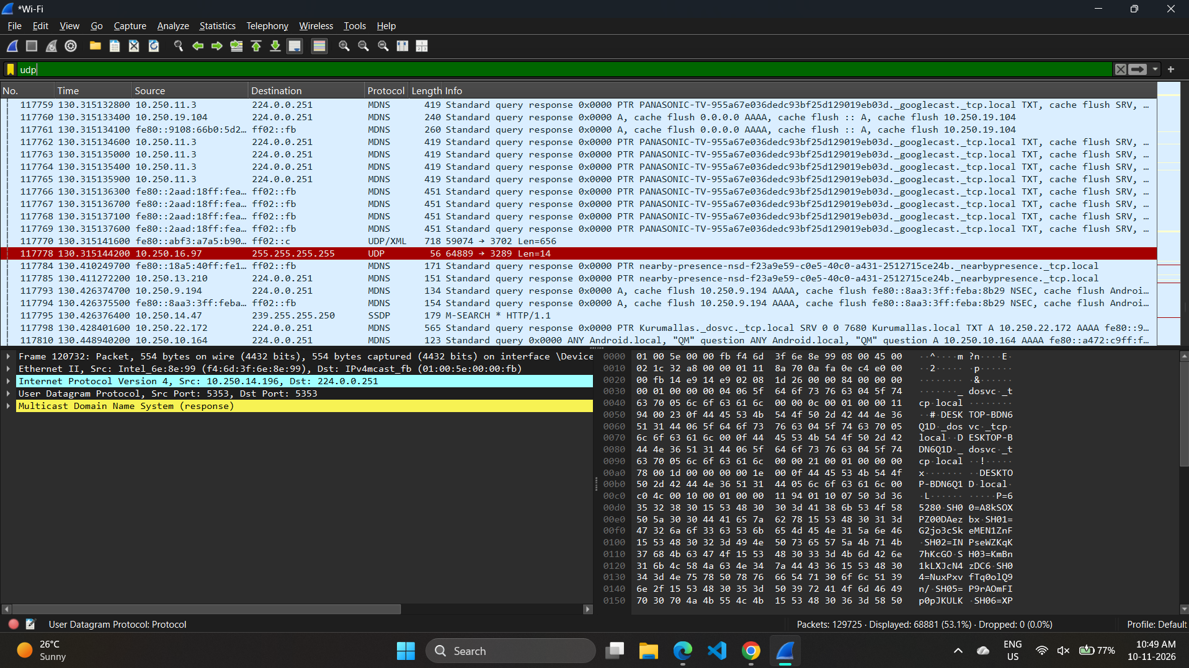

Figure 4: TCP LENGTH Packets Using Display Filter
Enter tcp.len>0 in the display filter bar and press Enter. Show the resulting TCP LENGTH packets.


