EXPERIMENT – 11.2
Name: K.dheeraj
Roll No: 2520030193
Title
Multithreaded Counter Application using POSIX Threads and Mutex Synchronization
Aim
To modify the multithreaded counter application using a mutex and compare the synchronized result with the race-condition version.
Theory
A mutex (mutual exclusion) is a synchronization mechanism used to protect shared resources from simultaneous access by multiple threads. pthread_mutex_lock() locks the critical section before modifying the shared counter, while pthread_mutex_unlock() releases the lock after the modification. This prevents simultaneous updates to the shared counter.
Algorithm
1. Initialize the shared counter to zero.
2. Initialize a mutex using pthread_mutex_init().
3. Create four threads using pthread_create().
4. Each thread locks the mutex before updating the counter.
5. Increment the counter 100000 times.
6. Unlock the mutex after each update.
7. Use pthread_join() to wait for all threads.
8. Display the expected and actual counter values.
9. Destroy the mutex using pthread_mutex_destroy().
10. Compare the result with the race-condition version.
Program Code
#include <stdio.h>
#include <pthread.h>
#define THREADS 4
#define ITERATIONS 100000
int counter = 0;
pthread_mutex_t lock;
void *increment(void *arg)
{
for (int i = 0; i < ITERATIONS; i++)
{
pthread_mutex_lock(&lock);
counter++;
pthread_mutex_unlock(&lock);
}
return NULL;
}
int main()
{
pthread_t threads[THREADS];
pthread_mutex_init(&lock, NULL);
for (int i = 0; i < THREADS; i++)
pthread_create(&threads[i], NULL, increment, NULL);
for (int i = 0; i < THREADS; i++)
pthread_join(threads[i], NULL);
printf("Expected counter value: %d\n", THREADS * ITERATIONS);
printf("Actual counter value: %d\n", counter);
pthread_mutex_destroy(&lock);
return 0;
}
Execution and Screenshots
Screenshot 1 – Program Code
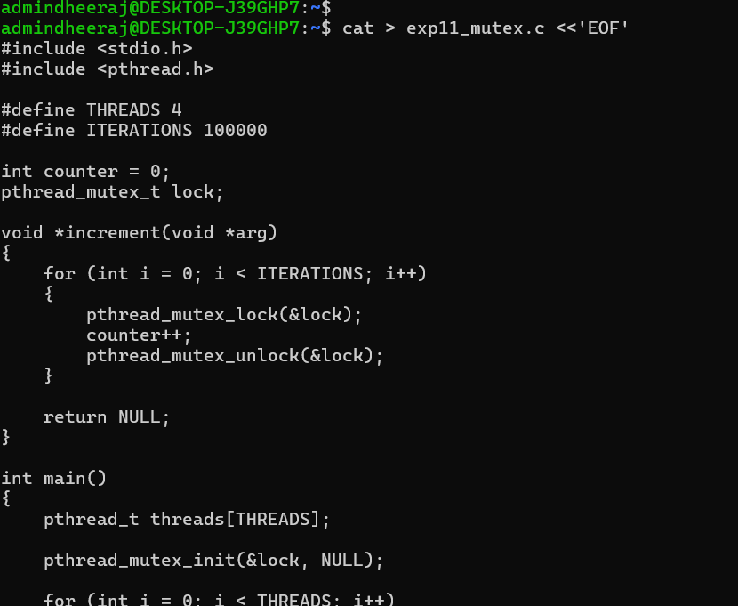
Screenshot 2 – Compilation
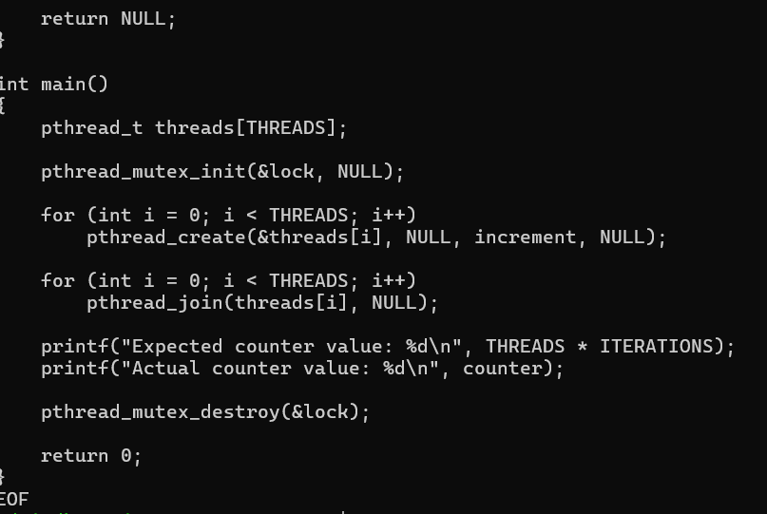
Screenshot 3 – Execution Output
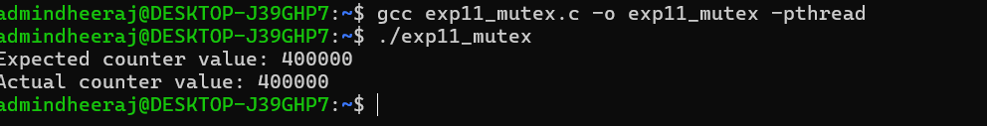
Observed Output
Expected counter value: 400000
Actual counter value: 400000
Result
The multithreaded counter application was successfully synchronized using a mutex. The expected counter value was 400000 and the actual counter value was also 400000, demonstrating that mutex synchronization prevents the race condition.

