EXPERIMENT – 12.1
Name: K.dheeraj
Roll No: 2520030193
Title
Producer-Consumer Problem using POSIX Threads and Semaphores
Aim
To implement the producer-consumer problem using POSIX threads and counting semaphores for synchronization.
Theory
The producer-consumer problem is a synchronization problem in which a producer generates items and places them into a shared buffer, while a consumer removes items from the buffer. Counting semaphores track the number of empty and filled buffer positions. A mutex protects the shared buffer from simultaneous access by multiple threads.
Algorithm
1. Initialize the buffer.
2. Initialize the empty semaphore with the buffer size and the full semaphore to zero.
3. Initialize the mutex.
4. Create producer and consumer threads.
5. The producer waits for an empty position, inserts an item, and signals that a position is filled.
6. The consumer waits for a filled position, removes an item, and signals that a position is empty.
7. Wait for both threads to complete.
8. Destroy the semaphores and mutex.
Program Code
#include <stdio.h>
#include <pthread.h>
#include <semaphore.h>
#include <unistd.h>
#define BUFFER_SIZE 5
#define ITEMS 10
int buffer[BUFFER_SIZE];
int in = 0;
int out = 0;
sem_t empty;
sem_t full;
pthread_mutex_t mutex;
void *producer(void *arg)
{
for (int i = 1; i <= ITEMS; i++)
{
sem_wait(&empty);
pthread_mutex_lock(&mutex);
buffer[in] = i;
printf("Produced: %d\n", i);
in = (in + 1) % BUFFER_SIZE;
pthread_mutex_unlock(&mutex);
sem_post(&full);
}
return NULL;
}
void *consumer(void *arg)
{
for (int i = 1; i <= ITEMS; i++)
{
sem_wait(&full);
pthread_mutex_lock(&mutex);
int item = buffer[out];
printf("Consumed: %d\n", item);
out = (out + 1) % BUFFER_SIZE;
pthread_mutex_unlock(&mutex);
sem_post(&empty);
}
return NULL;
}
int main()
{
pthread_t producer_thread, consumer_thread;
sem_init(&empty, 0, BUFFER_SIZE);
sem_init(&full, 0, 0);
pthread_mutex_init(&mutex, NULL);
pthread_create(&producer_thread, NULL, producer, NULL);
pthread_create(&consumer_thread, NULL, consumer, NULL);
pthread_join(producer_thread, NULL);
pthread_join(consumer_thread, NULL);
sem_destroy(&empty);
sem_destroy(&full);
pthread_mutex_destroy(&mutex);
return 0;
}
Execution and Screenshots
Screenshot 1 – Program Code (Producer)
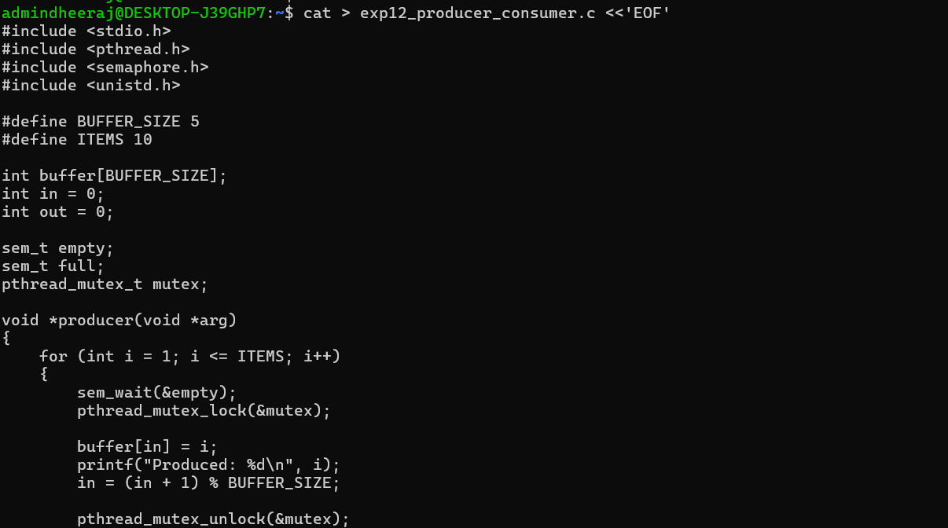
Screenshot 2 – Consumer Function
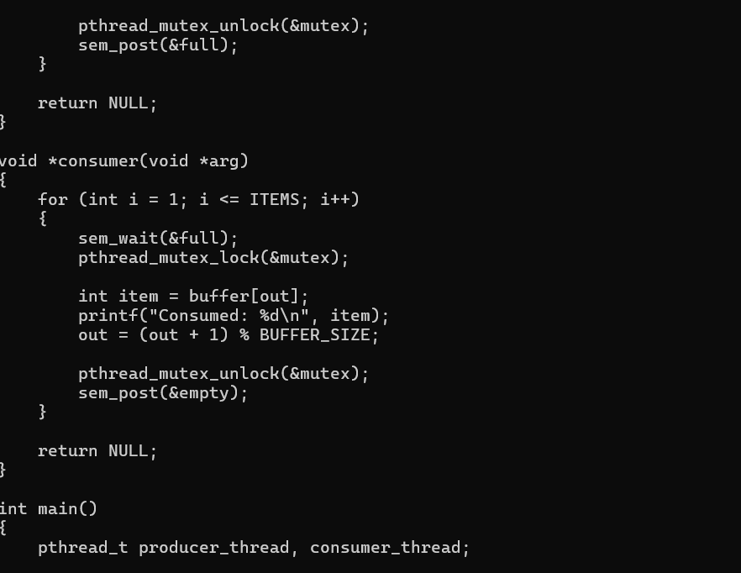
Screenshot 3 – Main Function and End of Code
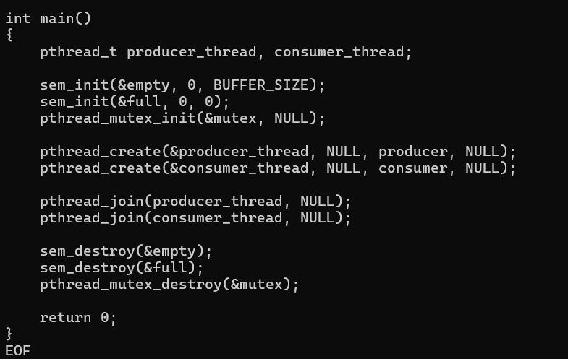
Screenshot 4 – Compilation and Execution Output
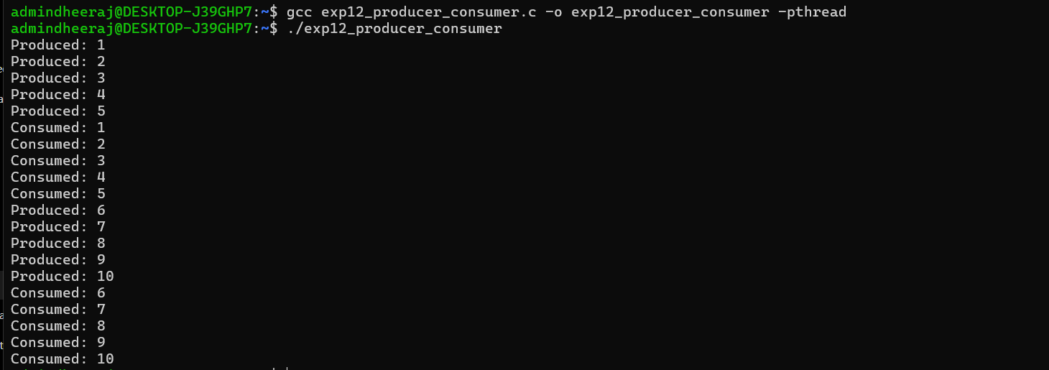
Observed Output
Produced: 1
Produced: 2
Produced: 3
Produced: 4
Produced: 5
Consumed: 1
Consumed: 2
Consumed: 3
Consumed: 4
Consumed: 5
Produced: 6
Produced: 7
Produced: 8
Produced: 9
Produced: 10
Consumed: 6
Consumed: 7
Consumed: 8
Consumed: 9
Consumed: 10
Result
The producer-consumer problem was implemented using POSIX threads, counting semaphores, and mutex synchronization. The output shows the producer generating ten items and the consumer consuming those items.

