OPERATING SYSTEMS LABORATORY
PRACTICAL EXPERIMENT – 11
Name | Mohith
Roll Number | 2520030028
Section | 8
QUESTION 11
To Store Commands, Maintain History Buffer, Handle Capacity Limits, Retrieve Entries, Display History, Validate Consistency.
To Create Pipeline Structures, Store Commands, Maintain Execution Order, Connect Processes, Validate Pipeline Layout, Test Configurations.
AIM
To implement a command history buffer and pipeline structure, handle capacity limits, retrieve and validate commands, maintain pipeline execution order, connect processes, and test the configuration.
THEORY
A command history buffer stores previously entered commands for retrieval and display. A fixed-size buffer handles capacity limits by removing the oldest entry when full. A pipeline connects processes so data can pass between them using pipe(). Process creation and synchronization are demonstrated using fork() and wait().
ALGORITHM
1. Initialize the history buffer and pipeline structure.
2. Store and display commands.
3. Retrieve a history entry.
4. Test the history capacity limit.
5. Validate the history buffer.
6. Store pipeline commands in execution order.
7. Validate the pipeline layout.
8. Create processes using fork().
9. Connect processes using pipe().
10. Transfer data and synchronize processes using wait().
11. Display the final test result.
C PROGRAM
#include <stdio.h>
#include <string.h>
#include <unistd.h>
#include <sys/wait.h>
#define MAX 5
char history[MAX][50];
int hcount = 0;
char pipeline[MAX][30];
int pcount = 0;
void add_history(char *cmd)
{
int i;
if (hcount == MAX)
{
for (i = 1; i < MAX; i++)
strcpy(history[i-1], history[i]);
hcount--;
printf("History capacity reached. Oldest entry removed.\n");
}
strcpy(history[hcount++], cmd);
}
void show_history()
{
int i;
printf("\nCommand History:\n");
for (i = 0; i < hcount; i++)
printf("%d. %s\n", i + 1, history[i]);
}
void pipeline_test()
{
int fd[2];
pid_t p1, p2;
char msg[] = "Pipeline Data";
char buf[50];
pipe(fd);
p1 = fork();
if (p1 == 0)
{
close(fd[0]);
write(fd[1], msg, strlen(msg) + 1);
close(fd[1]);
printf("Process 1: Command executed.\n");
return;
}
p2 = fork();
if (p2 == 0)
{
close(fd[1]);
read(fd[0], buf, sizeof(buf));
close(fd[0]);
printf("Process 2: Received -> %s\n", buf);
return;
}
close(fd[0]);
close(fd[1]);
wait(NULL);
wait(NULL);
printf("Pipeline execution completed successfully.\n");
}
int main()
{
int i;
char *cmds[] = {"pwd", "ls", "cd /home", "echo Hello", "date"};
printf("========================================\n");
printf(" COMMAND HISTORY AND PIPELINE TEST\n");
printf("========================================\n");
printf("\n1. COMMAND HISTORY\n");
printf("----------------------------------------\n");
for (i = 0; i < 5; i++)
add_history(cmds[i]);
show_history();
printf("\n2. RETRIEVE HISTORY ENTRY\n");
printf("----------------------------------------\n");
printf("Entry 3: %s\n", history[2]);
printf("\n3. CAPACITY LIMIT TEST\n");
printf("----------------------------------------\n");
add_history("whoami");
show_history();
printf("\n4. HISTORY VALIDATION\n");
printf("----------------------------------------\n");
if (hcount <= MAX)
printf("History is valid.\n");
printf("\n5. PIPELINE STRUCTURE\n");
printf("----------------------------------------\n");
strcpy(pipeline[0], "echo");
strcpy(pipeline[1], "filter");
strcpy(pipeline[2], "display");
pcount = 3;
for (i = 0; i < pcount; i++)
printf("Process %d: %s\n", i + 1, pipeline[i]);
printf("\n6. PIPELINE VALIDATION\n");
printf("----------------------------------------\n");
if (pcount > 0 && pcount <= MAX)
printf("Pipeline layout is valid.\n");
printf("\n7. PIPELINE PROCESS TEST\n");
printf("----------------------------------------\n");
pipeline_test();
printf("\n========================================\n");
printf("ALL TESTS COMPLETED SUCCESSFULLY\n");
printf("========================================\n");
return 0;
}
COMPILATION AND EXECUTION
gcc q11.c -o q11
./q11
EXECUTION OUTPUT – SCREENSHOT 1
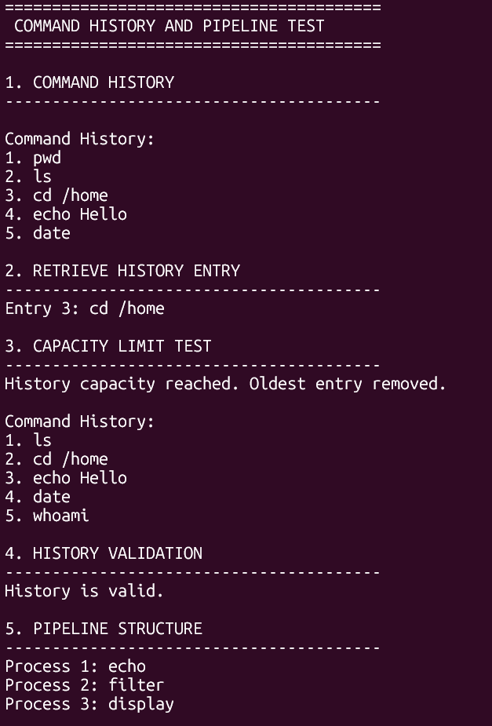
EXECUTION OUTPUT – SCREENSHOT 2
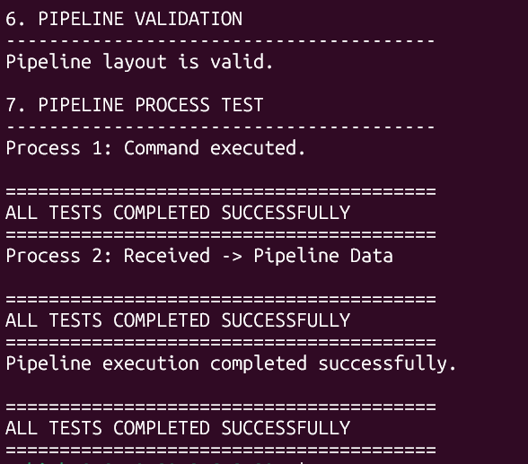
RESULT
The command history buffer and pipeline structure were implemented successfully. The program stored and displayed commands, handled the history capacity limit, retrieved entries, validated the history, created and validated a pipeline layout, and demonstrated inter-process communication and synchronization. All tests were completed successfully.

