OPERATING SYSTEMS LABORATORY
PRACTICAL EXPERIMENT – 13
Name | Mohith
Roll Number | 2520030028
Section | 8
QUESTION 13
To Parse Input Redirection, Open Files, Redirect stdin, Handle Missing Files, Restore Streams, Test File Inputs.
To Parse Output Redirection, Create Output Files, Redirect stdout, Handle Permissions, Verify Output Data, Test Redirection.
AIM
To implement input and output redirection using files, redirect standard input and output, handle file errors, and test redirected data.
THEORY
Input redirection allows a program to read data from a file instead of the keyboard. Output redirection sends program output to a file instead of the terminal. The open() system call opens or creates files, while dup2() redirects stdin or stdout to the required file descriptor. File descriptors are closed after use.
ALGORITHM
1. Create an input file and write sample data into it.
2. Open the input file in read mode.
3. Redirect stdin using dup2().
4. Read and display the redirected input.
5. Create/open an output file.
6. Redirect stdout using dup2().
7. Write output data to the output file.
8. Close the file descriptors.
9. Verify the generated output file.
C PROGRAM
#include <stdio.h>
#include <unistd.h>
#include <fcntl.h>
int main()
{
int in, out;
char buf[100];
printf("========================================\n");
printf(" INPUT AND OUTPUT REDIRECTION TEST\n");
printf("========================================\n");
printf("\n1. INPUT REDIRECTION\n");
printf("----------------------------------------\n");
out = open("input.txt", O_WRONLY | O_CREAT | O_TRUNC, 0644);
write(out, "Hello from input file\n", 22);
close(out);
in = open("input.txt", O_RDONLY);
if (in < 0)
printf("Error: Input file not found.\n");
else
{
dup2(in, STDIN_FILENO);
fgets(buf, sizeof(buf), stdin);
close(in);
printf("Input received: %s", buf);
}
printf("\n2. OUTPUT REDIRECTION\n");
printf("----------------------------------------\n");
out = open("output.txt", O_WRONLY | O_CREAT | O_TRUNC, 0644);
if (out < 0)
printf("Error: Cannot create output file.\n");
else
{
dup2(out, STDOUT_FILENO);
printf("Output redirected successfully.\n");
printf("Data written to output.txt\n");
close(out);
}
return 0;
}
COMPILATION AND EXECUTION
gcc q13.c -o q13
./q13
cat output.txt
EXECUTION OUTPUT
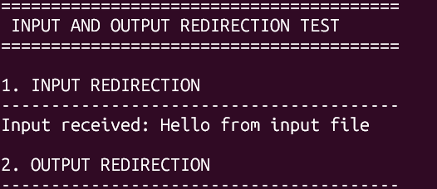
RESULT
Input redirection was tested successfully using an input file and stdin redirection. The program then redirected stdout to an output file. File opening, data transfer, and redirection operations were implemented successfully.

