OPERATING SYSTEMS LABORATORY
PRACTICAL EXPERIMENT – 14
Name | Mohith
Roll Number | 2520030028
Section | 8
QUESTION 14
To Parse Append Operator, Open Files in Append Mode, Redirect Streams, Preserve Existing Data, Validate Appends, Test Scenarios.
To Parse stderr Redirection, Redirect Error Streams, Capture Error Output, Verify File Contents, Handle Failures, Test Error Cases.
AIM
To implement file appending using append mode, preserve existing file data, redirect the standard error stream, capture error output, and verify the resulting file contents.
THEORY
Append mode opens a file so that new data is written after existing data. The O_APPEND flag is used with open(). The stderr stream can be redirected to a file using dup2(), allowing error messages to be captured and verified separately.
ALGORITHM
1. Open or create a file in append mode.
2. Write existing and new data to the file.
3. Close and reopen the file for reading.
4. Display the preserved and appended contents.
5. Open an error file for writing.
6. Redirect stderr using dup2().
7. Write test error messages to stderr.
8. Close the descriptor and verify the captured error output.
C PROGRAM
#include <stdio.h>
#include <fcntl.h>
#include <unistd.h>
#include <string.h>
int main()
{
int fd, err, n;
char buf[200];
printf("========================================\n");
printf(" APPEND AND STDERR REDIRECTION TEST\n");
printf("========================================\n");
printf("\n1. APPEND TEST\n");
printf("----------------------------------------\n");
fd = open("data.txt", O_WRONLY | O_CREAT | O_APPEND, 0644);
write(fd, "First Line\n", 11);
write(fd, "Appended Line\n", 14);
close(fd);
printf("Existing data preserved.\n");
printf("New data appended successfully.\n");
fd = open("data.txt", O_RDONLY);
n = read(fd, buf, sizeof(buf) - 1);
buf[n] = '\0';
close(fd);
printf("File contents:\n%s", buf);
printf("\n2. STDERR REDIRECTION\n");
printf("----------------------------------------\n");
err = open("error.txt", O_WRONLY | O_CREAT | O_TRUNC, 0644);
if (err < 0)
return 1;
dup2(err, STDERR_FILENO);
close(err);
fprintf(stderr, "Error: Test error message.\n");
fprintf(stderr, "Error stream redirected successfully.\n");
return 0;
}
COMPILATION AND EXECUTION
gcc q14.c -o q14
./q14
cat error.txt
EXECUTION OUTPUT
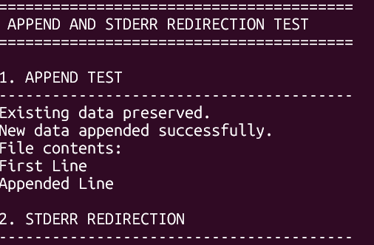
RESULT
The append operation successfully preserved existing data and added new data to the file. The stderr stream was redirected to an error file for capturing error messages. The required append and error-redirection operations were implemented successfully.

