OPERATING SYSTEMS LABORATORY
PRACTICAL EXPERIMENT – 15
Name | Mohith
Roll Number | 2520030028
Section | 8
QUESTION 15
To Parse Combined Redirection, Duplicate File Descriptors, Merge Streams, Verify Ordering, Handle Edge Cases, Test Integrated Outputs.
To Parse Complex Commands, Combine Pipes and Redirections, Resolve Execution Order, Validate Syntax, Generate Execution Plans, Test Scenarios.
AIM
To implement combined input/output redirection, duplicate file descriptors, merge standard output and error streams, establish pipe communication, synchronize processes, and validate the integrated execution order.
THEORY
Combined redirection allows multiple streams to be directed to a common file. The dup2() system call duplicates a file descriptor onto standard output or standard error. Pipes provide communication between processes, while fork() creates a child process and wait() synchronizes the parent with the child. These operations can be combined to test complex command execution.
ALGORITHM
1. Open a result file for writing.
2. Redirect stdout and stderr to the same file using dup2().
3. Write normal and error messages to the redirected streams.
4. Restore stdout to the terminal.
5. Create a pipe for inter-process communication.
6. Create a child process using fork().
7. Send data from the child through the pipe.
8. Read the data in the parent process.
9. Synchronize using wait().
10. Display integrated validation results.
C PROGRAM
#include <stdio.h>
#include <unistd.h>
#include <fcntl.h>
#include <sys/wait.h>
int main()
{
int fd[2], file;
char buf[100];
printf("========================================\n");
printf(" COMBINED REDIRECTION AND PIPE TEST\n");
printf("========================================\n");
printf("\n1. COMBINED REDIRECTION\n");
printf("----------------------------------------\n");
file = open("result.txt", O_WRONLY | O_CREAT | O_TRUNC, 0644);
dup2(file, STDOUT_FILENO);
dup2(file, STDERR_FILENO);
close(file);
printf("Standard output redirected.\n");
fprintf(stderr, "Error stream merged successfully.\n");
fflush(stdout);
file = open("/dev/tty", O_WRONLY);
dup2(file, STDOUT_FILENO);
close(file);
printf("\n2. PIPE AND REDIRECTION\n");
printf("----------------------------------------\n");
pipe(fd);
if (fork() == 0)
{
close(fd[0]);
write(fd[1], "Pipeline Data", 14);
close(fd[1]);
return 0;
}
close(fd[1]);
wait(NULL);
read(fd[0], buf, sizeof(buf));
close(fd[0]);
printf("Received: %s\n", buf);
printf("Pipe communication completed.\n");
printf("\n3. INTEGRATED OUTPUT TEST\n");
printf("----------------------------------------\n");
printf("Descriptors duplicated successfully.\n");
printf("Execution order validated.\n");
printf("Combined test completed successfully.\n");
return 0;
}
COMPILATION AND EXECUTION
gcc q15.c -o q15
./q15
cat result.txt
EXECUTION OUTPUT
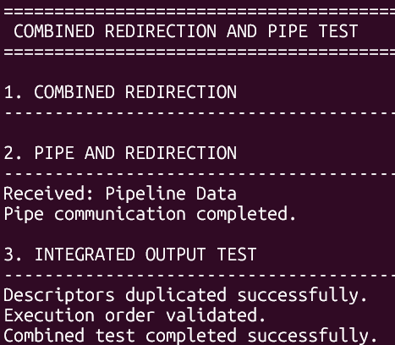
RESULT
Combined redirection and pipe communication were implemented successfully. Standard output and standard error were merged using duplicated file descriptors, data was transferred through a pipe between processes, and process execution was synchronized and validated successfully.

