EXPERIMENT – 4
Name: K.dheeraj
Roll No: 2520030193
Section: 8
Title
Multiple Child Processes using wait() and waitpid() and Observation of Zombie Processes
Aim
To create multiple child processes using fork(), use wait()/waitpid() for synchronization, and observe and eliminate zombie processes.
Theory
- fork() creates a new child process.
- Multiple child processes can be created from a parent process.
- wait() allows the parent to wait for a child process to terminate.
- waitpid() allows the parent to wait for a specific child process.
- A zombie process is a terminated child process that has not yet been collected by its parent.
- Calling wait() or waitpid() collects the terminated child and eliminates the zombie state.
Algorithm
- Start the program.
- Create the first child process using fork().
- Display the PID and PPID of Child 1.
- Create the second child process using fork().
- Display the PID and PPID of Child 2.
- Display the parent PID and both child PIDs.
- Allow the child processes to terminate.
- Observe the zombie process using the ps command.
- Use waitpid() to collect Child 1 and Child 2.
- Observe that the zombie processes are eliminated.
- Terminate the parent process.
Program Code
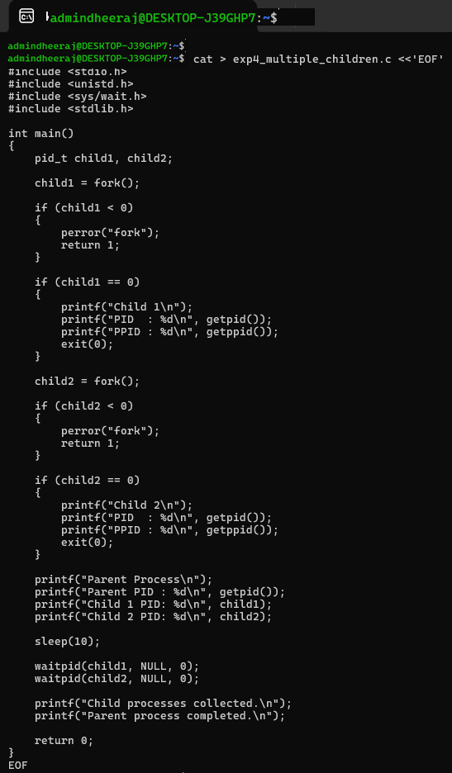
Execution and Screenshots
Screenshot 1 — Compilation and Execution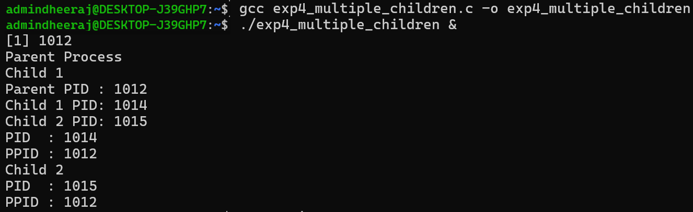
Screenshot 2 — Zombie Process Observation
Screenshot 3 — Process Tree / Process State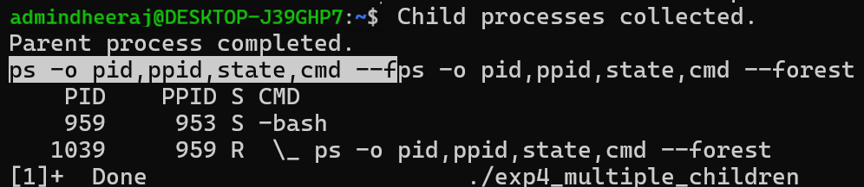
Screenshot 4 — Zombie Elimination
Result
Multiple child processes were successfully created using fork(). The child processes were observed in the zombie state, and waitpid() was used to collect the terminated child processes and eliminate the zombie state.

