EXPERIMENT – 5
Name: K.dheeraj
Roll No: 2520030193
Section: 8
Title
Inter-Process Communication using Anonymous Pipes
Aim
To implement an anonymous pipe for producer-consumer communication and implement the command pipeline ls -l | grep ".c" using fork(), pipe(), dup2(), and exec().
Theory
- A pipe provides a communication channel between processes.
- pipe() creates the pipe and provides file descriptors for reading and writing.
- fork() creates child processes.
- dup2() redirects standard input or output to the pipe.
- exec() executes another program.
- In the command ls -l | grep ".c", the output of ls -l is connected to the input of grep.
Algorithm
- Start the program.
- Create an anonymous pipe using pipe().
- Create the first child process using fork().
- Redirect the first child's standard output to the pipe using dup2().
- Execute ls -l using execlp().
- Create the second child process using fork().
- Redirect the second child's standard input from the pipe using dup2().
- Execute grep ".c" using execlp().
- Close the unused pipe file descriptors.
- Use waitpid() to wait for both child processes.
- Terminate the program.
Program Code
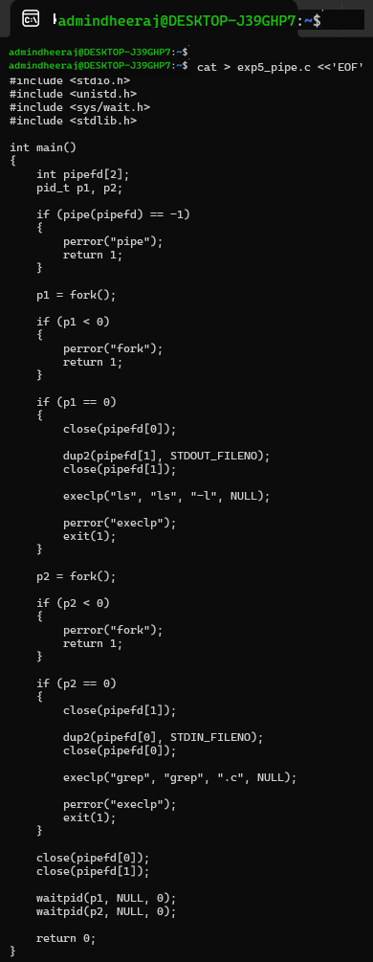

Execution and Screenshots
Screenshot 1 — Compilation
Screenshot 2 — Program Execution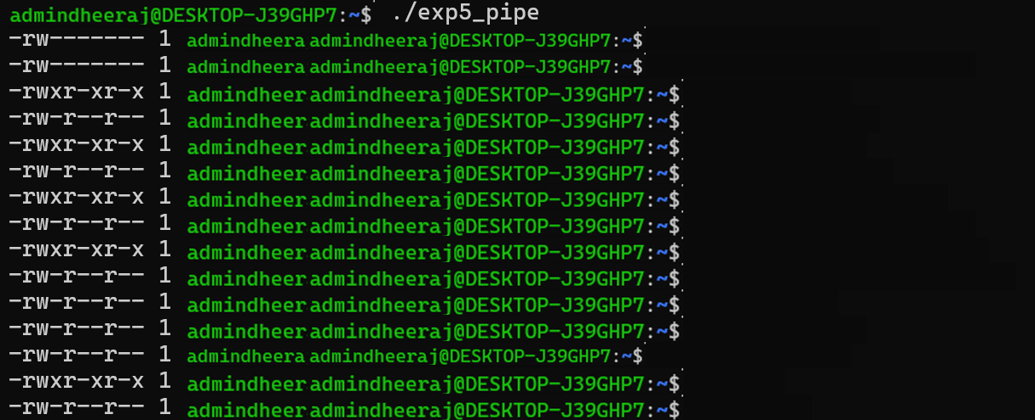
Result
The anonymous pipe was successfully implemented, and the ls -l | grep ".c" pipeline was executed using fork(), pipe(), dup2(), and exec().

