EXPERIMENT – 6
Name: K.dheeraj
Roll No: 2520030193
Section: 8
Title
FIFO Client-Server Communication and Signal Handling
Aim
To implement a FIFO-based client-server communication system and handle SIGINT, SIGTERM, and SIGUSR1 signals.
Theory
- A FIFO (First In First Out) is a named pipe used for communication between processes.
- mkfifo() creates a named FIFO.
- The server opens the FIFO and waits for messages from the client.
- The client writes a message into the FIFO.
- SIGUSR1 is used to demonstrate user-defined signal handling.
- SIGINT and SIGTERM are signals used to request process termination.
Algorithm
- Start the program.
- Register handlers for SIGUSR1, SIGINT, and SIGTERM.
- Create a FIFO using mkfifo().
- Display the server PID.
- Open the FIFO for reading.
- Read the message sent by the client.
- Display the received message.
- Handle SIGUSR1, SIGINT, and SIGTERM when received.
- Close the FIFO.
- Terminate the server.
Program Code
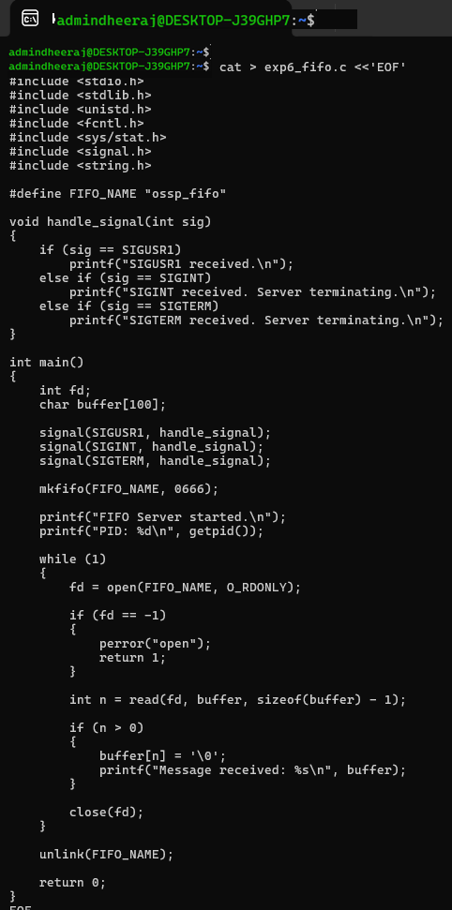

Execution and Screenshots
Screenshot 1 — Compilation and Server Execution
Screenshot 2 — FIFO Client Communication
IN TERMINAL 2
IN TERMINAL 1

Screenshot 3 — SIGUSR1
In Terminal 2
In Terminal 1
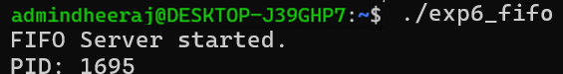
In Terminal 2
Screenshot 4 — SIGINT / SIGTERM
In Terminal 1
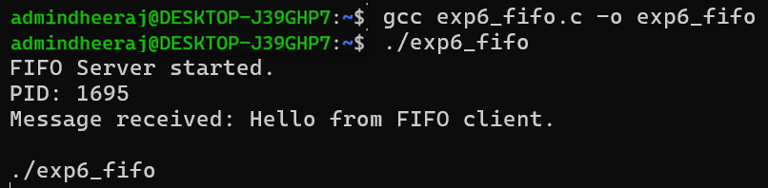
Result
FIFO-based client-server communication was implemented successfully, and the required SIGINT, SIGTERM, and SIGUSR1 signals were handled.

