EXPERIMENT – 9
Name: K.dheeraj
Roll No: 2520030193
Section: 8
Title
Low-Level File Operations using lseek() and File Descriptor Redirection using dup2()
Aim
To perform low-level file operations and demonstrate the use of lseek(), compare low-level file operations with standard library file operations, and perform file descriptor redirection using dup2().
Theory
- lseek() – Changes the current file offset of an open file descriptor.
- Standard library file operations – Functions such as fopen(), fgets(), fputs(), and fclose() provide higher-level file handling.
- dup2() – Duplicates a file descriptor and can be used to redirect standard input or output to a file.
Algorithm
- Start the program.
- Open input.txt using open().
- Create output.txt using open().
- Read data from input.txt using read().
- Write the data to output.txt using write().
- Use lseek() to reset the file position.
- Close the low-level file descriptors.
- Open the input and output files using standard library functions.
- Copy the contents using fgets() and fputs().
- Open redirected_output.txt.
- Use dup2() to redirect standard output to the file.
- Write output using printf().
- Close the files and stop the program.
Program Code
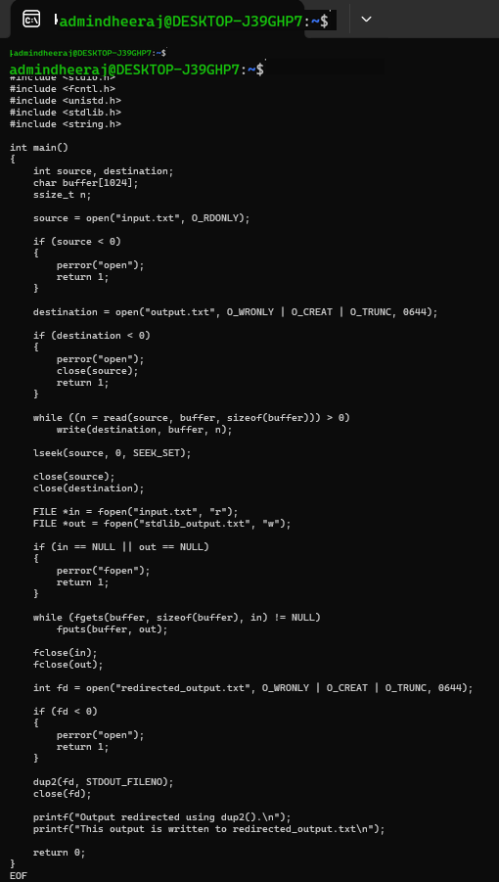
Execution Screenshots
Screenshot 1 – Low-Level File Copy
Screenshot 2 – Standard Library File Copy

Screenshot 3 – dup2() File Redirection
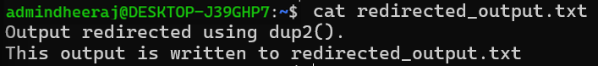
Result
The program successfully performed low-level file copying using open(), read(), and write(). The file operation was compared with standard library file handling, and output redirection was successfully demonstrated using dup2().

