PRACTICAL EXPERIMENT – 4
Name: K Dheeraj
Roll No: 2520030193
Section: 8
Skill: Lexical Analysis, Tokenization, Command Parsing and Syntax Validation
Title
Implementation of Tokenization and Parser Logic for Command Input.
Aim
To split command input into tokens, identify delimiters, handle whitespace, create token structures, validate token streams, generate a parse or execution structure, and handle empty commands.
Theory
Command parsing begins by splitting input into individual tokens using delimiters such as spaces and tabs. The tokens are stored in a token structure and validated before an execution structure is produced. The parser also handles empty commands and identifies invalid token sequences.
Algorithm
- Start the program.
- Read a command from the user.
- Check whether the command is empty.
- Split the input into tokens using whitespace delimiters.
- Store each token in the token structure.
- Validate the token stream.
- Detect invalid token sequences.
- Generate the parse or execution structure.
- Display the tokens and parsing result.
- Repeat until the exit command is entered.
- Stop the program.
Code
#include <stdio.h>
#include <stdlib.h>
#include <string.h>
#include <ctype.h>
#define MAX_INPUT 200
#define MAX_TOKENS 50
typedef struct
{
char *value;
} Token;
typedef struct
{
Token tokens[MAX_TOKENS];
int count;
} TokenStream;
void tokenize(char *input, TokenStream *stream)
{
stream->count = 0;
char *token = strtok(input, " \t\n");
while (token != NULL && stream->count < MAX_TOKENS)
{
stream->tokens[stream->count].value = token;
stream->count++;
token = strtok(NULL, " \t\n");
}
}
int validate_tokens(TokenStream *stream)
{
if (stream->count == 0)
return 0;
if (strcmp(stream->tokens[0].value, "|") == 0)
return -1;
if (strcmp(stream->tokens[stream->count - 1].value, "|") == 0)
return -1;
for (int i = 0; i < stream->count - 1; i++)
{
if (strcmp(stream->tokens[i].value, "|") == 0 &&
strcmp(stream->tokens[i + 1].value, "|") == 0)
{
return -1;
}
}
return 1;
}
void display_parse_tree(TokenStream *stream)
{
printf("\nParse / Execution Structure:\n");
printf("COMMAND\n");
for (int i = 0; i < stream->count; i++)
{
if (strcmp(stream->tokens[i].value, "|") == 0)
{
printf(" PIPE\n");
}
else
{
printf(" ARGUMENT: %s\n", stream->tokens[i].value);
}
}
}
int main()
{
char input[MAX_INPUT];
TokenStream stream;
printf("=== OSSP Experiment 4 ===\n");
printf("Tokenizer and Parser\n");
printf("Enter a command to parse.\n");
printf("Type exit to quit.\n\n");
while (1)
{
printf("parser> ");
fflush(stdout);
if (fgets(input, sizeof(input), stdin) == NULL)
break;
if (strcmp(input, "\n") == 0)
{
printf("Empty command detected.\n");
continue;
}
input[strcspn(input, "\n")] = '\0';
if (strcmp(input, "exit") == 0)
break;
tokenize(input, &stream);
printf("\nTokens:\n");
for (int i = 0; i < stream.count; i++)
{
printf("Token %d: %s\n",
i + 1,
stream.tokens[i].value);
}
int result = validate_tokens(&stream);
if (result == -1)
{
printf("\nSyntax Error: Invalid token sequence.\n");
continue;
}
display_parse_tree(&stream);
printf("\nParsing successful.\n");
}
printf("Exiting parser...\n");
return 0;
}
Execution Screenshots
1. Main C Code – Part 1
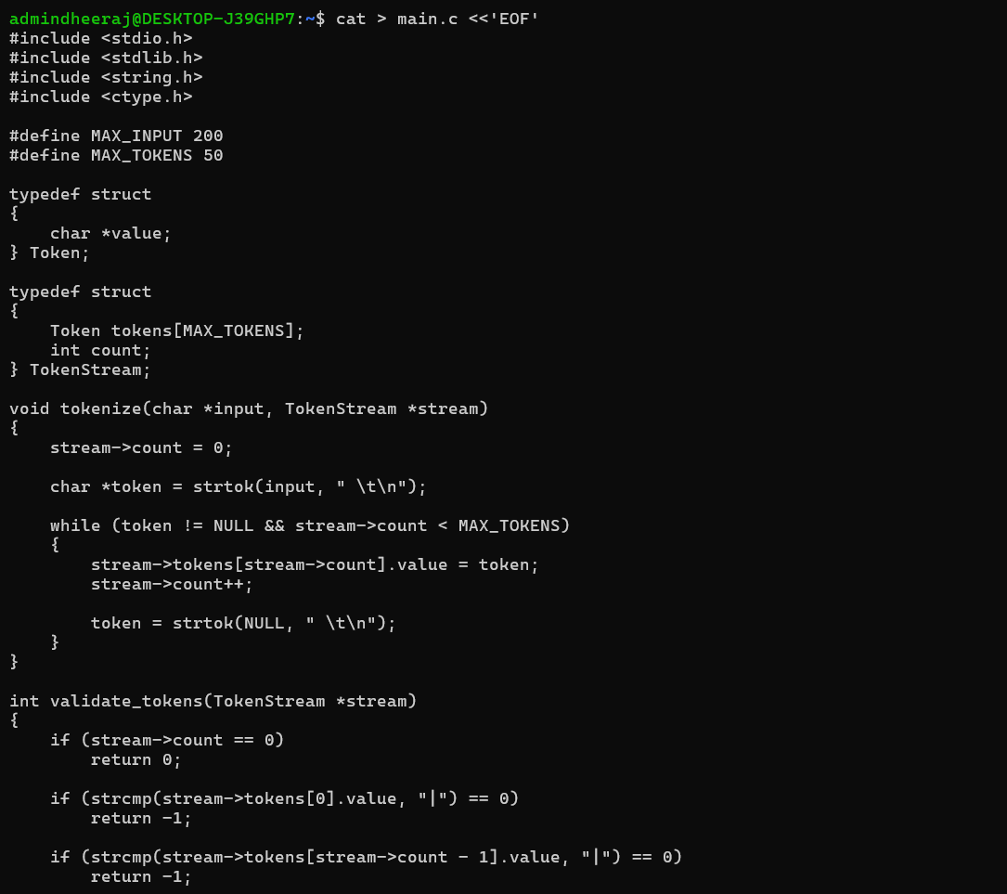
2. Main C Code – Part 2
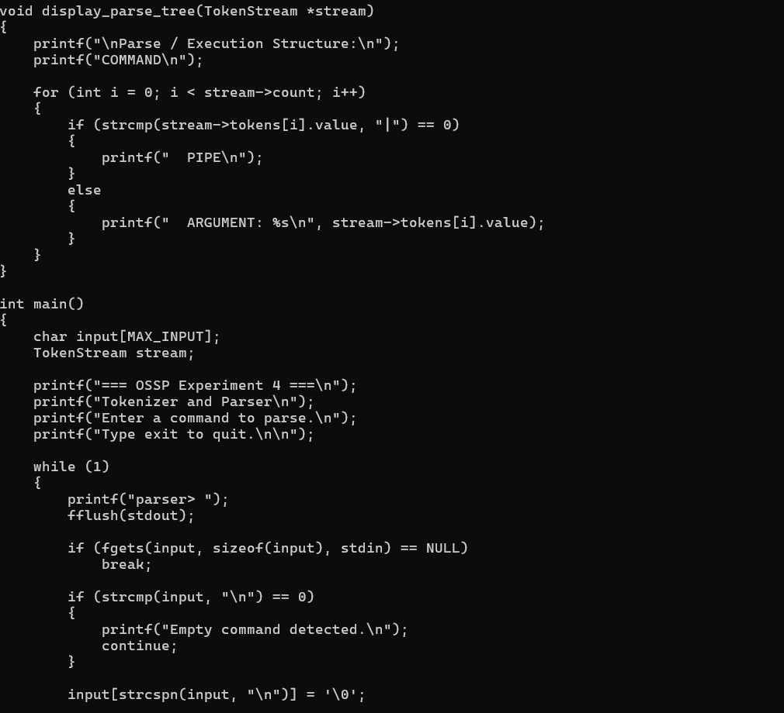
3. Main C Code – Part 3
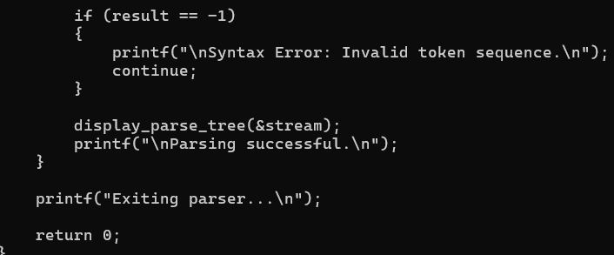
4. Compilation and Tokenization / Parsing
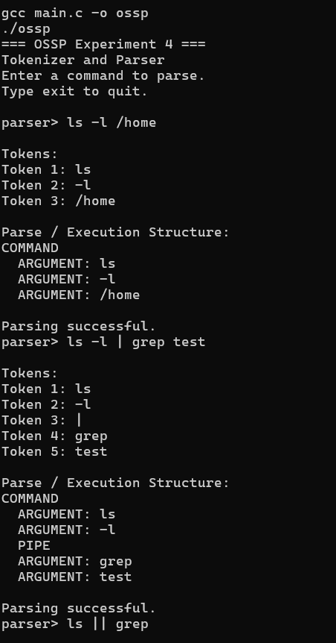
5. Empty Command Handling
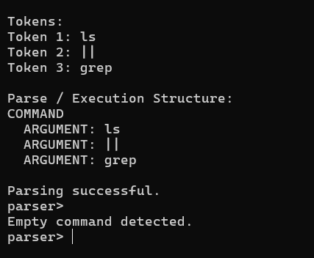
Result
The tokenizer and parser program was executed successfully. Command input was split into tokens, token structures and parse/execution structures were displayed, and empty command input was detected and handled.

