PRACTICAL EXPERIMENT – 5
Name: K Dheeraj
Roll No: 2520030193
Section: 8
Skill: Quote Parsing, String Processing, Variable Expansion and Syntax Validation
Title
Implementation of Single and Double Quote Parsing with Variable Expansion.
Aim
To apply single quotes for preserving literal content, ignore variable expansion inside single quotes, store quoted strings, apply double quotes to preserve spaces while allowing variable expansion, parse quoted commands, and test edge cases.
Theory
Single quotes preserve the literal content inside them, so variable expansion is not performed. Double quotes preserve spaces within the quoted text while allowing environment variables to be expanded. The parser identifies quoted sections, stores the resulting tokens, validates the parsing result, and detects unclosed quotes.
Algorithm
- Start the program.
- Read command input from the user.
- Check for the exit command and empty input.
- Identify single-quoted strings and preserve their contents literally.
- Identify double-quoted strings and preserve spaces inside them.
- Expand environment variables found inside double quotes.
- Store the resulting text as tokens.
- Detect unclosed single or double quotes.
- Display the parsed tokens and parsing result.
- Repeat until exit is entered.
- Stop the program.
Code
#include <stdio.h>
#include <stdlib.h>
#include <string.h>
#include <ctype.h>
#define MAX_INPUT 300
#define MAX_TOKENS 50
#define MAX_TOKEN 200
void add_char(char *token, int *len, char ch)
{
if (*len < MAX_TOKEN - 1)
token[(*len)++] = ch;
}
void expand_variable(const char *input, int *i, char *token, int *len)
{
char name[100];
int n = 0;
(*i)++;
while (input[*i] != '\0' &&
(isalnum((unsigned char)input[*i]) || input[*i] == '_'))
{
if (n < 99)
name[n++] = input[*i];
(*i)++;
}
name[n] = '\0';
char *value = getenv(name);
if (value != NULL)
{
for (int j = 0; value[j] != '\0'; j++)
add_char(token, len, value[j]);
}
(*i)--;
}
int parse_command(char *input)
{
char tokens[MAX_TOKENS][MAX_TOKEN];
int token_count = 0;
int i = 0;
while (input[i] != '\0')
{
while (isspace((unsigned char)input[i]))
i++;
if (input[i] == '\0')
break;
int len = 0;
while (input[i] != '\0' &&
!isspace((unsigned char)input[i]))
{
if (input[i] == '\'')
{
i++;
while (input[i] != '\0' && input[i] != '\'')
{
add_char(tokens[token_count], &len, input[i]);
i++;
}
if (input[i] != '\'')
{
printf("Syntax Error: Unclosed single quote.\n");
return 0;
}
i++;
}
else if (input[i] == '"')
{
i++;
while (input[i] != '\0' && input[i] != '"')
{
if (input[i] == '$')
expand_variable(input, &i,
tokens[token_count], &len);
else
add_char(tokens[token_count],
&len, input[i]);
i++;
}
if (input[i] != '"')
{
printf("Syntax Error: Unclosed double quote.\n");
return 0;
}
i++;
}
else
{
add_char(tokens[token_count], &len, input[i]);
i++;
}
}
tokens[token_count][len] = '\0';
token_count++;
if (token_count >= MAX_TOKENS)
break;
}
printf("\nParsed Tokens:\n");
for (int j = 0; j < token_count; j++)
printf("Token %d: [%s]\n", j + 1, tokens[j]);
printf("\nParsing successful.\n");
return 1;
}
int main()
{
char input[MAX_INPUT];
printf("=== OSSP Experiment 5 ===\n");
printf("Single and Double Quote Parser\n");
printf("Single quotes: literal content\n");
printf("Double quotes: variable expansion allowed\n");
printf("Type exit to quit.\n\n");
while (1)
{
printf("quote> ");
fflush(stdout);
if (fgets(input, sizeof(input), stdin) == NULL)
break;
input[strcspn(input, "\n")] = '\0';
if (strcmp(input, "exit") == 0)
break;
if (strlen(input) == 0)
{
printf("Empty command.\n");
continue;
}
parse_command(input);
printf("\n");
}
printf("Exiting quote parser...\n");
return 0;
}
Execution Screenshots
1. Main C Code – Part 1
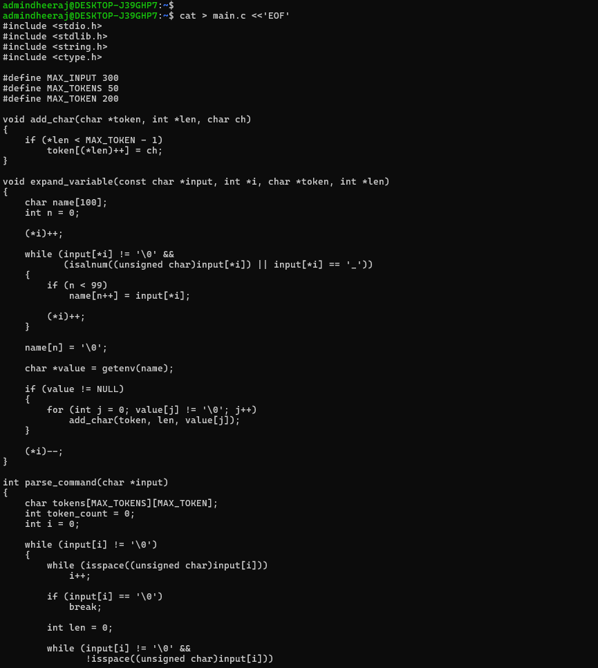
2. Main C Code – Part 2
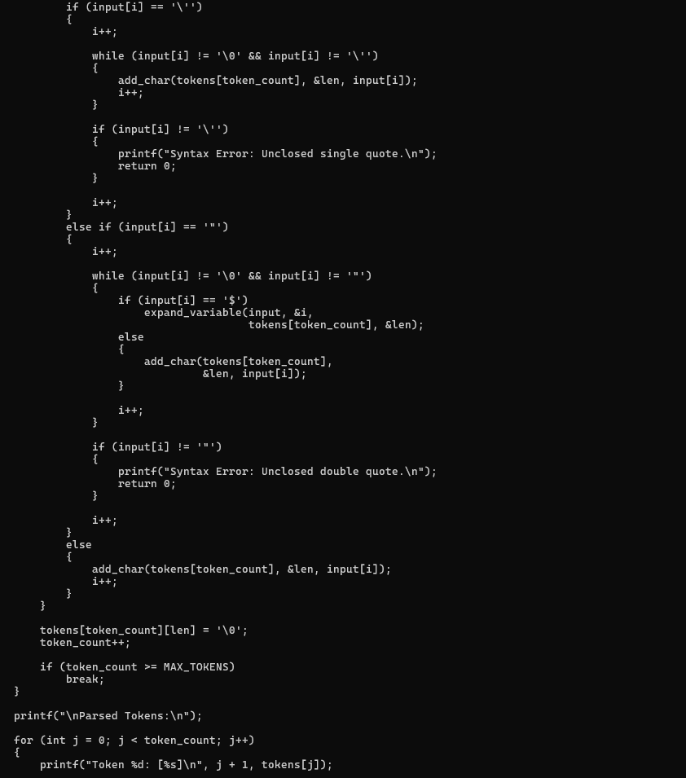
3. Main C Code – Part 3 and Compilation
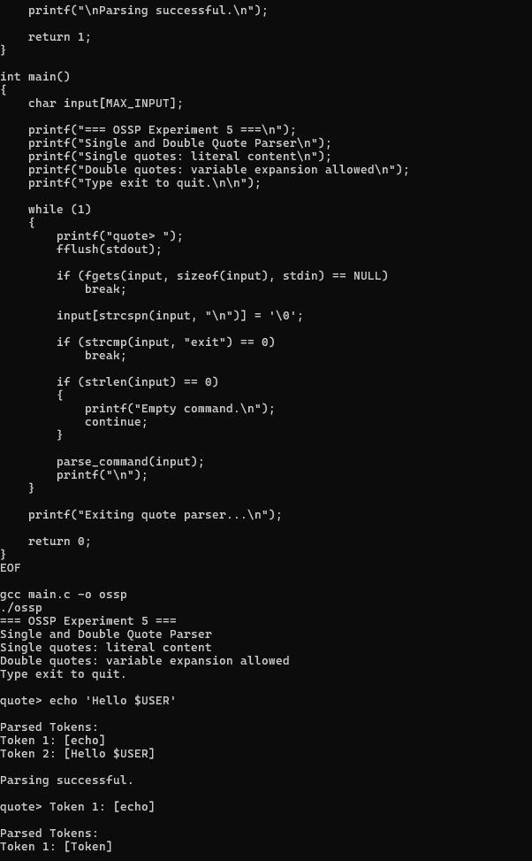
4. Quote Parsing and Edge-Case Execution
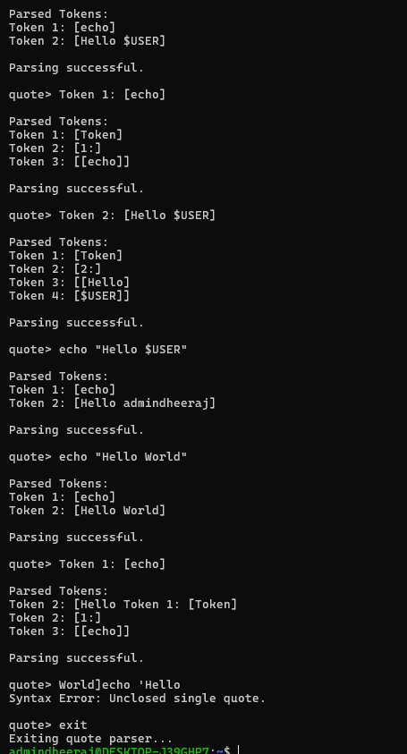
Result
The single and double quote parser was executed successfully. Single-quoted content was preserved literally, double-quoted content allowed variable expansion and preserved spaces, and the parser detected an unclosed single quote.

