PRACTICAL EXPERIMENT – 6
Name: K Dheeraj
Roll No: 2520030193
Section: 8
Skill: Escape Sequence Handling, Process Creation, Program Execution and Error Handling
Title
Implementation of Escape Sequence Handling and Process Execution in a Shell.
Aim
To handle escaped spaces and special symbols while preserving characters, validate parsed arguments, create child processes, execute programs with arguments, handle execution errors, and manage the parent process.
Theory
Escape sequences allow special characters such as spaces and symbols to be preserved as part of an argument. A command parser processes escaped characters and creates an argument list. The fork() system call creates a child process, while execvp() replaces the child process with the requested program. The parent process waits for the child using waitpid(), and execution errors are reported when a command cannot be launched.
Algorithm
- Start the program.
- Read command input from the user.
- Parse the input into arguments while handling escaped characters.
- Preserve escaped spaces and special symbols in the corresponding arguments.
- Display the parsed arguments.
- Create a child process using fork().
- In the child process, execute the command using execvp().
- If execution fails, display an error message.
- In the parent process, wait for the child process using waitpid().
- Display the child process completion status.
- Repeat until the exit command is entered.
- Stop the program.
Code
#include <stdio.h>
#include <stdlib.h>
#include <string.h>
#include <unistd.h>
#include <sys/wait.h>
#define MAX_INPUT 300
#define MAX_ARGS 50
#define MAX_ARG_LEN 200
int parse_command(char *input, char *args[])
{
static char tokens[MAX_ARGS][MAX_ARG_LEN];
int count = 0;
int i = 0;
while (input[i] != '\0')
{
while (input[i] == ' ' || input[i] == '\t')
i++;
if (input[i] == '\0')
break;
int len = 0;
while (input[i] != '\0' &&
input[i] != ' ' &&
input[i] != '\t')
{
if (input[i] == '\\')
{
i++;
if (input[i] == '\0')
break;
tokens[count][len++] = input[i];
i++;
}
else
{
tokens[count][len++] = input[i];
i++;
}
if (len >= MAX_ARG_LEN - 1)
break;
}
tokens[count][len] = '\0';
args[count] = tokens[count];
count++;
if (count >= MAX_ARGS - 1)
break;
}
args[count] = NULL;
return count;
}
int main()
{
char input[MAX_INPUT];
char *args[MAX_ARGS];
printf("=== OSSP Experiment 6 ===\n");
printf("Escape Sequence Parser and Process Execution\n");
printf("Type a command. Type exit to quit.\n\n");
while (1)
{
printf("ossp> ");
fflush(stdout);
if (fgets(input, sizeof(input), stdin) == NULL)
break;
input[strcspn(input, "\n")] = '\0';
if (strcmp(input, "exit") == 0)
break;
if (strlen(input) == 0)
{
printf("Empty command.\n");
continue;
}
int count = parse_command(input, args);
printf("\nParsed Arguments:\n");
for (int i = 0; i < count; i++)
printf("Argument %d: [%s]\n", i + 1, args[i]);
if (count == 0)
continue;
pid_t pid = fork();
if (pid < 0)
{
perror("fork");
continue;
}
if (pid == 0)
{
printf("\nChild Process PID: %d\n", getpid());
printf("Executing: %s\n\n", args[0]);
execvp(args[0], args);
perror("Execution failed");
exit(1);
}
else
{
int status;
printf("\nParent Process PID: %d\n", getpid());
waitpid(pid, &status, 0);
if (WIFEXITED(status))
printf("\nChild process completed.\n");
else
printf("\nChild process terminated abnormally.\n");
}
}
printf("Exiting OSSP Shell...\n");
return 0;
}
Execution Screenshots
1. Main C Code – Part 1
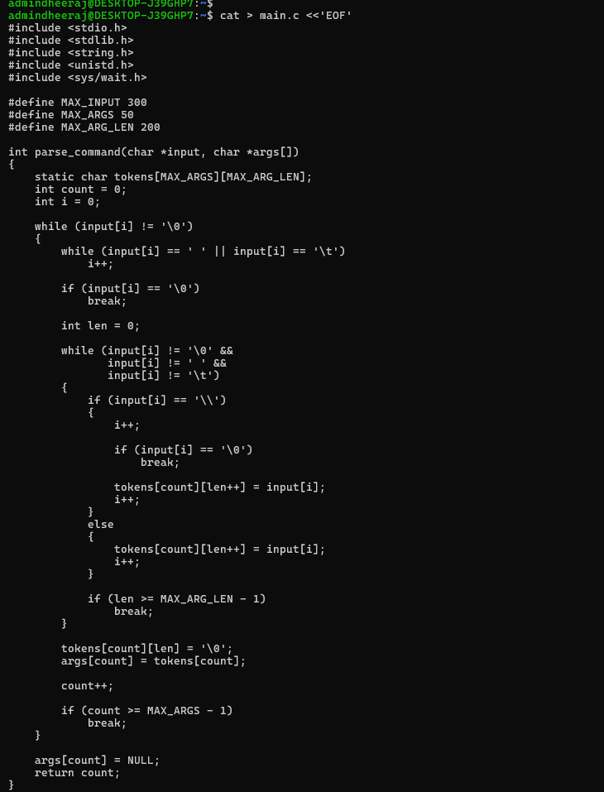
2. Main C Code – Part 2 and Compilation
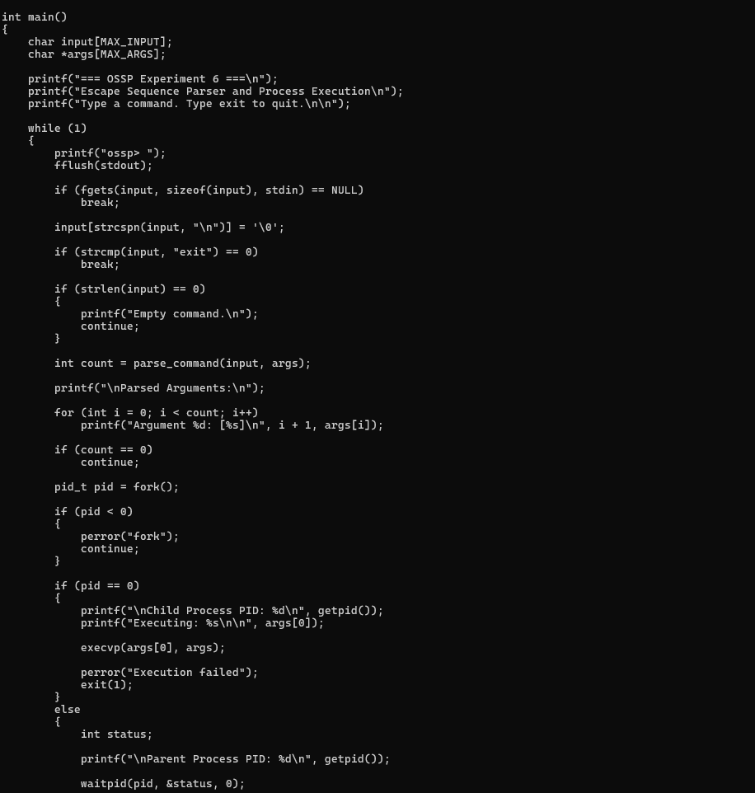
3. Escape Sequence and Child Process Execution
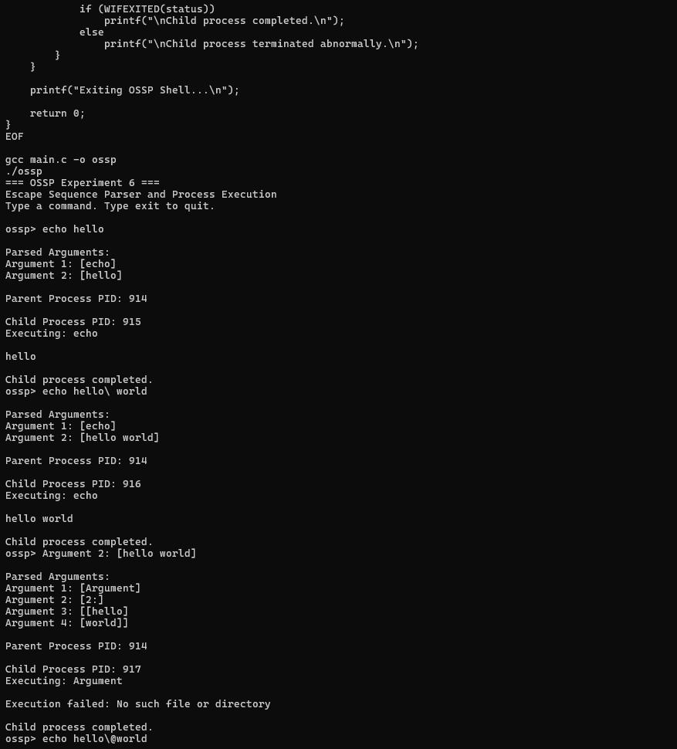
4. Command Execution and Error Handling
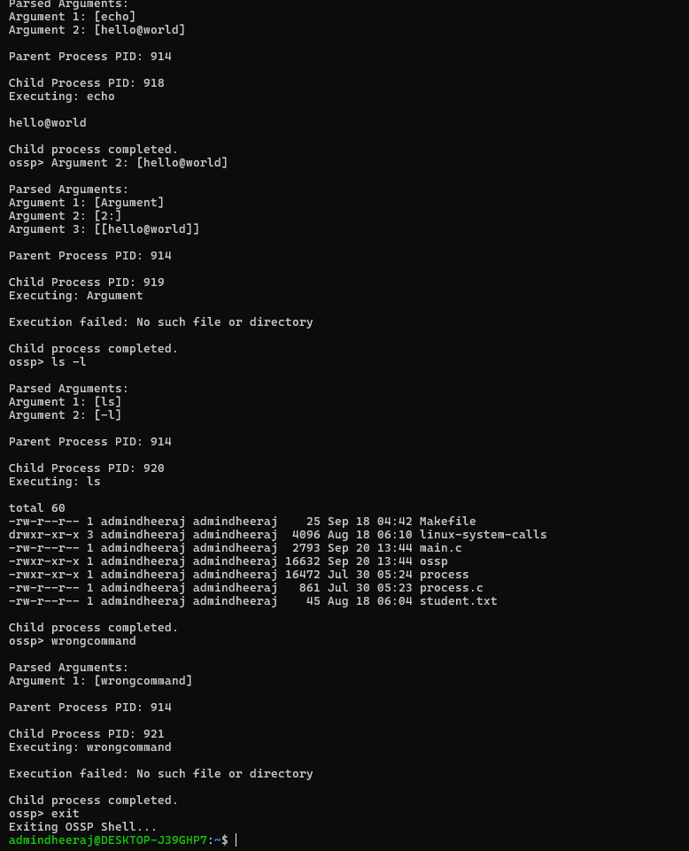
Result
The escape sequence parser and process execution program was executed successfully. Escaped spaces and special symbols were preserved in parsed arguments. Child processes were created and commands were executed using execvp(), while invalid commands produced an execution error and the parent process waited for child completion.

