ITM University Gwalior
School of Computing and Intelligent Systems
Project-Based Learning (PBL)
Mini Project Report — Submission Format
Course: Data Analytics Using Python
Course Code: CSL0312
Program: B.Tech. CSE (Artificial Intelligence & Machine Learning)
Semester: III Section: F
Academic Session: July–Dec 2026
Project Details
Project Title: Stock Price Trend Analysis Using Historical Data (NVIDIA Corporation – NVDA)
Domain (as per Section 6): Financial & Economics Analysis
Team Leader Name & Roll No.: K Anvesh Reddy (BETN1AI25168)
Team Member Name & Roll No.: G Madhava Reddy (BETN1AI25161)
Team Member Name & Roll No.: K Karthik (BETN1AI25179)
Faculty Mentor: Dr. Sanjay Jain
Date of Submission: 19-10-2026

1. Introduction & Problem Statement
Stock prices change every day under the influence of market demand, company performance, economic news and investor sentiment. Because prices keep moving, it is difficult for investors to recognise the direction of the market by looking at raw historical figures alone, and investing without a proper trend analysis can lead to financial losses. Analysing historical data helps investors, financial analysts and students understand past market behaviour and make more informed, data-driven observations.
This project studies the historical share price of NVIDIA Corporation (NVDA) from 2 January 2020 to 30 July 2026 using Python. The problem addressed is: how can the direction, strength, momentum and volume support of a stock’s price trend be identified clearly from its historical data? To answer this, the raw data downloaded from Yahoo Finance was cleaned and validated, explored statistically and then analysed with widely used technical indicators — the 20-day and 50-day Exponential Moving Averages (EMA), the Moving Average Convergence Divergence (MACD), the Average Directional Index (ADX) with its directional indicators (+DI and −DI), and trading volume.
The signals from these indicators were combined by a rule-based classifier that labels each trading day as Strong Bullish, Strong Bearish or Mixed/Weak. The results are presented through charts and tables so that price movements are easy to interpret. The scope of the project is limited to descriptive trend analysis of a single stock using Open, High, Low, Close and Volume data; it does not forecast future prices and the findings are not investment advice, since technical indicators are signals rather than guaranteed predictions.

2. Dataset Description & Source
Dataset Name: NVIDIA Corporation (NVDA) Historical Price Data (NVDA_Historical_Data.csv)
Source / Organization: Yahoo Finance
Dataset Link (URL): https://finance.yahoo.com/quote/NVDA/history/
Type of Dataset: ☒ Public ☐ Private ☐ Self-Collected
Number of Records: 1,652 trading days (2020-01-02 to 2026-07-30)
Number of Attributes/Columns: 6 (Date, Close, High, Low, Open, Volume)
☒ Dataset meets minimum quality criteria (Section 7): 1,652 records (minimum 500), 6 attributes (minimum 5) and zero missing values after removing the two header rows of the Yahoo Finance file.
Brief description of attributes/columns
Column | Final Data Type | Description
Date | datetime64[ns] | Trading date; the dataset is sorted from oldest to newest.
Open | float64 | Price of the first trade of the day (USD).
High | float64 | Highest traded price during the day (USD).
Low | float64 | Lowest traded price during the day (USD).
Close | float64 | Closing price of the day (USD), as provided by Yahoo Finance (prices appear split-adjusted).
Volume | float64 | Number of shares traded during the day.

3. Data Cleaning & Preprocessing
The raw CSV exported from Yahoo Finance contains two extra header rows (“Ticker” and “Date”) below the column names, which made every column load as text. The following steps were carried out in Google Colab and verified at each stage.
S. No. | Step | Action and Result
1 | Load data | NumPy, pandas, Matplotlib and Seaborn were imported and the CSV was read into a DataFrame named stock.
2 | Remove extra header rows | The “Ticker” and “Date” rows (index 0 and 1) were dropped and the index was reset, leaving 1,652 records.
3 | Rename column | The first column, named “Price” by Yahoo Finance, was renamed “Date”.
4 | Fix data types | All six columns were initially of type object. Date was converted to datetime64[ns] and Close, High, Low, Open and Volume were converted to float64.
5 | Missing values | Null-value check returned 0 for every column; no imputation was required.
6 | Duplicates | The duplicate-row check returned 0; no rows were removed.
7 | Invalid prices | Minimum values were High 5.22, Low 4.49, Open 4.98 and Close 4.89 — all positive, so no zero or negative prices exist.
8 | Chronological order | The Date column is monotonically increasing (True), so the data is correctly arranged from oldest to newest for trend analysis.
9 | Price consistency | No record has an Open or a Close above the High or below the Low (0 violations in both checks).

After these steps the dataset was complete, correctly typed, sorted and free of logical errors, so it was suitable for indicator calculation. The complete code and printed outputs for every step are given in Appendix A. Outlier removal was deliberately not applied: extreme daily moves in a stock are genuine market events and are part of the behaviour being studied.

4. Exploratory Data Analysis (EDA)
4.1 Summary statistics
Descriptive statistics were generated for Open, High, Low, Close and Volume. Prices span a very wide range because NVDA rose from under 5 USD to over 235 USD within the study period.
Statistic | Open | High | Low | Close | Volume (millions)
Count | 1652 | 1652 | 1652 | 1652 | 1652
Mean | 69.56 | 70.70 | 68.30 | 69.54 | 387.91
Std. Deviation | 66.85 | 67.79 | 65.74 | 66.78 | 198.87
Minimum | 4.98 | 5.22 | 4.49 | 4.89 | 65.53
25% | 15.32 | 15.63 | 15.07 | 15.32 | 224.17
50% (Median) | 30.12 | 30.56 | 29.41 | 30.06 | 365.27
75% | 126.38 | 128.87 | 123.33 | 126.28 | 504.40
Maximum | 229.60 | 236.26 | 229.03 | 235.47 | 1,543.91

4.2 Daily return and technical indicators
- Daily return: calculated as the percentage change of the closing price from the previous day (the first row is NaN because there is no earlier day).
- EMA 20 and EMA 50: exponential moving averages of the closing price. When EMA 20 is above EMA 50 the trend is labelled Bullish, otherwise Bearish. A crossover is recorded on the day the label changes from the previous day.
- MACD (12, 26, 9): MACD line = EMA 12 − EMA 26; the signal line is a 9-period EMA of the MACD line; the histogram is MACD minus signal. A histogram moving from negative to positive is a bullish crossover and from positive to negative a bearish crossover.
- ADX (14) with +DI and −DI: calculated with the ta library to measure trend strength irrespective of direction. Below 20 is typically a weak or sideways trend, 20–25 a developing trend and above 25 a stronger trend.
- Volume analysis: a day is flagged as high-volume when its volume exceeds twice the average volume.
4.3 Crossover signals identified
Indicator | Bullish Crossovers | Bearish Crossovers | No Crossover Days
EMA 20 / EMA 50 | 18 | 18 | 1,616
MACD / Signal line | 66 | 66 | 1,520

The first EMA crossover was bullish on 2020-01-10 and the first bearish crossover was on 2020-03-16, when the Close fell to its period low of 4.89. The most recent EMA crossovers are bullish on 2026-07-15 and bearish on 2026-07-28. Several clusters of crossovers on consecutive or nearby days (for example 2020-12-31 to 2021-01-11 and 2023-01-06 to 2023-01-09) show that EMA crossovers can flip quickly when the two averages are close together.
4.4 Volume analysis
The average daily volume is 387,911,210 shares. The highest volume in the dataset is 1,543,911,000 shares on 2023-05-25, when the Close was 37.90 and the daily return was +24.37%; on that day ADX was 38.01 with +DI at 61.02 against −DI at 9.50, showing very strong buying pressure. The last ten high-volume days (above twice the average) fall between 2023-08-24 and 2025-01-27, and the highest of these include 1,156,044,000 shares on 2023-08-24 and 1,142,269,000 shares on 2024-03-08.
4.5 Overall trend classification
A Strong Bullish day requires EMA 20 > EMA 50, MACD > signal line, ADX > 25 and +DI > −DI. A Strong Bearish day requires EMA 20 < EMA 50, MACD < signal line, ADX > 25 and −DI > +DI. All other days are Mixed/Weak.
Overall Trend | Number of Days | Share of 1,652 Days | Interpretation
Mixed/Weak | 1,299 | 78.6% | No strong, confirmed trend
Strong Bullish | 282 | 17.1% | Confirmed uptrend
Strong Bearish | 71 | 4.3% | Confirmed downtrend

5. Data Visualization & Observations
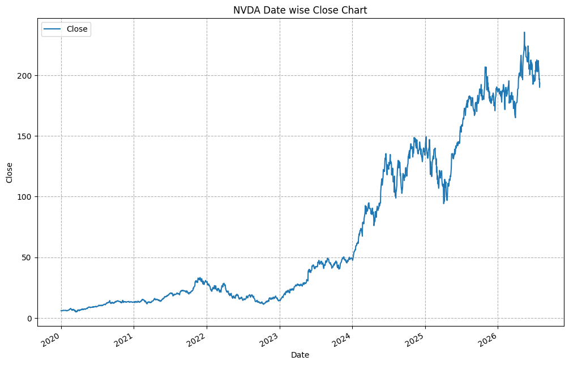
Figure 1: NVDA date-wise closing price chart (2020–2026)
Observation: The price stayed below about 35 USD until 2023 and then rose steeply from early 2024, reaching a peak of roughly 235 USD in mid-2026. The long-term direction is clearly upward, with sharp corrections in 2022 and in early 2025.
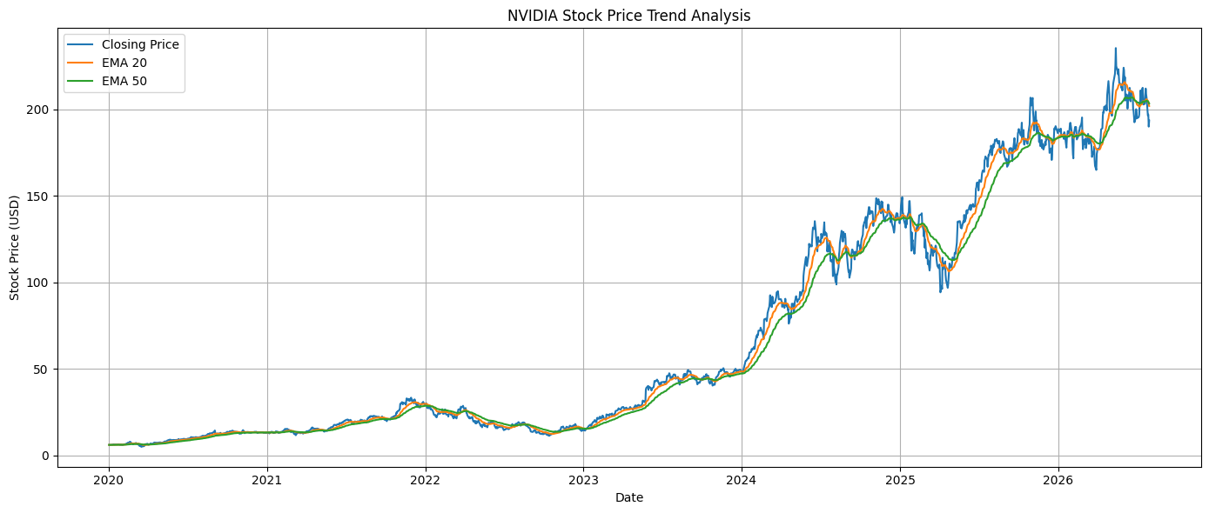
Figure 2: NVDA closing price with EMA 20 and EMA 50
Observation: Both EMAs follow the price closely and smooth out its daily noise. EMA 20 reacts faster than EMA 50. During strong rallies (2023–2024 and 2025) EMA 20 stays above EMA 50, while in the 2022 decline and the early-2025 dip it falls below it. The two lines are almost on top of each other at the end of the series, showing a trend that has recently lost direction.
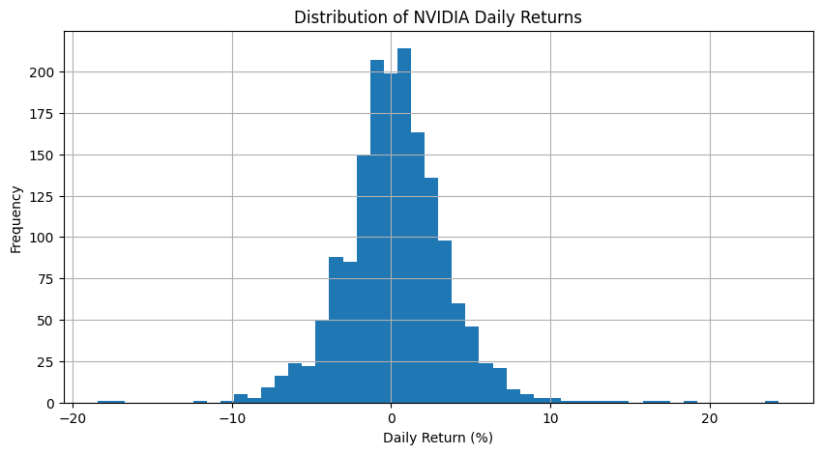
Figure 3: Distribution of NVDA daily returns
Observation: Daily returns are centred near 0% and most values lie between about −5% and +5%, giving an almost bell-shaped histogram. A few extreme days exist on both tails, up to about +24% and close to −18%, showing that large single-day moves do occur.
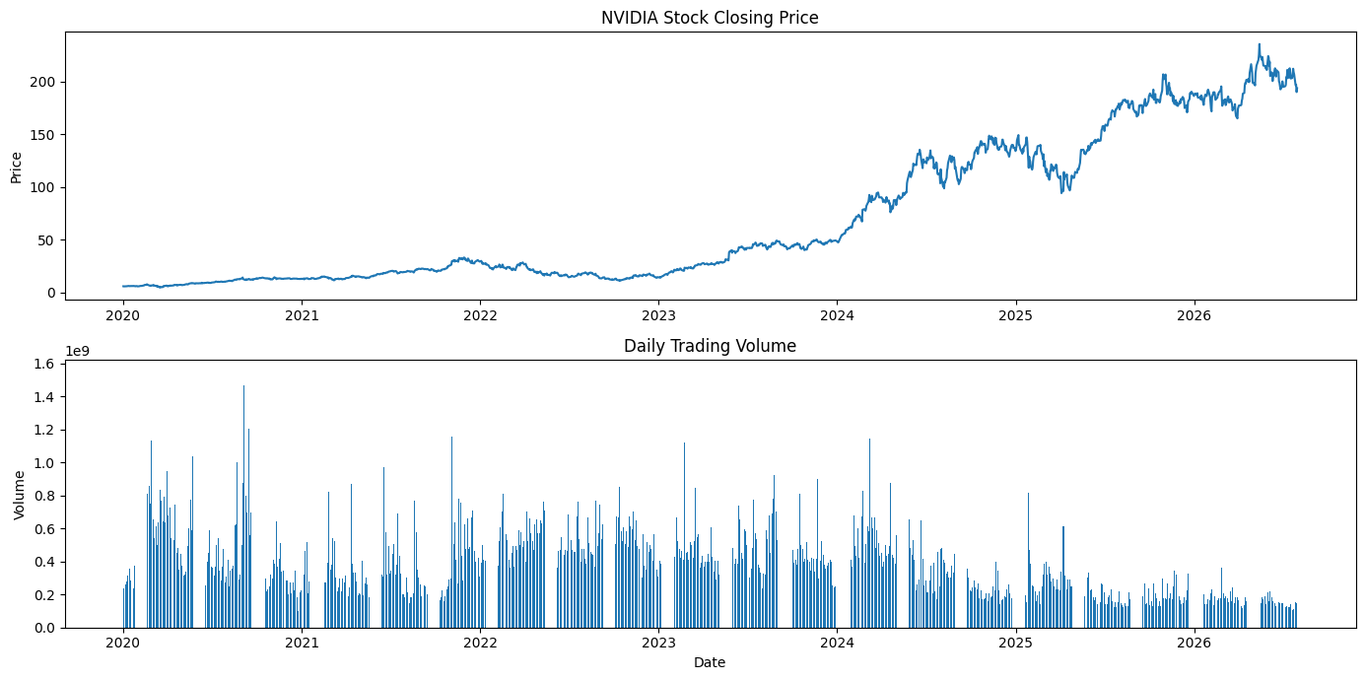
Figure 4: NVDA closing price and daily trading volume
Observation: Volume was highest in 2020–2021, remained high through 2023–early 2024 with several spikes above 1 billion shares, and then declined to a lower, steadier level from 2025 even while the price kept making new highs.
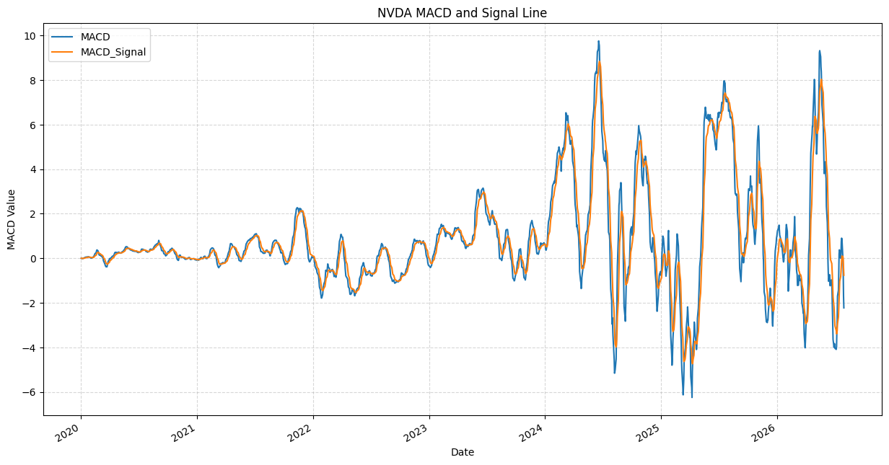
Figure 5: NVDA MACD and signal line
Observation: The MACD and signal lines oscillate around zero. Their swings were small before 2023 and became much larger from 2024 onwards (peaks near +10 and troughs near −6), indicating stronger momentum and higher volatility in the later period.
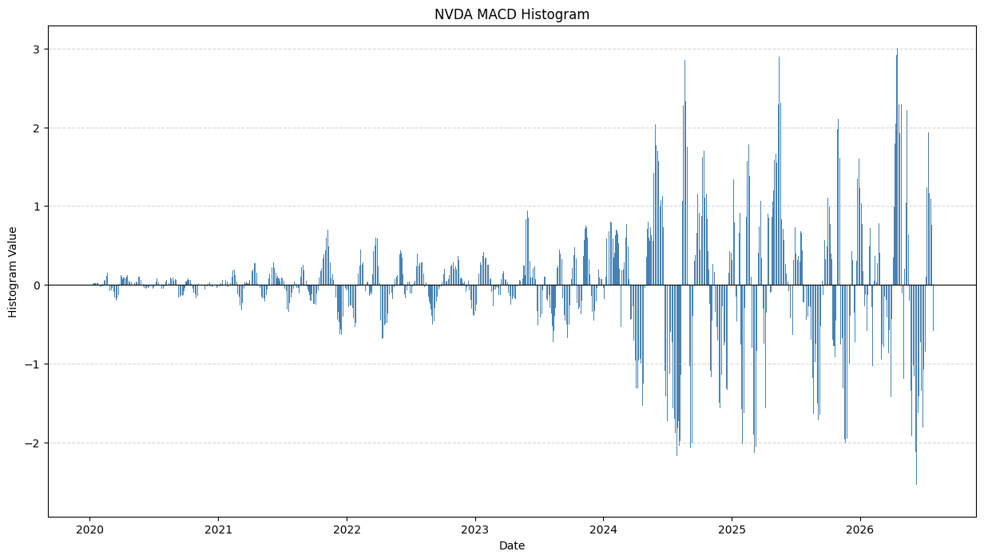
Figure 6: NVDA MACD histogram
Observation: Bars above zero show bullish momentum and bars below zero show bearish momentum. The histogram is very small before 2023 and has large positive and negative spikes after 2024 (about +3 to −2.5). The most recent bars are negative, in line with the MACD signal in Section 4.
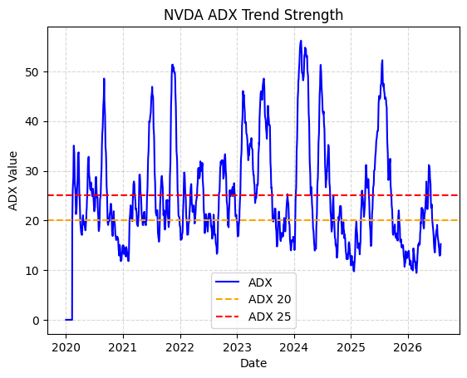
Figure 7: NVDA ADX trend strength with levels 20 and 25
Observation: ADX is above 25 only in short bursts — notably 2021, late 2021, 2023–2024 and 2025 with peaks of about 50–56 — and spends most of the time near or below 20. The latest values are about 15, so the market is currently in a weak or sideways phase. The flat line at zero at the start is the warm-up period of the indicator.
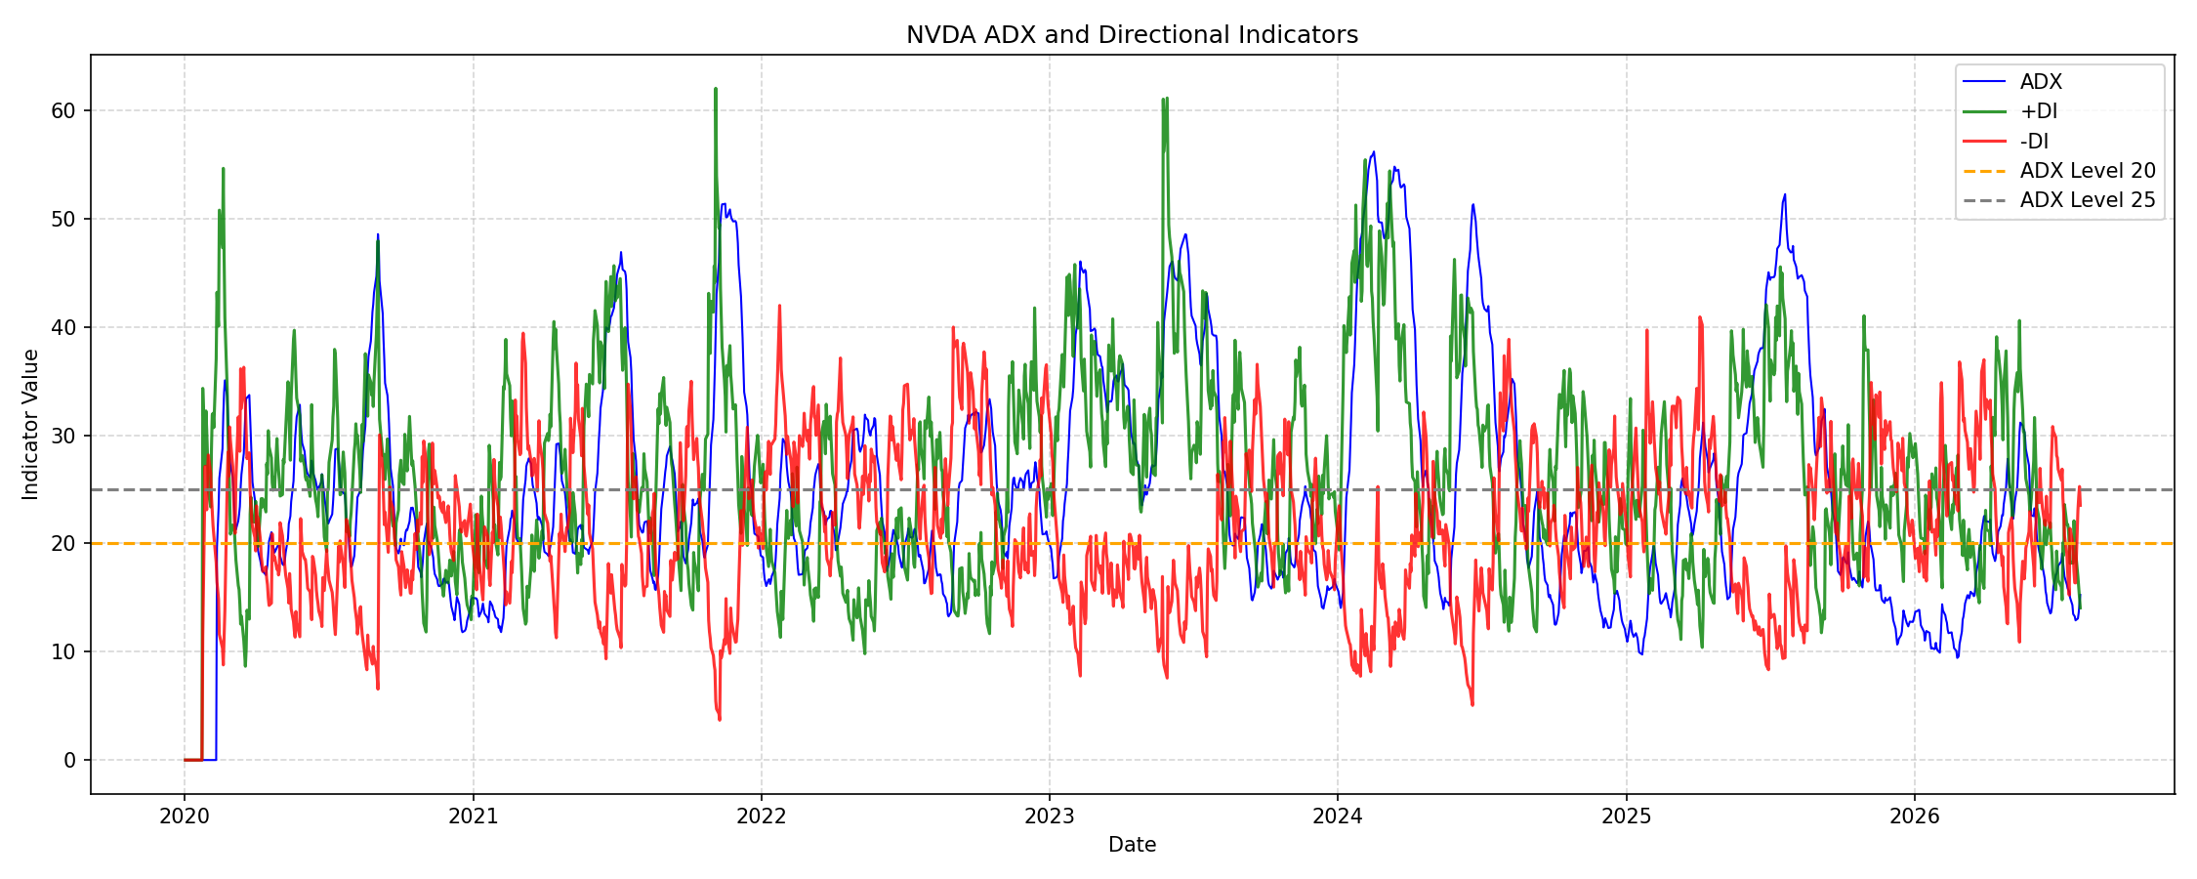
Figure 8: NVDA ADX with +DI and −DI directional indicators
Observation: When +DI (green) is above −DI (red) buyers dominate the direction, and when −DI is above +DI sellers dominate. The directional lines cross often, while ADX (blue) shows whether the move has real strength: the clearest bullish phases occur when +DI is well above −DI and ADX rises above 25. At the end of the series −DI (about 23.5) is above +DI (about 14.0) but ADX is only about 15, so the recent selling pressure is directional but not yet backed by a strong trend.

6. Statistical Analysis (Basic)
6.1 Central tendency and spread
- Closing price: mean = 69.54, median = 30.06 and standard deviation = 66.78. The mean is more than double the median, so the distribution is strongly right-skewed — most days occurred at lower price levels while the later high-price years pull the average up.
- Variability: the standard deviation (66.78) is almost equal to the mean (69.54), giving a coefficient of variation of about 0.96. This reflects the very large price growth over the period rather than only day-to-day noise.
- Price range: Close ranged from 4.89 to 235.47; the inter-quartile range is 15.32 (25%) to 126.28 (75%).
- Volume: mean 387.91 million and median 365.27 million shares (slightly right-skewed); standard deviation 198.87 million; range 65.53 million to 1,543.91 million.
- Daily returns: the histogram is symmetric around zero with fat tails; the largest observed daily gain is +24.37% (2023-05-25).
6.2 Frequency of signals
- EMA crossovers: 36 in total (18 bullish + 18 bearish) over 1,652 days, about one crossover every 46 trading days.
- MACD crossovers: 132 in total (66 bullish + 66 bearish), about one every 12.5 trading days — nearly four times as frequent as EMA crossovers.
- Overall trend: Mixed/Weak 78.6%, Strong Bullish 17.1%, Strong Bearish 4.3% of all days; strong bullish days outnumber strong bearish days by about 4 to 1 (282 : 71).
- High-volume days are defined by the threshold 2 × 387.91 million = 775.82 million shares.
6.3 Latest indicator snapshot (30 July 2026)
Indicator | Value | Reading
Close | 193.54 | Below both EMAs
EMA 20 / EMA 50 | 201.97 / 203.44 | EMA 20 < EMA 50: Bearish trend
MACD / Signal | −2.226 / −0.761 | MACD below signal line
MACD histogram | −1.465 | Negative and widening over the last four days
ADX | 15.25 | Below 20: weak or sideways trend
+DI / −DI | 14.05 / 23.52 | −DI above +DI: sellers dominate direction

Because ADX (15.25) is below 25, the classification rule would label the latest day as Mixed/Weak even though the directional indicators lean bearish. ADX guidelines are rules of thumb and not guaranteed trading signals.

7. Key Insights & Interpretation
1. Strong long-term uptrend: the closing price rose from 5.96 USD on 2 January 2020 to 193.54 USD on 30 July 2026 (about 32 times), after peaking at 235.47 USD. The growth accelerated from 2024 and was interrupted by corrections in 2022 and early 2025.
2. Confirmed trends are uncommon: 78.6% of days are Mixed/Weak, meaning that all four conditions (EMA, MACD, ADX and DI) agree on only about one day in five. Requiring several indicators to agree filters out noise but also reduces the number of signals.
3. Bullish confirmation dominates: Strong Bullish days (282) are about four times as many as Strong Bearish days (71), consistent with NVDA’s overall upward path during the period.
4. Indicators differ in speed: MACD produced 66 crossovers of each type against 18 for EMA 20/50, so MACD is more sensitive but gives more frequent, possibly false, signals while EMA crossovers are slower and rarer. Since moving averages lag price, a crossover can occur after a move has already begun.
5. Current position is a weak pullback: short-term indicators are bearish (EMA 20 below EMA 50 since 28 July 2026, negative and widening MACD histogram, −DI above +DI), but ADX of 15.25 shows the downward trend is not yet strong. This suggests a pullback or consolidation rather than a confirmed downtrend.
6. Volume reveals participation: the largest volume (1.54 billion shares on 2023-05-25) coincided with the biggest daily gain (+24.37%) and a very strong ADX of 38.01, supporting the idea that big moves are backed by heavy participation. Volume has been lower since 2025, even as prices reached new highs; this was observed in the data but its cause was not analysed.

8. Conclusion & Future Scope
This project successfully applied Python-based data cleaning, exploratory analysis, technical indicators and visualization to six and a half years of NVIDIA stock data. The Yahoo Finance data was cleaned and validated (1,652 records, no missing values, no duplicates, no invalid prices) and then analysed using EMA 20/50, MACD, ADX with +DI/−DI and volume. The analysis shows that NVDA has been in a pronounced long-term uptrend, that confirmed strong trends are relatively rare (about 21% of days, mostly bullish), and that as of 30 July 2026 the short-term indicators are bearish while trend strength is weak. The rule-based classification makes the trend easy to read, but it describes the past and should be treated as decision support rather than a prediction or investment advice.
Future scope
- Add the remaining techniques listed in the synopsis — Price Action (swing highs/lows) and On-Balance Volume (OBV) — to further confirm trends.
- Back-test the EMA and MACD crossover signals to measure how often they led to profitable moves, and tune the indicator periods.
- Build interactive dashboards using Plotly so users can explore periods and indicators.
- Extend the analysis to several stocks or sector indices for comparison, and add volatility measures.
- Use machine-learning models such as time-series forecasting or classification on the indicator features to predict trend direction.

9. References
1. Yahoo Finance — NVIDIA Corporation (NVDA) historical prices (dataset source). https://finance.yahoo.com/quote/NVDA/history/
2. NumPy — numerical and statistical computing library for Python. https://numpy.org/
3. pandas — data cleaning and analysis library for Python. https://pandas.pydata.org/
4. Matplotlib — plotting library used to create the charts. https://matplotlib.org/
5. Seaborn — statistical data visualization library. https://seaborn.pydata.org/
6. ta (Technical Analysis Library in Python) — used to calculate ADX, +DI and −DI. https://github.com/bukosabino/ta
7. Google Colab — development environment used to run the notebook. https://colab.research.google.com/
8. Wilder, J. W. (1978). New Concepts in Technical Trading Systems. Trend Research — original definition of the ADX and directional indicators.

10. AI Tool Usage Declaration
☐ No AI tools were used in this project.
☒ AI tools were used, as detailed below:
AI Tool Used | Purpose (e.g., debugging, documentation) | Extent of Use / Section Applied
Claude (Anthropic) | Documentation — drafting and formatting this report from the notebook outputs | Report text, Sections 1–10; no new analysis or charts were created

11. Project Links & Deliverables
GitHub Repository Link: _______________________________________________________
Python Notebook (.ipynb) File Name: Untitled8_ordered.ipynb
PBL Report File Name: PBL_Report_NVDA_Stock_Trend_Analysis.docx
☐ GitHub repository includes code, notebook, and a PBL report and README

12. Report Structure Checklist (Section 8 Compliance)
S. No. | Report Section (as per Section 8 format) | Included (✓)
1 | Title Page | ✓
2 | Introduction & Problem Statement | ✓
3 | Dataset Description & Source | ✓
4 | Data Cleaning & Preprocessing | ✓
5 | Exploratory Data Analysis (EDA) | ✓
6 | Data Visualization & Observations | ✓
7 | Statistical Analysis (Basic) | ✓
8 | Key Insights & Interpretation | ✓
9 | Conclusion & Future Scope | ✓
10 | References | ✓

13. Declaration by Student(s)
I/We hereby declare that this Mini Project Report is our own original work, prepared using publicly available/open datasets. All sources of data, references, and AI tool assistance have been duly acknowledged. I/We understand that any instance of plagiarism in code or report will attract strict academic action, as per Section 15 of the PBL guidelines.
Team Leader Signature: _________________________________________
Team Member Signature(s): _________________________________________
Date: _________________________________________

14. For Faculty Use Only — PBL Final Report Evaluation
Evaluation Component B — PBL Final Report Submission | Mid-Term (PBL Based): 10 Marks (Section 10 of PBL Guidelines)
Evaluation Criteria | Max Marks | Marks Awarded
Data Cleaning & Preprocessing | 2
Exploratory Data Analysis (EDA) | 2
Visualization & Observations | 2
Statistical Analysis | 2
Insights, Interpretation & Conclusion | 2
Total (out of 10) | 10
Faculty Remarks:
Faculty Mentor Signature: _________________________________________
Date: _________________________________________

Appendix A: Python Code and Outputs
This appendix lists the notebook code (Google Colab, file Untitled8_ordered.ipynb) in the order it was run, together with the printed output of each cell. Plot code is included under A.4; the charts it produces are shown in Section 5. Long lines that were cut off at the page edge in the exported PDF are completed in the same style.
A.1 Importing libraries and loading the data
import numpy as np
import pandas as pd
import matplotlib.pyplot as plt
import seaborn as sns

stock=pd.read_csv('/content/NVDA_Historical_Data.csv')
stock.head()
Output:
Price Close High Low Open Volume
0 Ticker NVDA NVDA NVDA NVDA NVDA
1 Date NaN NaN NaN NaN NaN
2 2020-01-02 5.963803291320801 5.963803291320801 5.884505079799994 5.934967621143992 237536000
3 2020-01-03 5.868346214294434 5.91209732246454 5.81937484385445 5.844233438817881 205384000
4 2020-01-06 5.892956733703613 5.898176996723833 5.749026353781372 5.77512766888247 262636000
A.2 Data cleaning and preprocessing
Removing header rows, renaming and resetting the index
stock = stock.drop(index=[0, 1])
stock = stock.rename(columns={'Price': 'Date'})
stock = stock.reset_index(drop=True)
stock.head()
Output:
Date Close High Low Open Volume
0 2020-01-02 5.963803 5.963803 5.884505 5.934968 237536000
1 2020-01-03 5.868346 5.912097 5.819375 5.844233 205384000
2 2020-01-06 5.892957 5.898177 5.749026 5.775128 262636000
3 2020-01-07 5.964302 6.010041 5.876302 5.921296 314856000
4 2020-01-08 5.975488 6.016753 5.920053 5.960075 277108000
Data types before conversion
stock.info()
Output:
<class 'pandas.core.frame.DataFrame'>
RangeIndex: 1652 entries, 0 to 1651
Data columns (total 6 columns):
# Column Non-Null Count Dtype
--- ------ -------------- -----
0 Date 1652 non-null object
1 Close 1652 non-null object
2 High 1652 non-null object
3 Low 1652 non-null object
4 Open 1652 non-null object
5 Volume 1652 non-null object
dtypes: object(6)
memory usage: 77.6+ KB
Converting data types
stock['Date'] = pd.to_datetime(stock['Date'])
cols_to_convert = ['Close', 'High', 'Low', 'Open', 'Volume']
stock[cols_to_convert] = stock[cols_to_convert].astype(float)
stock.info()
Output:
<class 'pandas.core.frame.DataFrame'>
RangeIndex: 1652 entries, 0 to 1651
Data columns (total 6 columns):
# Column Non-Null Count Dtype
--- ------ -------------- -----
0 Date 1652 non-null datetime64[ns]
1 Close 1652 non-null float64
2 High 1652 non-null float64
3 Low 1652 non-null float64
4 Open 1652 non-null float64
5 Volume 1652 non-null float64
dtypes: datetime64[ns](1), float64(5)
memory usage: 77.6 KB
Missing values and duplicates
stock.isnull().sum()
stock.duplicated().sum()
Output:
Date 0
Close 0
High 0
Low 0
Open 0
Volume 0
dtype: int64

np.int64(0)
Checking for zero or negative prices
stock[['High','Low','Open','Close']].min()
Output:
High 5.221916
Low 4.494121
Open 4.977162
Close 4.885131
dtype: float64
Checking that the data is sorted by date
stock["Date"].is_monotonic_increasing
Output:
True
Checking price consistency (Open and Close within High-Low range)
range = stock[(stock["Open"] > stock["High"]) | (stock["Open"] < stock["Low"])]
len(range)

range = stock[(stock['Close'] > stock['High'])|(stock['Close'] < stock['Low'])]
len(range)
Output:
0

0
A.3 Exploratory data analysis and technical indicators
Summary statistics
stock[['Open', 'High', 'Low', 'Close', 'Volume']].describe()
Output:
Open High Low Close Volume
count 1652.000000 1652.000000 1652.000000 1652.000000 1.652000e+03
mean 69.561440 70.702156 68.295317 69.544562 3.879112e+08
std 66.848604 67.792805 65.738256 66.782261 1.988716e+08
min 4.977162 5.221916 4.494121 4.885131 6.552850e+07
25% 15.318487 15.634950 15.069972 15.320235 2.241674e+08
50% 30.118192 30.561985 29.408358 30.064522 3.652675e+08
75% 126.384063 128.867607 123.331718 126.279369 5.044025e+08
max 229.602402 236.264633 229.033071 235.465576 1.543911e+09
Daily return
stock['Daily_Return']= stock['Close'].pct_change()*100
stock[["Date", "Close", "Daily_Return"]].head()
Output:
Date Close Daily_Return
0 2020-01-02 5.963803 NaN
1 2020-01-03 5.868346 -1.600607
2 2020-01-06 5.892957 0.419377
3 2020-01-07 5.964302 1.210680
4 2020-01-08 5.975488 0.187551
Exponential moving averages (EMA 20 and EMA 50)
stock['EMA_20']=stock['Close'].ewm(span=20, adjust=False).mean()
stock['EMA_50']=stock['Close'].ewm(span=50, adjust=False).mean()
stock[['Close','EMA_20','EMA_50']].tail()
Output:
Close EMA_20 EMA_50
1647 206.839996 205.862346 205.045583
1648 196.509995 204.971646 204.710854
1649 197.009995 204.213393 204.408859
1650 190.009995 202.860688 203.844198
1651 193.544998 201.973480 203.440308
EMA trend (Bullish when EMA 20 > EMA 50)
stock['Trend'] = np.where(stock['EMA_20'] > stock['EMA_50'],'Bullish','Bearish')
stock[['Date', 'Close', 'EMA_20', 'EMA_50', 'Trend']].tail()
Output:
Date Close EMA_20 EMA_50 Trend
1647 2026-07-24 206.839996 205.862346 205.045583 Bullish
1648 2026-07-27 196.509995 204.971646 204.710854 Bullish
1649 2026-07-28 197.009995 204.213393 204.408859 Bearish
1650 2026-07-29 190.009995 202.860688 203.844198 Bearish
1651 2026-07-30 193.544998 201.973480 203.440308 Bearish
Previous trend and crossover signal
stock['Previous_Trend'] = stock['Trend'].shift(1)
stock[['Date', 'Close', 'EMA_20', 'EMA_50', 'Trend', 'Previous_Trend']].tail()
Output:
Date Close EMA_20 EMA_50 Trend Previous_Trend
1647 2026-07-24 206.839996 205.862346 205.045583 Bullish Bullish
1648 2026-07-27 196.509995 204.971646 204.710854 Bullish Bullish
1649 2026-07-28 197.009995 204.213393 204.408859 Bearish Bullish
1650 2026-07-29 190.009995 202.860688 203.844198 Bearish Bearish
1651 2026-07-30 193.544998 201.973480 203.440308 Bearish Bearish
stock['signal'] = np.where((stock['Trend'] == 'Bullish') & (stock['Previous_Trend'] == 'Bearish'), 'Bullish Crossover',
np.where((stock['Trend'] == 'Bearish') & (stock['Previous_Trend'] == 'Bullish'), 'Bearish Crossover', 'No Crossover'))
stock[['Date', 'Close', 'EMA_20', 'EMA_50', 'Trend', 'Previous_Trend', 'signal']].tail()
Output:
Date Close EMA_20 EMA_50 Trend Previous_Trend signal
1647 2026-07-24 206.839996 205.862346 205.045583 Bullish Bullish No Crossover
1648 2026-07-27 196.509995 204.971646 204.710854 Bullish Bullish No Crossover
1649 2026-07-28 197.009995 204.213393 204.408859 Bearish Bullish Bearish Crossover
1650 2026-07-29 190.009995 202.860688 203.844198 Bearish Bearish No Crossover
1651 2026-07-30 193.544998 201.973480 203.440308 Bearish Bearish No Crossover
All EMA crossover dates
stock[stock['signal'] != 'No Crossover'][['Date', 'Close', 'EMA_20', 'EMA_50', 'signal']]
Output:
Date Close EMA_20 EMA_50 signal
6 2020-01-10 6.073431 5.971819 5.966023 Bullish Crossover
50 2020-03-16 4.885131 6.294572 6.348986 Bearish Crossover
67 2020-04-08 6.639946 6.239618 6.234345 Bullish Crossover
252 2020-12-31 13.002532 13.113593 13.115768 Bearish Crossover
254 2021-01-05 13.350874 13.131642 13.122916 Bullish Crossover
255 2021-01-06 12.563799 13.077561 13.100990 Bearish Crossover
258 2021-01-11 13.566752 13.153308 13.130723 Bullish Crossover
296 2021-03-08 11.546656 13.407914 13.513766 Bearish Crossover
318 2021-04-08 14.264381 13.385844 13.344233 Bullish Crossover
515 2022-01-18 25.821426 28.122415 28.165265 Bearish Crossover
563 2022-03-28 28.134928 25.257219 25.081860 Bullish Crossover
573 2022-04-11 21.851700 25.137564 25.192820 Bearish Crossover
653 2022-08-05 18.936426 17.599774 17.529880 Bullish Crossover
669 2022-08-29 15.757252 17.462196 17.561447 Bearish Crossover
722 2022-11-11 16.286633 13.807174 13.800066 Bullish Crossover
759 2023-01-06 14.826057 15.247008 15.265265 Bearish Crossover
760 2023-01-09 15.593352 15.279993 15.278131 Bullish Crossover
940 2023-09-27 42.388920 43.816527 43.823507 Bearish Crossover
946 2023-10-05 44.604782 43.864351 43.835948 Bullish Crossover
957 2023-10-20 41.309929 44.034814 44.046626 Bearish Crossover
970 2023-11-08 46.487278 43.730983 43.722248 Bullish Crossover
1155 2024-08-06 104.078461 113.890311 114.095707 Bearish Crossover
1163 2024-08-16 124.375000 114.050245 113.800155 Bullish Crossover
1177 2024-09-06 102.660805 115.743212 115.786284 Bearish Crossover
1189 2024-09-24 120.681427 115.999864 115.744782 Bullish Crossover
1274 2025-01-28 128.797653 136.577516 136.763169 Bearish Crossover
1348 2025-05-14 135.150604 115.998970 115.174511 Bullish Crossover
1487 2025-12-02 181.228867 184.200359 184.294793 Bearish Crossover
1506 2025-12-30 187.311539 183.561291 183.365697 Bullish Crossover
1531 2026-02-05 171.670609 183.630687 184.130721 Bearish Crossover
1534 2026-02-10 188.310318 184.729802 184.546686 Bullish Crossover
1550 2026-03-05 183.116653 185.050096 185.112207 Bearish Crossover
1578 2026-04-15 198.638489 183.120949 182.294535 Bullish Crossover
1629 2026-06-29 194.970001 204.606431 204.928039 Bearish Crossover
1640 2026-07-15 212.500000 204.520494 204.404957 Bullish Crossover
1649 2026-07-28 197.009995 204.213393 204.408859 Bearish Crossover
stock['signal'].value_counts()
Output:
signal
No Crossover 1616
Bullish Crossover 18
Bearish Crossover 18
dtype: int64
MACD (fast EMA 12, slow EMA 26, signal line 9)
stock['EMA_12'] = stock['Close'].ewm(span=12, adjust=False).mean()
stock['EMA_26'] = stock['Close'].ewm(span=26, adjust=False).mean()
stock['MACD'] = stock['EMA_12'] - stock['EMA_26']

stock['MACD_Signal'] = stock['MACD'].ewm(span=9, adjust=False).mean()
stock[['Date', 'Close', 'MACD', 'MACD_Signal']].tail()
Output:
Date Close MACD MACD_Signal
1647 2026-07-24 206.839996 0.859400 0.099514
1648 2026-07-27 196.509995 -0.009317 0.077748
1649 2026-07-28 197.009995 -0.649944 -0.067791
1650 2026-07-29 190.009995 -1.702857 -0.394804
1651 2026-07-30 193.544998 -2.226389 -0.761121
stock['MACD_Histogram'] = stock['MACD'] - stock['MACD_Signal']
stock[['Date', 'Close', 'MACD', 'MACD_Signal', 'MACD_Histogram']].tail()
Output:
Date Close MACD MACD_Signal MACD_Histogram
1647 2026-07-24 206.839996 0.859400 0.099514 0.759886
1648 2026-07-27 196.509995 -0.009317 0.077748 -0.087065
1649 2026-07-28 197.009995 -0.649944 -0.067791 -0.582153
1650 2026-07-29 190.009995 -1.702857 -0.394804 -1.308053
1651 2026-07-30 193.544998 -2.226389 -0.761121 -1.465268
MACD crossover signal
stock['Previous_MACD_Histogram'] = stock['MACD_Histogram'].shift(1)
stock[['Date', 'Close', 'MACD', 'MACD_Signal', 'MACD_Histogram', 'Previous_MACD_Histogram']].tail()
Output:
Date Close MACD MACD_Signal MACD_Histogram Previous_MACD_Histogram
1647 2026-07-24 206.839996 0.859400 0.099514 0.759886 0.994375
1648 2026-07-27 196.509995 -0.009317 0.077748 -0.087065 0.759886
1649 2026-07-28 197.009995 -0.649944 -0.067791 -0.582153 -0.087065
1650 2026-07-29 190.009995 -1.702857 -0.394804 -1.308053 -0.582153
1651 2026-07-30 193.544998 -2.226389 -0.761121 -1.465268 -1.308053
stock['MACD_Signal_Type']= np.where((stock['MACD_Histogram'] > 0) & (stock['Previous_MACD_Histogram'] < 0), 'Bullish Crossover',
np.where((stock['MACD_Histogram'] < 0) & (stock['Previous_MACD_Histogram'] > 0), 'Bearish Crossover', 'No Crossover'))
stock[['Date', 'Close', 'MACD', 'MACD_Signal', 'MACD_Histogram', 'Previous_MACD_Histogram', 'MACD_Signal_Type']].tail()
Output:
Date Close MACD MACD_Signal MACD_Histogram Previous_MACD_Histogram MACD_Signal_Type
1647 2026-07-24 206.839996 0.859400 0.099514 0.759886 0.994375 No Crossover
1648 2026-07-27 196.509995 -0.009317 0.077748 -0.087065 0.759886 Bearish Crossover
1649 2026-07-28 197.009995 -0.649944 -0.067791 -0.582153 -0.087065 No Crossover
1650 2026-07-29 190.009995 -1.702857 -0.394804 -1.308053 -0.582153 No Crossover
1651 2026-07-30 193.544998 -2.226389 -0.761121 -1.465268 -1.308053 No Crossover
stock['MACD_Signal_Type'].value_counts()
Output:
MACD_Signal_Type
No Crossover 1520
Bullish Crossover 66
Bearish Crossover 66
dtype: int64
ADX, +DI and -DI (14-period)
!pip install ta
from ta.trend import ADXIndicator

adx_indicator = ADXIndicator(
high=stock['High'],
low=stock['Low'],
close=stock['Close'],
window=14
)

stock['ADX'] = adx_indicator.adx()
stock['DI_Positive'] = adx_indicator.adx_pos()
stock['DI_Negative'] = adx_indicator.adx_neg()

stock[['Date', 'Close', 'ADX', 'DI_Positive', 'DI_Negative']].tail(10)
Output:
Successfully installed ta-0.11.0

Date Close ADX DI_Positive DI_Negative
1642 2026-07-17 202.809998 15.013523 18.155721 21.387429
1643 2026-07-20 203.279999 14.311866 18.251846 20.250232
1644 2026-07-21 207.289993 13.478595 18.182214 19.170595
1645 2026-07-22 212.059998 13.361489 22.089843 17.413053
1646 2026-07-23 208.759995 13.252747 20.765059 16.368748
1647 2026-07-24 206.839996 12.898147 19.313211 16.356760
1648 2026-07-27 196.509995 13.070122 16.924287 23.041346
1649 2026-07-28 197.009995 13.612940 15.971603 24.294421
1650 2026-07-29 190.009995 14.482541 14.901530 25.257472
1651 2026-07-30 193.544998 15.249060 14.046178 23.517380
Volume analysis
stock.loc[stock['Volume'].idxmax()]
Output:
Date 2023-05-25 00:00:00
Close 37.902241
High 39.39917
Low 36.559993
Open 38.444128
Volume 1543911000.0
Daily_Return 24.369669
EMA_20 30.139743
EMA_50 27.831863
Trend Bullish
Previous_Trend Bullish
signal No Crossover
EMA_12 31.17298
EMA_26 29.586928
MACD 1.586053
MACD_Signal 1.03685
MACD_Histogram 0.549203
Previous_MACD_Histogram 0.128227
MACD_Signal_Type No Crossover
ADX 38.007051
DI_Positive 61.020116
DI_Negative 9.504495
Name: 855, dtype: object
average_volume = stock['Volume'].mean()
stock['High_Volume'] = stock['Volume'] > (2 * average_volume)
print("Average Volume:", average_volume)
print("\nHigh-volume days:")
print(stock.loc[stock['High_Volume'], ['Date', 'Close', 'Volume']].tail(10))
Output:
Average Volume: 387911209.82929784

High-volume days:
Date Close Volume
917 2023-08-24 47.071301 1.156044e+09
918 2023-08-25 45.928528 9.253410e+08
954 2023-10-17 43.856186 8.123330e+08
980 2023-11-22 48.625286 8.994200e+08
1041 2024-02-22 78.398666 8.651000e+08
1042 2024-02-23 78.677155 8.293880e+08
1052 2024-03-08 87.376793 1.142269e+09
1081 2024-04-19 76.068367 8.751980e+08
1105 2024-05-23 103.619705 8.350650e+08
1273 2025-01-27 118.243401 8.188309e+08
Overall trend classification
stock['Overall_Trend'] = np.where(
(stock['EMA_20'] > stock['EMA_50']) &
(stock['MACD'] > stock['MACD_Signal']) &
(stock['ADX'] > 25) &
(stock['DI_Positive'] > stock['DI_Negative']),
'Strong Bullish',
np.where(
(stock['EMA_20'] < stock['EMA_50']) &
(stock['MACD'] < stock['MACD_Signal']) &
(stock['ADX'] > 25) &
(stock['DI_Negative'] > stock['DI_Positive']),
'Strong Bearish',
'Mixed/Weak'
)
)
print(stock['Overall_Trend'].value_counts())
Output:
Overall_Trend
Mixed/Weak 1299
Strong Bullish 282
Strong Bearish 71
Name: count, dtype: int64
A.4 Visualization code
The charts produced by this code are shown as Figures 1–8 in Section 5. The first EMA plot below (blue/red/orange version) and the combined MACD/histogram panel are additional notebook charts that are not repeated in Section 5.
Closing price chart (Figure 1)
stock.plot(x='Date',y='Close',figsize=(12,8),title='NVDA Date wise Close Chart', xlabel='Date', ylabel = 'Close')
plt.grid(linestyle = '--')
plt.show()
Close with EMA 20 and EMA 50 – first version
stock.plot(x='Date',y=['Close','EMA_20','EMA_50'],figsize=(15,8),title='NVDA chart with EMA 20,50 Indicator', xlabel='Date', ylabel='Price')
plt.gca().get_lines()[0].set_alpha(0.5)
plt.gca().get_lines()[0].set_linewidth(0.8)
plt.gca().get_lines()[1].set_linewidth(1.5)
plt.gca().get_lines()[2].set_linewidth(2)
plt.grid(linestyle = '--')
plt.show()
Closing price with EMA 20 and EMA 50 (Figure 2)
plt.figure(figsize=(14, 6))
plt.plot(stock['Date'],stock['Close'],label='Closing Price')
plt.plot(stock['Date'],stock['EMA_20'],label='EMA 20')
plt.plot(stock['Date'],stock['EMA_50'],label='EMA 50')
plt.title('NVIDIA Stock Price Trend Analysis')
plt.xlabel('Date')
plt.ylabel('Stock Price (USD)')
plt.legend()
plt.grid(True)
plt.tight_layout()
plt.show()
Distribution of daily returns (Figure 3)
plt.figure(figsize=(10, 5))
plt.hist(stock['Daily_Return'].dropna(), bins=50)
plt.title('Distribution of NVIDIA Daily Returns')
plt.xlabel('Daily Return (%)')
plt.ylabel('Frequency')
plt.grid(True)
plt.show()
Closing price and daily trading volume (Figure 4)
plt.figure(figsize=(14, 7))
plt.subplot(2, 1, 1)
plt.plot(stock['Date'], stock['Close'])
plt.title('NVIDIA Stock Closing Price')
plt.ylabel('Price')
plt.subplot(2, 1, 2)
plt.bar(stock['Date'], stock['Volume'])
plt.title('Daily Trading Volume')
plt.ylabel('Volume')
plt.xlabel('Date')
plt.tight_layout()
plt.show()
MACD and signal line (Figure 5)
stock.plot(x='Date', y=['MACD', 'MACD_Signal'], figsize=(15, 8))
plt.title('NVDA MACD and Signal Line')
plt.xlabel('Date')
plt.ylabel('MACD Value')
plt.grid(linestyle='--', alpha=0.5)
plt.show()
MACD histogram (Figure 6)
plt.figure(figsize=(15, 8))
plt.bar(stock['Date'], stock['MACD_Histogram'], color='steelblue', width=1)
plt.axhline(0, color='black', linewidth=0.8)
plt.title('NVDA MACD Histogram')
plt.xlabel('Date')
plt.ylabel('Histogram Value')
plt.grid(axis='y', linestyle='--', alpha=0.5)
plt.show()
MACD analysis – combined panel
fig, axes = plt.subplots(2, 1, figsize=(15, 9),sharex=True,gridspec_kw={'height_ratios': [2, 1]})
# MACD and Signal lines
axes[0].plot(stock['Date'], stock['MACD'],
label='MACD', color='blue')
axes[0].plot(stock['Date'], stock['MACD_Signal'],
label='Signal Line', color='red')
axes[0].axhline(0, color='black', linestyle='--', linewidth=0.8)
axes[0].set_title('NVDA MACD Analysis')
axes[0].set_ylabel('MACD Value')
axes[0].legend()
axes[0].grid(linestyle='--', alpha=0.4)
# Histogram
axes[1].bar(stock['Date'], stock['MACD_Histogram'],
color='steelblue', width=1)
axes[1].axhline(0, color='black', linewidth=0.8)
axes[1].set_xlabel('Date')
axes[1].set_ylabel('Histogram')
axes[1].grid(axis='y', linestyle='--', alpha=0.4)
plt.tight_layout()
plt.show()
ADX trend strength (Figure 7)
plt.plot(stock['Date'], stock['ADX'],label='ADX', color='blue')
plt.plot(figsize=(15,8))
plt.axhline(20, color='orange', linestyle='--',label='ADX 20')
plt.axhline(25, color='red', linestyle='--',label='ADX 25')
plt.title('NVDA ADX Trend Strength')
plt.xlabel('Date')
plt.ylabel('ADX Value')
plt.legend()
plt.grid(linestyle='--', alpha=0.5)
plt.show()
ADX with +DI and -DI (Figure 8)
plt.figure(figsize=(15, 6))
plt.plot(stock['Date'], stock['ADX'],
label='ADX', color='blue', linewidth=1)
plt.plot(stock['Date'], stock['DI_Positive'],
label='+DI', color='green', alpha=0.8)
plt.plot(stock['Date'], stock['DI_Negative'],
label='-DI', color='red', alpha=0.8)
plt.axhline(20, color='orange', linestyle='--',
label='ADX Level 20')
plt.axhline(25, color='gray', linestyle='--',
label='ADX Level 25')
plt.title('NVDA ADX and Directional Indicators')
plt.xlabel('Date')
plt.ylabel('Indicator Value')
plt.legend()
plt.grid(linestyle='--', alpha=0.5)
plt.show()

