

Embedded Systems and Design &

Sensors, Instruments and Experimentation

# Project Report

**Audio Augmented Device**

*Submitted to Prof. Sanket Patel & Prof. Vinod Mall Submitted on: 7th December 2023*

# Group Members

| Deval Patel | AU2040017 |
| --- | --- |
| Rahi Shah | AU2040070 |
| Kuntal Panchal | AU2040141 |
| Raj Patel | AU2040187 |
| Kanvi Patel | AU2040235 |

Audio Augmented Device

# Contents

1. Synopsys…………………………………………………………………………………. 3
2. Block Diagram………………………………………………………………………… .3
3. List of Components……………………………………………………………………..3
   1. NIR Sensor…………………………………………………………………. 3
   2. NIR Transmitter 4
   3. Voltage Regulator 4
   4. Microcontroller (STM32) 4
   5. Display (Serial Monitor) 4
4. Circuit Diagram 5
5. Theory 5
6. Design Calculations 6
   1. Voltage Regulators and ‘R’ Values 6
   2. 3D-Printed Parts 7
7. Codes 7
   1. For ADC Reading 7
   2. For ‘R-Value’ Calculation (Voltage Regulator) 8
8. Problems Faced 9
9. To get the Averaged values of numerous readings 9
10. Using Multiple Channel ADCs simultaneously 9
11. Not getting sufficient reading values 10
12. Getting different values through combined module and IR Sensor 10
13. Showing output as a Graph 11
14. Applications 11
15. Scope of Improvements 11
16. Learning Outcomes 12
17. **ABSTRACT**

These "Smart Glasses" are intended to assist blind people in identifying the objects/obstacles in their path. The glasses' first task is to detect the object, followed by detecting the distance between the object and the glasses, and finally, the name of the object will be converted to an audio signal, which the person will listen to through a headphone connected to the glasses. The glasses used a variety of technologies to complete its tasks, including OpenCV, (gTTS), and Google translation. The text in the image was detected using OpenCV. Text to Speech technology was used to convert the text to speech (gTTS). The glasses used Google Translation API to translate the text. An Ultrasonic sensor in the glasses measures the required distance between the user and the object to take a clear picture. The Raspberry Pi 3 B was used for all computing and processing operations. As a result, it provides extremely high accuracy, demonstrating the glasses' ability to recognize most objects. However, the glasses have some limitations, such as only supporting the English language and identifying the object from 40-150 cm. It is possible to support many languages in the future e and improve the design to make it smaller and more comfortable to wear.

1. **INTRODUCTION**

There are many people in our world who are afflicted with various illnesses or disabilities. 1.99% of India's population is blind. To make their lives simpler and better, these people require assistance. The main objective of "Smart Glasses" is to assist those who are blind or have other visual impairments in object detection and audio conversion. The purpose of "Smart Glasses" is to assist people in various aspects of their lives. For instance, wearing these glasses makes it easier to walk safely. People who are blind or have vision problems may be able to walk without assistance. You can use these smart glasses as a smart stick. "Smart Glasses" encourage those who are blind or have vision problems to learn and succeed in a variety of fields.

Main purpose: Made for blind or visually impaired people.

These glasses contain an ultrasonic sensor that calculates the distance between the object and the person wearing the glasses. Then it detects the object and converts it into text and the audio signal will be generated of that text which is sent to the heard by the person wearing the glasses.

1. **BLOCK DIAGRAM**

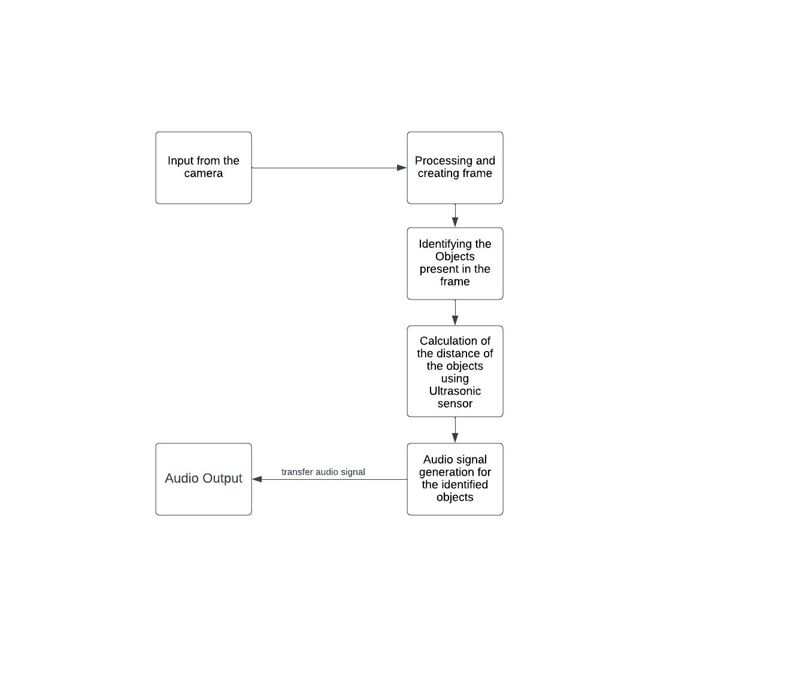

1. **LIST OF COMPONENTS**
   1. *Ultrasonic Sensor*
      * It emits the ultrasonic waves and receives them back and calculates the distance from the time taken in this process
      * Generally, the ranging accuracy is 2 to 400 cm.
      * D = ½* t * c
      * Where D = Distance between the sensor and object
      * t = time taken between emission and reception of the wave
      * c = speed of the sonic wave
      * Here, an Ultrasonic sensor is used to measure the distance between the object and the person who is wearing the glasses. (The range should be from 40 to 150 cm). If the condition is satisfied only, it will show the distance.

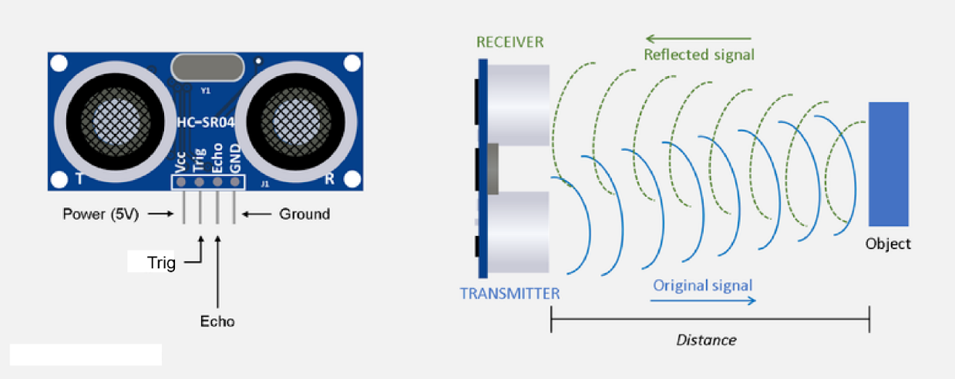

* 1. *Raspberry Pi 3 Model B and Pi cam* 
     + Raspberry pi is mainly used to build hardware projects and industrial purposes. The operating system needs to be installed to do the operations.It provides GPIO(General purpose input/output) to control the input-output operations.It is the main component of this project.

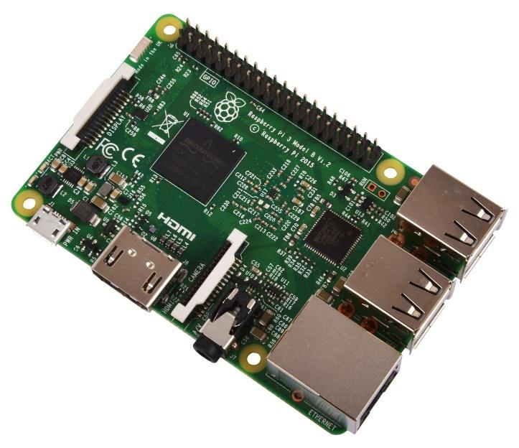

* + - Pi Cam: It is the camera from which high-definition photos and videos can be captured in raspberry pi. Pi cam module can be attached to the raspberry pi with the help of the CSI(Camera serial interface).

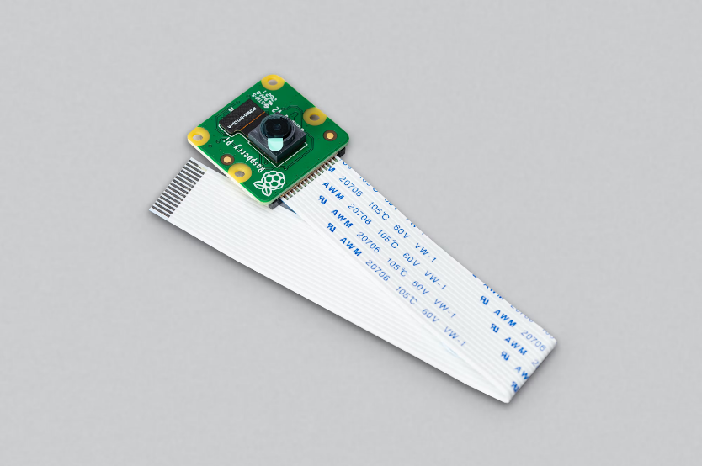

* 1. *Headphones*

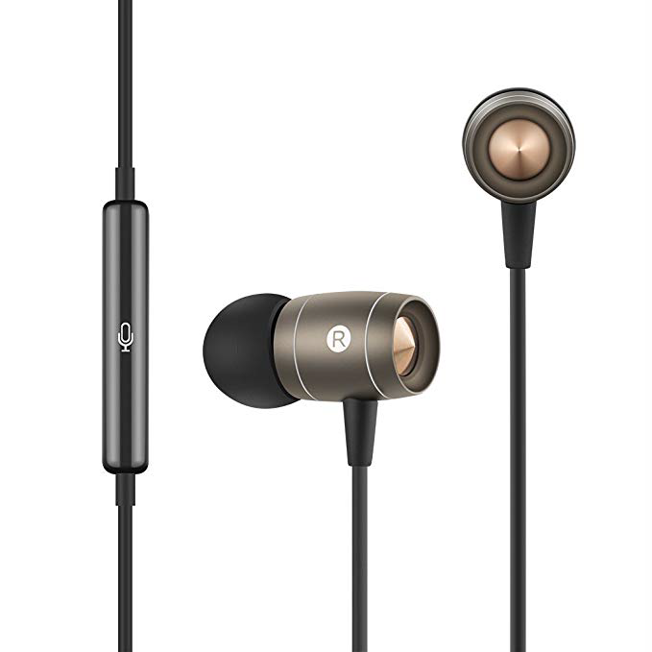

* 1. *SD Card 64GB*

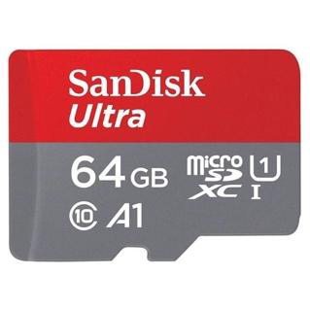

* 1. *Display (Serial Monitor)*
     + Serial monitor will display the output of the Pi cam on the monitor screen.
     + It shows the frame around the object within its range detected by ultrasonic sensor along with its confidence level (certainty of the object from 0 to 100) .
  2. *Jumper Wires*

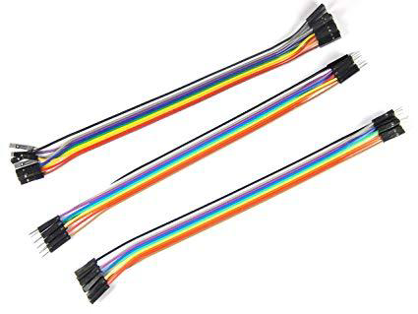

* 1. *Resistor 1k* *Ω*

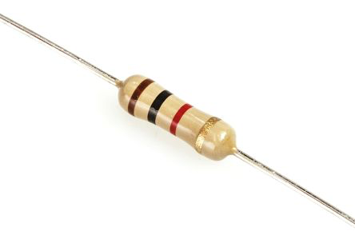

* 1. *Breadboard*

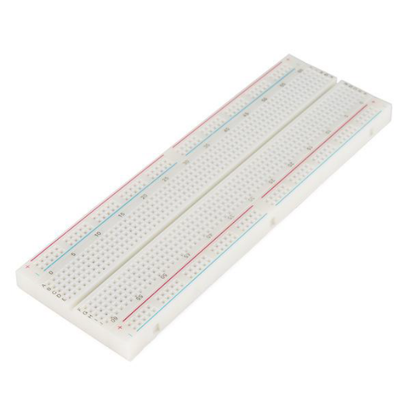

| **Component** | **Quantity** | **Cost per piece** | **Acquired from** |
| --- | --- | --- | --- |
| Raspberry pi 3 b | 1 |  | University |
| Pi camera | 1 |  | University |
| SD Cards 64GB | 1 | 750/- | Raju retails private limited. Branch- CG road |
| SD Cards 32GB | 1 | 531/- | Delta electronic parts |
| Breadboard | 1 |  | University |
| Jumper wires | - |  | University |
| Ultrasonic sensor | 1 |  | University |

1. **CIRCUIT DIAGRAM**

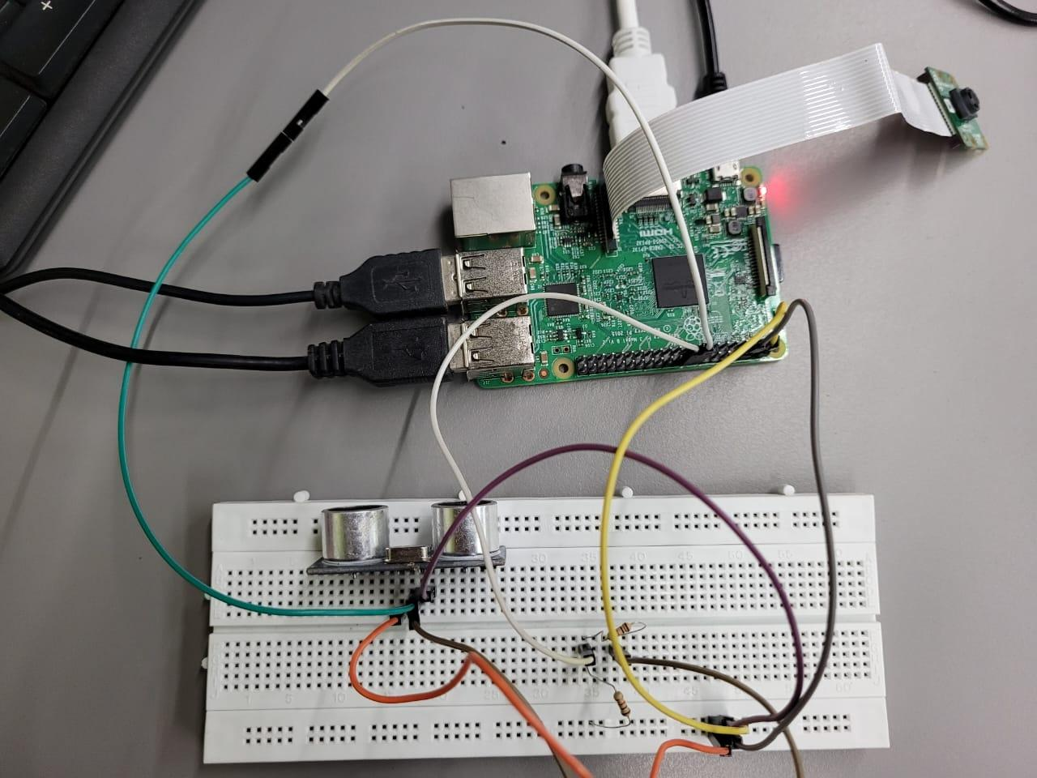

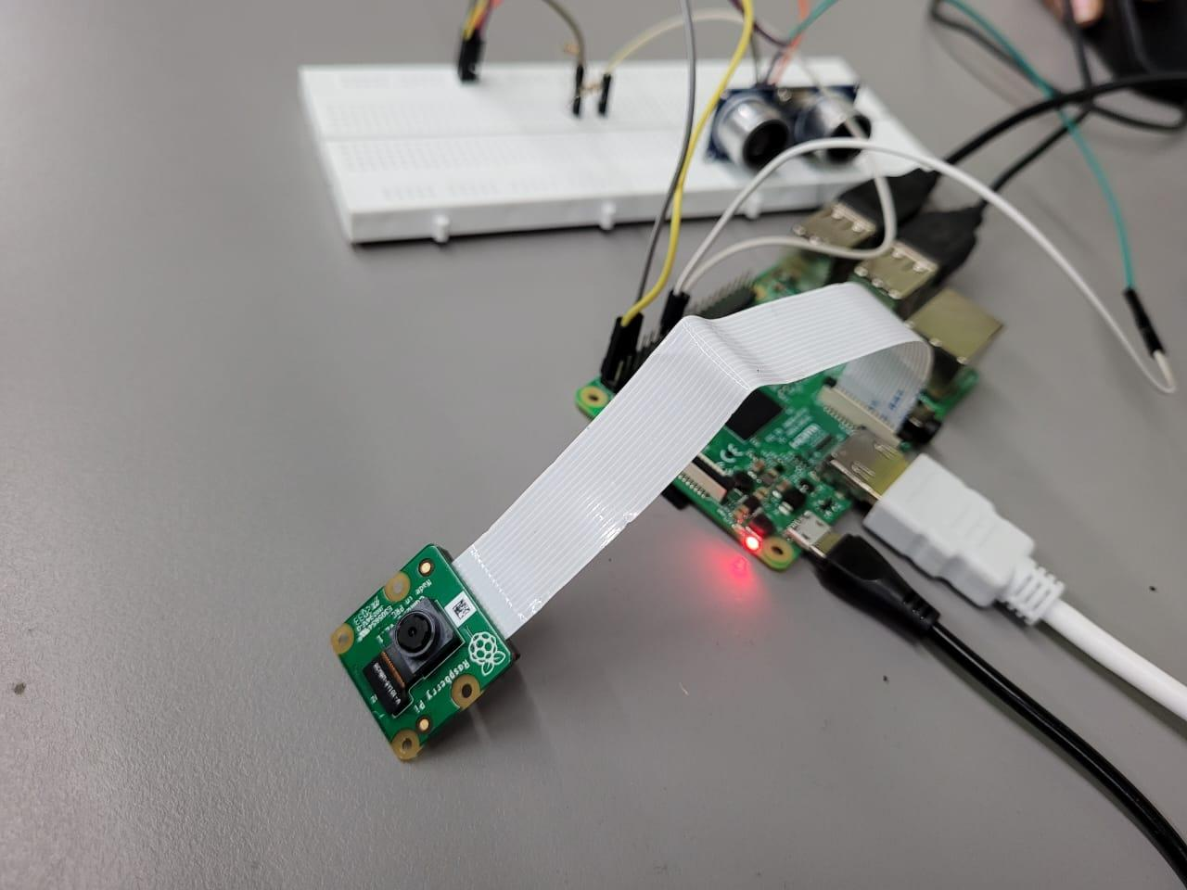

This is the circuit diagram used for the connections of the receiver and transmitter modules.

1. **THEORY**

**COMPONENTS USED**

1. Raspberry Pi 3 model B
2. Ultrasonic sensor
3. Headphones
4. Pi cam
5. SD card 64GB

**INSTALLATION NEEDED**

1. Python 3
2. Open CV: OpenCV is a large open-source library for computer vision, machine learning, and image processing, and it currently plays a significant part in real-time operation, which is critical in today's systems. It can analyze photos and videos to recognize objects, people, and even human handwriting. Python can process the OpenCV array structure for analysis when combined with other libraries such as NumPy.
3. gTTs: (to convert text to voice): "Smart Glasses" rely on image processing, which takes time to perfect. First, I must photograph text and detect the text, especially if the image or font is obscured by the image, and then convert the text to audio utilizing (gTTS). One of the limits is that all this processing takes time. Furthermore, "Smart Glasses" require some time to regulate the distance recognizes the item from 40-150 cm to be accurate.
4. Operating System: Raspbian stretch
5. **DESIGN CALCULATIONS**

| **Component** | **Quantity** | **Cost per piece** | **Acquired from** |
| --- | --- | --- | --- |
| Raspberry pi 3 b | 1 |  | University |
| Pi camera | 1 |  | University |
| SD Cards 64GB | 1 | 750/- | Raju retails private limited. Branch- CG road |
| SD Cards 32GB | 1 | 531/- | Delta electronic parts |
| Breadboard | 1 |  | University |
| Jumper wires | - |  | University |
| Ultrasonic sensor | 1 |  | University |

1. **CODES**
2. *Audio Augmented Device*

1. **PROBLEMS FACED**
   1. *Initially, we decided to attach the Raspberry Pi 3 B with our laptop using Virtual Network Computing (VNC) which was not working properly and frequently disconnecting.*

Solution:

Thereafter we performed the project with the help of a monitor connecting it via HDMI cable.

* 1. *After connecting the Raspberry Pi for accessing the internet in the Raspberry Pi we tried connecting the Pi with an ethernet cable which didn’t work.*

Solution:

We used the Wi-Fi module to access the internet via our mobile/laptop hotspot.

* 1. *The Raspberry Pi 3 is the core component that powers the device. However, the Raspberry Pi 3 gets overheated frequently due to less RAM*

Solution:We attached a cooling fan to resolve the problem which nullified the overheating issue of the Raspberry Pi 3 B. The positioning of the fan was such that it cooled the processor ideally.

* 1. *TensorFlow/TensorFlow lite for object detection*

Pi could not support it as it required 4 GB of RAM, The Raspberry Pi 3 Model B, on the other hand, only has 1 GB of RAM.

Solution: We decided to use OpenCV instead. Because of the limited RAM, another issue of lagging is currently present.

* 1. *Ultrasonic sensor was not providing us with the output*

The ultrasonic sensor was not providing us with the output which made us reiterate the code a few times.

Solution:

We changed the ultrasonic sensor twice and then we realized that the ultrasonic sensor was defective.

* 1. *Our 32GB SD card got corrupt whilst we were working on our project*

Solution:

We bought a new 64GB SD card and then reinstalled everything from the beginning.

1. **SCOPE OF IMPROVEMENTS**

It can be modified in such a way that it can detect the text in the frame along with the object and convert it into an audio file that can be heard by the person visually impaired. This can be helpful for blind people to identify the texts as well as the objects. We can upgrade the Raspberry Pi configurations to provide user’s smoother experience. We can use the external webcam to improve the precision of object detection instead of the Pi cam. We can improve the design of the devices and can modify them into smart glasses which the person can use on daily basis. Additionally, it utilizes the Google API to translate words from English to a variety of languages. We can provide text detection using OCR which will help blind people to read documents easily.

1. **LEARNING OUTCOMES**

This project gave us the necessary learning experience of using Raspberry Pi and ultrasonic sensors and combining both. Through this project, we can detect the object using pi cam and measure the distance using an ultrasonic sensor. We got to know new libraries of python. We learned to implement codes in the Raspbian Operating System. We tried to connect different devices to the module. We learned how to coordinate with different people and work together.