Software Requirements Specification
for
Game Factory for educating Illiterate people
Version 1.0 approved
Prepared by Kanv Kumar, Syam Kumar Patnala, T Bharat, Sai Teja
IIIT Sricity
25 th September 2015
Table of Contents
Table of Contents ii
Revision History ii
1. Introduction 1
1.1 Purpose 1
1.2 Document Conventions 1
1.3 Intended Audience and Reading Suggestions 1
1.4 Product Scope 1
1.5 References 1
2. Overall Description 2
2.1 Product Perspective 2
2.2 Product Functions 2
2.3 User Classes and Characteristics 2
2.4 Operating Environment 2
2.5 Design and Implementation Constraints 2
2.6 User Documentation 2
2.7 Assumptions and Dependencies 3
3. External Interface Requirements 3
3.1 User Interfaces 3
3.2 Hardware Interfaces 3
3.3 Software Interfaces 3
3.4 Communications Interfaces 3
4. System Features 4
4.1 System Feature 1 4
4.2 System Feature 2 (and so on) 4
5. Other Nonfunctional Requirement
s 4
5.1 Performance Requirements 4
5.2 Safety Requirements 5
5.3 Security Requirements 5
5.4 Software Quality Attributes 5
5.5 Business Rules 5
6. Other Requirements 5
Appendix A: Glossary 5
Appendix B: Analysis Models 5
Appendix C: To Be Determined List 6

Revision History
To be updated....
Name | Date | Reason For Changes | Version

Introduction

Purpose
To educate the illiterate people ,children less than 10 years old and also if someone is interested to learn a new language, this game application would be useful to get started with that language.

Document Conventions
Italic style : We use this for highlighting the technical points in the document.
Bold style : Heading in the document.

Intended Audience and Reading Suggestions
This game doesn't need any prerequisites to learn and play. In the further documentation we have explained in detail how to use this game application and also the complete description about the game.

Product Scope
We intend to build this app for learning purpose .
We are basically giving 4 kinds of learning games like counting, learning language words, letters, simple maths.
We intend to have more number of users for this app who can use this application after deploying it on the web.

References
Source code of existing game engine ( i.e “libgdx”) libraries and some of the already build games.
Use of “stackoverflow” website for getting some of the doubts cleared.

Overall Description

Product Perspective

This project comes under the class of games which is used by the illiterate people for learning.

Product Functions

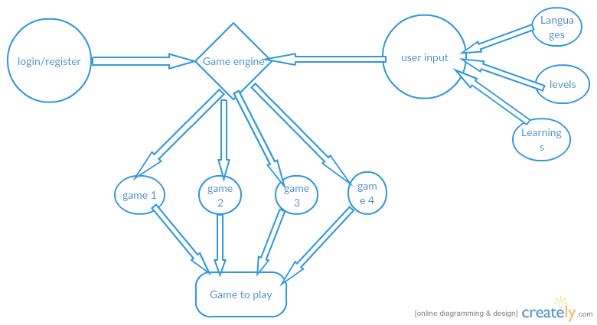

The game engine will take the user input and according to the input given, a game would be generated. Basically the game input will be language the user wants to play in, difficulty level the user wants to set like Easy, Medium, Hard, Expert and finally what type of game the user wants to learn from.

User Classes and Characteristics
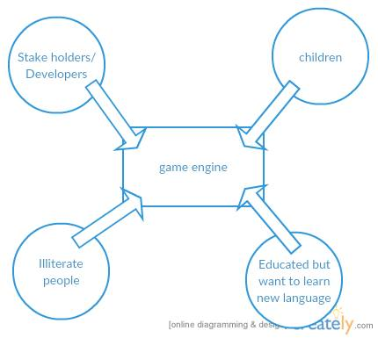

Stakeholders are the main people who build and maintain this app, users/illiterate people will be the end-users.

Operating Environment
To build this game factory software, we need game framework LIBGDX which is a Java based engine to create games. We would use this engine and manipulate the user input through this game engine to generate user-required games.

Eclipse Development environment for coding in Java and designing different modules of the game, JavaScript and XML files are also required for the user-interface.

Also a good text editor like sublime.

The game would initially be released for the PC users only.

Design and Implementation Constraints

We are using Libgdx, Java, JavaScript, MySQL ,Django, XML

User Documentation
To be updated.....

Assumptions and Dependencies

Assumption is we would be able to generate dynamic games according to user input by manipulating some modules of the game engine.

If we are not able to generate dynamic games then we have to make 3 to 4 games and provide an interface to choose among these games.

External Interface Requirements

User Interfaces
Login Page will be having User Interface for navigating to the input page for the game to be generated.

Input Page: Taking the input from the user to generate the required game.

Game page: Playing the required game. The game download link would be available here to play.

Hardware Interfaces
Controls: Number keys used for counting game.
All the letters will be used for word game.
Mouse click may also be used for shooting

Software Interfaces
This game engine is modified version of any game engine and we are using Libgdx as the game engine. We are storing the user-input in Mysql database and the OS which we are using to build
this engine are Linux/Windows.
Queries are made to the database using the controller module in the game engine to retrieve the user input.
Also java libraries would be used....(to be updated)

Communications Interfaces
The user requires an Internet connection to download the game. After that, the game can be played off-line.

System Features
The main system features of this game are:-

Select the type of game

4.1.1 Description and Priority
Priority is high. Taking the input from the user for the type of game he wants to play like counting game, language word game, basic math game, language letter game.

4.1.2 Stimulus/Response Sequences
After Logging into the game, the user will first select the type of game, they want to play. For selecting the game type, there will be screen-shots of 4 different types of games and the user just needs to click the required game screen-shot.

4.1.3 Functional Requirements

REQ-1: Counting game:

Counting the number of given colors/objects and matching that count with the options given in a particular language.

REQ-2: Language word game

Identify the given object and then choose the matching option in that particular language.

REQ-3: Basic math game

Some numbers will be displayed for 3-5 seconds and then some numbers would be swapped. After swapping, the user has to remember the new number and choose that number(after swapping) from the options.

Language Input for the game
4.2.1 Description and priority:
Priority is high since language is important while playing the game so that user can learn the new language.

4.2.2 Stimulus/Response:
Taking the language input from the drop down list and then selecting the required language in which the game will be played.

4.2.3 Functional Requirements:

REQ-1: Hindi

REQ-2: English

REQ-3: Tamil

REQ-4: Telugu

Other Nonfunctional Requirements

Performance Requirements

The user interface has to be easy and understandable. The game application would be very light weighted so that it doesn't require more space and more system resources while executing that game.

Security and Safety Requirements

User Password shouldn't be weak while registering for this game factory application.
User Password should be changed frequently after every 3 months.
Database should be well structured so that there is no problem when a different user/player plays.

Software Quality Attributes
The code which will be building is scalable in terms of code modifications, code enhancements.
Also the code build can be extended for further use in different modules in the project.
Testing the software for bugs and fixing them. Also adapting Agile Methodology like Scrum, we can build better software faster.
Use of this software would be extremely easy as it is targeted for illiterate audience.
Moreover, the final product would be robust in terms of quality and performance.

Business Rules
<List any operating principles about the product, such as which individuals or roles can perform which functions under specific circumstances. These are not functional requirements in themselves, but they may imply certain functional requirements to enforce the rules.>

If the game is having some glitches, then the user can contact the developers for their assistance and thus bugs might be solved.

Feedback from the users will be appreciated.

Other Requirements
The database which we create should be structured so that the query time should be less.
The database should be normalized before running the queries.
Appendix A: Glossary
To be updated....

Appendix B: Analysis Models
To be updated....
Appendix C: To Be Determined List
To be updated....

