Software Requirements Specification
for
3D Stealth game using Unity
Version 1.0
Prepared by Kanv Kumar
IIIT Sricity
25th September, 2015
Table of Contents
Table of Contents ii
Revision History ii
1. Introduction 1
1.1 Purpose 1
1.2 Document Conventions 1
1.3 Intended Audience and Reading Suggestions 1
1.4 Product Scope 1
1.5 References 1
2. Overall Description 2
2.1 Product Perspective 2
2.2 Product Functions 2
2.3 User Classes and Characteristics 2
2.4 Operating Environment 2
2.5 Design and Implementation Constraints 2
2.6 User Documentation 2
2.7 Assumptions and Dependencies 3
3. External Interface Requirements 3
3.1 User Interfaces 3
3.2 Hardware Interfaces 3
3.3 Software Interfaces 3
3.4 Communications Interfaces 3
4. System Features 4
4.1 System Feature 1 4
4.2 System Feature 2 (and so on) 4
5. Other Nonfunctional Requirements 4
5.1 Performance Requirements 4
5.2 Safety Requirements 5
5.3 Security Requirements 5
5.4 Software Quality Attributes 5
5.5 Business Rules 5
6. Other Requirements 5
Appendix A: Glossary 5
Appendix B: Analysis Models 5
Appendix C: To Be Determined List 6

Revision History
Name | Date | Reason For Changes | Version

Introduction

Purpose
The purpose of this software is to build and play a 3D stealth game in which there would be enemies surrounding the main player. The game is meant for having fun and covers different kinds of features like shooting enemies, picking weapons, hiding from enemies using objects and finally reaching the exit point of that level.

Document Conventions
The conventions used in this document are:

Bold font style for sections.
Italic for normal text/description

Intended Audience and Reading Suggestions
This document is primarily meant for the developers, end users and investors of this project (if required).

For users, it would be helpful to read the “product description section” and then go for reading the key features implemented in the “Functional Requirements section”.

For Developers, it is suggested to go through the “System Features section”.

Product Scope
The game is built using a 3D game engine which is “Unity”. The game uses different modules present in the engine like rendering module to render graphics, character module for developing characters and “Physics” engine ( inbuilt in “Unity” ) to optimize FPS (Frames per Second).

The enemy is built using some of the AI features of “Unity”.

The game environment has been looked into and different textures have been designed to make the game more real.

Also, “Unity” is used by many other leading Game Companies including “EA” (Electronic Arts), “Activision” and “Ubisoft”.

Also, “Unity” game engine is scalable and very efficient to program games.

References
IEEE.
IEEE Std 830-1998 IEEE Recommended Practice for Software Requirements Specifications.
IEEE Computer Society, 1998.
Unity website.

Overall Description

Product Perspective
Basically, the game has two types of characters in it: one is the main player and the other is enemies. All enemies are identical to each other but have a unique id.

Controls of the game have been defined in the following way:

Player can press space-bar to jump, forward movement by forward arrow, backward movement
with
backward arrow, Left movement with Left arrow, Right movement with Right arrow, Left
Mouse click
for shooting enemies, Crouch with 'c', 'Esc' for pausing game and going to
pause menu.

If player sees enemy , player would either shoot the enemy or hide from the enemy using wall cover or some other object.

The game ends when the player is killed.

Product Functions
In the game, the player has health, can move left, right, forward, backward, jump, crouch.
Also, the payer can interact with the environment using “Walk item” option and can drop item, pick item, use item.

Also, there is an Inventory option in the pause menu available for changing the weapons, upgrading the weapons.

The player can shoot the enemy using guns.

User Classes and Characteristics
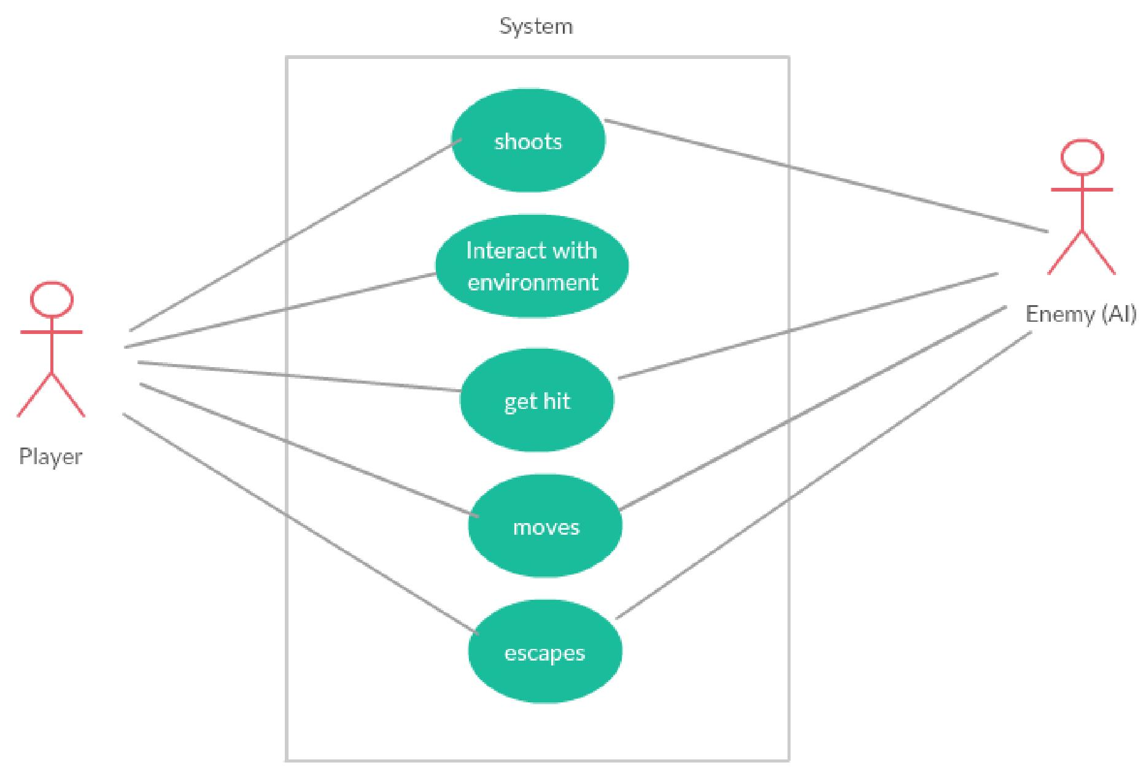

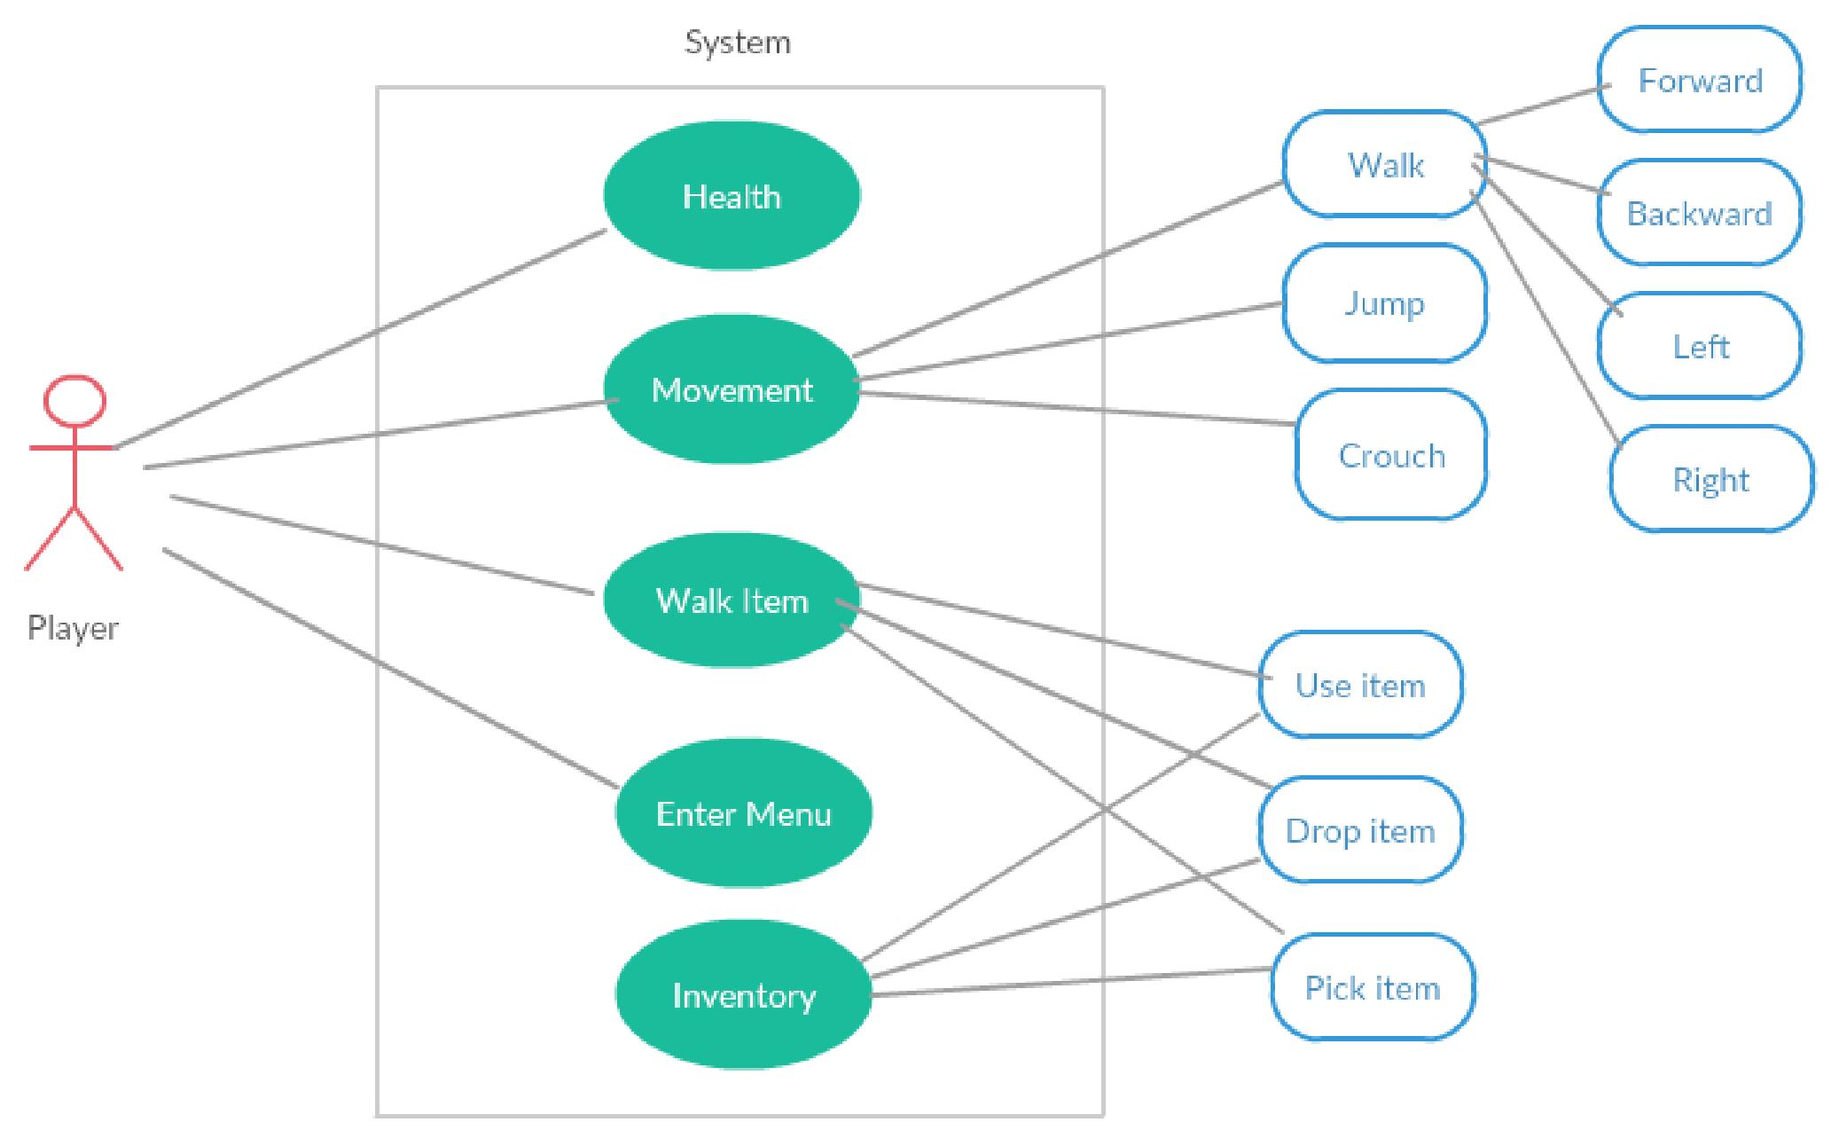

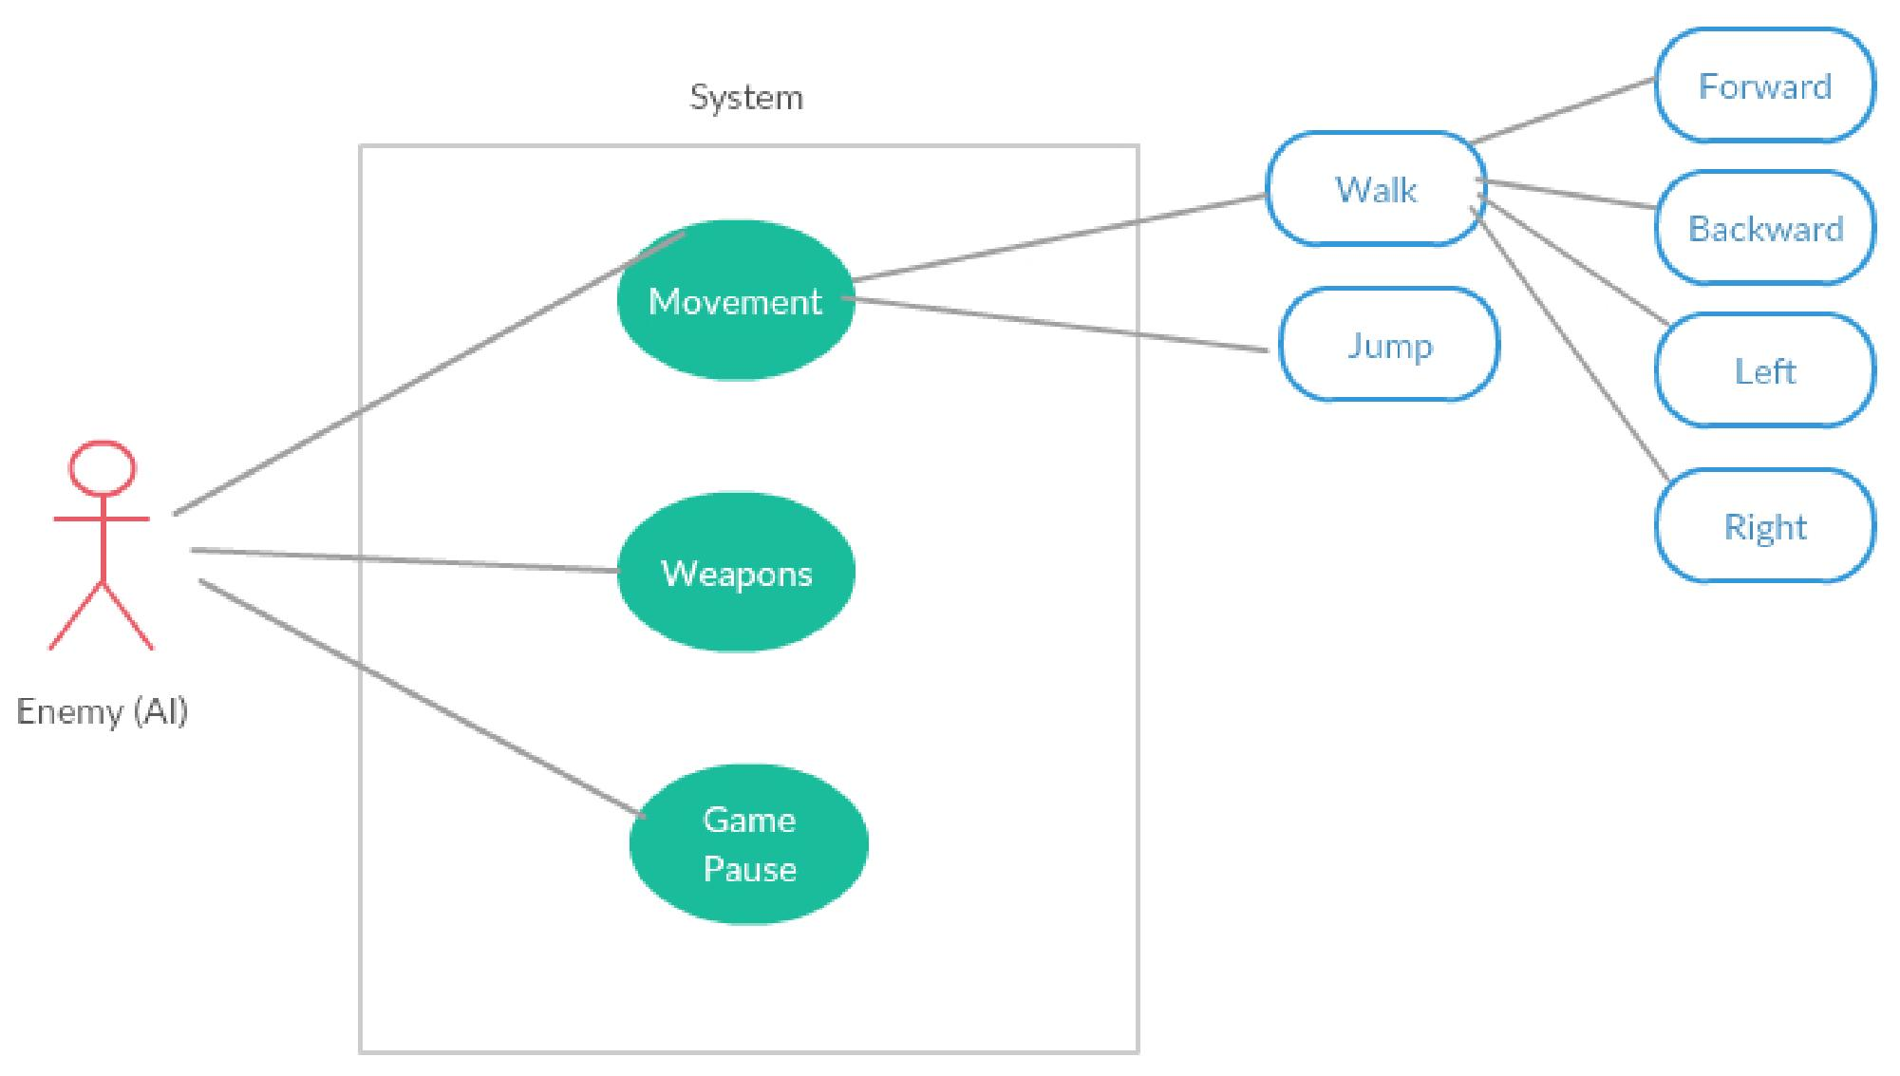

Operating Environment
To build this software, we need game framework UNITY which is used to develop 3D games. We would use this engine to design the game characters, game enemies, rendering graphics, and then testing the game for bugs.

Eclipse Development environment for coding in C++/ JS /BOO.

Also a good text editor like sublime.

The game would initially be released for the PC users only.

Design and Implementation Constraints
We are using Unity game engine with Language JS, C++, BOO (or anyone of these languages) to program the game.

Assumptions and Dependencies
Assumption is, it will be easier to code in BOO (Programming Language), but the language might change if BOO is found difficult to understand.

Also assuming Game Logic is easier to implement but could become complicated, if more features added afterwards.

External Interface Requirements

User Interfaces
The game environment is smooth in terms of playing and is tested in all conditions for potential bugs. The FPS ( Frames per second) in the game varies with respect to hardware specifications of the graphic card used, the RAM of the PC system and the clock rate of the processor.
User Interface is needed for shooting the enemies and giving more realistic game-play feeling.

Hardware Interfaces
This game software uses 3D graphic rendering and would require a dedicated graphics card to experience the best performance of the game.
Also, the game requires a Keyboard and a mouse to play.

Software Interfaces
The game source files is having different modules in it by which the game works and renders 3D graphics to the system. There is no network connection required in this game to play for now and the beta version of this game doesn't support multi-player option.

The input from the user is read and given to the game engine for processing and the output is then passed and displayed to the user on screen.

Also use of Multi-threading forms an important part of developing this game and making it more robust in terms of performance.

Communications Interfaces
The user requires an Internet connection to download the game. After that, the game can be played off-line.

System Features
Using the flow of Use cases, the Main System Features are:

Main Player Characteristics
4.1.1 Description and Priority
Priority is High since the main player is the key component of this game system.
4.1.2 Stimulus/Response Sequences
The Player will be able to shoot, walk, move, take cover behind objects.
The Less the health, the more are the chances for the game to be over.
4.1.3 Functional Requirements
REQ-1: Health
Will display the health meter of the player and when health is critical, then
screen becomes red.

REQ-2: Movement
Can be forward, backward, left, right. Also, the player can jump, can crouch.

REQ-3: Walk item
The player can use this option to use item, drop item, pick item.

REQ-4: Enter Menu
Player can enter the menu while in game by pressing “Esc” key and then game pauses and pause menu appears.

REQ-5: Inventory
Using Inventory, Player can use items, drop item, change weapons in the inventory. Inventory contains all the items equipped by the player.

Enemy Characteristics:
4.2.1 Description and Priority:
Priority of Enemy is high since enemy is as important as the main player in the game. Without enemy, there is no point in playing the game and thus no fun!!

4.2.2 Stimulus/Response Sequences:
The enemy will be able to move, shoot, run and jump. The lesser the health of the enemies, the easier for the main player to kill them.

4.1.3 Functional Requirements:

REQ-1: Health:
Has less health than main player.

REQ-2: Movement:
Can be forward, backward, left, right. Also, the enemy can jump.

REQ-3: Weapons:
Can have different types of weapons.

REQ-4: Game Pause:
When the game is paused all the enemy movements are paused till the user
returns back to the game area.

Other Nonfunctional Requirements

Performance Requirements
The user interface has to be easy and understandable. The game application would be very light weighted so that it doesn't require more space and more system resources while executing that game.

Safety and Security Requirements
Playing this game for more hours can damage eyes of the user. It is thus suggested that the user takes continuous breaks after playing for 2-3 hours continuously.

Also, the copyrights of the game software is reserved by the developers and can't be used directly without asking the developers.

Software Quality Attributes
The code which will be building is scalable in terms of code modifications, code enhancements.
Also the code build can be extended for further use in different modules in the project.
Testing the software for bugs and fixing them. Also we have adapted Agile Methodology like Scrum, so that we can build better software faster.
Moreover, the final product would be robust in terms of quality and performance.

Business Rules
If the game is having some glitches, then the user can contact the developers for their assistance and thus bugs might be resolved.

Feedback from the users will be appreciated.

Other Requirements
<Define any other requirements not covered elsewhere in the SRS. This might include database requirements, internationalization requirements, legal requirements, reuse objectives for the project, and so on. Add any new sections that are pertinent to the project.>
Appendix A: Glossary
To be Updated.....
Appendix B: Analysis Models
To be Updated....
Appendix C: To Be Determined List
To be Updated....

