

BAHRIA UNIVERSITY KARACHI CAMPUS
Department of Software Engineering

COURSE: SEN-211
Software Requirements Engineering
PROJECT Report
CLASS: BSE – 3B (Fall - 2025)

ARGOS-Your Watchful Assistant In Requirement Gathering

Submitted By:
Kanwal Bibi (02-131242-065)
Submitted to:
Course Instructor: Engr. Nabiha Faisal

Date: 30-11-25

Abstract
For any software system to be successful, requirements engineering is essential. However, ambiguity, formatting problems, inconsistent stakeholder input, and a lack of automated documentation are common problems with traditional online methods of gathering requirements. The entire requirement gathering process, from elicitation to documentation, is automated by ARGOS, a web-based intelligent assistant. It allows stakeholders to submit requirements via an online form, organizes them in a SQL Server database, retrieves the most recent submission, creates structured PDF and uses PlantUML to create UML diagrams.
The design, architecture, components, and results of the ARGOS system are presented in this report.
1. Introduction
1.1 Background
Poor requirement engineering techniques—ambiguous inputs, missing documentation, poor stakeholder communication, and ineffective modeling—are the primary cause of software project failure. It is now crucial to create tools that precisely gather, organize, and record requirements automatically due to the increasing demand for online systems.
1.2 Problem Statement
Online requirement forms usually lack structure, do not offer automated modeling features, cut long lines in PDF exports, and do not maintain formatting. As a result, requirement artifacts become inconsistent and incomplete.
1.3 Objective
By capturing stakeholder requirements online and storing structured data in a SQL Server database, ARGOS seeks to offer a unified RE solution. Argos formats and retrieves requirements automatically creates PDF documentation from the most recent submission; and uses PlantUML to automatically create UML class diagrams.
1.4 Scope
The system has been created especially for the "Online Donation System" domain, however, the architecture is adaptable to any kind of business.

2. System Design
2.1 System Architecture
ARGOS has a three-layer architecture made up of:
- Frontend (HTML Form): Interface for stakeholder input
- Backend (python): backend processing, PDF module, UML generator
- Database (SQL Server): Keeping track of every submission
2.2 Data Flow of ARGOS
1. The requirement form is opened by the user.
2. Completes every field
3. Information is entered and kept in a SQL database.
4. ARGOS retrieves the most recent submission when you select "View Requirements."
5. The structured outcome appears on the screen.
6. The user can select "Download PDF."
7. The class diagram is produced by the PlantUML module.
Use Case Diagram:
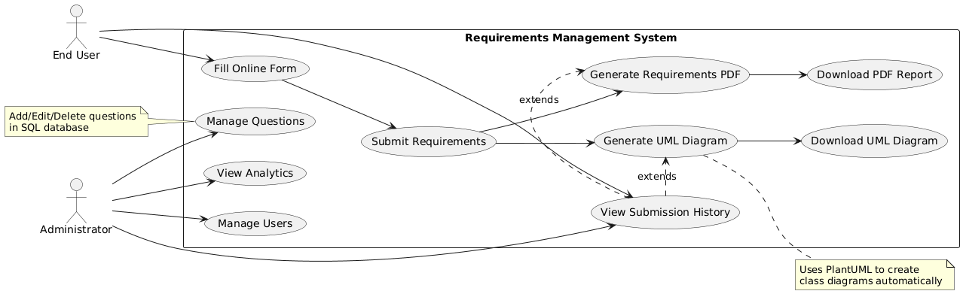
2.3 Requirements Form (Frontend Module)
Multiple text fields, multi-line requirements, proper wrapping, validation, a smooth layout, and submit and back buttons are all supported by the collection form.
User-friendly elicitation is guaranteed by the frontend.
2.4 Backend Processing Module
This module retrieves only the most recent submission and stores all form values in SQL Server. It organizes requirements into sections that are easy to read, then sends structured relationships to the PlantUML module; passes cleaned text to the PDF generator (resolving the line-cutting issue).
Sequence Diagram:
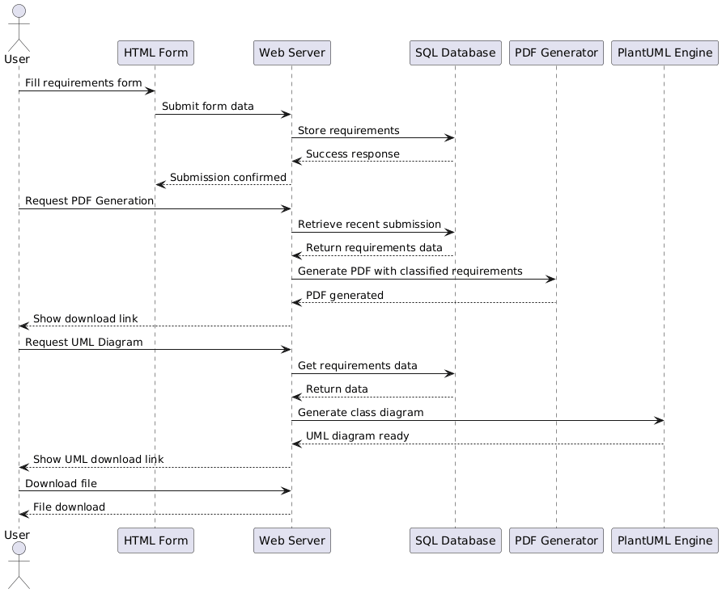

2.5 Database Design (SQL Server)
The requirements table, auto-increment primary key, submission Id (for the most recent submission logic), and columns for every requirement category make up the database.

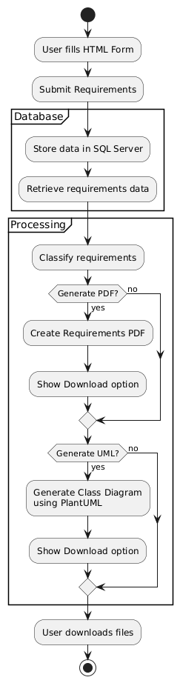
Activity Diagram:

2.6 PDF Generation Module
This module does the following:
- retrieves the most recent record
- formats text into multi-line paragraphs
- ensures that no text is cut during PDF rendering
- resolves wrapping issues for lengthy requirement statements
- exports a clean, organized, and professional PDF
2.7 PlantUML Class Diagram Generator
Database content is transformed by ARGOS into entities, relationships, and attributes. Then uses PlantUML syntax to dynamically create a class diagram and produces an image that can be downloaded.
Class Diagram:
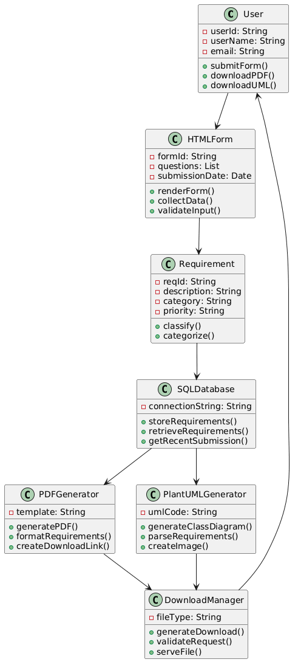
3. Results
3.1 Successful Requirement Gathering
- Every requirement was accurately recorded.
- Proper formatting
- Long statements preserved
- No text truncation
3.2 Latest Submission Feature
The assignment requirement is met since only the most recent user input is used to generate PDFs and diagrams.
3.3 Working PDF Export
• Well-organized headings
• No missing text
• Expert formatting
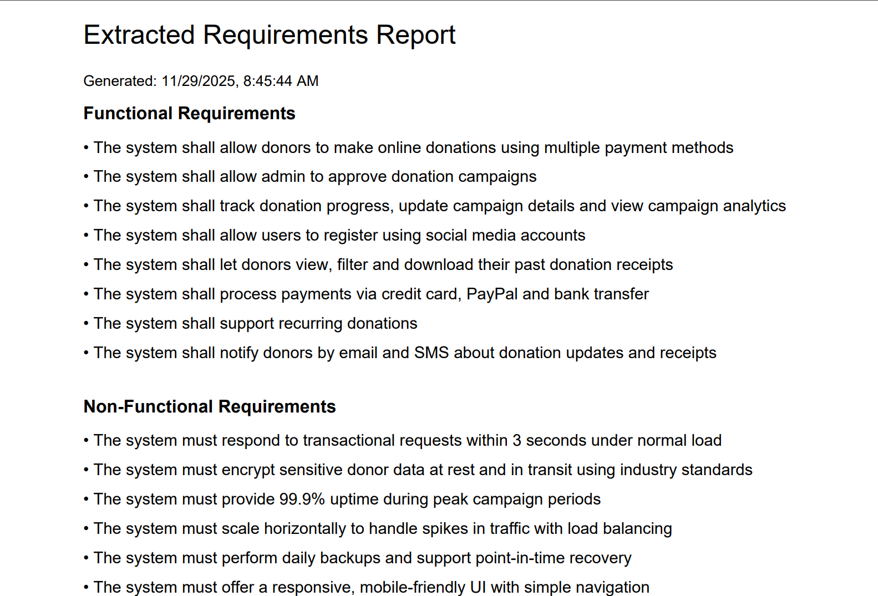
3.4 Auto-Generated UML Diagram
• Formatted correctly
• Accurate class relationships
• Downloadable automatically
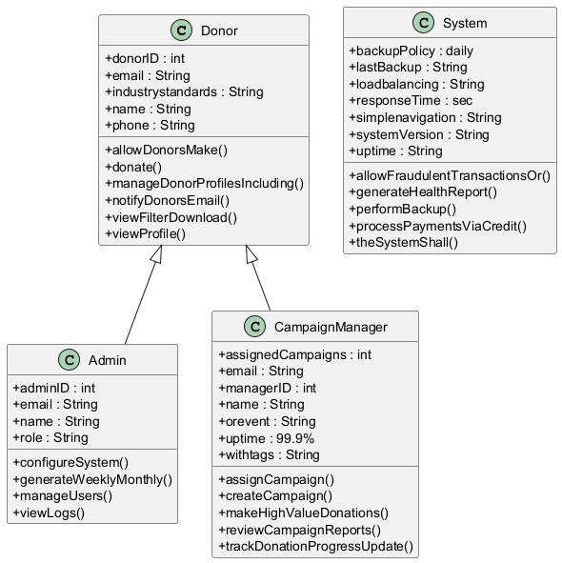
4. Output Screen:
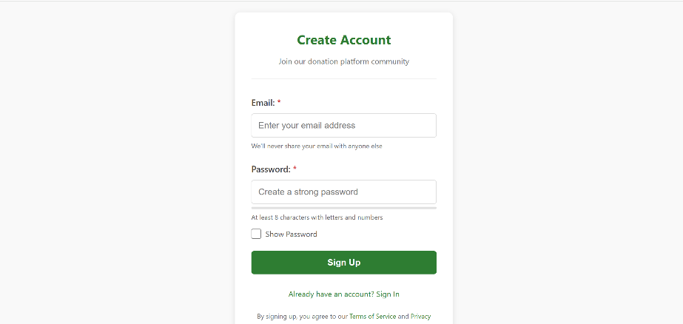

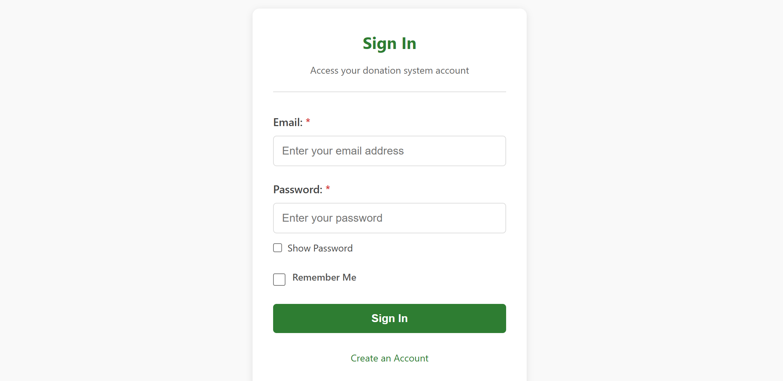

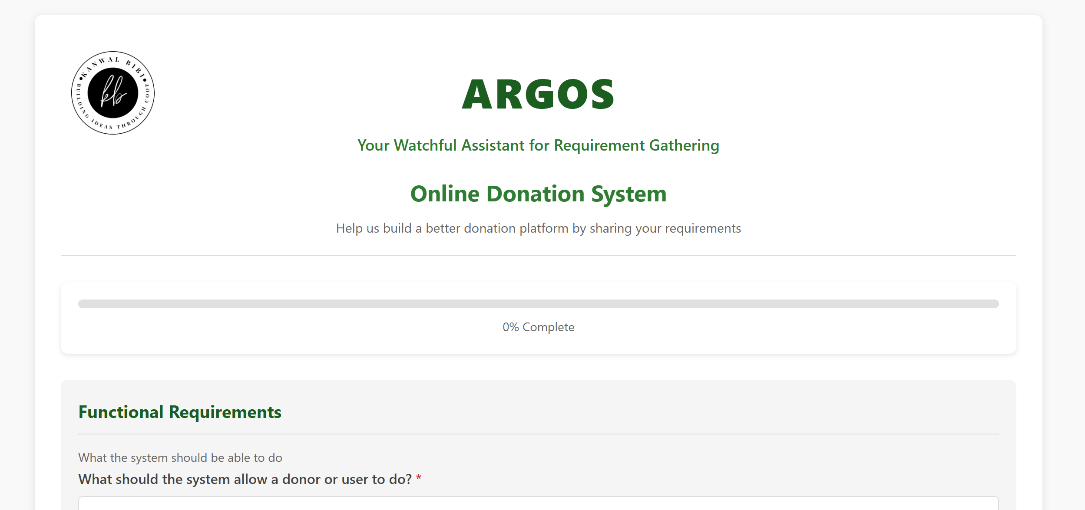

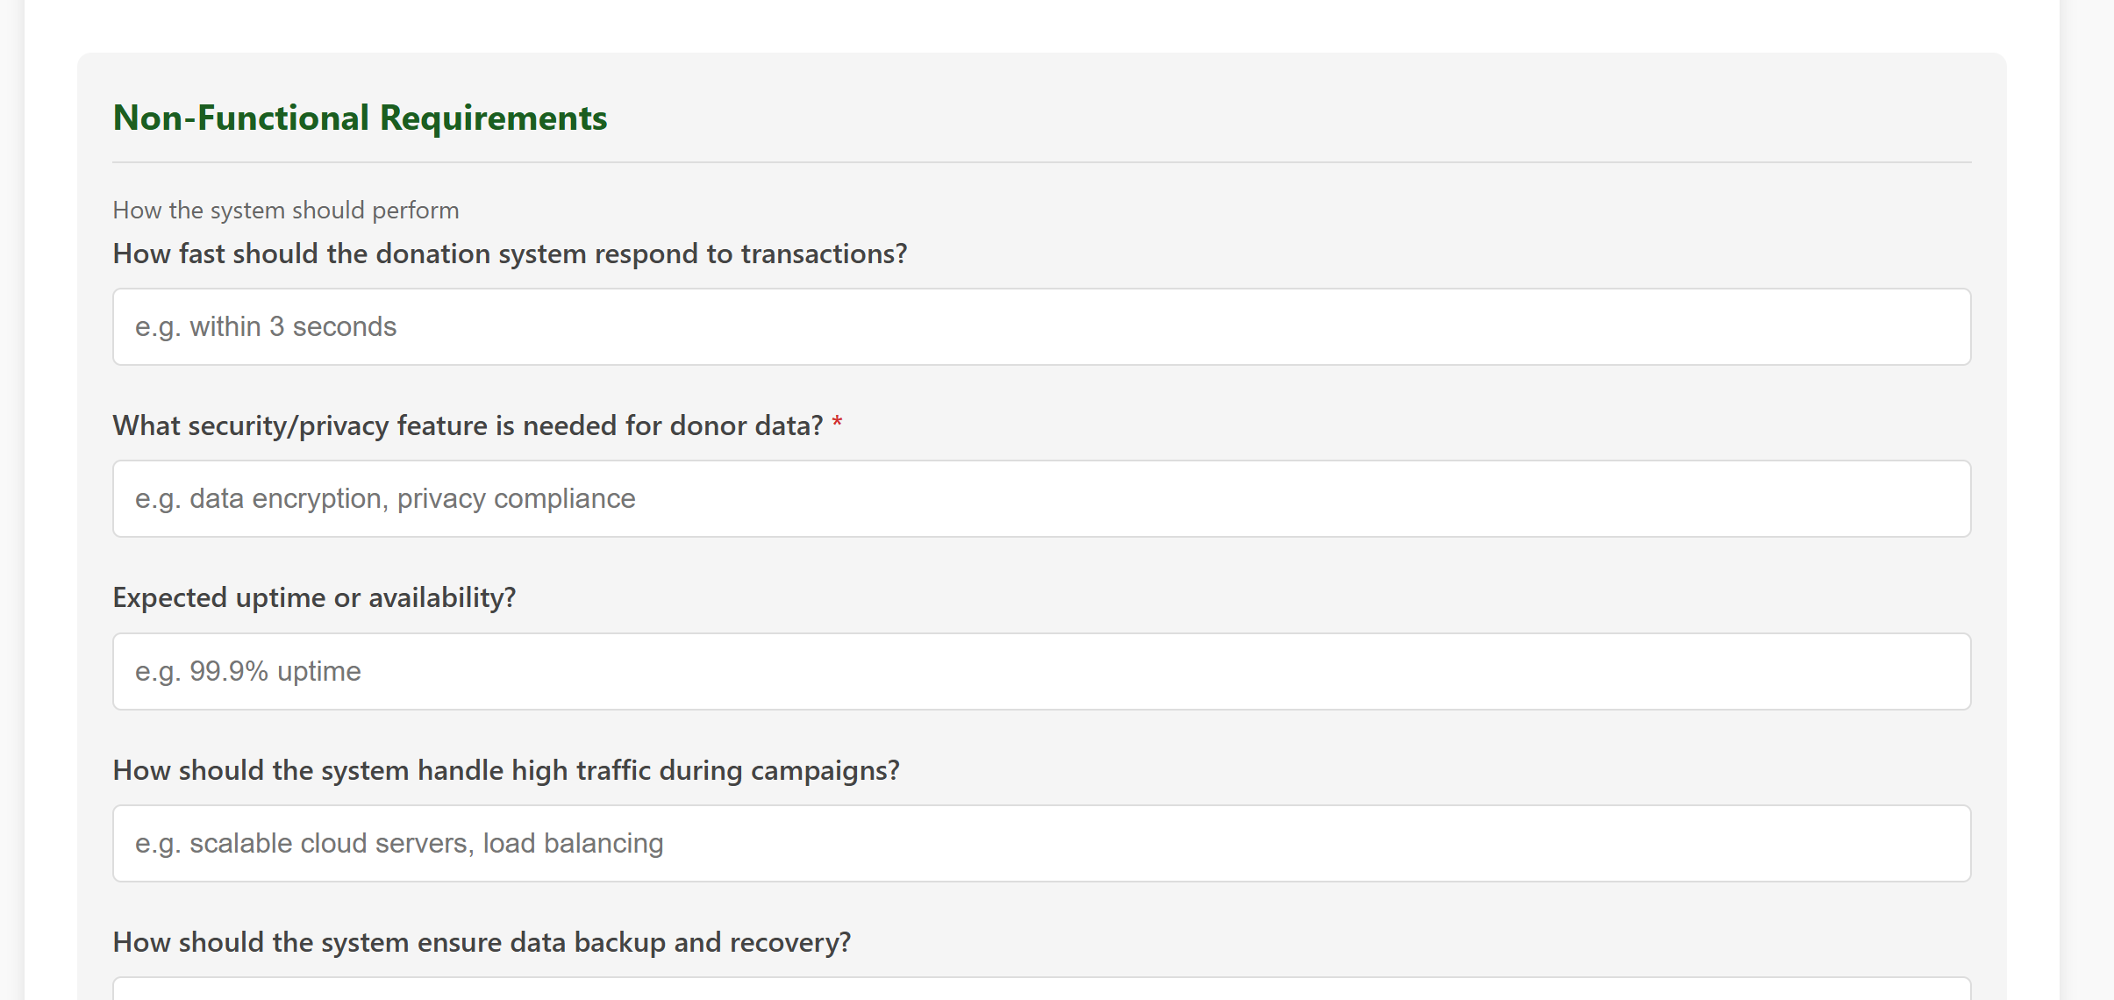

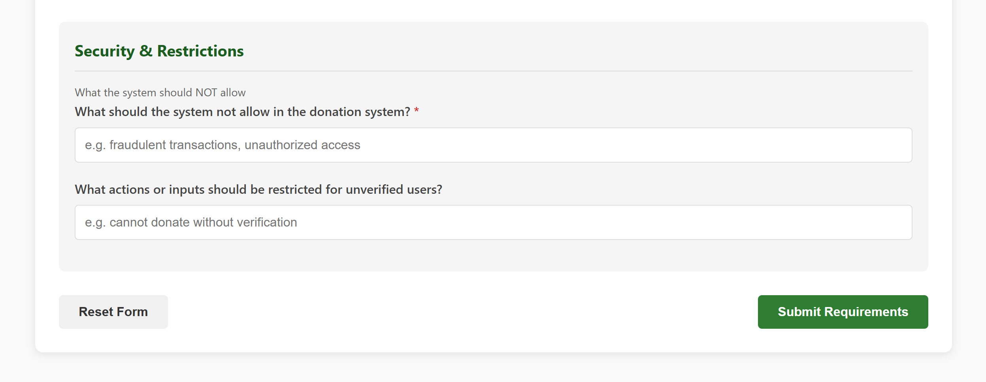

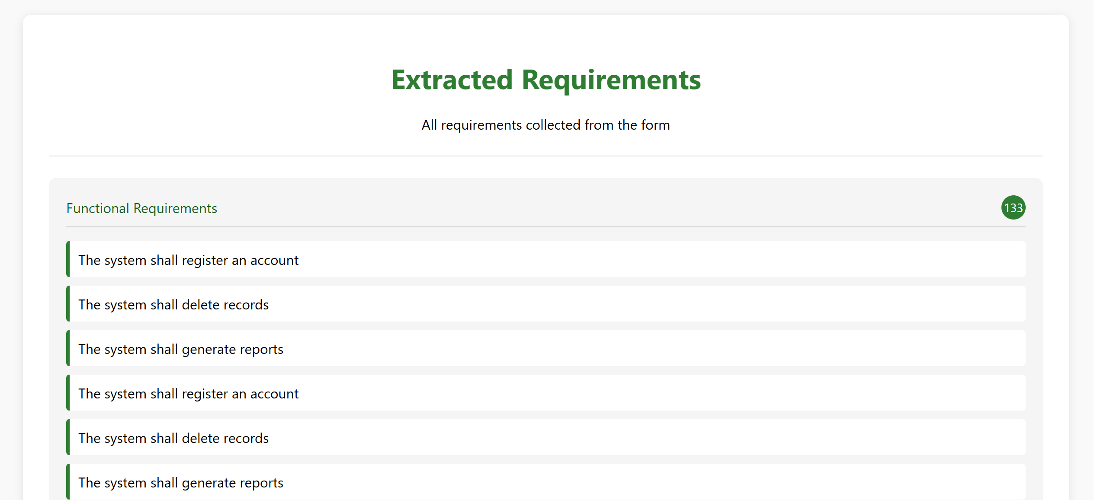
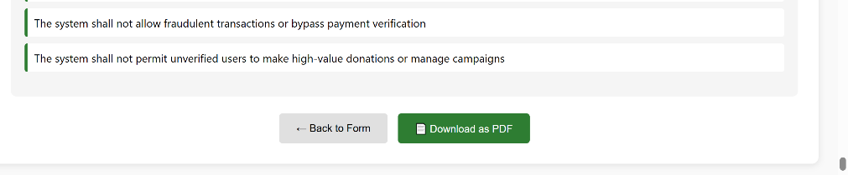

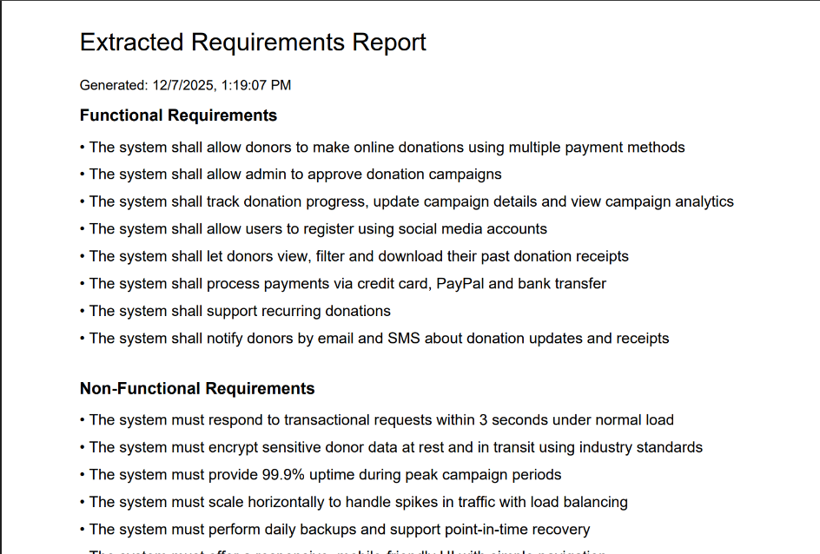

5. Appendix
form.html:
<!DOCTYPE html>
<html lang="en">
<head>
<meta charset="UTF-8">
<meta name="viewport" content="width=device-width, initial-scale=1.0">
<title>Online Donation System - Requirement Collection Form</title>
<style>
:root {
--primary-color: #2e7d32;
--primary-light: #4caf50;
--primary-dark: #1b5e20;
--secondary-color: #f5f5f5;
--text-color: #333;
--border-color: #ddd;
--error-color: #d32f2f;
--success-color: #388e3c;
}

* {
box-sizing: border-box;
margin: 0;
padding: 0;
}

body {
font-family: 'Segoe UI', Tahoma, Geneva, Verdana, sans-serif;
line-height: 1.6;
color: var(--text-color);
background-color: #f9f9f9;
padding: 20px;
max-width: 1200px;
margin: 0 auto;
}

.container {
background-color: white;
border-radius: 10px;
box-shadow: 0 2px 10px rgba(0, 0, 0, 0.1);
padding: 30px;
margin-bottom: 30px;
}

header {
text-align: center;
margin-bottom: 30px;
padding-bottom: 20px;
border-bottom: 1px solid var(--border-color);
}
header img {
height: 120px;
margin-bottom: -100px;
display: flex;
align-items: flex-start;
}
h1 {
color: var(--primary-color);
margin-bottom: 10px;
font-size: 28px;
}

.subtitle {
color: #666;
font-size: 16px;
}

.form-section {
margin-bottom: 30px;
padding: 20px;
background-color: var(--secondary-color);
border-radius: 8px;
}

.section-title {
color: var(--primary-dark);
margin-bottom: 15px;
padding-bottom: 10px;
border-bottom: 1px solid var(--border-color);
font-size: 20px;
}

.form-group {
margin-bottom: 20px;
}

label {
display: block;
margin-bottom: 8px;
font-weight: 600;
color: #444;
}

.input-hint {
display: block;
font-size: 14px;
color: #666;
margin-top: 5px;
}

input[type="text"], select {
width: 100%;
padding: 12px;
border: 1px solid var(--border-color);
border-radius: 5px;
font-size: 16px;
transition: border-color 0.3s, box-shadow 0.3s;
}

input[type="text"]:focus, select:focus {
outline: none;
border-color: var(--primary-color);
box-shadow: 0 0 0 2px rgba(46, 125, 50, 0.2);
}

.progress-container {
margin-bottom: 30px;
background-color: white;
padding: 20px;
border-radius: 8px;
box-shadow: 0 2px 5px rgba(0, 0, 0, 0.1);
}

.progress-bar {
height: 10px;
background-color: #e0e0e0;
border-radius: 5px;
overflow: hidden;
margin-bottom: 10px;
}

.progress-fill {
height: 100%;
background-color: var(--primary-color);
width: 0%;
transition: width 0.5s ease;
}

.progress-text {
text-align: center;
font-size: 14px;
color: #666;
}

.button-group {
display: flex;
justify-content: space-between;
margin-top: 30px;
}

button {
padding: 12px 25px;
border: none;
border-radius: 5px;
font-size: 16px;
font-weight: 600;
cursor: pointer;
transition: background-color 0.3s, transform 0.2s;
}

button:focus {
outline: none;
box-shadow: 0 0 0 2px rgba(46, 125, 50, 0.5);
}

button:hover {
transform: translateY(-2px);
}

.btn-primary {
background-color: var(--primary-color);
color: white;
}

.btn-primary:hover {
background-color: var(--primary-dark);
}

.btn-secondary {
background-color: #f0f0f0;
color: var(--text-color);
}

.btn-secondary:hover {
background-color: #e0e0e0;
}

.form-navigation {
display: flex;
justify-content: space-between;
margin-top: 30px;
}

.required::after {
content: " *";
color: var(--error-color);
}

.error-message {
color: var(--error-color);
font-size: 14px;
margin-top: 5px;
display: none;
}

.success-message {
background-color: #e8f5e9;
color: var(--success-color);
padding: 15px;
border-radius: 5px;
margin-bottom: 20px;
display: none;
}

@media (max-width: 768px) {
body {
padding: 10px;
}

.container {
padding: 15px;
}

.form-section {
padding: 15px;
}

.button-group {
flex-direction: column;
gap: 10px;
}

button {
width: 100%;
}
}
</style>
</head>
<body>
<div class="container">
<header>
<div class="row" style="align-items: center;">
<div class="col-4">
<img src="https://i.ibb.co/hJ5PXZp5/Light-removebg-preview.png" alt="Logo">
</div>
<div class="col-8" style="text-align: center;">
<!-- ARGOS Top pe -->
<h1 style="font-size: 48px; font-weight: 900; color: #1b5e20; margin: 0 0 8px 0; letter-spacing: 2px;">
ARGOS
</h1>
<p style="font-size: 18px; color: #2e7d32; margin: 0 0 20px 0; font-weight: 600;">
Your Watchful Assistant for Requirement Gathering
</p>

<!-- Original title neeche chhota aur elegant -->
<h2 style="font-size: 26px; color: var(--primary-color); margin: 0;">
Online Donation System
</h2>
<p class="subtitle" style="font-size: 15px; margin-top: 8px;">
Help us build a better donation platform by sharing your requirements
</p>
</div>
</div>
</header>

<div class="progress-container">
<div class="progress-bar">
<div class="progress-fill" id="progressFill"></div>
</div>
<div class="progress-text" id="progressText">0% Complete</div>
</div>

<div class="success-message" id="successMessage">
Thank you! Your requirements have been submitted successfully.
</div>

<form action="/submit" method="post" id="donationForm">
<!-- Functional Requirements Section -->
<div class="form-section">
<h2 class="section-title">Functional Requirements</h2>
<p class="input-hint">What the system should be able to do</p>

<div class="form-group">
<label for="functional_1" class="required">What should the system allow a donor or user to
do?</label>
<input type="text" id="functional_1" name="functional_1"
placeholder="e.g. make online donations, track donation history">
<div class="error-message" id="error_functional_1">This field is required</div>
</div>

<div class="form-group">
<label class="required">Should the admin approve campaigns?</label>
<select id="functional_2" name="functional_2">
<option value="">Select</option>
<option value="yes">Yes</option>
<option value="no">No</option>
</select>
<div class="error-message" id="error_functional_2">This field is required</div>
</div>

<div class="form-group">
<label for="functional_3" class="required">What feature should a campaign manager have?</label>
<input type="text" id="functional_3" name="functional_3"
placeholder="e.g. track donation progress, update campaign details">
<div class="error-message" id="error_functional_3">This field is required</div>
</div>

<div class="form-group">
<label>How should users register?</label>
<input type="radio" id="functional_4_1" name="functional_4" value="email"> <label
for="functional_4_1">Email</label>
<input type="radio" id="functional_4_2" name="functional_4" value="social"> <label
for="functional_4_2">Social Media</label>
</div>

<div class="form-group">
<label for="functional_5">How can donors track their donation history?</label>
<input type="text" id="functional_5" name="functional_5"
placeholder="e.g. view past donations, download receipts">
</div>

<div class="form-group">
<label for="functional_6" class="required">What payment methods should the system support?</label>
<input type="text" id="functional_6" name="functional_6"
placeholder="e.g. credit card, PayPal, bank transfer">
<div class="error-message" id="error_functional_6">This field is required</div>
</div>

<div class="form-group">
<label>Should recurring donations be allowed?</label>
<select id="functional_7" name="functional_7">
<option value="">Select</option>
<option value="yes">Yes</option>
<option value="no">No</option>
</select>
</div>

<div class="form-group">
<label for="functional_8">How should the system notify donors about updates?</label>
<input type="text" id="functional_8" name="functional_8"
placeholder="e.g. email or SMS notifications, in-app alerts">
</div>
</div>

<!-- Non-Functional Requirements Section -->
<div class="form-section">
<h2 class="section-title">Non-Functional Requirements</h2>
<p class="input-hint">How the system should perform</p>

<div class="form-group">
<label for="nonfunc_1">How fast should the donation system respond to transactions?</label>
<input type="text" id="nonfunc_1" name="nonfunc_1" placeholder="e.g. within 3 seconds">
</div>

<div class="form-group">
<label for="nonfunc_2" class="required">What security/privacy feature is needed for donor
data?</label>
<input type="text" id="nonfunc_2" name="nonfunc_2"
placeholder="e.g. data encryption, privacy compliance">
<div class="error-message" id="error_nonfunc_2">This field is required</div>
</div>

<div class="form-group">
<label for="nonfunc_3">Expected uptime or availability?</label>
<input type="text" id="nonfunc_3" name="nonfunc_3" placeholder="e.g. 99.9% uptime">
</div>

<div class="form-group">
<label for="nonfunc_4">How should the system handle high traffic during campaigns?</label>
<input type="text" id="nonfunc_4" name="nonfunc_4"
placeholder="e.g. scalable cloud servers, load balancing">
</div>

<div class="form-group">
<label for="nonfunc_5">How should the system ensure data backup and recovery?</label>
<input type="text" id="nonfunc_5" name="nonfunc_5"
placeholder="e.g. daily backups, disaster recovery plan">
</div>

<div class="form-group">
<label for="nonfunc_6">Usability standards?</label>
<input type="text" id="nonfunc_6" name="nonfunc_6"
placeholder="e.g. responsive design, simple navigation">
</div>
</div>

<!-- Domain-Specific Requirements Section -->
<div class="form-section">
<h2 class="section-title">Domain-Specific Requirements</h2>
<p class="input-hint">Features specific to donation systems</p>

<div class="form-group">
<label for="domain_1" class="required">Which domain feature is important in the donation
system?</label>
<input type="text" id="domain_1" name="domain_1" placeholder="e.g. donation campaign management">
<div class="error-message" id="error_domain_1">This field is required</div>
</div>

<div class="form-group">
<label for="domain_2">How should the system categorize donations by campaign or cause?</label>
<input type="text" id="domain_2" name="domain_2" placeholder="e.g. by charity, event, or project">
</div>

<div class="form-group">
<label for="domain_3">How should the system generate donation reports for NGOs or admins?</label>
<input type="text" id="domain_3" name="domain_3"
placeholder="e.g. weekly, monthly, or custom reports">
</div>

<div class="form-group">
<label for="domain_4">How should the system manage donor profiles and preferences?</label>
<input type="text" id="domain_4" name="domain_4"
placeholder="e.g. personal info, donation frequency, alerts">
</div>
</div>

<!-- Inverse / Negative Requirements Section -->
<div class="form-section">
<h2 class="section-title">Security & Restrictions</h2>
<p class="input-hint">What the system should NOT allow</p>

<div class="form-group">
<label for="inverse_1" class="required">What should the system not allow in the donation
system?</label>
<input type="text" id="inverse_1" name="inverse_1"
placeholder="e.g. fraudulent transactions, unauthorized access">
<div class="error-message" id="error_inverse_1">This field is required</div>
</div>

<div class="form-group">
<label for="inverse_2">What actions or inputs should be restricted for unverified users?</label>
<input type="text" id="inverse_2" name="inverse_2"
placeholder="e.g. cannot donate without verification">
</div>
</div>

<div class="button-group">
<button type="button" class="btn-secondary" id="resetBtn">Reset Form</button>
<button type="submit" class="btn-primary">Submit Requirements</button>
</div>
</form>
</div>

<script>
document.addEventListener('DOMContentLoaded', function() {
const form = document.getElementById('donationForm');
const progressFill = document.getElementById('progressFill');
const progressText = document.getElementById('progressText');
const successMessage = document.getElementById('successMessage');
const resetBtn = document.getElementById('resetBtn');

// Required fields
const requiredFields = [
'functional_1', 'functional_2', 'functional_3', 'functional_6',
'nonfunc_2', 'domain_1', 'inverse_1'
];

// Update progress bar
function updateProgress() {
let filledCount = 0;
requiredFields.forEach(fieldId => {
const field = document.getElementById(fieldId);
if (field && field.value.trim() !== '') {
filledCount++;
}
});

const progress = (filledCount / requiredFields.length) * 100;
progressFill.style.width = `${progress}%`;
progressText.textContent = `${Math.round(progress)}% Complete`;
}

// Validate form on submit
form.addEventListener('submit', function() {
updateProgress();
let isValid = true;

// Clear previous errors
document.querySelectorAll('.error-message').forEach(el => {
el.style.display = 'none';
});

// Check required fields
requiredFields.forEach(fieldId => {
const field = document.getElementById(fieldId);
const errorElement = document.getElementById(`error_${fieldId}`);

if (!field.value.trim()) {
isValid = false;
errorElement.style.display = 'block';
field.style.borderColor = 'var(--error-color)';
} else {
field.style.borderColor = '';
}
});

if (isValid) {
// Show success message
successMessage.style.display = 'block';

// In a real application, you would submit the form here
// form.submit();

// For demo purposes, we'll just reset after a delay
setTimeout(() => {
successMessage.style.display = 'none';
form.reset();
updateProgress();
}, 3000);
}
});

// Reset form
resetBtn.addEventListener('click', function() {
if (confirm('Are you sure you want to reset the form? All entered data will be lost.')) {
form.reset();
updateProgress();

// Clear errors
document.querySelectorAll('.error-message').forEach(el => {
el.style.display = 'none';
});

// Reset field borders
document.querySelectorAll('input').forEach(input => {
input.style.borderColor = '';
});
}
});

// Update progress as user types
form.addEventListener('input', function() {
updateProgress();
});

// Initialize progress
updateProgress();
});
</script>
</body>
</html>

Templaterequirements.html:
<!DOCTYPE html>
<html lang="en">
<head>
<meta charset="UTF-8">
<meta name="viewport" content="width=device-width, initial-scale=1.0">
<title>Extracted Requirements</title>
<style>
/* (your same CSS copy as before) */
:root {
--primary-color: #2e7d32;
--primary-light: #4caf50;
--primary-dark: #1b5e20;
--secondary-color: #f5f5f5;
--text-color: #333;
--border-color: #ddd;
}
body { font-family: 'Segoe UI', sans-serif; background-color: #f9f9f9; padding: 20px; }
.container { background: white; padding: 30px; border-radius: 10px; box-shadow: 0 2px 10px rgba(0,0,0,0.1); max-width: 1200px; margin: auto; }
header { text-align: center; border-bottom: 1px solid var(--border-color); padding-bottom: 10px; margin-bottom: 25px; }
h1 { color: var(--primary-color); }
.section { background: var(--secondary-color); padding: 20px; border-radius: 8px; margin-bottom: 25px; }
ul { list-style-type: none; padding: 0; }
li { background: white; margin-bottom: 10px; padding: 10px; border-left: 4px solid var(--primary-color); border-radius: 4px; }
.section-title { color: var(--primary-dark); display: flex; justify-content: space-between; align-items: center; border-bottom: 1px solid #ccc; padding-bottom: 8px; margin-bottom: 15px; }
.section-count { background: var(--primary-color); color: white; border-radius: 50%; width: 28px; height: 28px; display: flex; align-items: center; justify-content: center; font-size: 14px; }
.button-group { display: flex; justify-content: center; gap: 15px; margin-top: 25px; }
button { padding: 12px 25px; border: none; border-radius: 5px; cursor: pointer; font-size: 15px; }
.btn-primary { background-color: var(--primary-color); color: white; }
.btn-primary:hover { background-color: var(--primary-dark); }
.btn-secondary { background-color: #e0e0e0; }
</style>
</head>
<body>
<div class="container">
<header>
<h1>Extracted Requirements</h1>
<p class="subtitle">All requirements collected from the form</p>
</header>

<!-- Functional -->
<div class="section">
<div class="section-title">
<span>Functional Requirements</span>
<span class="section-count">{{ categorized["Functional"]|length }}</span>
</div>
<ul id="functional-list">
{% for req in categorized["Functional"] %}
<li>{{ req }}</li>
{% else %}
<li>No functional requirements found.</li>
{% endfor %}
</ul>
</div>

<!-- Non-Functional -->
<div class="section">
<div class="section-title">
<span>Non-Functional Requirements</span>
<span class="section-count">{{ categorized["Non-Functional"]|length }}</span>
</div>
<ul id="nonfunctional-list">
{% for req in categorized["Non-Functional"] %}
<li>{{ req }}</li>
{% else %}
<li>No non-functional requirements found.</li>
{% endfor %}
</ul>
</div>

<!-- Domain -->
<div class="section">
<div class="section-title">
<span>Domain-Specific Requirements</span>
<span class="section-count">{{ categorized["Domain"]|length }}</span>
</div>
<ul id="domain-list">
{% for req in categorized["Domain"] %}
<li>{{ req }}</li>
{% else %}
<li>No domain-specific requirements found.</li>
{% endfor %}
</ul>
</div>

<!-- Inverse -->
<div class="section">
<div class="section-title">
<span>Inverse (Negative) Requirements</span>
<span class="section-count">{{ categorized["Inverse"]|length }}</span>
</div>
<ul id="inverse-list">
{% for req in categorized["Inverse"] %}
<li>{{ req }}</li>
{% else %}
<li>No inverse requirements found.</li>
{% endfor %}
</ul>
</div>

<!-- Buttons -->
<div class="button-group">
<button class="btn-secondary" onclick="window.location.href='/form'">← Back to Form</button>
<button class="btn-primary" id="downloadBtn">📄 Download as PDF</button>
</div>
</div>

<!-- jsPDF for PDF export -->
<!-- (keep the rest of your original HTML exactly the same) -->
<script src="https://cdnjs.cloudflare.com/ajax/libs/jspdf/2.5.1/jspdf.umd.min.js"></script>
<script>
document.getElementById('downloadBtn').addEventListener('click', function() {
const { jsPDF } = window.jspdf;
const doc = new jsPDF({
unit: 'mm',
format: 'a4'
});

const margin = 20;
const pageWidth = doc.internal.pageSize.getWidth();
const pageHeight = doc.internal.pageSize.getHeight();
const maxTextWidth = pageWidth - margin * 2;
const titleFontSize = 18;
const sectionFontSize = 12;
const bodyFontSize = 11;
const lineHeight = 6; // mm; adjust if you change font size

let y = margin;

// Header
doc.setFontSize(titleFontSize);
doc.text('Extracted Requirements Report', margin, y);
y += 10;

doc.setFontSize(12);
const now = new Date();
doc.setFontSize(10);
doc.text(`Generated: ${now.toLocaleString()}`, margin, y);
y += 8;

// Utility to add a section with wrapped text and bullets
function addSection(title, elementId) {
// Check page space for section title
if (y + 12 > pageHeight - margin) {
doc.addPage();
y = margin;
}

// Section title
doc.setFontSize(sectionFontSize);
doc.setFont(undefined, 'bold');
doc.text(title, margin, y);
doc.setFont(undefined, 'normal');
y += 8;

// Get items
const items = document.getElementById(elementId).children;
for (let i = 0; i < items.length; i++) {
let text = items[i].textContent.trim();
if (!text) continue;

// Prepare wrapped lines for the item
// We'll reserve a small space for bullet; text begins slightly indented
const bulletPrefix = '• ';
const bulletWidthApprox = 4; // mm approximate reserved for bullet + gap
const wrapped = doc.splitTextToSize(text, maxTextWidth - bulletWidthApprox);

// If not enough room on current page for the whole wrapped block, add page
const requiredHeight = wrapped.length * lineHeight + 2;
if (y + requiredHeight > pageHeight - margin) {
doc.addPage();
y = margin;
}

// Draw first line with bullet
doc.setFontSize(bodyFontSize);
doc.text(bulletPrefix + wrapped[0], margin, y);
y += lineHeight;

// Draw remaining wrapped lines with small indent (so they align under text, not under bullet)
const indent = 4; // mm
for (let w = 1; w < wrapped.length; w++) {
// Page break check for each subsequent line
if (y + lineHeight > pageHeight - margin) {
doc.addPage();
y = margin;
}
doc.text(wrapped[w], margin + indent, y);
y += lineHeight;
}

// small gap after each item
y += 1;
}

// extra gap after section
y += 6;
}

const sections = [
{ title: "Functional Requirements", id: "functional-list" },
{ title: "Non-Functional Requirements", id: "nonfunctional-list" },
{ title: "Domain-Specific Requirements", id: "domain-list" },
{ title: "Inverse Requirements", id: "inverse-list" }
];

// Add sections
for (const s of sections) {
addSection(s.title, s.id);
}

// Footer (page numbers)
const pageCount = doc.internal.getNumberOfPages();
for (let i = 1; i <= pageCount; i++) {
doc.setPage(i);
doc.setFontSize(9);
const footerText = `Page ${i} of ${pageCount}`;
doc.text(footerText, pageWidth - margin, pageHeight - 10, { align: 'right' });
}

doc.save('Extracted_Requirements.pdf');
});
</script>

</body>
</html>

Signin.html:
<!DOCTYPE html>
<html lang="en">
<head>
<meta charset="UTF-8">
<meta name="viewport" content="width=device-width, initial-scale=1.0">
<title>Sign In</title>
<style>
:root {
--primary-color: #2e7d32;
--primary-light: #4caf50;
--primary-dark: #1b5e20;
--secondary-color: #f5f5f5;
--text-color: #333;
--border-color: #ddd;
--error-color: #d32f2f;
--success-color: #388e3c;
}

* {
box-sizing: border-box;
margin: 0;
padding: 0;
}

body {
font-family: 'Segoe UI', Tahoma, Geneva, Verdana, sans-serif;
line-height: 1.6;
color: var(--text-color);
background-color: #f9f9f9;
padding: 20px;
min-height: 100vh;
display: flex;
justify-content: center;
align-items: center;
}

.container {
background-color: white;
border-radius: 10px;
box-shadow: 0 2px 10px rgba(0, 0, 0, 0.1);
padding: 30px;
width: 100%;
max-width: 400px;
}

header {
text-align: center;
margin-bottom: 30px;
padding-bottom: 20px;
border-bottom: 1px solid var(--border-color);
}

h2 {
color: var(--primary-color);
margin-bottom: 10px;
font-size: 24px;
}

.subtitle {
color: #666;
font-size: 14px;
}

.form-group {
margin-bottom: 20px;
}

label {
display: block;
margin-bottom: 8px;
font-weight: 600;
color: #444;
}

.input-hint {
display: block;
font-size: 14px;
color: #666;
margin-top: 5px;
}

input[type="text"],
input[type="password"],
input[type="email"] {
width: 100%;
padding: 12px;
border: 1px solid var(--border-color);
border-radius: 5px;
font-size: 16px;
transition: border-color 0.3s, box-shadow 0.3s;
}

input[type="text"]:focus,
input[type="password"]:focus,
input[type="email"]:focus {
outline: none;
border-color: var(--primary-color);
box-shadow: 0 0 0 2px rgba(46, 125, 50, 0.2);
}

.checkbox-group {
display: flex;
align-items: center;
margin-bottom: 20px;
}

input[type="checkbox"] {
margin-right: 10px;
width: 18px;
height: 18px;
cursor: pointer;
}

.checkbox-label {
font-size: 14px;
color: #555;
cursor: pointer;
}

.show-password {
display: flex;
align-items: center;
margin-top: 10px;
}

.show-password input[type="checkbox"] {
width: auto;
margin-right: 8px;
}

.show-password label {
font-size: 14px;
font-weight: normal;
margin-bottom: 0;
cursor: pointer;
}

button {
width: 100%;
padding: 12px;
background-color: var(--primary-color);
color: white;
border: none;
border-radius: 5px;
font-size: 16px;
font-weight: 600;
cursor: pointer;
transition: background-color 0.3s, transform 0.2s;
}

button:focus {
outline: none;
box-shadow: 0 0 0 2px rgba(46, 125, 50, 0.5);
}

button:hover {
background-color: var(--primary-dark);
transform: translateY(-2px);
}

.links {
margin-top: 25px;
text-align: center;
}

.links a {
display: block;
color: var(--primary-color);
text-decoration: none;
margin-bottom: 10px;
font-size: 14px;
transition: color 0.3s;
}

.links a:hover {
color: var(--primary-dark);
text-decoration: underline;
}

.required::after {
content: " *";
color: var(--error-color);
}

.error-message {
color: var(--error-color);
font-size: 14px;
margin-top: 5px;
display: none;
}

.success-message {
background-color: #e8f5e9;
color: var(--success-color);
padding: 15px;
border-radius: 5px;
margin-bottom: 20px;
display: none;
}

@media (max-width: 480px) {
body {
padding: 10px;
}

.container {
padding: 20px;
}

h2 {
font-size: 22px;
}
}
</style>

<script>
function togglePassword() {
let pass = document.getElementById("password");
if (pass.type === "password") {
pass.type = "text";
} else {
pass.type = "password";
}
}
</script>
</head>
<body>

<div class="container">
<header>
<h2>Sign In</h2>
<p class="subtitle">Access your donation system account</p>
</header>

<form action="{{ url_for('login') }}" method="POST">
<div class="form-group">
<label for="email" class="required">Email:</label>
<input type="email" id="email" name="email" required placeholder="Enter your email address">
<div class="error-message" id="error_email">Please enter a valid email address</div>
</div>

<div class="form-group">
<label for="password" class="required">Password:</label>
<input type="password" id="password" name="password" required placeholder="Enter your password">

<div class="show-password">
<input type="checkbox" id="showPassword" onclick="togglePassword()">
<label for="showPassword">Show Password</label>
</div>
<div class="error-message" id="error_password">Password is required</div>
</div>

<div class="checkbox-group">
<input type="checkbox" id="remember" name="remember">
<label for="remember" class="checkbox-label">Remember Me</label>
</div>

<button type="submit">Sign In</button>
</form>

<div class="links">
<!-- <a href="/forgot">Forgot Password?</a> -->
<a href="/signup">Create an Account</a>
</div>
</div>

</body>
</html>

app.py:
from flask import Flask, render_template, request, redirect, url_for, session, flash
import db

app = Flask(__name__)
app.secret_key = "any_strong_secret_key_here_123"

# ==================== LOGIN / SIGNUP ====================

@app.route("/", methods=["GET", "POST"])
def index():
if "user" in session:
return redirect("/form")

# Agar POST request hai (matlab form submit kiya) toh login logic chalao
if request.method == "POST":
return login() # wohi login function jo neeche hai

# Agar GET request hai toh sirf signin page dikhao
return render_template("signin.html") # tumhara original signin.html

@app.route("/signup")
def signup():
return render_template("signup.html") # tumhara original signup.html
@app.route("/logout_first_then_signin")
def logout_first_then_signin():
session.pop("user", None) # pehle logout kar do
return redirect("/") # phir signin page pe bhejo

@app.route("/register", methods=["POST"])
def register():
email = request.form["email"].strip().lower()
password = request.form["password"]

if not email or not password:
flash("Email and password required!", "error")
return redirect("/signup")

conn = db.get_connection()
cursor = conn.cursor()

# Check if already exists
cursor.execute("SELECT Email FROM Users WHERE Email = ?", (email,))
if cursor.fetchone():
conn.close()
flash("Email already registered!", "error")
return redirect("/signup")

# Create new user
cursor.execute("INSERT INTO Users (Email, Password) VALUES (?, ?)", (email, password))
conn.commit()
conn.close()

flash("Account created successfully! Now login.", "success")
return redirect("/")

@app.route("/login", methods=["POST"])
def login():
email = request.form["email"].strip().lower()
password = request.form["password"]

conn = db.get_connection()
cursor = conn.cursor()
cursor.execute("SELECT Email FROM Users WHERE Email = ? AND Password = ?", (email, password))
user = cursor.fetchone()
conn.close()

if user:
session["user"] = email
return redirect("/form")
else:
flash("Invalid email or password!", "error")
return redirect("/")

@app.route("/logout")
def logout():
session.pop("user", None)
flash("Logged out successfully", "success")
return redirect("/")

# ==================== PROTECTED PAGES ====================

@app.route("/form", methods=["GET"])
def form():
if "user" not in session:
flash("Please login first!", "error")
return redirect("/")
return render_template("form.html") # tumhara original form

@app.route("/submit", methods=["POST"])
def submit():
if "user" not in session:
return redirect("/")

# ←←← Tumhara pura original submit code yahan exactly same rahega →→→
responses = request.form.to_dict()
conn = db.get_connection()
cursor = conn.cursor()

cursor.execute("SELECT ISNULL(MAX(SubmissionID), 0) + 1 FROM dbo.Requirements")
new_id = cursor.fetchone()[0]

functional_mapping = {
"functional_2": {"yes": "allow admin to approve donation campaigns", "no": "not allow admin to approve donation campaigns"},
"functional_4": {"email": "allow users to register using email", "social": "allow users to register using social media accounts"},
"functional_7": {"yes": "support recurring donations", "no": "not support recurring donations"}
}

for key, value in responses.items():
value = value.strip()
if not value:
continue

if key in functional_mapping and value in functional_mapping[key]:
sentence = f"The system shall {functional_mapping[key][value]}"
req_type = "Functional"
elif key.startswith("functional"):
req_type = "Functional"
sentence = f"The system shall {value}"
elif key.startswith("nonfunc"):
req_type = "Non-Functional"
sentence = f"The system must {value}"
elif key.startswith("domain"):
req_type = "Domain"
sentence = f"The system shall support {value}"
elif key.startswith("inverse"):
req_type = "Inverse"
sentence = f"The system shall not {value}"
else:
req_type = "General"
sentence = value

cursor.execute("""
INSERT INTO dbo.Requirements (Type, Description, Priority, Stakeholder, SubmissionID)
VALUES (?, ?, ?, ?, ?)
""", (req_type, sentence, "Medium", "Client", new_id))

conn.commit()
conn.close()
return redirect(url_for("show_requirements", sid=new_id))

@app.route("/templaterequirements")
def show_requirements():
if "user" not in session:
return redirect("/")
sid = request.args.get("sid", type=int)
conn = db.get_connection()
cursor = conn.cursor()
query = "SELECT Type, Description FROM dbo.Requirements"
params = ()
if sid:
query += " WHERE SubmissionID = ?"
params = (sid,)
cursor.execute(query, params)
rows = cursor.fetchall()
conn.close()

categorized = {"Functional": [], "Non-Functional": [], "Domain": [], "Inverse": []}
for rtype, desc in rows:
if rtype in categorized:
categorized[rtype].append(desc)

return render_template("templaterequirements.html", categorized=categorized)

if __name__ == "__main__":
app.run(debug=True)

uml_generator.py
import db

def fetch_functional_requirements():
conn = db.get_connection()
cursor = conn.cursor()
cursor.execute("SELECT Description FROM dbo.Requirements WHERE Type='Functional'")
rows = cursor.fetchall()
cursor.close()
conn.close()
return [r[0] for r in rows]

def generate_uml(requirements):
uml = "@startuml\n"
uml += "class User {\n}\n"
uml += "class Admin {\n}\n"
uml += "class Manager {\n}\n"

for req in requirements:
r = req.lower()
if "login" in r:
uml += "User : +login()\n"
if "profile" in r:
uml += "User : +updateProfile()\n"
if "report" in r:
uml += "Manager : +generateReport()\n"
if "delete" in r or "manage" in r:
uml += "Admin : +manageRecords()\n"

uml += "Manager --|> User\n"
uml += "Admin --|> User\n"
uml += "@enduml\n"
return uml

if __name__ == "__main__":
reqs = fetch_functional_requirements()
uml_code = generate_uml(reqs)
with open("class_diagram.puml", "w", encoding="utf-8") as f:
f.write(uml_code)
print("✅ UML description generated in class_diagram.puml")

6. Conclusion
ARGOS effectively illustrates the simplification, organization, and automation of requirement engineering. It removes ambiguity, formatting problems, and a lack of modeling, which are the main obstacles to online requirement gathering. ARGOS offers an end-to-end RE solution appropriate for any business domain by combining SQL Server, structured HTML forms, automated PDF creation, and PlantUML diagram generation.
By using engineering expertise to address challenging stakeholder and documentation issues, this project is in line with the CLO and PLO.

