**Invited Experts Registration flow**

Invitation mail with verification code is triggered to an expert when he is invited for a task. Just type the verification code (invitation link) in browser and the following role selection page will be displayed

Role selection page

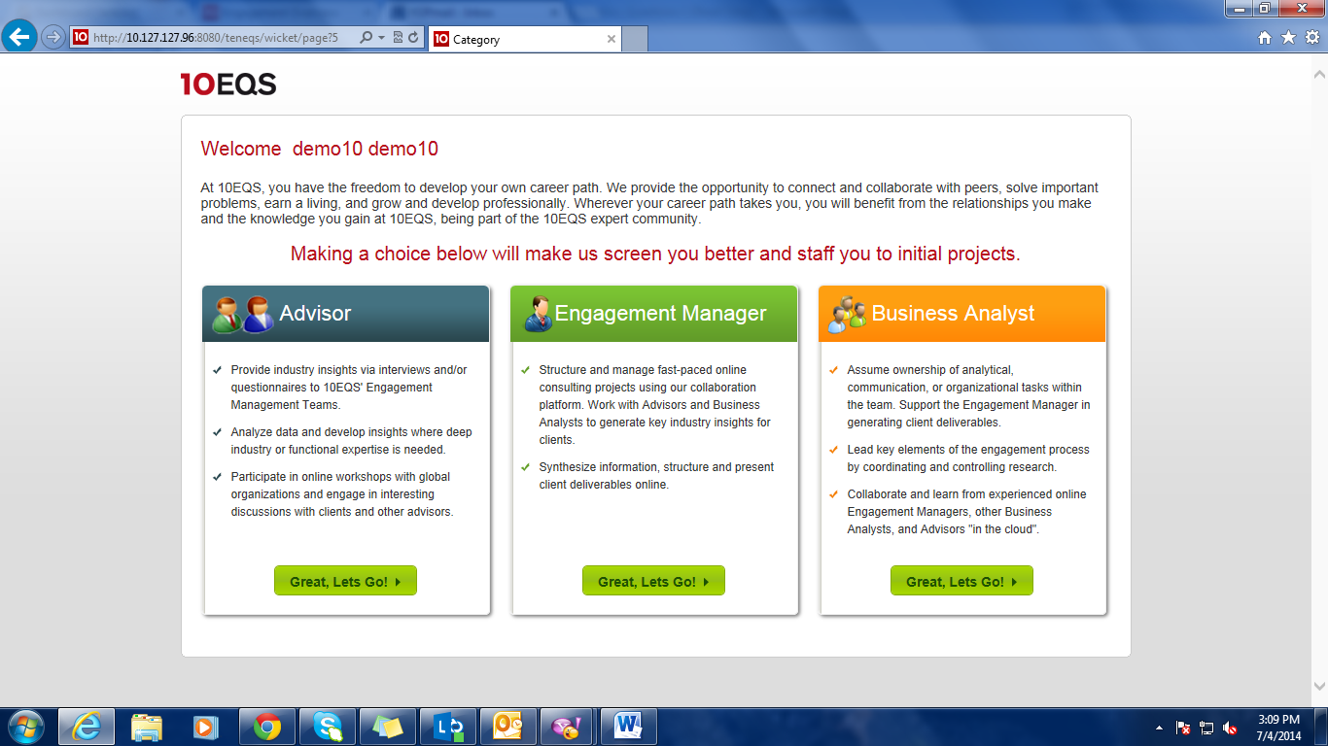

Select a role from above screen and following basic profile page will be displayed.

Basic profile page

