CS227 DIGITAL SYSTEMS

PROJECT REPORT

TOPIC: SMART HOME

BY:

M SHANMUKHA PRIYA 2101CS40

MAMTA KANWAR 2101CS42

AMISHA RAJE 2101CS08

**OBJECTIVE**

Voice Controlled Home Automation project using Arduino.

It enables the user to control home appliances through our voice command through our android app which in turn passes to the Arduino through Bluetooth.

**SCHEMATIC**

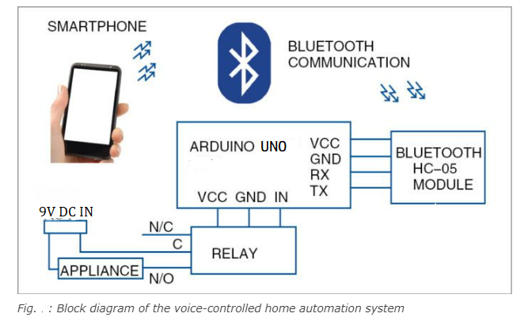

**CIRCUIT CONNECTION**

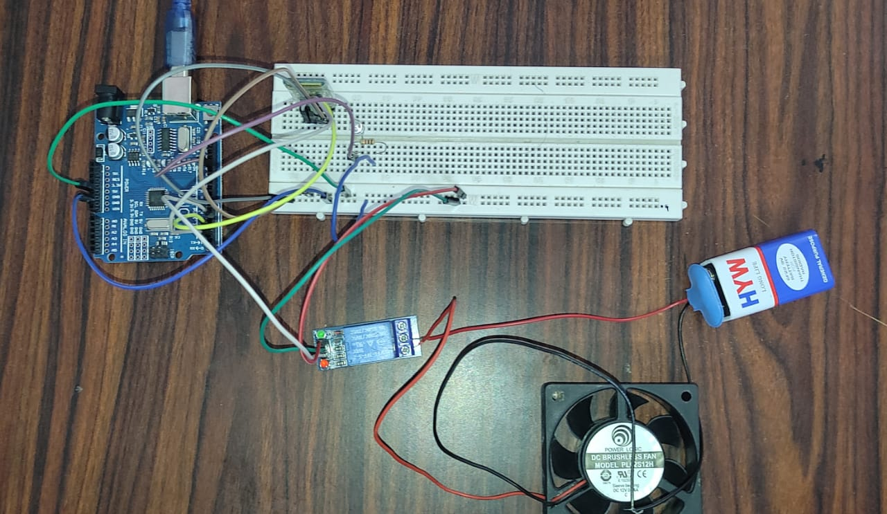

**COMPONENTS**

1. Arduino-The Arduino Uno is a microcontroller board connected to a computer with a USB cable.
2. Bluetooth module- it is used to sense our signal sent from the Android app
3. Relay (5V 2-CHANNEL relay): A relay is basically an electromagnetic switch which can be turned on and off by applying the voltage across its contacts.
4. Breadboard
5. Jumper wires- Male to male and male to female
6. 9V Battery-used as a power supply
7. LED
8. DC Fan
9. Resistor -1k[Ω](https://www.google.com/search?sxsrf=ALiCzsbGtJYvUyBQ65mlld3m1GXibgqt3g:1668811732878&q=ohm+1+%CF%89+in&sa=X&ved=2ahUKEwi32qOU6Lj7AhXT-TgGHX-FAS0Q6BMoAHoECGoQAg)

**PIN CONNECTIONS**

|  |  |
| --- | --- |
| **Component** | **Pin number in Arduino UNO** |
| TxD | Pin 3 |
| Ground | GND |
| VCC | 5V |
| RxD | Pin 2 |
| LED | Pin 13 |
| Fan | Pin 5 |

|  |  |
| --- | --- |
| **Relay Pins** | **Connected to** |
| In (Input) | Pin 5 of Arduino UNO |
| N/O | Positive terminal of Fan |
| COM | Negative Terminal of battery |

**WORKING PRINCIPLE**

We are giving voice commands to our Android app (i.e. Bluetooth Voice app downloaded from Google PlayStore) to turn on and off appliances which pass the command to our Arduino via Bluetooth thus controlling the appliances.

The Android app reads the voice and converts the audio signal into text. It provides a value for each appliance which is fed to the microcontroller device (Arduino UNO here). The microcontroller uses the port in serial mode. After reading the data, it decodes the input value and sends a signal to the parallel port through which the relay circuit will be activated.

The relay is connected to the output pins of Arduino UNO, which is used as a switch to the load.

For demonstration, a DC Fan and a LED have been used. A battery of 9V has been used as a power supply to the fan.

**WORKING OF ANDROID APP**

**Name of the app:** Bluetooth Voice (downloaded from Google Playstore)

**Description and working:** The application first searches for the Bluetooth device. Bluetooth module HC-05 is used as a remote which is connected to the control unit for sensing the signals sent by the Android voice application. If it is available then it launches the voice recognizer. It reads the voice and converts the audio signal into text. If this text matches any of the commands, the app sends a single character, mapped to a particular command, to the Bluetooth module.

Based on the character received, we can control if each appliance goes HIGH or LOW.

**App Interface:**

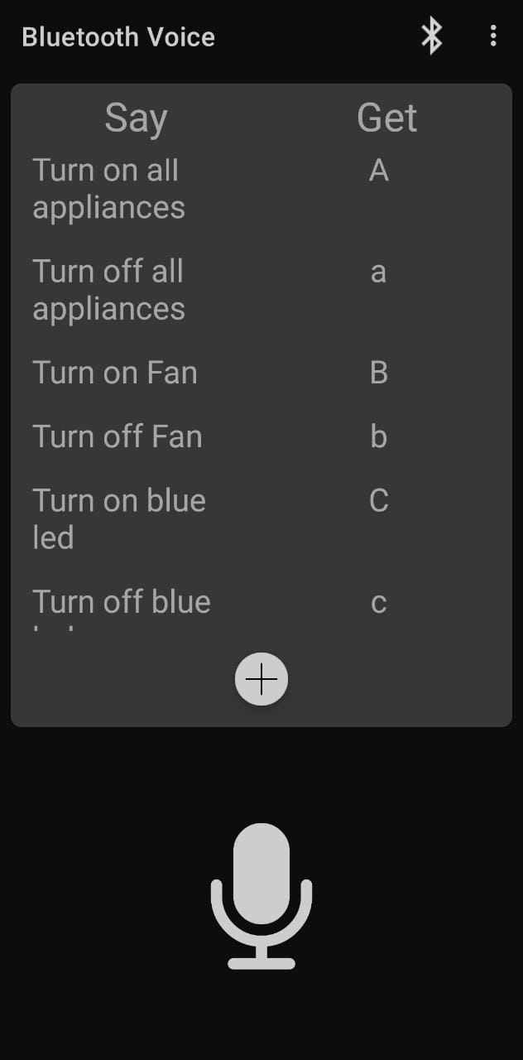

|  |  |
| --- | --- |
| **Commands we are giving** | **Code sent by the app to the Bluetooth module** |
| Turn on all appliances | A |
| Turn off all appliances | a |
| Turn on fan | B |
| Turn off fan | b |
| Turn on blue LED | C |
| Turn off blue LED | c |

**CODE**

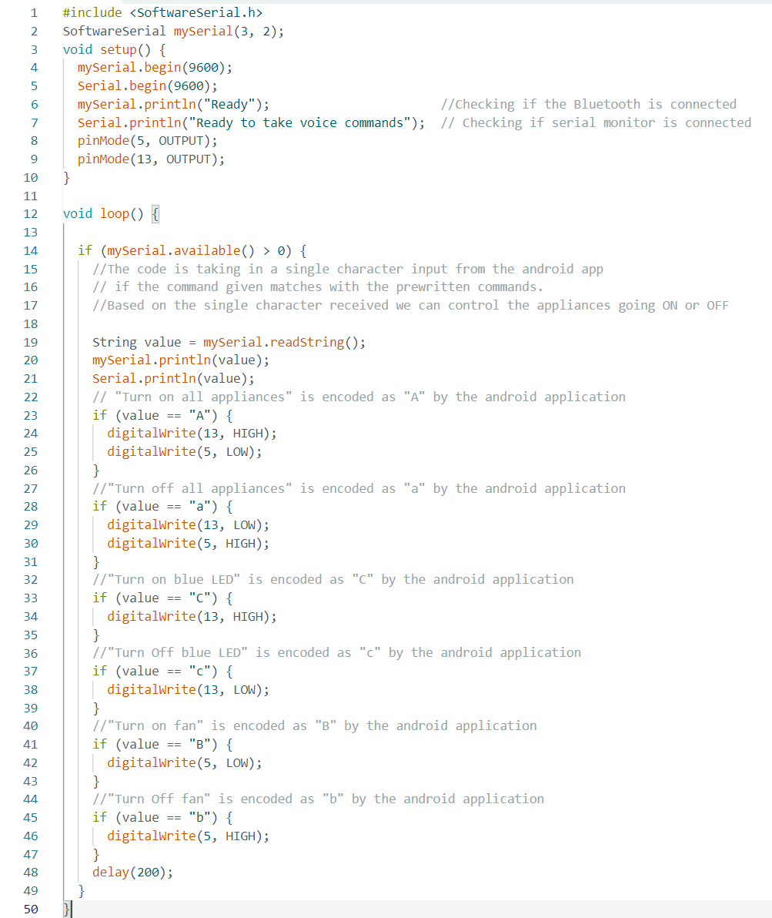

**PROBLEMS FACED**

While connecting the DC fan we had an issue regarding its connection with the Arduino.

Initially, we tried connecting it the way we connected LED but due to low voltage, it was not able to work that way.  
Then we tried using a diode and resistor along with a transistor which could act like a switch to operate the fan with a 9V battery but in this case, also we were not successful and due to high voltage across the transistor, it was almost about to melt.

Finally, we used the Relay Module which is now acting as a switch between the fan and Arduino and is successfully taking inputs from Arduino.

**RELEVANCE TO SMART CITY**

We have demonstrated home automation on a very small scale in our project but our idea aims to connect to the AC Home Appliance which is done easily using Relay in a similar manner. We would be using 220 V AC from our houses instead of the 9V battery we used and other home appliances in place of the fan which we did.

Further modifications to this can be controlling the speed of the fan.

We can also control Air conditioners, door locks, televisions, thermostats, home monitors, cameras, lights, refrigerators etc. in a similar manner.

That would automate the entire home and ease the process of switching on and off appliances.

This app is also very beneficial for disabled people.

**INDIVIDUAL CONTRIBUTION**

**Mamta Kanwar:** Made circuit connection

**M Shanmukha Priya:** Wrote Arduino Code

**Amisha Raje:** Made circuit connection

All three made equal contributions in deciding the project, getting components, making Report, PPT, recording and editing the video.