Corona Virus tracker

React Native Application for Android & IOS

INSTALLATION GUIDELINE

Installation for IOs and android app

The CoronaTracker

© Zebody

315 St Germain Ave

Ontario, TO M5M 1W4

Table of Contents

1. Download necessary packages
2. Set up Firebase
3. Set up Android App
4. Set up IOS App

Download Necessary Packages

Open the command terminal inside the main folder CovidTrackerApp containing your Android and IOS folder and inside you terminal run:

* npm install

That should install all relevant node packages. Make sure you have node installed on your computer. If you don’t have node visit: <https://nodejs.org/en/download/> to download the right package for your operating system.

Set up Firebase

In order to save data to the database a Firebase account and firebase application have to be created to get the credentials that connect the app to your database.

1. The first Step is to create an Account by visiting <https://firebase.google.com/> and press Create Project or Get Started depending on whether you are logged into your google account.

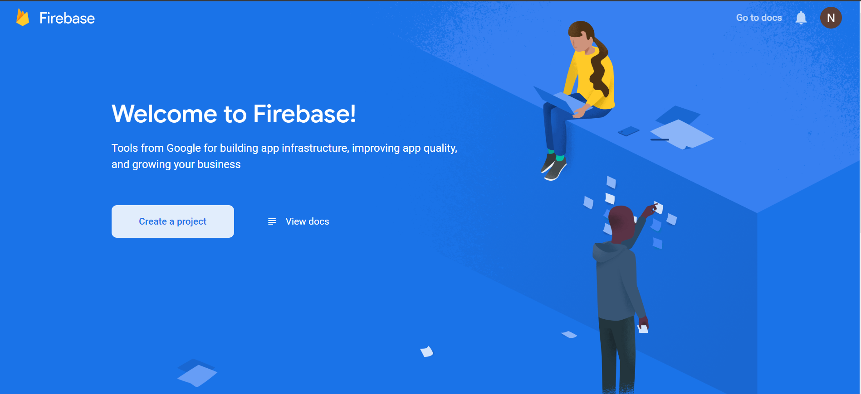

1. Than choose a name for you firebase account, where you will create the application that will connect to the mobile apps.

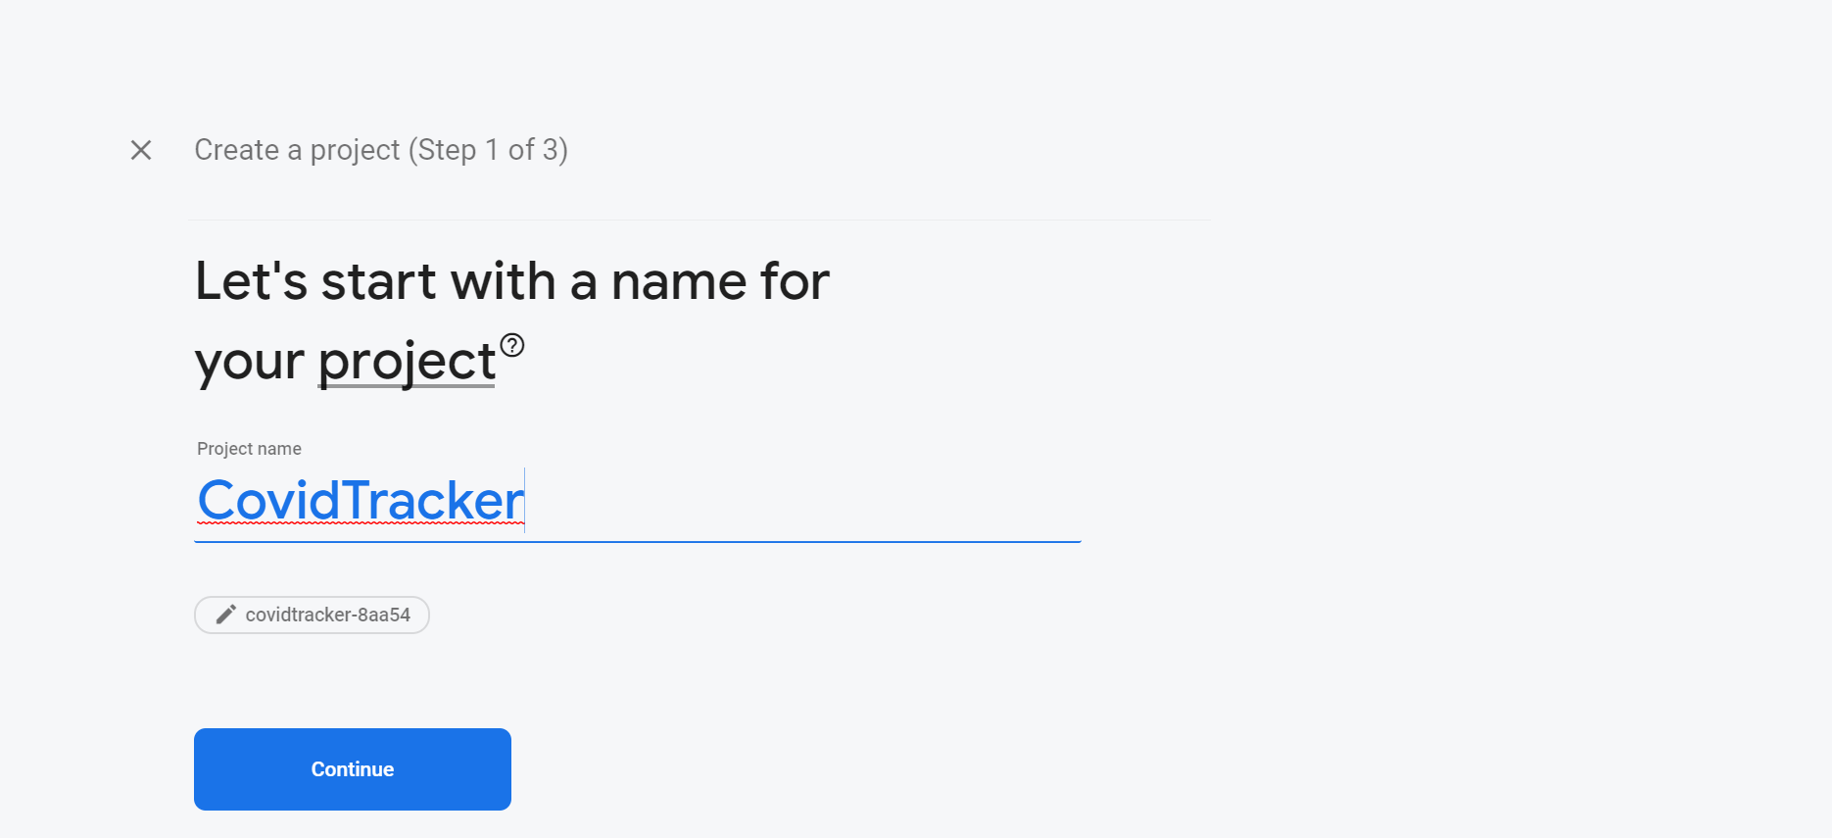

1. Create a web application to connect both the IOS and Android version of your app to your firebase account. Click on the Icon surrounded by red lines.

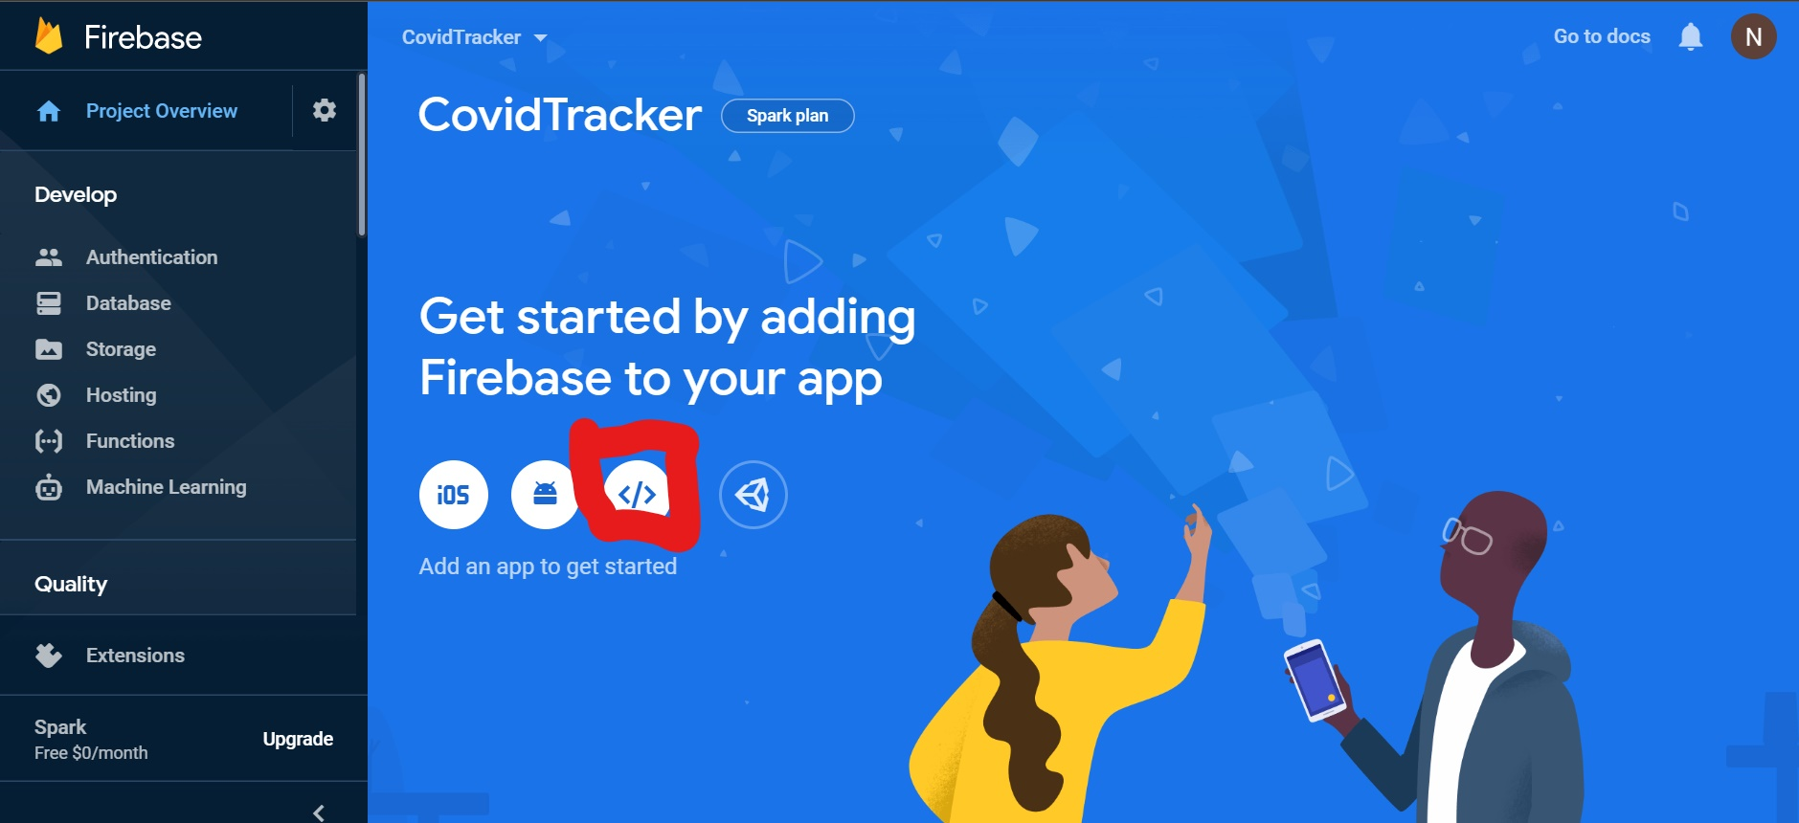

1. Create an application within your Firebase Account. Choose any name you like.

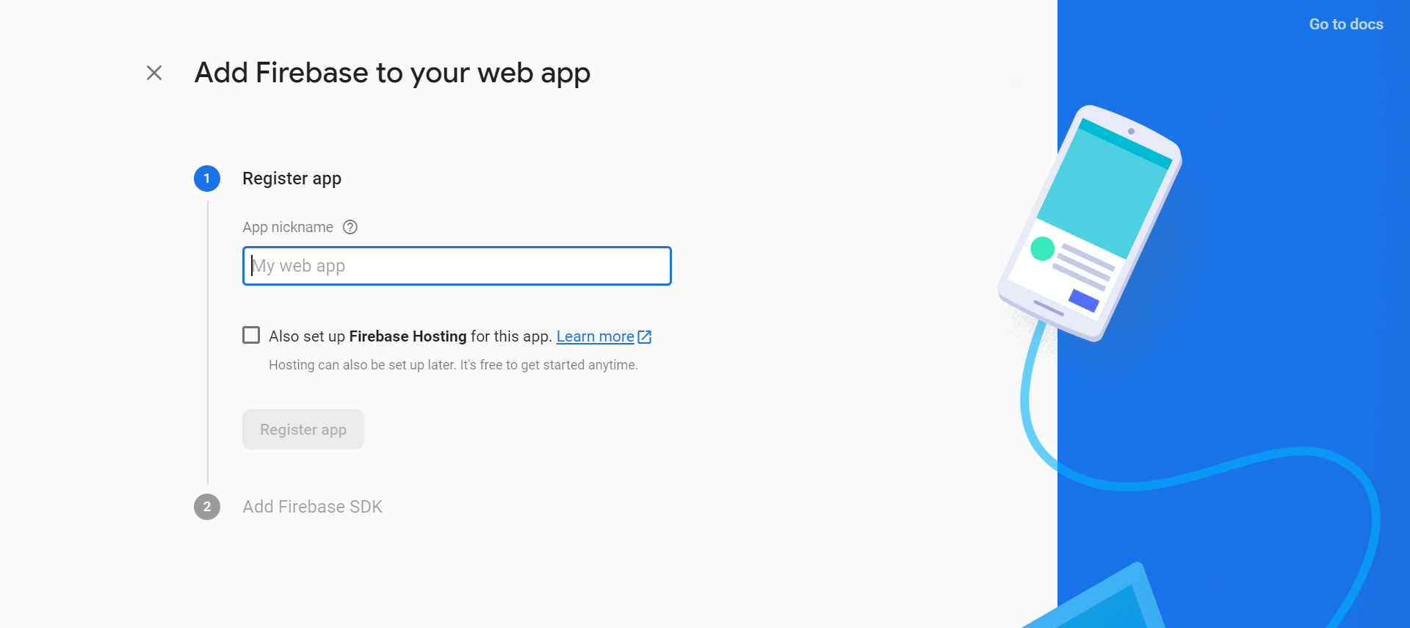

1. Copy the credentials surrounded by redlines for your app. 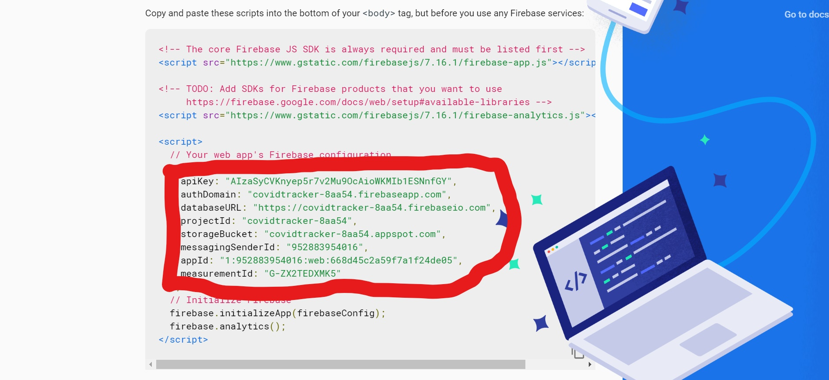
2. Access the App within your favorite IDE and open the Fire.js file. Add the credentials inside the initializeApp function..

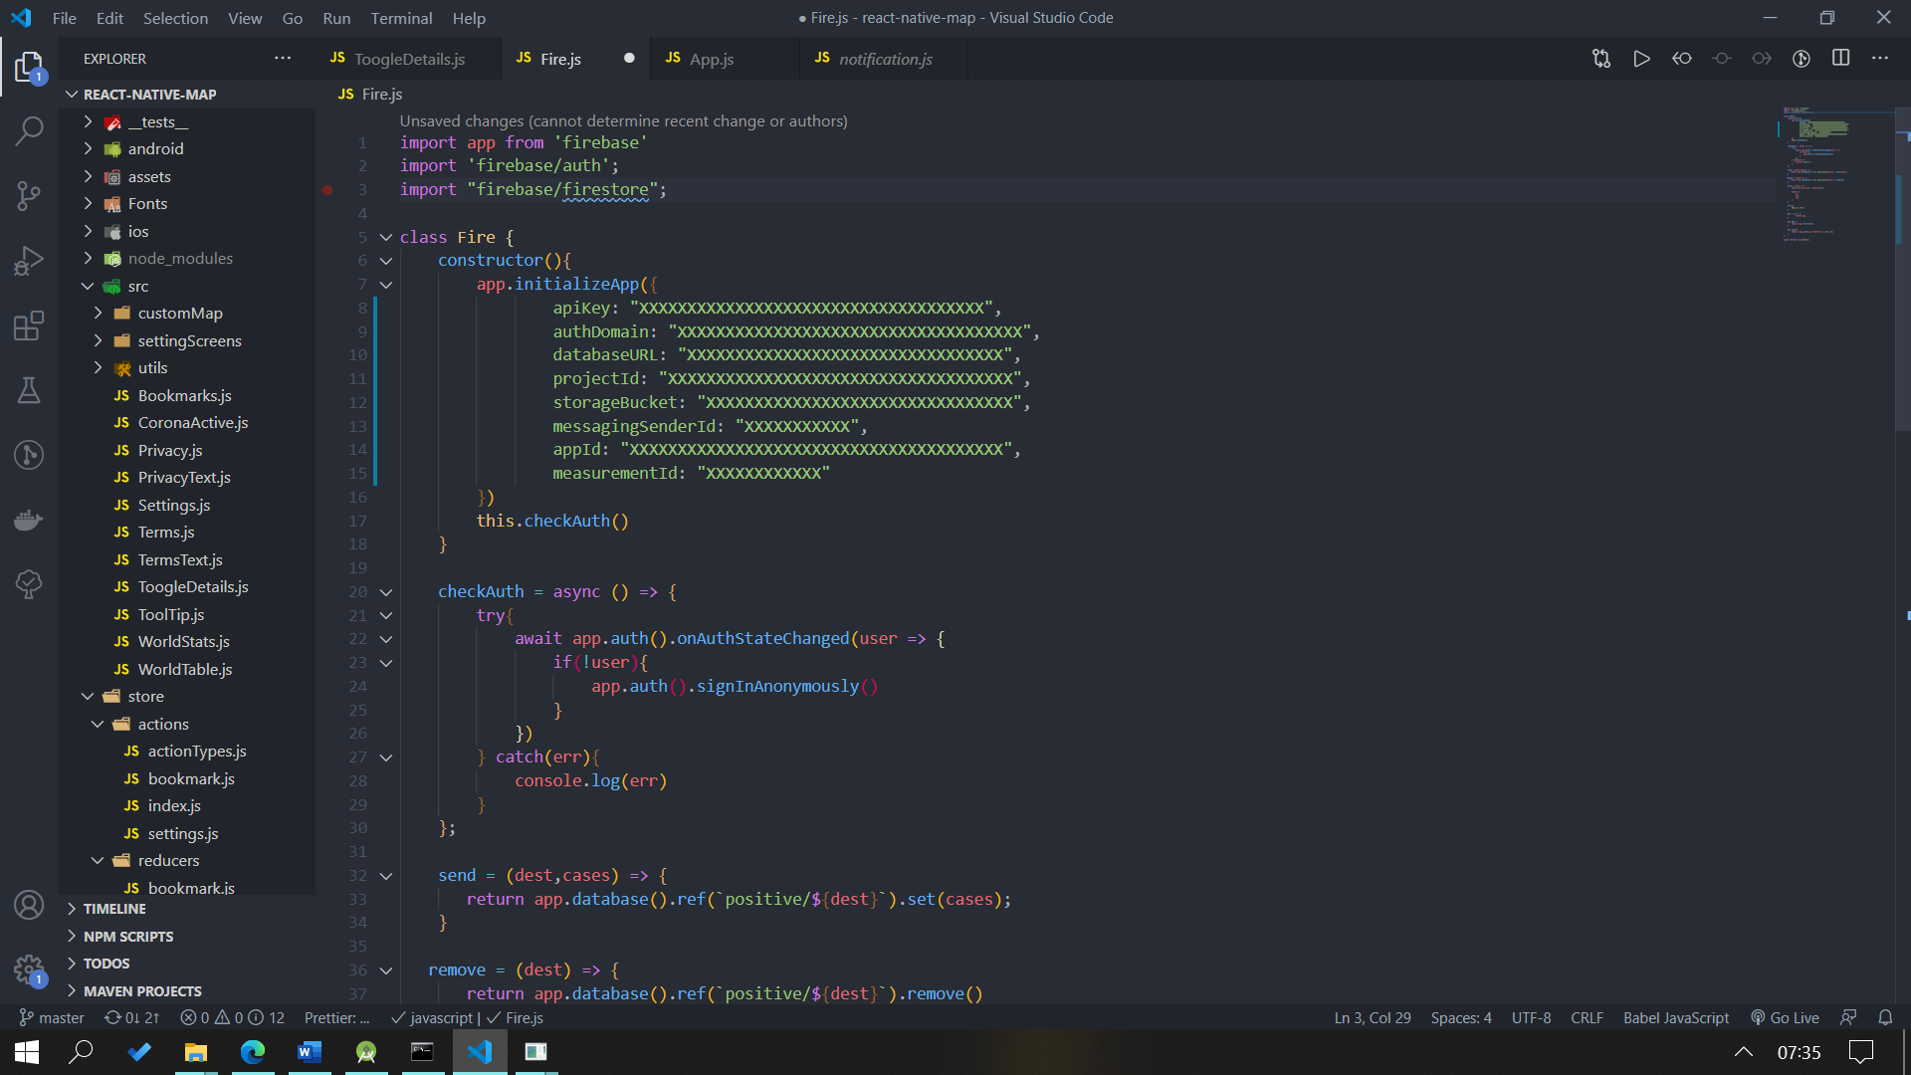

1. A Google API key has to be generated to allow users to access google maps on the app. You will have to enter your billing information to create a google API.

For android:

Visit: <https://developers.google.com/maps/documentation/android-sdk/get-api-key> to generate a key. After you have the key add it to the AndroidManifest.xml file.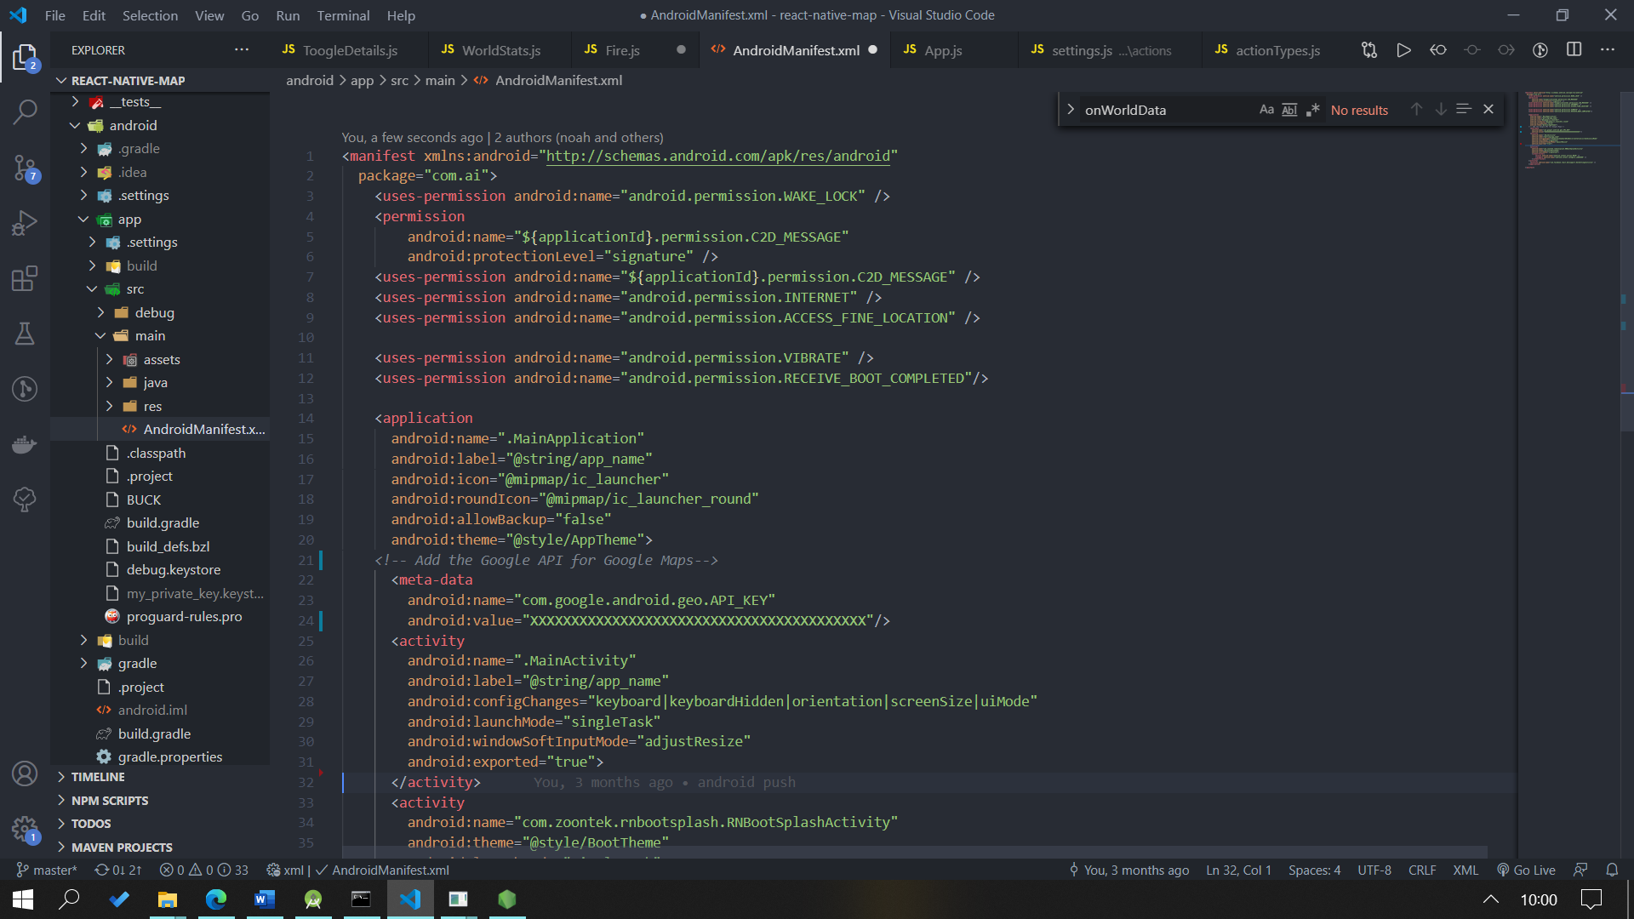

For IOS visit: <https://developers.google.com/maps/documentation/ios-sdk/get-api-key#objective-c>

Once you have the API key add it to AppDelegate.m file.

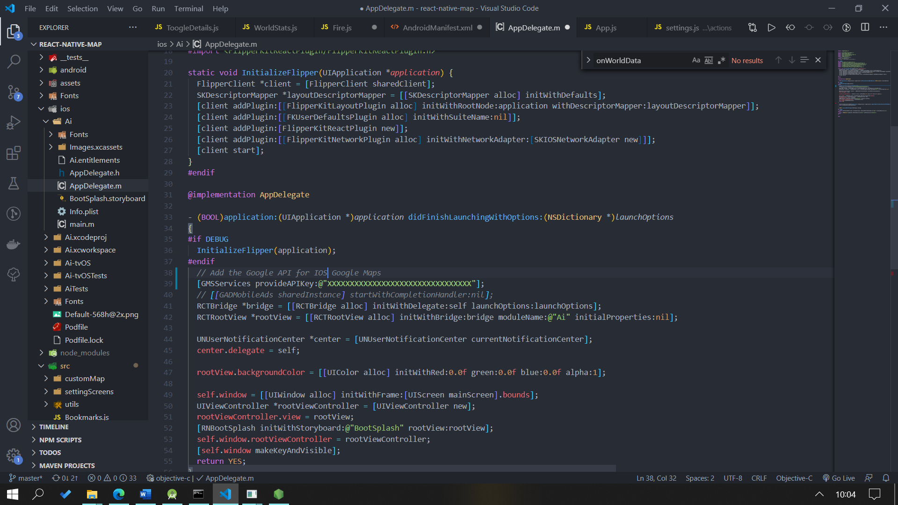

Set up the Android App

To run the android application you need to have Android Studio installed on your computer.

Once you installed android studio open the android folder inside android studio and wait a couple minutes for the set up.

After it successfully downloaded the necessary packages go to your terminal pointing to the CovidTracker folder and run

* npm run android

This may take a while to set up, if the emulator does not open. Make sure to go back to Android Studio and create an environment for your Emulator.

If get a server 500 error run.

* npm start

If the app seems to lag, test the app on a physical device. The app contains 500k data points and will only run smoothly on Android 7+ or a physical devices newer than 3-4 years old.

Set up the IOS App

To run the IOS app go inside the IOS folder in your terminal and run

* pod install

That should install all the necessary packages to run the App on a mac operating system.

Once the packages are installed go back to your main folder and run

* npm run ios

If you encounter any errors follow the solutions listed in the android sections.