Why Ordinary People Should Care About Open-Source Software Security
Hanyun Cheng
Advanced Writing in Tech Prof
Northeastern University
Prof. Elham Dehghan
July 29, 2026

Why a Small Open-Source Software Problem Can Reach Ordinary Users
Every time people log into a school website, check a bank account, shop online, or join a video meeting, they usually see only one app or website. They may not think about the software pieces working behind the screen. However, many of those services depend on open-source software. Open-source software is code that can be viewed, used, changed, and shared by other people. It helps developers build apps and websites faster, but it also creates a security question that affects more than programmers.
Open-source software security matters because open-source code has become part of the digital infrastructure that ordinary people use every day. According to the Open Source Security Foundation (2022), open-source software is now a major part of the modern software ecosystem. This means that a weakness in one project can move through many systems before it reaches the final user. For a regular person, the issue may appear only as a hacked account, a broken website, or a warning to change a password. The technical cause may be hidden, but the result can still be personal.
What is open-source software?
Open-source software is different from closed software because its code is publicly available. Developers can read it, use it in their own projects, suggest changes, and report problems. This openness is one reason open-source software is so useful. A company does not need to build every part of an app from the beginning. It can use existing open-source packages for login systems, databases, web design, encryption, or data processing.
The Linux Foundation Research report shows that open-source software is widely used in modern software systems and business applications (Linux Foundation Research, 2025). For ordinary users, this means open source is not something separate from daily life. It may be inside the apps, websites, and online services they already use. A student may never visit GitHub, but the school website that student uses may still depend on open-source code.
Why does public code still have security risks?
A common misunderstanding is that open-source software is automatically safe because the code is public. Public code can be helpful because more people can inspect it and suggest improvements. However, public code does not mean that enough people are actually reviewing it carefully.
Some open-source projects are maintained by only a small number of people. Some maintainers work on important projects in their free time. Wermke et al. (2020) explain that open-source maintainers often face security responsibilities with limited resources and support. A project may be used by many companies, schools, or public services, but still depend on a small group of maintainers. Because of this, open-source security depends not only on the code being visible, but also on whether the project has active maintainers, clear review rules, and enough testing.
This also shows why open-source security is a community issue. A project needs people who can review changes, respond to reports, fix problems, and decide which contributions should be trusted. If that work is delayed or ignored, a problem can remain in the project for a long time. Users may not see this process, but they depend on it.
What is a software supply chain?
A software supply chain is the set of code, tools, packages, and services that are used to build a final software product. A normal user may only see a finished website, but that website may depend on many open-source components. Those components may also depend on other components.
This can make one small problem much larger. If a weak or harmful package is used by many other projects, the problem can spread. Zahan et al. (2023) explain that organizations need to know which software components they use because those components can create security risks. This is why software bills of materials, or SBOMs, have become important. They help organizations understand what is inside their software.
A simple way to understand this is to compare it to a food supply chain. A customer may only see the final product, but the safety of that product depends on ingredients, packaging, transportation, and storage. Software works in a similar way. A user may only see an app, but the safety of that app depends on many earlier pieces of code.

Figure 1
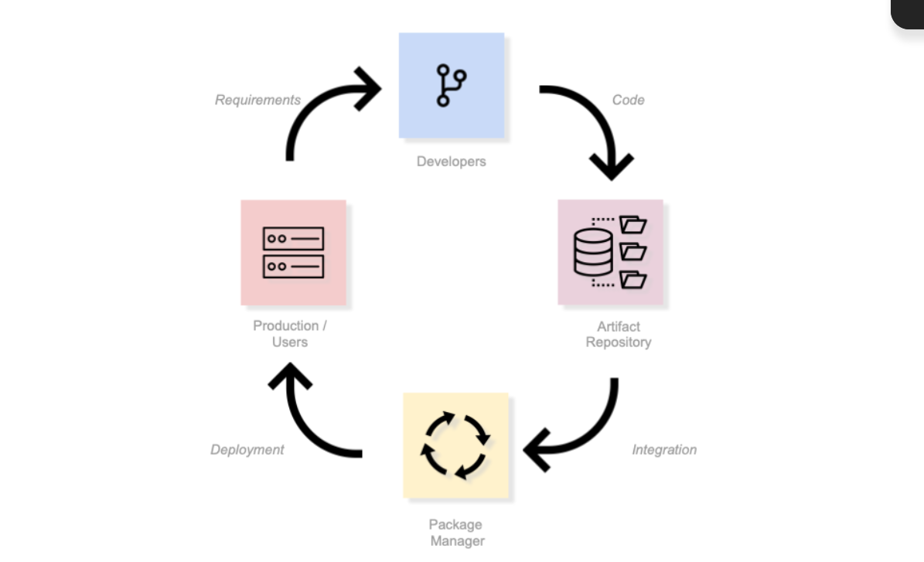
A simplified software supply chain
Caption: This diagram shows how code moves from developers to repositories, package managers, and finally production systems used by ordinary users. A weakness at an earlier stage can affect users later in the chain..
Source: FINOS, Open Source Readiness, Components of the Open Source Supply Chain, https://osr.finos.org/docs/bok/activities/level-2/supply-chain-security
How can this affect ordinary people?
Most ordinary users will never inspect source code. They may never know the name of the open-source package behind an app or website. Still, they can be affected by open-source security problems. If a vulnerable component is used in a banking app, school website, hospital system, or online store, the result may include exposed information, stolen passwords, broken services, or privacy risks.
This is why open-source security is not only a technical issue. It is also a public issue. CISA describes open-source software security as part of reducing risk across the broader software ecosystem (Cybersecurity and Infrastructure Security Agency, 2023). Since schools, businesses, hospitals, banks, and government services all depend on software, open-source security is connected to daily life.
The impact can also be indirect. If a hospital system is slowed down by a software problem, patients may experience delays. If a school platform is affected, students may lose access to assignments or records. If an online store has a vulnerability, customers may have to worry about personal information or payment data. These examples show that open-source security is not only about code. It is about the services people rely on.
Who is working on this problem?
Government agencies and security organizations have started paying more attention to open-source software security. CISA has published an Open Source Software Security Roadmap to explain how open-source risks can be reduced (Cybersecurity and Infrastructure Security Agency, 2023). OpenSSF also provides tools, reports, and best practices to support safer open-source development (Open Source Security Foundation, 2022).
In its 2025 vision brief, OpenSSF emphasizes cooperation among developers, companies, and public institutions to improve open-source security (Open Source Security Foundation, 2025). These efforts show that open-source security is no longer only a private concern for programmers. It is becoming part of public digital safety. The responsibility is shared because many groups benefit from open-source code. Developers maintain it, companies use it, governments rely on it, and ordinary people depend on the services built with it.
What can regular users do?
Regular users do not need to become programmers to care about this issue. They can still take basic steps to reduce risk. Keeping apps, browsers, and operating systems updated is important because updates often fix known vulnerabilities. Using strong passwords and multi-factor authentication can also reduce harm if a service is attacked. Users can also pay attention to whether companies clearly explain security updates and data protection practices.
These steps do not solve every open-source security problem. Larger responsibility belongs to software companies, maintainers, governments, and organizations that depend on open-source code. However, ordinary users benefit from understanding that digital services are built from many connected parts. When people understand this, they can better understand why security updates, responsible companies, and public investment in software security matter.
Why this matters
Open-source software is often invisible, but it supports many parts of modern life. People may not see the code, but they still depend on the communities and maintainers who care for it. A small weakness in one project can move through the software supply chain and affect many apps, websites, and users. For this reason, open-source software security should not be seen as a topic only for programmers. It is part of the hidden infrastructure of digital life, and ordinary users should understand why it matters.

Reflective Note
For this project, I chose the explainer article genre. My topic is why ordinary people should care about open-source software security. I chose this genre because the topic includes technical ideas, but it also affects a public audience. Many people use apps and websites every day, but they may not know that these services often depend on open-source code. An explainer article allows me to define key terms, use simple examples, and organize the information with clear section headings.
My target audience is college students and everyday internet users who do not have a computer science background. I imagine this article being published on a university news blog or a public technology website. The tone is informative and clear rather than highly academic. For design, I use short sections, direct headings, and a suggested infographic because public readers often scan online articles before reading closely.

References
Cybersecurity and Infrastructure Security Agency. (2023). Open source software security roadmap. https://www.cisa.gov/resources-tools/resources/cisa-open-source-software-security-roadmap
Linux Foundation Research. (2025). Census III of free and open source software. https://www.linuxfoundation.org/press/open-source-usage-trends-and-security-challenges-revealed-in-new-study
Open Source Security Foundation. (2022). Addressing cybersecurity challenges in open source software. https://openssf.org/resources/publications/
Open Source Security Foundation. (2025). Secure open source software vision brief 2025. https://openssf.org/wp-content/uploads/2025/02/OpenSSF_2025_Vision_Brief.pdf
Wermke, D., Wohler, N., Fourney, A., Parnin, C., Fahl, S., & Acar, Y. (2020). Always contribute back: A qualitative study on security challenges of the open source supply chain. IEEE Symposium on Security and Privacy Workshops.
Zahan, N., Lin, T. H.-J., Akefirad, R., Li, Y., Menzies, T., & Williams, L. (2023). Software bills of materials are required. Are we there yet? IEEE Security & Privacy, 21(2), 82-88.
FINOS, Open Source Readiness, Components of the Open Source Supply Chain, https://osr.finos.org/docs/bok/activities/level-2/supply-chain-security

