WELLNEX

By
Kanza Noor 2022-GCUF-070475

BACHELOR OF SCIENCE
IN
COMPUTER SCIENCE



DEPARTMENT OF COMPUTER SCIENCE
GC University Faisalabad

2026

Certificate

This is to certify that the project proposal titled “WellNex” has been prepared and submitted by Kanza Noor, Roll No. 116175, student of Christian College of Business, Arts and Technology, affiliated with Government College University, Faisalabad (GCUF), in partial fulfillment of the requirements for the degree of Bachelor of Science in Computer Science (BSCS).

Supervisor’s Name: ____________________
Supervisor’s Signature: _______________

Abstract

Mental health is a critical component of overall well-being, yet access to professional therapy is often limited due to cost, stigma, or lack of availability. The WellNex is a cross-platform mobile application designed to provide users with private, accessible, and intelligent mental wellness support. The app integrates an on-device AI-powered therapy chatbot, a secure diary for daily emotional journaling, and an interactive dashboard that visualizes trends in stress, anxiety, mood, and confidence. By analyzing diary entries and chat interactions, the app offers personalized insights while ensuring user data remains private and encrypted. This project leverages Flutter for cross-platform development, Firebase for authentication and cloud storage, and Python-based AI models exported for on-device inference. The system is intended to supplement professional therapy, promoting self-awareness, emotional resilience, and proactive mental health management.

Acknowledgement
I would like to express my sincere gratitude to all those who supported me throughout the development of this project. First, I thank my project supervisor for their guidance, encouragement, and valuable feedback during every stage of this work. I am also grateful to my peers for their suggestions, insights, and moral support. Additionally, I acknowledge the developers and contributors of the open-source tools and frameworks, such as Flutter, Firebase, and TensorFlow, which made this project possible. Finally, I thank my family for their continuous support and motivation, without which this work would not have been possible.

Table of Contents
- Introduction
- System Overview
2.1 Text-Based Flowcharts
2.1.1 Main App Flow
2.1.2 Therapy Chat Sub-Flow
2.1.3 Diary Sub-Flow
2.1.4 Dashboard Sub-Flow
2.1.5 Data Sync Sub-Flow
- Problem Statement
- Purpose of the Project
- Objectives
5.1 Primary Objectives
5.2 Secondary Objectives
- Scope of the Project
- Methodology
- Tools and Technologies
- Ethical & Privacy Considerations
- Project Timeline (Gantt-Style)
- Expected outcomes
- Limitations
- Future work
- Conclusion
- References

1. Introduction
Mental health issues such as stress, anxiety, and burnout are rising globally. Many individuals cannot access therapy due to cost, stigma, or lack of availability. Smartphones provide a practical avenue for offering private, affordable support.
The Smart Wellness Companion is a Flutter-based mobile application designed to support users’ mental well-being. It offers user signup/login, a therapy chatbot powered by a local AI model (on-device inference for privacy), a diary for daily life entries, and a dashboard displaying trends in psychological metrics (e.g., stress, anxiety, confidence). The app uses Flutter for cross-platform UI, Firebase for authentication and storage, and Python for AI model development (exported for on-device use). The Diary module allows users to log daily stories, which are analysed for trends, enhancing the dashboard’s insights.
2. System Overview
This section outlines the overall structure and process flows within the application.
2.1 Text-Based Flowcharts
2.1.1 Main App Flow
- Start: App launches (splash screen).
- Check Authentication (Firebase Auth):
  - Yes: Navigate to Main Dashboard.
  - No: Go to Signup/Login screen.
- Signup/Login (Firebase Email/Password or Google Auth):
  - Success:
    - Save User ID locally
    - Proceed to Onboarding
  - Failure:
    - Show error → Retry
- Onboarding:
  - Optional profile setup (age, gender for AI personalization)
- Main Navigation:
  - Bottom nav bar → Dashboard | Therapy Chat | Diary | Settings
- Exit/Background:
  - Save session state

2.1.2 Therapy Chat Sub-Flow
- Open Therapy Chat (load previous chats from SQLite/Firestore).
- User enters message.
- Local processing: tokenize → analyse sentiment (on-device ML model).
- AI generates response (empathetic guidance).
- Store:
  - User message + AI reply → SQLite → Sync to Firestore
  - Update stress/anxiety metrics
- Error Handling:
  - Use fallback response → Log issue
- Display response → Continue chatting
- On Exit:
  - Sync data → Refresh Dashboard
2.1.3 Diary Sub-Flow
- Enter Diary (load entries from SQLite/Firestore).
- View entries (date-sorted with edit/delete options).
- Add Entry?
  - No: Browse and exit
  - Yes:
    - Open form → text, mood emoji, date
- Submit Entry:
  - Validate (non-empty)
  - Save to SQLite → Sync to Firestore
  - Analyze (sentiment, stress/anxiety keywords)
  - Update trends
  - If error → Save offline → Retry later
- Confirmation → Add more or exit
- On Exit → Sync data → Refresh Dashboard
2.1.4 Dashboard Sub-Flow
- Open Dashboard
- Fetch data from Firestore:
  - Chats
  - Diary entries
  - Metrics
- Compute trends:
  - Stress: Line chart (2 days, week, month, year)
  - Anxiety: Bar chart
  - Confidence: Pie chart (improvement %)
  - Mood Heatmap: Positive/negative diary days
- Display visuals with fl_chart
- Interactive: tap to view logs
- Alerts: display suggestions if trends worsen
- Refresh options:
  - Pull-to-refresh
  - Firebase listener
2.1.5 Data Sync Sub-Flow
- Background service (Isolate or Firestore listener)
- Monitor new chats/diary entries
- Analyze/Update metrics hourly
- Notifications with Firebase Messaging
  - e.g., “Your mood is improving!”
- Repeat loop

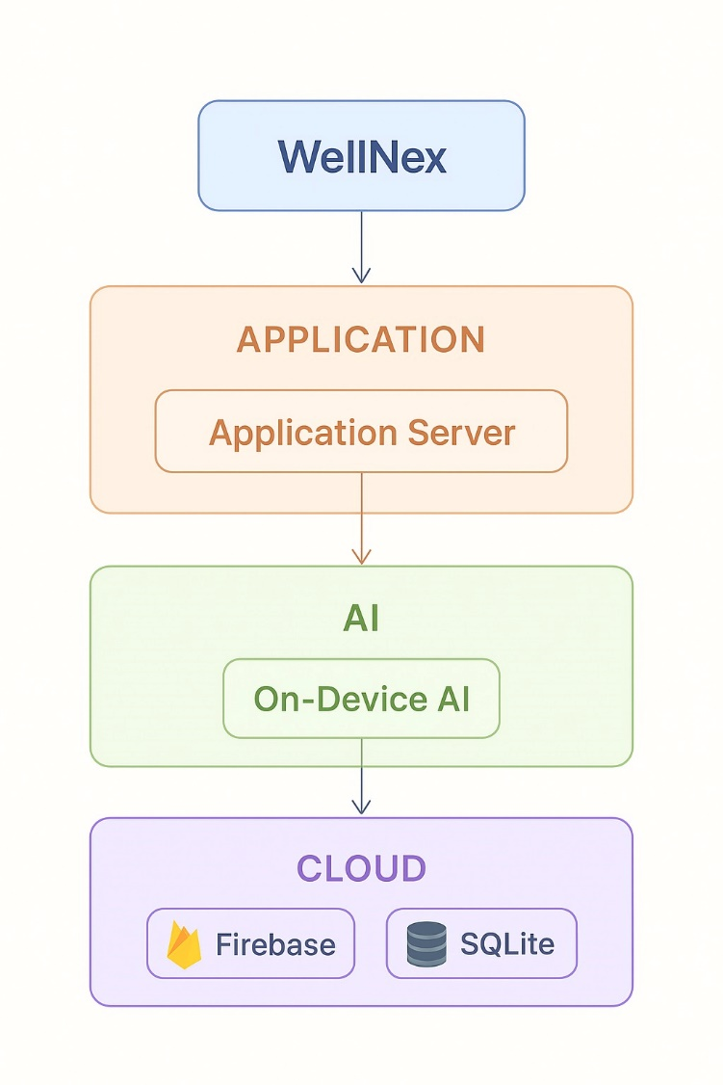

3. Problem Statement
Mental health challenges, such as stress, anxiety, and depression, affect millions of people worldwide. Despite growing awareness, access to professional mental health services remains limited due to high costs, social stigma, and insufficient availability of trained therapists. Existing digital wellness applications often fail to provide personalized, actionable insights and may compromise user privacy by storing sensitive data in cloud servers.
There is a clear need for a secure, accessible, and intelligent mobile solution that empowers users to monitor and manage their mental well-being through personalized guidance, diary reflections, and real-time trend analysis—while ensuring that sensitive personal data remains private and under the user’s control. The wellness app addresses this gap by integrating an on-device AI therapy chatbot, a diary for emotional journaling, and a visual dashboard to track stress, anxiety, mood, and confidence trends over time.

4. Purpose of the Project
The purpose of this project is to design and develop a mobile application that empowers users to actively monitor and improve their mental well-being. Specifically, the app seeks to:
- Provide a private, on-device AI-powered therapy chatbot for personalized emotional support.
- Enable users to record daily reflections through a secure diary system.
- Analyze diary entries and chat interactions to extract actionable insights on stress, anxiety, confidence, and mood trends.
- Visualize these trends via a user-friendly dashboard to encourage self-awareness and proactive well-being management.
- Ensure data privacy and security through encrypted storage and adherence to best practices, giving users full control over their sensitive information.
This ensures the app acts as a supplement to professional therapy, rather than a replacement, while addressing the gaps in current digital mental wellness tools.

5. Objectives
5.1 Primary Objectives
- Develop a Flutter-based cross-platform mental wellness app.
- Implement a privacy-safe, on-device AI therapy chatbot.
- Provide a diary system for emotional journaling.
- Analyze diary and chat data to extract trends.
- Display stress, anxiety, mood, and confidence trends on a dashboard.
5.2 Secondary Objectives
- Implement Firebase Authentication for secure access.
- Ensure encrypted data storage (local + cloud).
- Create a simple and user-friendly interface.
- Offer reminders and motivational notifications.

6. Scope of the Project
In Scope
- Android/iOS Flutter App
- Authentication (Firebase)
- Diary entries with sentiment analysis
- Local AI chatbot (TFLite model)
- Trend visualization dashboard
- Offline storage with sync
- Basic notifications
Out of Scope
- Professional therapy
- Video or voice-based therapy
- Cloud-based AI computation
- Multi-language support (future work)

7. Methodology
Phase 1: Requirements Gathering
Interview users, define functional and non-functional requirements.
Phase 2: System Design
- App architecture (MVVM)
- UI/UX wireframes
- Database schema (SQLite + Firestore)
- AI model structure
Phase 3: Development
- Flutter UI and navigation
- Firebase integration
- Diary module
- Chatbot interface
- On-device sentiment model
Phase 4: Integration
- Connect AI model to Flutter
- Connect diary + chat metrics to dashboard
Phase 5: Testing
- Unit tests
- UI/UX testing
- Performance testing
- Security validation
Phase 6: Deployment
- Generate APK
- Deploy on device
- Final report + viva preparation

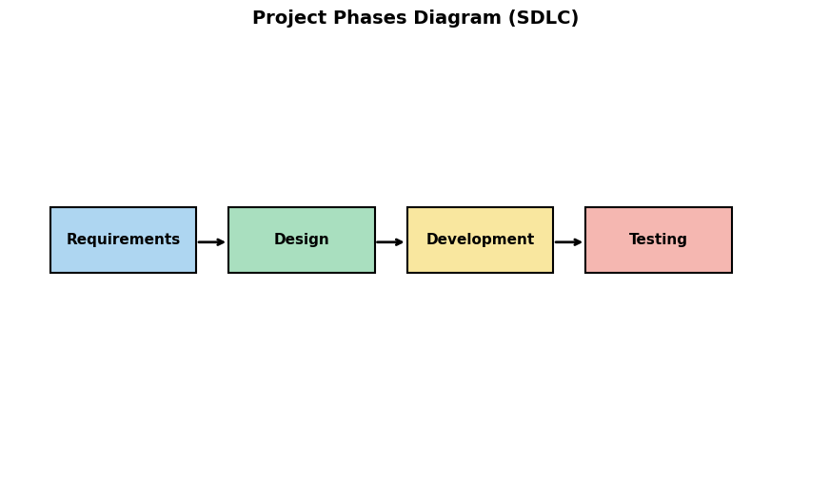
8. Tools and Technologies
Purpose | Tools
Frontend | Flutter, Dart
Backend | Firebase Auth, Firebase Firestore
AI/ML | Python, TensorFlow, TensorFlow Lite
Local Storage | SQLite
Notifications | Firebase Cloud Messaging
Design | Figma
IDE | VS Code
Version Control | GitHub

9. Ethical & Privacy Considerations
- The app is not a substitute for licensed therapy.
- Full transparency with user consent.
- No cloud-based AI → All sensitive text analyzed locally.
- Encrypted storage and GDPR/HIPAA-aligned principles.
- User can delete all data anytime.

10. Project Timeline (Gantt-Style)
Week | Tasks
1–2 | Requirements + literature review
3–4 | UI/UX design + architecture planning
5–7 | Flutter frontend development
8–10 | AI model development + conversion to TFLite
11–12 | Integration (AI + Firebase + SQLite)
13 | Testing + bug fixing
14 | Documentation
15 | Final project presentation

11. Expected Outcomes
- A fully functional Smart Wellness Companion app
- AI therapy chatbot with safe and empathetic responses
- Automated emotional and stress analysis
- Mood, stress, and anxiety dashboards
- Encrypted diary system
- Complete documentation and presentation
- Real-time recommendations
- Integration of multiple wellness modules in one platform

12. Limitations
- Accuracy depends on training datasets
- Requires internet connectivity
- Cannot replace medical professionals

13. Future Work
- IoT wearable integration
- AI chatbot support
- Multi-language support
- Voice based therapy
- Advanced predictive analytics
- Professional therapist

14. Conclusion
The WellNex project presents a practical and innovative solution for supporting mental well-being in a secure and accessible way. By combining an on-device AI therapy chatbot, a private diary system, and a data-driven dashboard, the application empowers users to monitor, understand, and manage their emotional health. The use of Flutter ensures cross-platform compatibility, while Firebase and local AI models provide secure authentication, data storage, and privacy-conscious processing.
This project addresses critical gaps in existing digital wellness tools, such as privacy concerns, lack of personalization, and limited actionable insights. While the app is not a replacement for professional therapy, it serves as a valuable supplement, promoting self-awareness, proactive emotional management, and resilience. Ultimately, the Smart Wellness Companion demonstrates how technology can be responsibly harnessed to enhance mental well-being in everyday life.

15. References
- Fitbit Research and Documentation
- MyFitnessPal official resources
- IEEE/ACM research on AI in health monitoring
- Kaggle health datasets

