Project Based Learning

20EE403 - Microcontroller

Automatic college bell

|  |  |  |  |  |
| --- | --- | --- | --- | --- |
| 4NM2033022 | DISHA RAVI |  | 4NM20EE032 | KANZAL HAQ |
|  |  |  |  |  |
| 4NM20EE038 | M SATWIK RAI |  |  |  |

By

**DEPARTMENT OF ELECTRICAL & ELECTRONICS ENGINEERING**



**NITTE-574 110, KARNATAKA, INDIA**

**(ISO 9001:2015 Certified, Accredited with ‘A’ Grade by NAAC)**

**Contents**

Chapter 1 Introduction 3

1.1 Introduction 3

1.2 Problem Definition 3

Chapter 2 Project Description 4

2.1 Objectives 4

Chapter 3 Project Implementation 6

3.1 Design Parameters 6

3.2 Tools Used 6

3.3 Project Implementation 6

Chapter 4 Results and Discussion 15

4.1 Results: 15

4.2 Discussion 15

References 16

**Chapter 1**

**1.1 Introduction:**

**O**ur Project takes over the task of Ringing of the Bell in Colleges. It replaces the Manual Switching of the Bell in the College. When this time equals to the Bell Ringing time, then the Relay for the Bell is switched on. The Bell Ringing time can be edited at any Time, so that it can be used at Normal Class Timings as well as Exam Times. The Real Time Clock is displayed on LCD display. The Microcontroller 8051 is used to control all the Functions, it get the time through the keypad and store it in its Memory. And when time and Bell time get equal then the Bell is switched on for a predetermined time

**1.2 Problem Definition:**

In market there many digital clocks available with bells but rings only at specific time. For e.g. Alarm Clock and some bells that ring after some time intervals and that cannot stop after specific time. For e.g. Musical Clock But all these limitations have been removed by our project. It rings only according to our college time table.

**Chapter 2**

**Project Description**

**2.1 Objectives**

In today’s world where time is money it can be wasted on Operating manual things and one of the most common would be school/college bell which has to be operated hour after hour and which is also not accurate and requires the use of manpower this can be easily overcome by using a fully automatic system which is operated using a microcontroller where the college bell is operated fully automatic and doesn’t requires any manpower and which is much more accurate than the one which is operated manually. It replaces the manual switching of the bell in the college.

**Circuit diagram:**

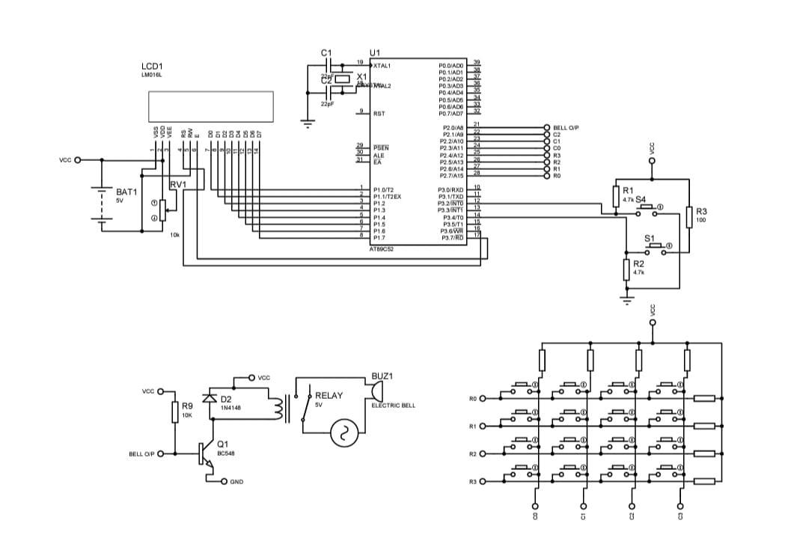

**Working of the system:**

**Case 1:**

When the device is turned ON two options are displayed in the LCD “backup & set time” if SW1 is pressed back up screen is displayed, the time starts from 00.

The external bell connected rings for the specified time interval

**Case 2:**

IF SW4 is pressed the time display is turned ON, user should provide the required date and time using the hex keypad

The 8051 check the higher nibble and lower nibble of both date and time and if the data is correct its is stored in the variables or else it will go back to initial positions

The time and date is correct the timer is started and the bell will ring on the specified time given

**Overview of MicroLABlet:**

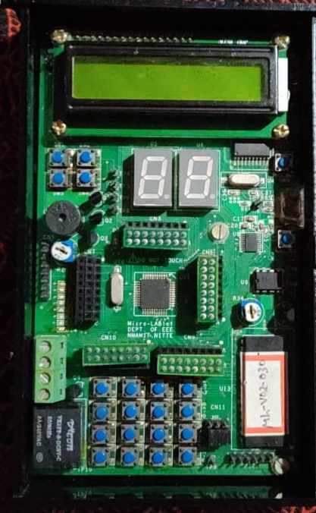Microlablet is an 8051 Microcontroller based development kit containing 10 peripherals multiplexed in a single board. This system is designed using SST89E516RD2 microcontroller that has 44 pins and 5 Ports.

The board consists of 16x2 LCD, 7 segment display, 8 LED’s, 4 interrupt switches, 4x4 hex-keypad, DAC, ADC, relay and buzzer. Connectors CN3, CN6, CN10, CN9 and CN7 are the connectors used for multiplexing peripherals.

CN3 must be placed in Cx-Bx for dumping of the required code.

16x2 alphanumeric LCD is interfaced with Port 1 of the microcontroller. . The control signals required for LCD operation are generated using P3.6 and P3.7 lines of Port 3. CN6 is placed in Cx-Bx position for LCD initialization.

**Chapter 3**

**Project implementation**

**3.1 Design parameters**

MicroLABlet is the kit designed containing 10 peripherals. The Collector terminals of the transistors are connected to VCC and Emitter terminals are connected to Port 0 terminals. The base of transistors is given to the LOW, MEDIUM and HIGH terminals trough 1k resistor.

**3.2 Tools Used:**

* 8051 MICROCONTROLLER
* CRYSTAL (11.059 MHZ ,32.768KHZ)
* DIODE(1N4700)
* RELAY SWITCH (12V MAGNETIC RELAY)
* RESISTORS (8,2,10,1) KΩ,330E
* TRANSISTOR (BC107) NPN
* CAPACITORS (1000µF ,10µF , 140pf)
* LED
* DISPLAY(16×2 LCD)
* BELL
* IC BASE (8,40 PIN)

**3.3 Simulation of the project:**

Code has been written using Keil and got the expected result using proteus software

The simulation of the working project is show below in the picture

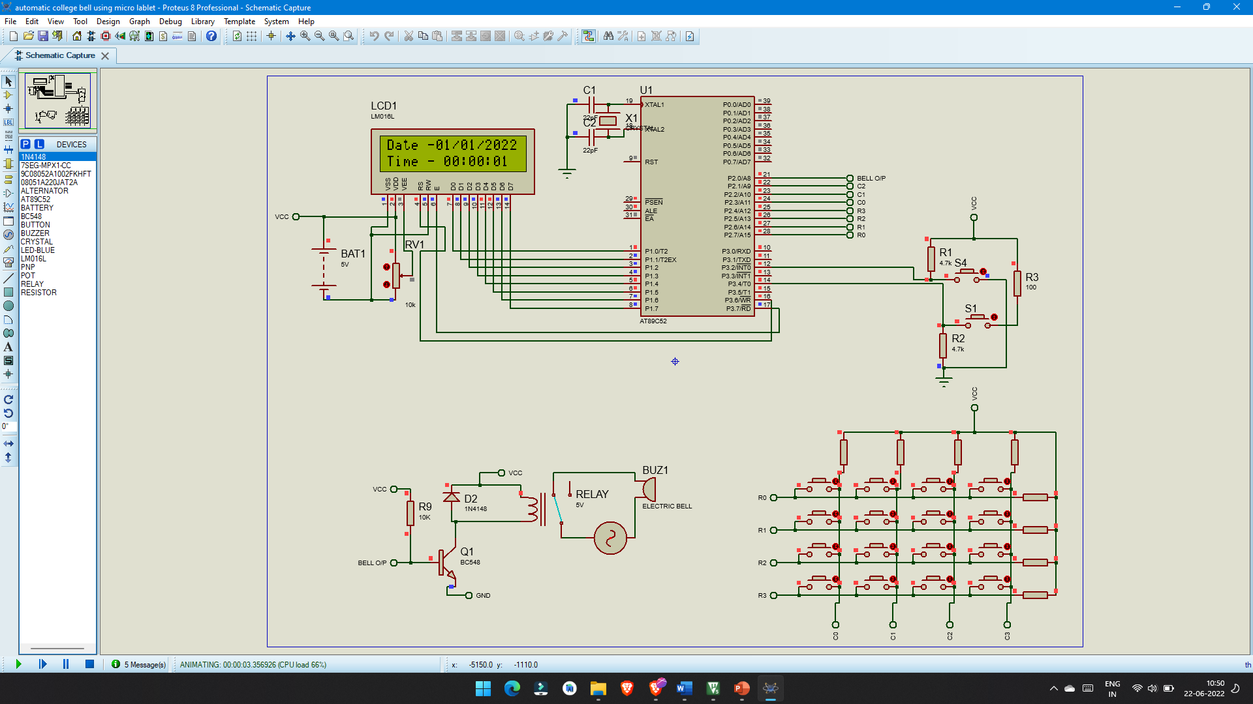

**program:**

**Click here: -**[**source code of the project**](https://drive.google.com/file/d/1Plo1vLHW0WW25CoBP5iC6tOZo_YvKoTH/view?usp=sharing)

**Applications :**

* This project can be used in educational institutes like schools and colleges
* This project can also be used in industries
* It is an automatic system
* Human errors can be avoided
* Safety is assured

**Chapter 4**

**Results and Discussion**

**4.1 Results**

The bell which can be for desired interval of its functioning as per expected the timing of the bell can be varied using the keypad supplied with it.

The time is displayed in the led screen The variation in timing is also applicable and is used in this circuit.

**4.2 Discussion**

The main component of the circuit is microcontroller, The time clock keeps the track of the time which is set and is used for the correct detection of time for display and for the bell ringing which has to be done accurately as our project focuses on the improvisation of the accuracy in school/college systems. The power is used and an alternative power supply is used for the times of power failure. The time which is tracked using 8051 is displayed in the display

**References**

* 8051 microcontroller and embedded systems by mazidi and mazidi
* [www.8051projects.com](http://www.8051projects.com)
* Applied electronics by R.S sedha
* [www.alldatasheet.com](http://www.alldatasheet.com)