**Appendix 3: Build Executable usign *Excelsior Jet 11.0***

**Avaialble to Download at :** [**https://github.com/kanzanoor/WegaGUI**](https://github.com/kanzanoor/WegaGUI)

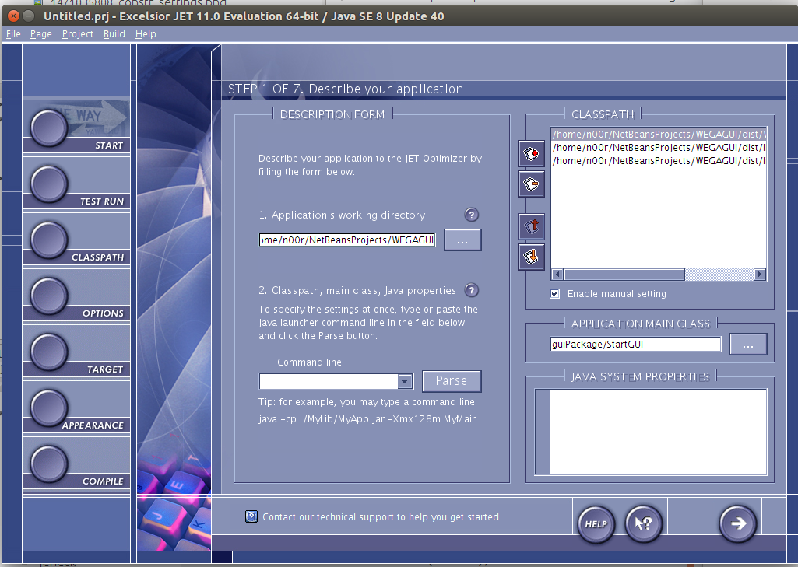

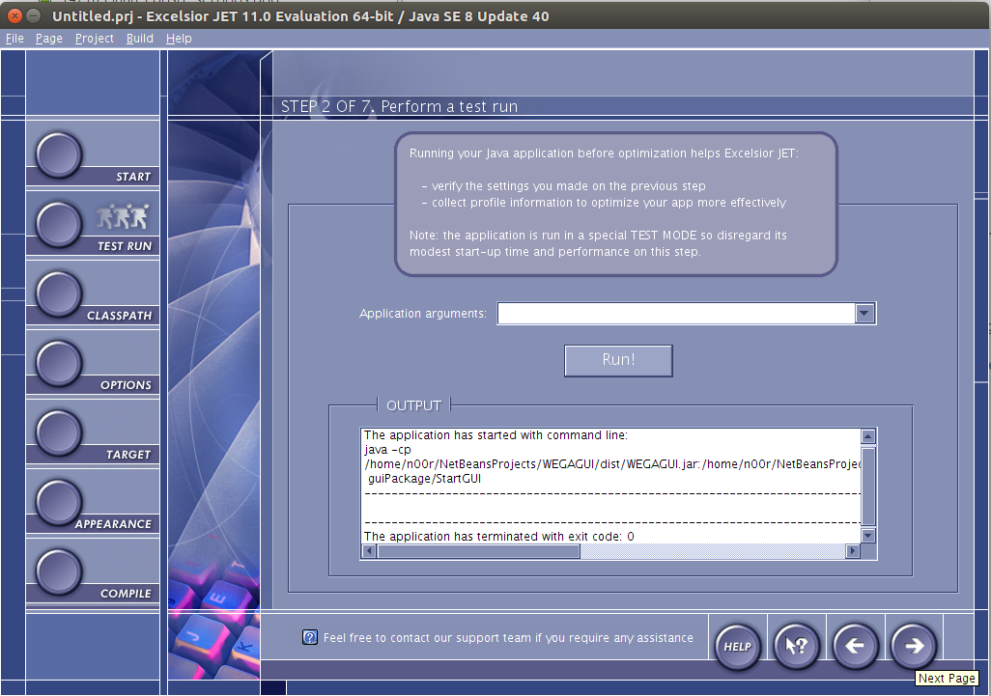

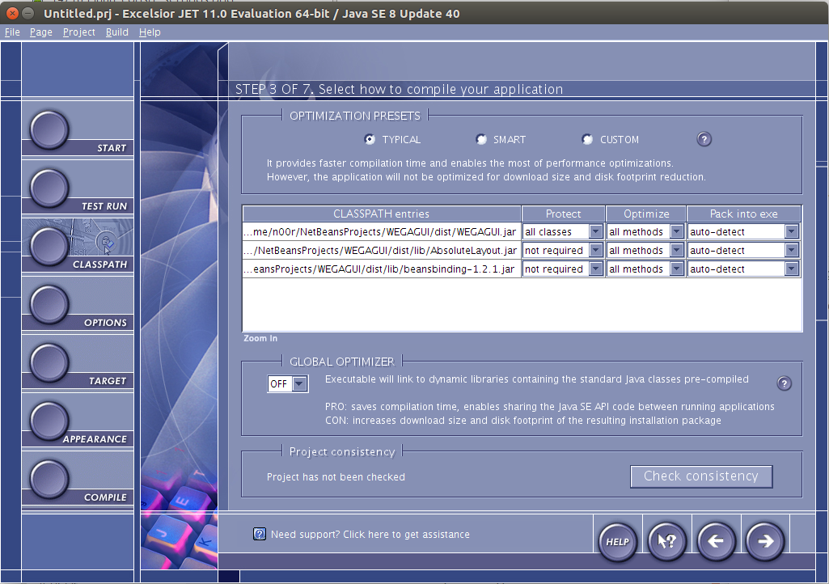

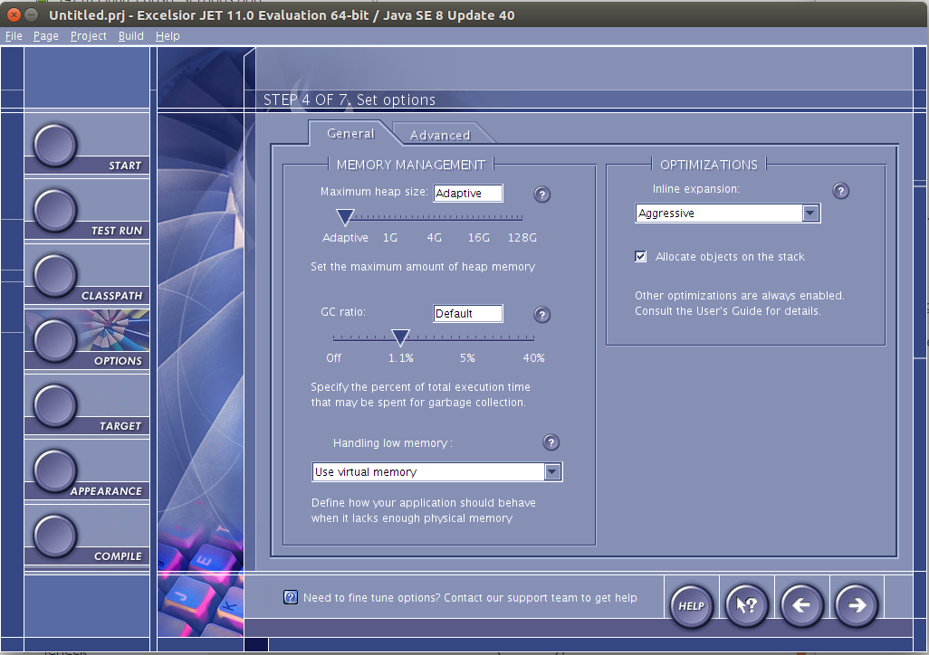

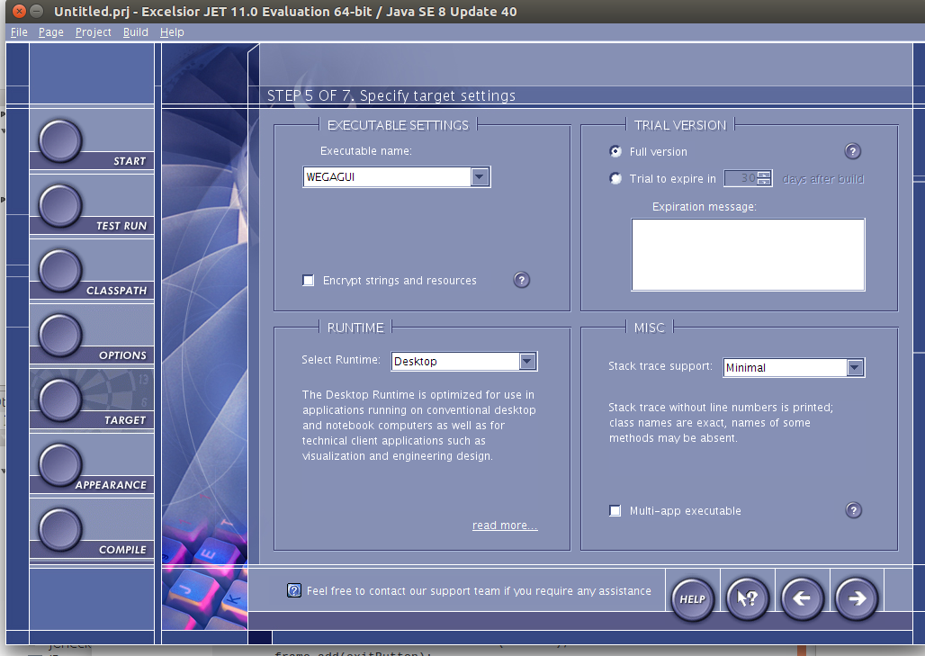

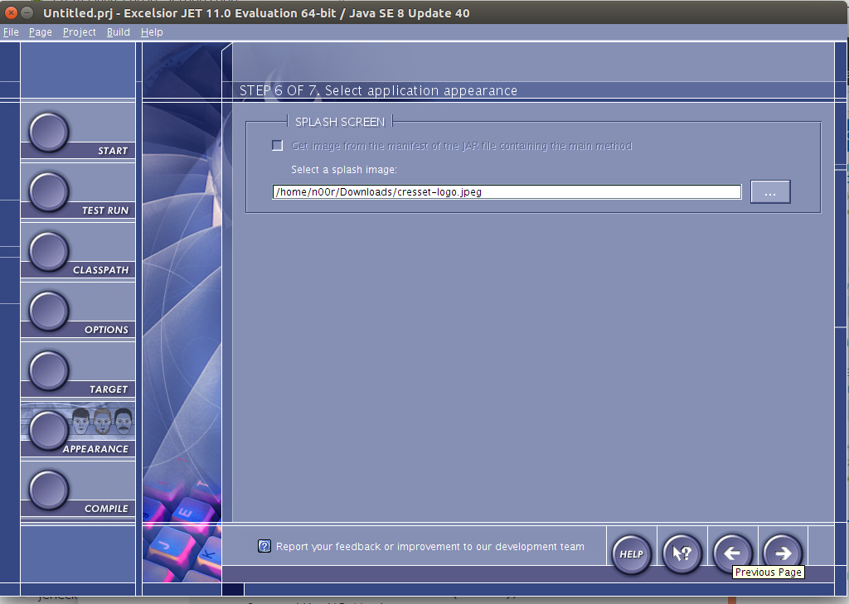

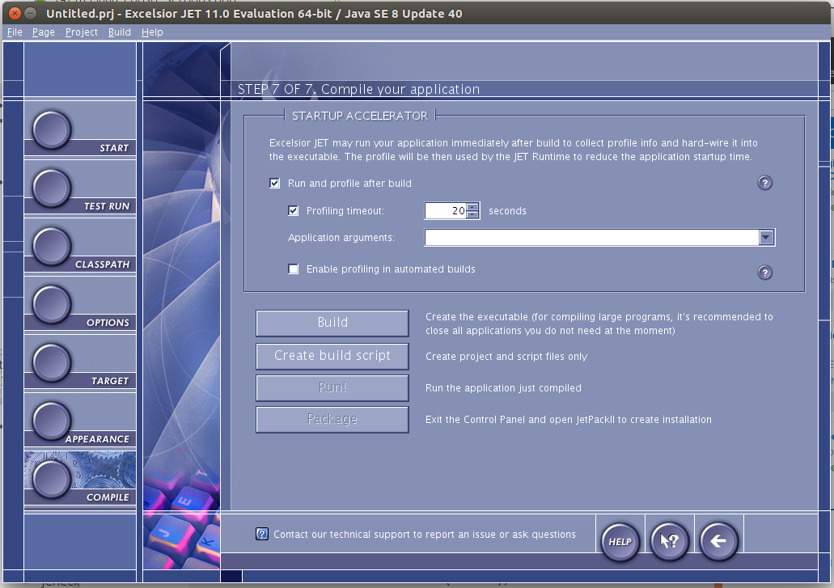

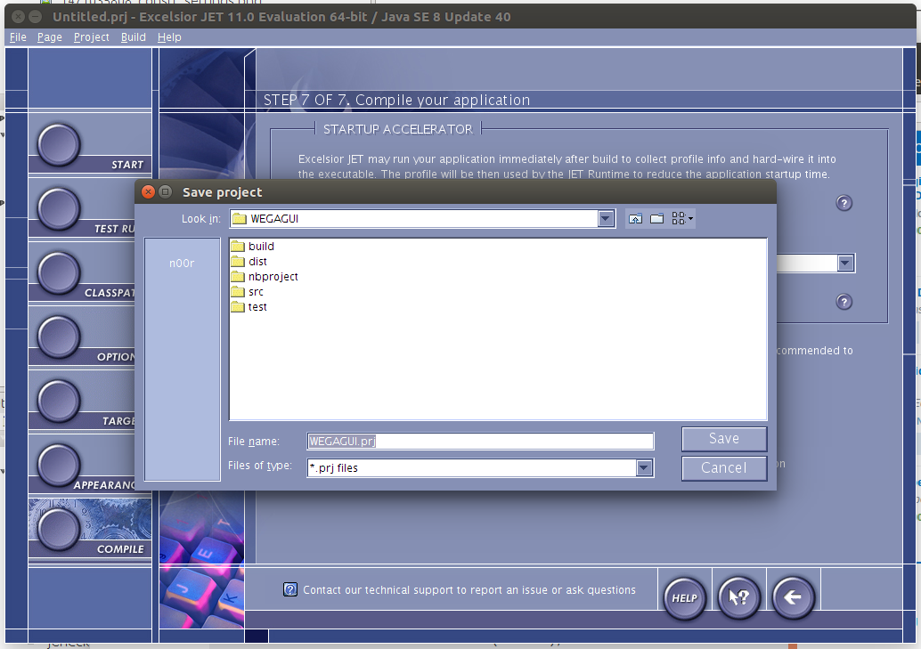

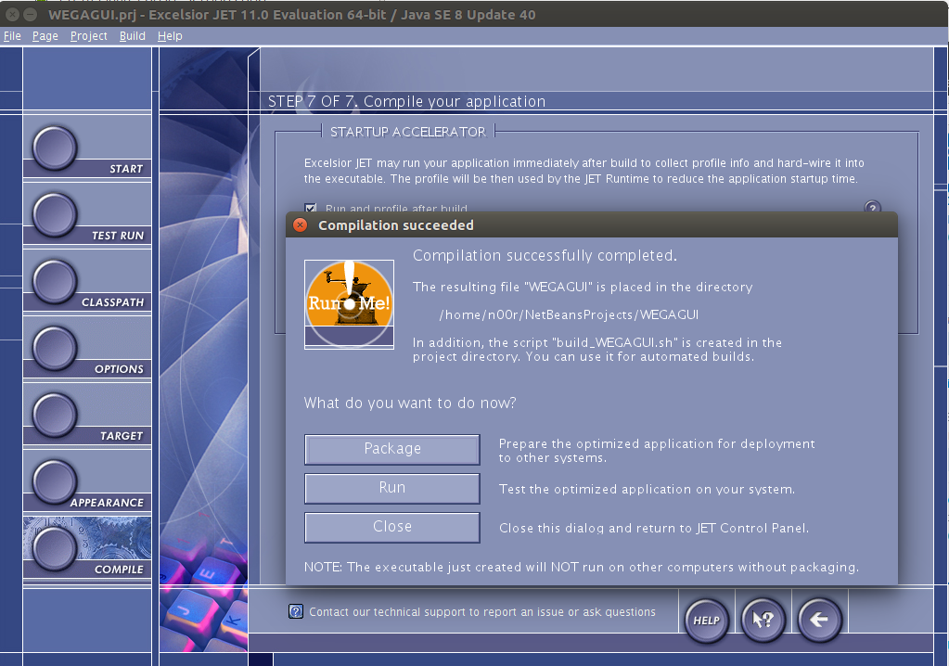

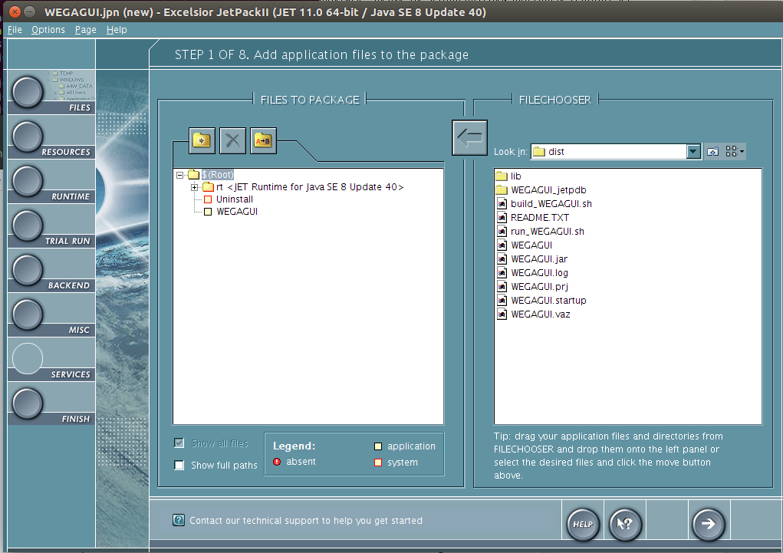

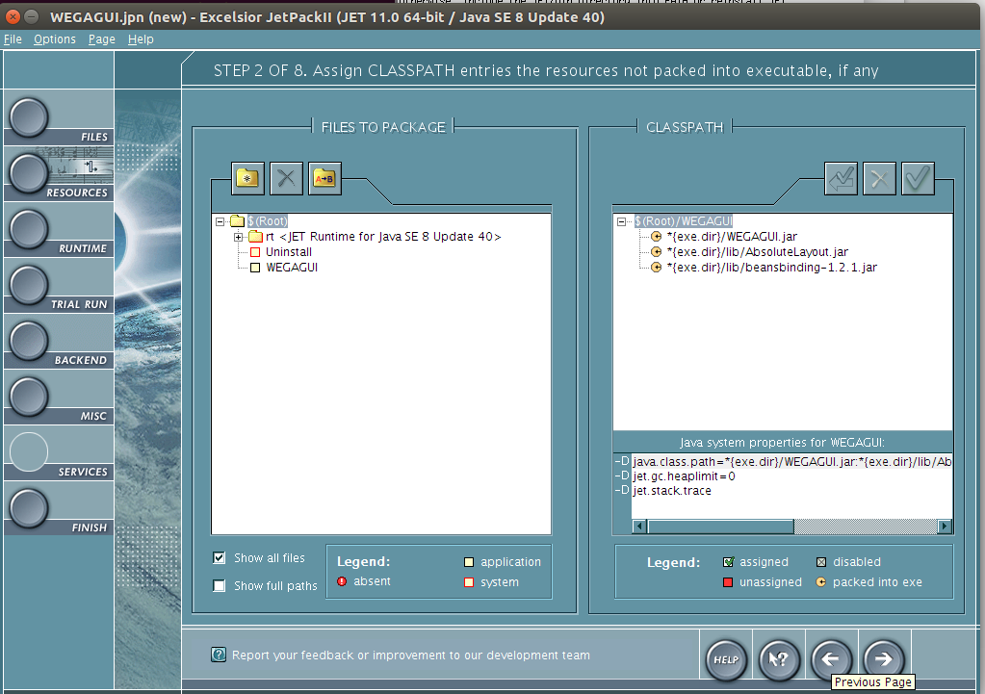

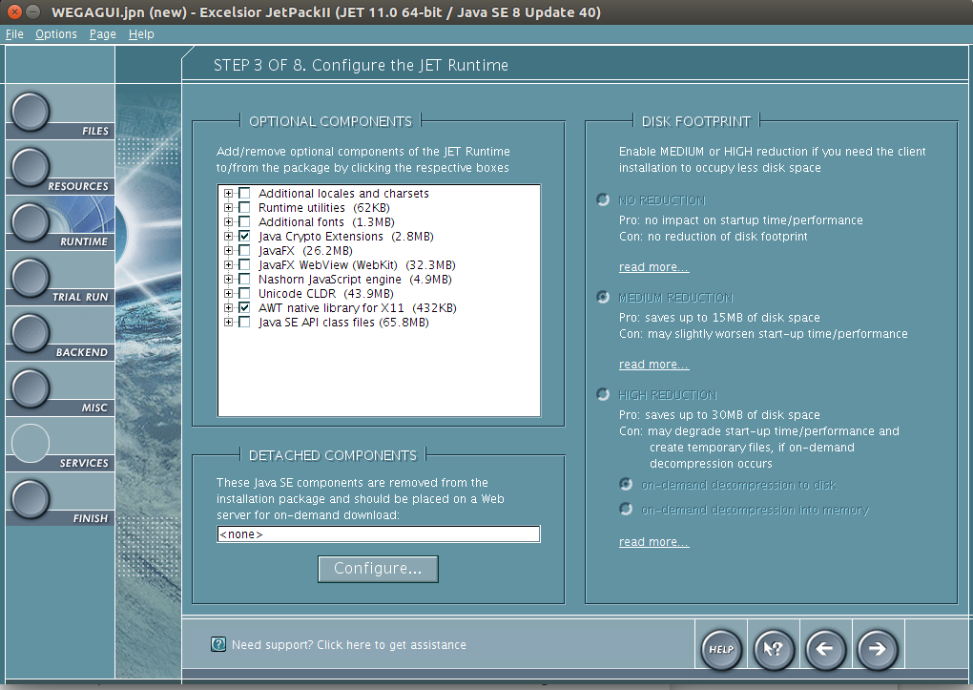

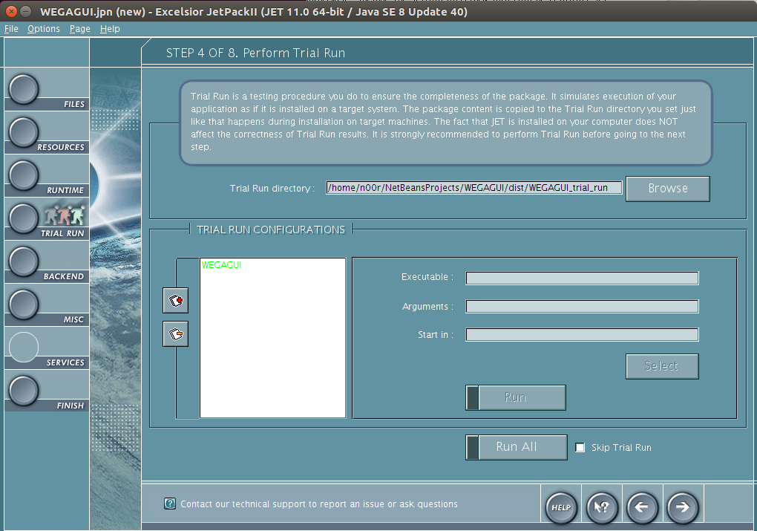

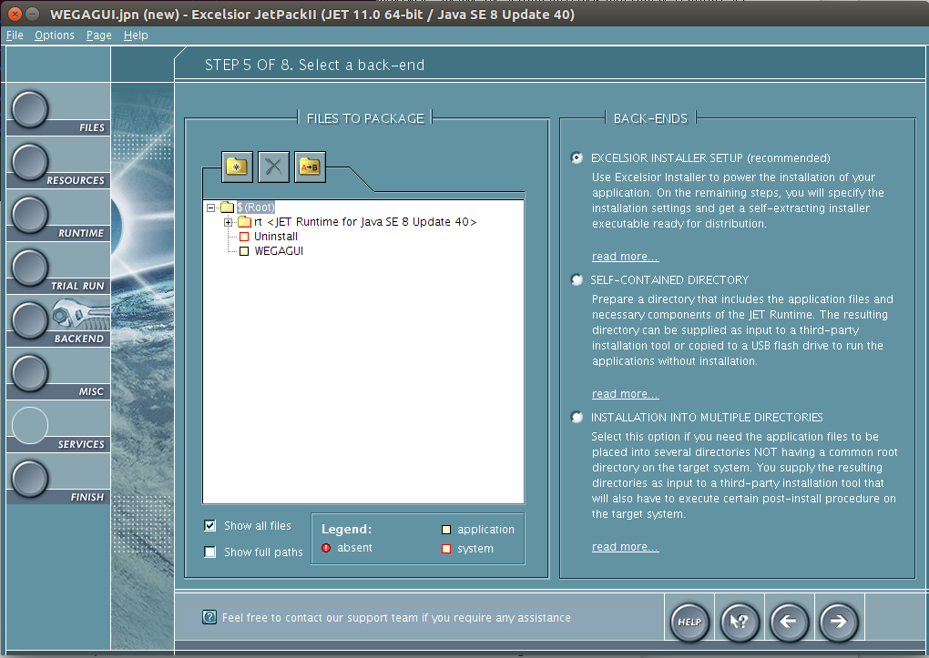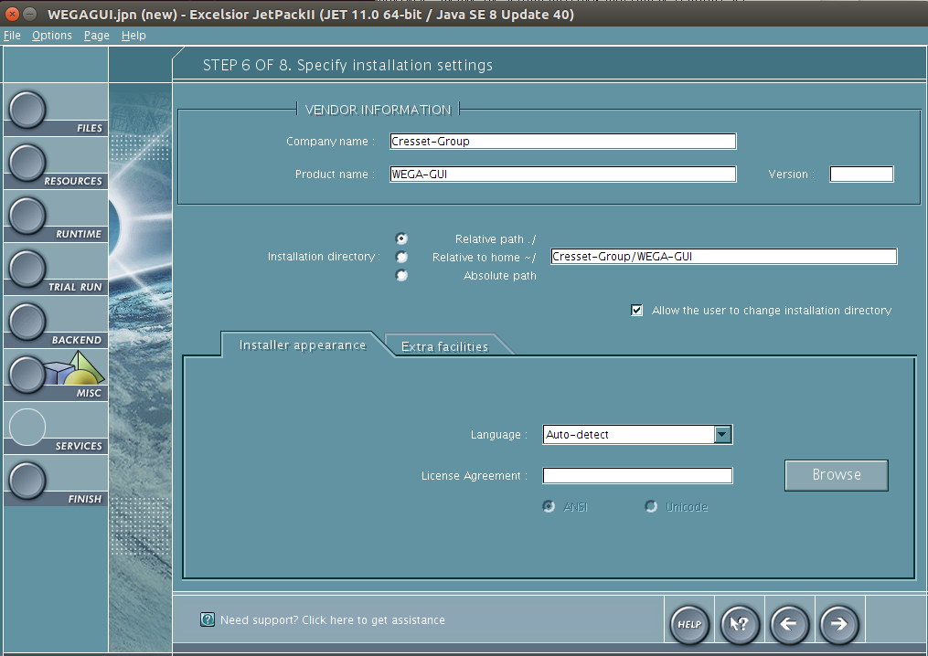

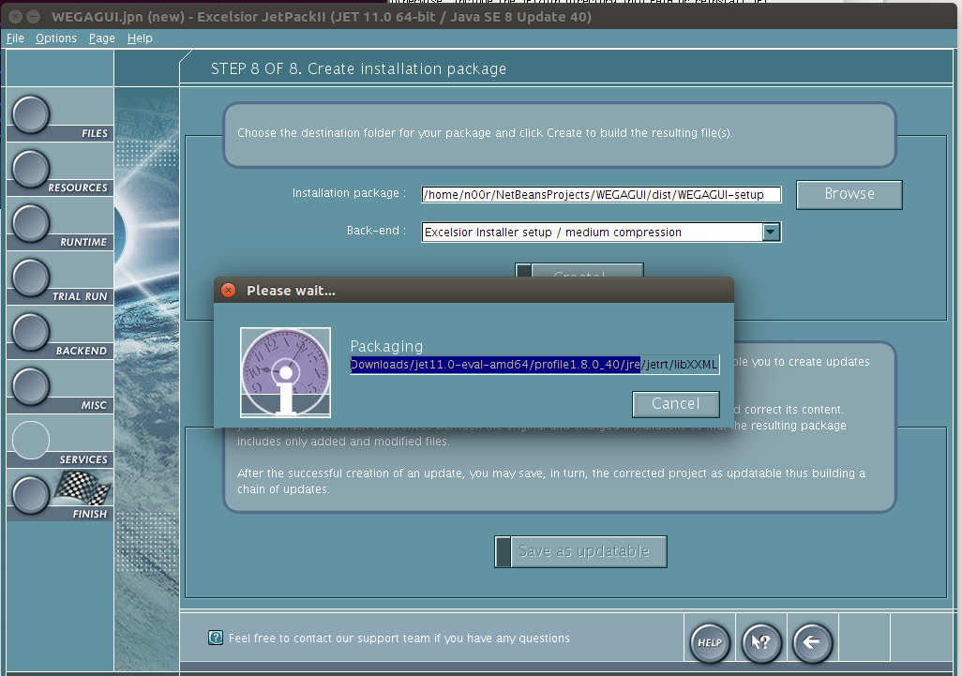

**Appendix 4: Build Mockups for WEGA GUI**

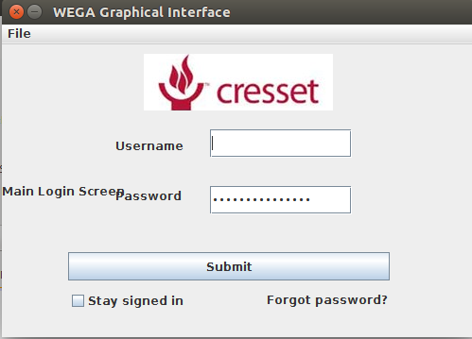

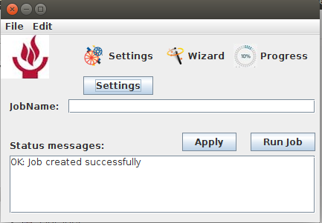

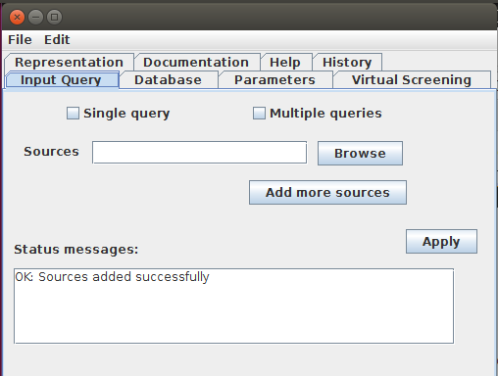

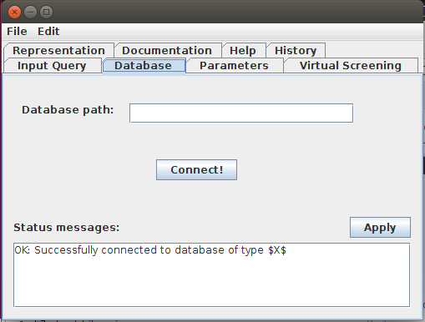

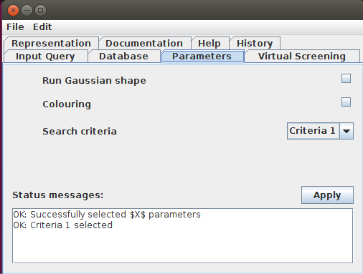

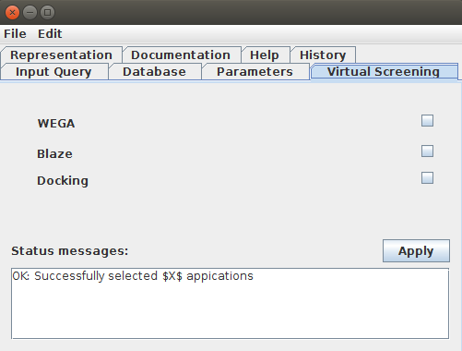

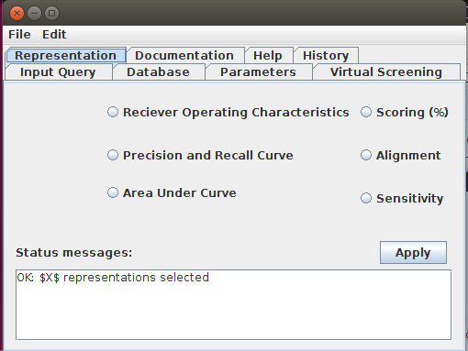

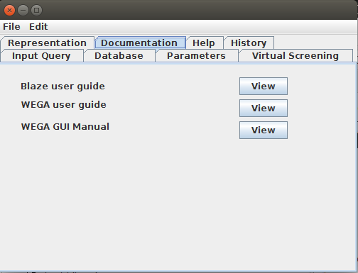

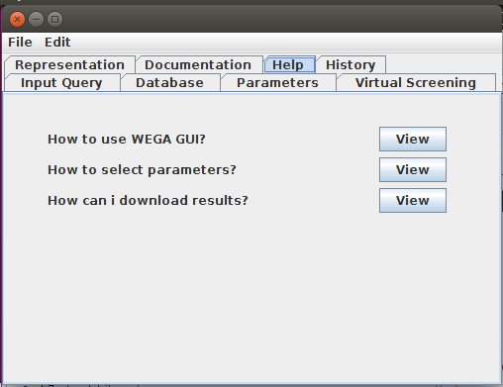

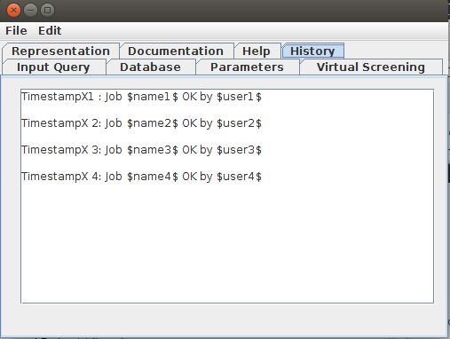

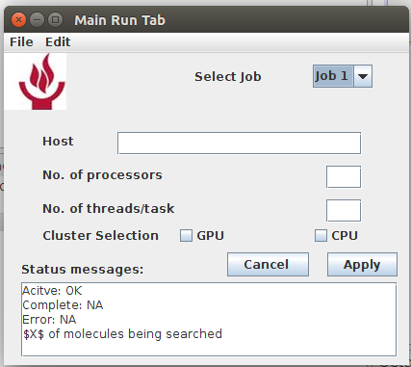

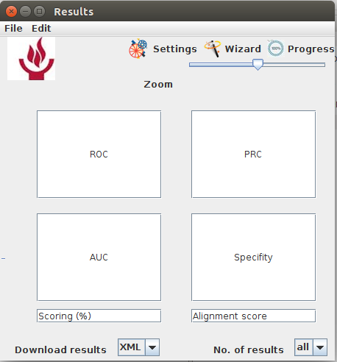

**Appendix 4: Build Mockups Code**

**StartGUI.java**

**/\***

**Author: Kanza Noor**

**Date: 2016/08/01**

**\*/**

**package guiPackage;**

**import java.awt.Toolkit;**

**import java.awt.event.WindowEvent;**

**import javax.swing.ImageIcon;**

**/\*\***

**\***

**\* @author KanzaNoor**

**\*/**

**public class StartGUI extends javax.swing.JFrame {**

**/\*\***

**\* Creates new form StartGUI**

**\*/**

**public StartGUI() {**

**initComponents();**

**this.setIconImage(new ImageIcon(getClass().getResource("cresetLogo.png")).getImage());**

**}**

**/\*\***

**or.**

**\*/**

**@SuppressWarnings("unchecked")**

**// <editor-fold defaultstate="collapsed" desc="Generated Code">**

**private void initComponents() {**

**jPanel1 = new javax.swing.JPanel();**

**jLabel1 = new javax.swing.JLabel();**

**jLabel2 = new javax.swing.JLabel();**

**jButton1 = new javax.swing.JButton();**

**jTextField2 = new javax.swing.JTextField();**

**jCheckBox1 = new javax.swing.JCheckBox();**

**jPasswordField1 = new javax.swing.JPasswordField();**

**jLabel3 = new javax.swing.JLabel();**

**jLabel5 = new javax.swing.JLabel();**

**jLabel4 = new javax.swing.JLabel();**

**jMenuBar1 = new javax.swing.JMenuBar();**

**jMenu1 = new javax.swing.JMenu();**

**jMenuItem1 = new javax.swing.JMenuItem();**

**jMenu2 = new javax.swing.JMenu();**

**javax.swing.GroupLayout jPanel1Layout = new javax.swing.GroupLayout(jPanel1);**

**jPanel1.setLayout(jPanel1Layout);**

**jPanel1Layout.setHorizontalGroup(**

**jPanel1Layout.createParallelGroup(javax.swing.GroupLayout.Alignment.LEADING)**

**.addGap(0, 100, Short.MAX_VALUE)**

**);**

**jPanel1Layout.setVerticalGroup(**

**jPanel1Layout.createParallelGroup(javax.swing.GroupLayout.Alignment.LEADING)**

**.addGap(0, 100, Short.MAX_VALUE)**

**);**

**setDefaultCloseOperation(javax.swing.WindowConstants.EXIT_ON_CLOSE);**

**setTitle("WEGA Graphical Interface");**

**setResizable(false);**

**getContentPane().setLayout(new org.netbeans.lib.awtextra.AbsoluteLayout());**

**jLabel1.setText("Username");**

**getContentPane().add(jLabel1, new org.netbeans.lib.awtextra.AbsoluteConstraints(120, 100, -1, -1));**

**jLabel2.setText("Password");**

**getContentPane().add(jLabel2, new org.netbeans.lib.awtextra.AbsoluteConstraints(120, 140, 150, 40));**

**jButton1.setText("Submit");**

**jButton1.addActionListener(new java.awt.event.ActionListener() {**

**public void actionPerformed(java.awt.event.ActionEvent evt) {**

**jButton1ActionPerformed(evt);**

**}**

**});**

**getContentPane().add(jButton1, new org.netbeans.lib.awtextra.AbsoluteConstraints(70, 220, 340, 30));**

**getContentPane().add(jTextField2, new org.netbeans.lib.awtextra.AbsoluteConstraints(220, 90, 150, 30));**

**jCheckBox1.setText("Stay signed in");**

**getContentPane().add(jCheckBox1, new org.netbeans.lib.awtextra.AbsoluteConstraints(70, 260, -1, -1));**

**jPasswordField1.setText("jPasswordField1");**

**getContentPane().add(jPasswordField1, new org.netbeans.lib.awtextra.AbsoluteConstraints(220, 150, 150, 30));**

**jLabel3.setText("Forgot password?");**

**getContentPane().add(jLabel3, new org.netbeans.lib.awtextra.AbsoluteConstraints(280, 260, 130, 20));**

**jLabel5.setIcon(new javax.swing.ImageIcon(getClass().getResource("/guiPackage/cresetLogo.png"))); // NOI18N**

**getContentPane().add(jLabel5, new org.netbeans.lib.awtextra.AbsoluteConstraints(150, 10, 200, 60));**

**jLabel4.setText("Main Login Screen");**

**jLabel4.setToolTipText("Enter you login informatin");**

**getContentPane().add(jLabel4, new org.netbeans.lib.awtextra.AbsoluteConstraints(0, 0, 500, 310));**

**jMenu1.setText("File");**

**jMenuItem1.setText("Close");**

**jMenu1.add(jMenuItem1);**

**jMenuBar1.add(jMenu1);**

**jMenuBar1.add(jMenu2);**

**setJMenuBar(jMenuBar1);**

**pack();**

**setLocationRelativeTo(null);**

**}// </editor-fold>**

**private void jButton1ActionPerformed(java.awt.event.ActionEvent evt) {**

**MasterInterface pg1 = new MasterInterface();**

**pg1.setVisible(true);**

**}**

**public void close(){**

**WindowEvent winClosingEvent = new WindowEvent(this,WindowEvent.WINDOW_CLOSING);**

**Toolkit.getDefaultToolkit().getSystemEventQueue().postEvent(winClosingEvent);**

**}**

**/\*\***

**\*/**

**public static void main(String args[]) {**

**//<editor-fold defaultstate="collapsed" desc=" Look and feel setting code (optional) ">**

**/* If Nimbus (introduced in Java SE 6) is not available, stay with the default look and feel.**

**\* For details see http://download.oracle.com/javase/tutorial/uiswing/lookandfeel/plaf.html**

**\*/**

**try {**

**for (javax.swing.UIManager.LookAndFeelInfo info : javax.swing.UIManager.getInstalledLookAndFeels()) {**

**if ("Windows".equals(info.getName())) {**

**javax.swing.UIManager.setLookAndFeel(info.getClassName());**

**break;**

**}**

**}**

**} catch (ClassNotFoundException ex) {**

**java.util.logging.Logger.getLogger(StartGUI.class.getName()).log(java.util.logging.Level.SEVERE, null, ex);**

**} catch (InstantiationException ex) {**

**java.util.logging.Logger.getLogger(StartGUI.class.getName()).log(java.util.logging.Level.SEVERE, null, ex);**

**} catch (IllegalAccessException ex) {**

**java.util.logging.Logger.getLogger(StartGUI.class.getName()).log(java.util.logging.Level.SEVERE, null, ex);**

**} catch (javax.swing.UnsupportedLookAndFeelException ex) {**

**java.util.logging.Logger.getLogger(StartGUI.class.getName()).log(java.util.logging.Level.SEVERE, null, ex);**

**}**

**//</editor-fold>**

**/* Create and display the form */**

**java.awt.EventQueue.invokeLater(new Runnable() {**

**public void run() {**

**new StartGUI().setVisible(true);**

**}**

**});**

**}**

**// Variables declaration - do not modify**

**private javax.swing.JButton jButton1;**

**private javax.swing.JCheckBox jCheckBox1;**

**private javax.swing.JLabel jLabel1;**

**private javax.swing.JLabel jLabel2;**

**private javax.swing.JLabel jLabel3;**

**private javax.swing.JLabel jLabel4;**

**private javax.swing.JLabel jLabel5;**

**private javax.swing.JMenu jMenu1;**

**private javax.swing.JMenu jMenu2;**

**private javax.swing.JMenuBar jMenuBar1;**

**private javax.swing.JMenuItem jMenuItem1;**

**private javax.swing.JPanel jPanel1;**

**private javax.swing.JPasswordField jPasswordField1;**

**private javax.swing.JTextField jTextField2;**

**// End of variables declaration**

**}**

**JobStartup_Pg.java**

**/\***

**Author: Kanza Noor**

**Date: 2016/08/01plate in the editor.**

**\*/**

**package guiPackage;**

**/\*\***

**\***

**\* @author KanzaNoor**

**\*/**

**public class JobStartup_pg extends javax.swing.JFrame {**

**public JobStartup_pg() {**

**initComponents();**

**}**

**/\*\***

**\* This method is called from within the constructor to initialize the form.**

**\* WARNING: Do NOT modify this code. The content of this method is always**

**\* regenerated by the Form Editor.**

**\*/**

**@SuppressWarnings("unchecked")**

**// <editor-fold defaultstate="collapsed" desc="Generated Code">**

**private void initComponents() {**

**jTabbedPane1 = new javax.swing.JTabbedPane();**

**jPanel1 = new javax.swing.JPanel();**

**jLabel1 = new javax.swing.JLabel();**

**jScrollPane1 = new javax.swing.JScrollPane();**

**jTextPane1 = new javax.swing.JTextPane();**

**jButton1 = new javax.swing.JButton();**

**jCheckBox1 = new javax.swing.JCheckBox();**

**jCheckBox2 = new javax.swing.JCheckBox();**

**jButton2 = new javax.swing.JButton();**

**jScrollPane3 = new javax.swing.JScrollPane();**

**jTextArea1 = new javax.swing.JTextArea();**

**jLabel2 = new javax.swing.JLabel();**

**jButton4 = new javax.swing.JButton();**

**jPanel2 = new javax.swing.JPanel();**

**jLabel4 = new javax.swing.JLabel();**

**jScrollPane2 = new javax.swing.JScrollPane();**

**jTextPane2 = new javax.swing.JTextPane();**

**jButton3 = new javax.swing.JButton();**

**jScrollPane4 = new javax.swing.JScrollPane();**

**jTextArea2 = new javax.swing.JTextArea();**

**jLabel5 = new javax.swing.JLabel();**

**jButton6 = new javax.swing.JButton();**

**jPanel3 = new javax.swing.JPanel();**

**jLabel6 = new javax.swing.JLabel();**

**jScrollPane5 = new javax.swing.JScrollPane();**

**jTextArea3 = new javax.swing.JTextArea();**

**jCheckBox3 = new javax.swing.JCheckBox();**

**jLabel3 = new javax.swing.JLabel();**

**jLabel7 = new javax.swing.JLabel();**

**jCheckBox4 = new javax.swing.JCheckBox();**

**jLabel8 = new javax.swing.JLabel();**

**jComboBox1 = new javax.swing.JComboBox<>();**

**jButton5 = new javax.swing.JButton();**

**jPanel4 = new javax.swing.JPanel();**

**jLabel9 = new javax.swing.JLabel();**

**jLabel10 = new javax.swing.JLabel();**

**jCheckBox5 = new javax.swing.JCheckBox();**

**jCheckBox6 = new javax.swing.JCheckBox();**

**jLabel11 = new javax.swing.JLabel();**

**jCheckBox7 = new javax.swing.JCheckBox();**

**jScrollPane6 = new javax.swing.JScrollPane();**

**jTextArea4 = new javax.swing.JTextArea();**

**jLabel12 = new javax.swing.JLabel();**

**jButton7 = new javax.swing.JButton();**

**jPanel5 = new javax.swing.JPanel();**

**jRadioButton1 = new javax.swing.JRadioButton();**

**jRadioButton2 = new javax.swing.JRadioButton();**

**jRadioButton3 = new javax.swing.JRadioButton();**

**jScrollPane7 = new javax.swing.JScrollPane();**

**jTextArea5 = new javax.swing.JTextArea();**

**jLabel13 = new javax.swing.JLabel();**

**jButton8 = new javax.swing.JButton();**

**jRadioButton4 = new javax.swing.JRadioButton();**

**jRadioButton5 = new javax.swing.JRadioButton();**

**jRadioButton6 = new javax.swing.JRadioButton();**

**jPanel6 = new javax.swing.JPanel();**

**jLabel14 = new javax.swing.JLabel();**

**jButton9 = new javax.swing.JButton();**

**jLabel15 = new javax.swing.JLabel();**

**jButton10 = new javax.swing.JButton();**

**jLabel16 = new javax.swing.JLabel();**

**jButton11 = new javax.swing.JButton();**

**jPanel7 = new javax.swing.JPanel();**

**jLabel17 = new javax.swing.JLabel();**

**jButton12 = new javax.swing.JButton();**

**jLabel18 = new javax.swing.JLabel();**

**jButton13 = new javax.swing.JButton();**

**jLabel19 = new javax.swing.JLabel();**

**jButton14 = new javax.swing.JButton();**

**jPanel8 = new javax.swing.JPanel();**

**jScrollPane8 = new javax.swing.JScrollPane();**

**jTextArea6 = new javax.swing.JTextArea();**

**jMenuBar1 = new javax.swing.JMenuBar();**

**jMenu1 = new javax.swing.JMenu();**

**jMenu2 = new javax.swing.JMenu();**

**setDefaultCloseOperation(javax.swing.WindowConstants.EXIT_ON_CLOSE);**

**jPanel1.setLayout(new org.netbeans.lib.awtextra.AbsoluteLayout());**

**jLabel1.setText("Sources");**

**jPanel1.add(jLabel1, new org.netbeans.lib.awtextra.AbsoluteConstraints(20, 40, 60, 40));**

**jScrollPane1.setViewportView(jTextPane1);**

**jPanel1.add(jScrollPane1, new org.netbeans.lib.awtextra.AbsoluteConstraints(90, 50, 220, -1));**

**jButton1.setText("Browse");**

**jPanel1.add(jButton1, new org.netbeans.lib.awtextra.AbsoluteConstraints(320, 50, -1, -1));**

**jCheckBox1.setText("Multiple queries");**

**jPanel1.add(jCheckBox1, new org.netbeans.lib.awtextra.AbsoluteConstraints(250, 10, -1, -1));**

**jCheckBox2.setText("Single query");**

**jCheckBox2.addActionListener(new java.awt.event.ActionListener() {**

**public void actionPerformed(java.awt.event.ActionEvent evt) {**

**jCheckBox2ActionPerformed(evt);**

**}**

**});**

**jPanel1.add(jCheckBox2, new org.netbeans.lib.awtextra.AbsoluteConstraints(60, 10, -1, -1));**

**jButton2.setText("Add more sources");**

**jPanel1.add(jButton2, new org.netbeans.lib.awtextra.AbsoluteConstraints(250, 90, -1, -1));**

**jTextArea1.setColumns(20);**

**jTextArea1.setRows(5);**

**jTextArea1.setText("OK: Sources added successfully");**

**jScrollPane3.setViewportView(jTextArea1);**

**jPanel1.add(jScrollPane3, new org.netbeans.lib.awtextra.AbsoluteConstraints(10, 180, 450, -1));**

**jLabel2.setText("Status messages:");**

**jPanel1.add(jLabel2, new org.netbeans.lib.awtextra.AbsoluteConstraints(10, 150, 290, 20));**

**jButton4.setText("Apply");**

**jButton4.addActionListener(new java.awt.event.ActionListener() {**

**public void actionPerformed(java.awt.event.ActionEvent evt) {**

**jButton4ActionPerformed(evt);**

**}**

**});**

**jPanel1.add(jButton4, new org.netbeans.lib.awtextra.AbsoluteConstraints(410, 140, -1, -1));**

**jTabbedPane1.addTab("Input Query", jPanel1);**

**jLabel4.setText("Database path:");**

**jScrollPane2.setViewportView(jTextPane2);**

**jButton3.setText("Connect!");**

**jTextArea2.setColumns(20);**

**jTextArea2.setRows(5);**

**jTextArea2.setText("OK: Successfully connected to database of type $X$");**

**jScrollPane4.setViewportView(jTextArea2);**

**jLabel5.setText("Status messages:");**

**jButton6.setText("Apply");**

**jButton6.addActionListener(new java.awt.event.ActionListener() {**

**public void actionPerformed(java.awt.event.ActionEvent evt) {**

**jButton6ActionPerformed(evt);**

**}**

**});**

**javax.swing.GroupLayout jPanel2Layout = new javax.swing.GroupLayout(jPanel2);**

**jPanel2.setLayout(jPanel2Layout);**

**jPanel2Layout.setHorizontalGroup(**

**jPanel2Layout.createParallelGroup(javax.swing.GroupLayout.Alignment.LEADING)**

**.addGroup(jPanel2Layout.createSequentialGroup()**

**.addGroup(jPanel2Layout.createParallelGroup(javax.swing.GroupLayout.Alignment.LEADING)**

**.addGroup(jPanel2Layout.createSequentialGroup()**

**.addGroup(jPanel2Layout.createParallelGroup(javax.swing.GroupLayout.Alignment.LEADING)**

**.addGroup(jPanel2Layout.createSequentialGroup()**

**.addGap(22, 22, 22)**

**.addComponent(jLabel4)**

**.addGap(18, 18, 18)**

**.addComponent(jScrollPane2, javax.swing.GroupLayout.PREFERRED_SIZE, 269, javax.swing.GroupLayout.PREFERRED_SIZE))**

**.addGroup(jPanel2Layout.createSequentialGroup()**

**.addGap(183, 183, 183)**

**.addComponent(jButton3)))**

**.addGap(0, 45, Short.MAX_VALUE))**

**.addGroup(jPanel2Layout.createSequentialGroup()**

**.addContainerGap()**

**.addGroup(jPanel2Layout.createParallelGroup(javax.swing.GroupLayout.Alignment.LEADING)**

**.addGroup(jPanel2Layout.createSequentialGroup()**

**.addComponent(jLabel5)**

**.addPreferredGap(javax.swing.LayoutStyle.ComponentPlacement.RELATED, javax.swing.GroupLayout.DEFAULT_SIZE, Short.MAX_VALUE)**

**.addComponent(jButton6))**

**.addComponent(jScrollPane4))))**

**.addContainerGap())**

**);**

**jPanel2Layout.setVerticalGroup(**

**jPanel2Layout.createParallelGroup(javax.swing.GroupLayout.Alignment.LEADING)**

**.addGroup(jPanel2Layout.createSequentialGroup()**

**.addGap(33, 33, 33)**

**.addGroup(jPanel2Layout.createParallelGroup(javax.swing.GroupLayout.Alignment.LEADING)**

**.addComponent(jScrollPane2, javax.swing.GroupLayout.PREFERRED_SIZE, javax.swing.GroupLayout.DEFAULT_SIZE, javax.swing.GroupLayout.PREFERRED_SIZE)**

**.addComponent(jLabel4))**

**.addGap(43, 43, 43)**

**.addComponent(jButton3)**

**.addPreferredGap(javax.swing.LayoutStyle.ComponentPlacement.RELATED, javax.swing.GroupLayout.DEFAULT_SIZE, Short.MAX_VALUE)**

**.addGroup(jPanel2Layout.createParallelGroup(javax.swing.GroupLayout.Alignment.LEADING)**

**.addComponent(jLabel5, javax.swing.GroupLayout.Alignment.TRAILING)**

**.addComponent(jButton6))**

**.addPreferredGap(javax.swing.LayoutStyle.ComponentPlacement.RELATED)**

**.addComponent(jScrollPane4, javax.swing.GroupLayout.PREFERRED_SIZE, javax.swing.GroupLayout.DEFAULT_SIZE, javax.swing.GroupLayout.PREFERRED_SIZE)**

**.addContainerGap())**

**);**

**jTabbedPane1.addTab("Database", jPanel2);**

**jLabel6.setText("Status messages:");**

**jTextArea3.setColumns(20);**

**jTextArea3.setRows(5);**

**jTextArea3.setText("OK: Successfully selected $X$ parameters\nOK: Criteria 1 selected");**

**jScrollPane5.setViewportView(jTextArea3);**

**jLabel3.setText("Run Gaussian shape");**

**jLabel7.setText("Colouring");**

**jLabel8.setText("Search criteria");**

**jComboBox1.setModel(new javax.swing.DefaultComboBoxModel<>(new String[] { "Criteria 1", "Criteria 2", "Criteria 3", "Criteria 4" }));**

**jComboBox1.addActionListener(new java.awt.event.ActionListener() {**

**public void actionPerformed(java.awt.event.ActionEvent evt) {**

**jComboBox1ActionPerformed(evt);**

**}**

**});**

**jButton5.setText("Apply");**

**jButton5.addActionListener(new java.awt.event.ActionListener() {**

**public void actionPerformed(java.awt.event.ActionEvent evt) {**

**jButton5ActionPerformed(evt);**

**}**

**});**

**javax.swing.GroupLayout jPanel3Layout = new javax.swing.GroupLayout(jPanel3);**

**jPanel3.setLayout(jPanel3Layout);**

**jPanel3Layout.setHorizontalGroup(**

**jPanel3Layout.createParallelGroup(javax.swing.GroupLayout.Alignment.LEADING)**

**.addGroup(jPanel3Layout.createSequentialGroup()**

**.addGroup(jPanel3Layout.createParallelGroup(javax.swing.GroupLayout.Alignment.LEADING)**

**.addGroup(javax.swing.GroupLayout.Alignment.TRAILING, jPanel3Layout.createSequentialGroup()**

**.addContainerGap()**

**.addGroup(jPanel3Layout.createParallelGroup(javax.swing.GroupLayout.Alignment.LEADING)**

**.addComponent(jScrollPane5, javax.swing.GroupLayout.DEFAULT_SIZE, 447, Short.MAX_VALUE)**

**.addGroup(jPanel3Layout.createSequentialGroup()**

**.addComponent(jLabel6)**

**.addPreferredGap(javax.swing.LayoutStyle.ComponentPlacement.RELATED, javax.swing.GroupLayout.DEFAULT_SIZE, Short.MAX_VALUE)**

**.addComponent(jButton5))))**

**.addGroup(jPanel3Layout.createSequentialGroup()**

**.addGap(54, 54, 54)**

**.addGroup(jPanel3Layout.createParallelGroup(javax.swing.GroupLayout.Alignment.LEADING)**

**.addGroup(jPanel3Layout.createSequentialGroup()**

**.addComponent(jLabel8)**

**.addPreferredGap(javax.swing.LayoutStyle.ComponentPlacement.RELATED, javax.swing.GroupLayout.DEFAULT_SIZE, Short.MAX_VALUE)**

**.addComponent(jComboBox1, javax.swing.GroupLayout.PREFERRED_SIZE, javax.swing.GroupLayout.DEFAULT_SIZE, javax.swing.GroupLayout.PREFERRED_SIZE))**

**.addGroup(jPanel3Layout.createSequentialGroup()**

**.addComponent(jLabel7)**

**.addPreferredGap(javax.swing.LayoutStyle.ComponentPlacement.RELATED, javax.swing.GroupLayout.DEFAULT_SIZE, Short.MAX_VALUE)**

**.addComponent(jCheckBox4))**

**.addGroup(jPanel3Layout.createSequentialGroup()**

**.addComponent(jLabel3)**

**.addPreferredGap(javax.swing.LayoutStyle.ComponentPlacement.RELATED, javax.swing.GroupLayout.DEFAULT_SIZE, Short.MAX_VALUE)**

**.addComponent(jCheckBox3)))))**

**.addContainerGap())**

**);**

**jPanel3Layout.setVerticalGroup(**

**jPanel3Layout.createParallelGroup(javax.swing.GroupLayout.Alignment.LEADING)**

**.addGroup(javax.swing.GroupLayout.Alignment.TRAILING, jPanel3Layout.createSequentialGroup()**

**.addContainerGap()**

**.addGroup(jPanel3Layout.createParallelGroup(javax.swing.GroupLayout.Alignment.TRAILING)**

**.addComponent(jCheckBox3)**

**.addComponent(jLabel3))**

**.addGap(12, 12, 12)**

**.addGroup(jPanel3Layout.createParallelGroup(javax.swing.GroupLayout.Alignment.TRAILING)**

**.addComponent(jCheckBox4)**

**.addComponent(jLabel7))**

**.addGap(18, 18, 18)**

**.addGroup(jPanel3Layout.createParallelGroup(javax.swing.GroupLayout.Alignment.BASELINE)**

**.addComponent(jLabel8)**

**.addComponent(jComboBox1, javax.swing.GroupLayout.PREFERRED_SIZE, javax.swing.GroupLayout.DEFAULT_SIZE, javax.swing.GroupLayout.PREFERRED_SIZE))**

**.addPreferredGap(javax.swing.LayoutStyle.ComponentPlacement.RELATED, 20, Short.MAX_VALUE)**

**.addGroup(jPanel3Layout.createParallelGroup(javax.swing.GroupLayout.Alignment.BASELINE)**

**.addComponent(jLabel6)**

**.addComponent(jButton5))**

**.addPreferredGap(javax.swing.LayoutStyle.ComponentPlacement.RELATED)**

**.addComponent(jScrollPane5, javax.swing.GroupLayout.PREFERRED_SIZE, javax.swing.GroupLayout.DEFAULT_SIZE, javax.swing.GroupLayout.PREFERRED_SIZE)**

**.addContainerGap())**

**);**

**jTabbedPane1.addTab("Parameters", jPanel3);**

**jLabel9.setText("WEGA");**

**jLabel10.setText("Blaze");**

**jLabel11.setText("Docking");**

**jTextArea4.setColumns(20);**

**jTextArea4.setRows(5);**

**jTextArea4.setText("OK: Successfully selected $X$ appications\n");**

**jScrollPane6.setViewportView(jTextArea4);**

**jLabel12.setText("Status messages:");**

**jButton7.setText("Apply");**

**jButton7.addActionListener(new java.awt.event.ActionListener() {**

**public void actionPerformed(java.awt.event.ActionEvent evt) {**

**jButton7ActionPerformed(evt);**

**}**

**});**

**javax.swing.GroupLayout jPanel4Layout = new javax.swing.GroupLayout(jPanel4);**

**jPanel4.setLayout(jPanel4Layout);**

**jPanel4Layout.setHorizontalGroup(**

**jPanel4Layout.createParallelGroup(javax.swing.GroupLayout.Alignment.LEADING)**

**.addGroup(javax.swing.GroupLayout.Alignment.TRAILING, jPanel4Layout.createSequentialGroup()**

**.addGap(40, 40, 40)**

**.addGroup(jPanel4Layout.createParallelGroup(javax.swing.GroupLayout.Alignment.TRAILING)**

**.addGroup(jPanel4Layout.createSequentialGroup()**

**.addComponent(jLabel11)**

**.addPreferredGap(javax.swing.LayoutStyle.ComponentPlacement.RELATED, javax.swing.GroupLayout.DEFAULT_SIZE, Short.MAX_VALUE)**

**.addComponent(jCheckBox7))**

**.addGroup(javax.swing.GroupLayout.Alignment.LEADING, jPanel4Layout.createSequentialGroup()**

**.addComponent(jLabel10)**

**.addPreferredGap(javax.swing.LayoutStyle.ComponentPlacement.RELATED, javax.swing.GroupLayout.DEFAULT_SIZE, Short.MAX_VALUE)**

**.addComponent(jCheckBox5))**

**.addGroup(javax.swing.GroupLayout.Alignment.LEADING, jPanel4Layout.createSequentialGroup()**

**.addComponent(jLabel9)**

**.addPreferredGap(javax.swing.LayoutStyle.ComponentPlacement.RELATED, javax.swing.GroupLayout.DEFAULT_SIZE, Short.MAX_VALUE)**

**.addComponent(jCheckBox6)))**

**.addGap(26, 26, 26))**

**.addGroup(jPanel4Layout.createSequentialGroup()**

**.addContainerGap()**

**.addGroup(jPanel4Layout.createParallelGroup(javax.swing.GroupLayout.Alignment.LEADING)**

**.addComponent(jScrollPane6, javax.swing.GroupLayout.DEFAULT_SIZE, 447, Short.MAX_VALUE)**

**.addGroup(jPanel4Layout.createSequentialGroup()**

**.addComponent(jLabel12)**

**.addPreferredGap(javax.swing.LayoutStyle.ComponentPlacement.RELATED, javax.swing.GroupLayout.DEFAULT_SIZE, Short.MAX_VALUE)**

**.addComponent(jButton7)))**

**.addContainerGap())**

**);**

**jPanel4Layout.setVerticalGroup(**

**jPanel4Layout.createParallelGroup(javax.swing.GroupLayout.Alignment.LEADING)**

**.addGroup(jPanel4Layout.createSequentialGroup()**

**.addGap(30, 30, 30)**

**.addGroup(jPanel4Layout.createParallelGroup(javax.swing.GroupLayout.Alignment.TRAILING)**

**.addComponent(jCheckBox6)**

**.addComponent(jLabel9))**

**.addGap(12, 12, 12)**

**.addGroup(jPanel4Layout.createParallelGroup(javax.swing.GroupLayout.Alignment.TRAILING)**

**.addComponent(jCheckBox5)**

**.addComponent(jLabel10))**

**.addPreferredGap(javax.swing.LayoutStyle.ComponentPlacement.UNRELATED)**

**.addGroup(jPanel4Layout.createParallelGroup(javax.swing.GroupLayout.Alignment.TRAILING)**

**.addComponent(jCheckBox7)**

**.addComponent(jLabel11))**

**.addPreferredGap(javax.swing.LayoutStyle.ComponentPlacement.RELATED, 11, Short.MAX_VALUE)**

**.addGroup(jPanel4Layout.createParallelGroup(javax.swing.GroupLayout.Alignment.BASELINE)**

**.addComponent(jLabel12)**

**.addComponent(jButton7))**

**.addPreferredGap(javax.swing.LayoutStyle.ComponentPlacement.RELATED)**

**.addComponent(jScrollPane6, javax.swing.GroupLayout.PREFERRED_SIZE, javax.swing.GroupLayout.DEFAULT_SIZE, javax.swing.GroupLayout.PREFERRED_SIZE)**

**.addContainerGap())**

**);**

**jTabbedPane1.addTab("Virtual Screening", jPanel4);**

**jRadioButton1.setText("Reciever Operating Characteristics");**

**jRadioButton2.setText("Precision and Recall Curve");**

**jRadioButton3.setText("Area Under Curve");**

**jTextArea5.setColumns(20);**

**jTextArea5.setRows(5);**

**jTextArea5.setText("OK: $X$ representations selected");**

**jScrollPane7.setViewportView(jTextArea5);**

**jLabel13.setText("Status messages:");**

**jButton8.setText("Apply");**

**jButton8.addActionListener(new java.awt.event.ActionListener() {**

**public void actionPerformed(java.awt.event.ActionEvent evt) {**

**jButton8ActionPerformed(evt);**

**}**

**});**

**jRadioButton4.setText("Scoring (%)");**

**jRadioButton5.setText("Alignment");**

**jRadioButton6.setText("Sensitivity");**

**javax.swing.GroupLayout jPanel5Layout = new javax.swing.GroupLayout(jPanel5);**

**jPanel5.setLayout(jPanel5Layout);**

**jPanel5Layout.setHorizontalGroup(**

**jPanel5Layout.createParallelGroup(javax.swing.GroupLayout.Alignment.LEADING)**

**.addGroup(jPanel5Layout.createSequentialGroup()**

**.addContainerGap()**

**.addGroup(jPanel5Layout.createParallelGroup(javax.swing.GroupLayout.Alignment.LEADING)**

**.addGroup(javax.swing.GroupLayout.Alignment.TRAILING, jPanel5Layout.createSequentialGroup()**

**.addGap(0, 0, Short.MAX_VALUE)**

**.addGroup(jPanel5Layout.createParallelGroup(javax.swing.GroupLayout.Alignment.LEADING)**

**.addComponent(jRadioButton1)**

**.addComponent(jRadioButton2)**

**.addComponent(jRadioButton3))**

**.addPreferredGap(javax.swing.LayoutStyle.ComponentPlacement.UNRELATED)**

**.addGroup(jPanel5Layout.createParallelGroup(javax.swing.GroupLayout.Alignment.LEADING)**

**.addComponent(jRadioButton6)**

**.addComponent(jRadioButton5)**

**.addComponent(jRadioButton4)))**

**.addComponent(jScrollPane7)**

**.addGroup(jPanel5Layout.createSequentialGroup()**

**.addComponent(jLabel13, javax.swing.GroupLayout.PREFERRED_SIZE, 290, javax.swing.GroupLayout.PREFERRED_SIZE)**

**.addGap(107, 107, 107)**

**.addComponent(jButton8)))**

**.addContainerGap())**

**);**

**jPanel5Layout.setVerticalGroup(**

**jPanel5Layout.createParallelGroup(javax.swing.GroupLayout.Alignment.LEADING)**

**.addGroup(jPanel5Layout.createSequentialGroup()**

**.addGap(20, 20, 20)**

**.addGroup(jPanel5Layout.createParallelGroup(javax.swing.GroupLayout.Alignment.BASELINE)**

**.addComponent(jRadioButton1)**

**.addComponent(jRadioButton4))**

**.addGap(24, 24, 24)**

**.addGroup(jPanel5Layout.createParallelGroup(javax.swing.GroupLayout.Alignment.BASELINE)**

**.addComponent(jRadioButton2)**

**.addComponent(jRadioButton5))**

**.addGroup(jPanel5Layout.createParallelGroup(javax.swing.GroupLayout.Alignment.LEADING)**

**.addGroup(jPanel5Layout.createSequentialGroup()**

**.addPreferredGap(javax.swing.LayoutStyle.ComponentPlacement.RELATED, 6, javax.swing.GroupLayout.PREFERRED_SIZE)**

**.addComponent(jRadioButton3))**

**.addGroup(javax.swing.GroupLayout.Alignment.TRAILING, jPanel5Layout.createSequentialGroup()**

**.addComponent(jRadioButton6)**

**.addPreferredGap(javax.swing.LayoutStyle.ComponentPlacement.RELATED, 6, javax.swing.GroupLayout.PREFERRED_SIZE)))**

**.addPreferredGap(javax.swing.LayoutStyle.ComponentPlacement.RELATED, javax.swing.GroupLayout.DEFAULT_SIZE, Short.MAX_VALUE)**

**.addGroup(jPanel5Layout.createParallelGroup(javax.swing.GroupLayout.Alignment.BASELINE)**

**.addComponent(jButton8)**

**.addComponent(jLabel13))**

**.addPreferredGap(javax.swing.LayoutStyle.ComponentPlacement.RELATED)**

**.addComponent(jScrollPane7, javax.swing.GroupLayout.PREFERRED_SIZE, javax.swing.GroupLayout.DEFAULT_SIZE, javax.swing.GroupLayout.PREFERRED_SIZE)**

**.addGap(9, 9, 9))**

**);**

**jTabbedPane1.addTab("Representation", jPanel5);**

**jLabel14.setText("Blaze user guide");**

**jButton9.setText("View");**

**jLabel15.setText("WEGA user guide");**

**jButton10.setText("View");**

**jLabel16.setText("WEGA GUI Manual");**

**jButton11.setText("View");**

**javax.swing.GroupLayout jPanel6Layout = new javax.swing.GroupLayout(jPanel6);**

**jPanel6.setLayout(jPanel6Layout);**

**jPanel6Layout.setHorizontalGroup(**

**jPanel6Layout.createParallelGroup(javax.swing.GroupLayout.Alignment.LEADING)**

**.addGroup(javax.swing.GroupLayout.Alignment.TRAILING, jPanel6Layout.createSequentialGroup()**

**.addGap(29, 29, 29)**

**.addGroup(jPanel6Layout.createParallelGroup(javax.swing.GroupLayout.Alignment.TRAILING)**

**.addGroup(jPanel6Layout.createSequentialGroup()**

**.addComponent(jLabel16)**

**.addPreferredGap(javax.swing.LayoutStyle.ComponentPlacement.RELATED, 180, Short.MAX_VALUE)**

**.addComponent(jButton11))**

**.addGroup(javax.swing.GroupLayout.Alignment.LEADING, jPanel6Layout.createSequentialGroup()**

**.addComponent(jLabel15)**

**.addPreferredGap(javax.swing.LayoutStyle.ComponentPlacement.RELATED, javax.swing.GroupLayout.DEFAULT_SIZE, Short.MAX_VALUE)**

**.addComponent(jButton10))**

**.addGroup(javax.swing.GroupLayout.Alignment.LEADING, jPanel6Layout.createSequentialGroup()**

**.addComponent(jLabel14)**

**.addPreferredGap(javax.swing.LayoutStyle.ComponentPlacement.RELATED, javax.swing.GroupLayout.DEFAULT_SIZE, Short.MAX_VALUE)**

**.addComponent(jButton9)))**

**.addGap(95, 95, 95))**

**);**

**jPanel6Layout.setVerticalGroup(**

**jPanel6Layout.createParallelGroup(javax.swing.GroupLayout.Alignment.LEADING)**

**.addGroup(jPanel6Layout.createSequentialGroup()**

**.addGap(18, 18, 18)**

**.addGroup(jPanel6Layout.createParallelGroup(javax.swing.GroupLayout.Alignment.BASELINE)**

**.addComponent(jLabel14)**

**.addComponent(jButton9))**

**.addPreferredGap(javax.swing.LayoutStyle.ComponentPlacement.RELATED)**

**.addGroup(jPanel6Layout.createParallelGroup(javax.swing.GroupLayout.Alignment.LEADING)**

**.addComponent(jLabel15)**

**.addComponent(jButton10))**

**.addPreferredGap(javax.swing.LayoutStyle.ComponentPlacement.RELATED)**

**.addGroup(jPanel6Layout.createParallelGroup(javax.swing.GroupLayout.Alignment.LEADING)**

**.addComponent(jLabel16)**

**.addComponent(jButton11))**

**.addContainerGap(154, Short.MAX_VALUE))**

**);**

**jTabbedPane1.addTab("Documentation", jPanel6);**

**jLabel17.setText("How to use WEGA GUI? ");**

**jButton12.setText("View");**

**jLabel18.setText("How to select parameters? ");**

**jButton13.setText("View");**

**jLabel19.setText("How can i download results? ");**

**jButton14.setText("View");**

**javax.swing.GroupLayout jPanel7Layout = new javax.swing.GroupLayout(jPanel7);**

**jPanel7.setLayout(jPanel7Layout);**

**jPanel7Layout.setHorizontalGroup(**

**jPanel7Layout.createParallelGroup(javax.swing.GroupLayout.Alignment.LEADING)**

**.addGroup(javax.swing.GroupLayout.Alignment.TRAILING, jPanel7Layout.createSequentialGroup()**

**.addGap(44, 44, 44)**

**.addGroup(jPanel7Layout.createParallelGroup(javax.swing.GroupLayout.Alignment.TRAILING)**

**.addGroup(jPanel7Layout.createSequentialGroup()**

**.addComponent(jLabel19)**

**.addPreferredGap(javax.swing.LayoutStyle.ComponentPlacement.RELATED, 128, Short.MAX_VALUE)**

**.addComponent(jButton14))**

**.addGroup(jPanel7Layout.createSequentialGroup()**

**.addGroup(jPanel7Layout.createParallelGroup(javax.swing.GroupLayout.Alignment.LEADING)**

**.addComponent(jLabel18)**

**.addComponent(jLabel17))**

**.addPreferredGap(javax.swing.LayoutStyle.ComponentPlacement.RELATED, javax.swing.GroupLayout.DEFAULT_SIZE, Short.MAX_VALUE)**

**.addGroup(jPanel7Layout.createParallelGroup(javax.swing.GroupLayout.Alignment.LEADING)**

**.addComponent(jButton12, javax.swing.GroupLayout.Alignment.TRAILING)**

**.addComponent(jButton13, javax.swing.GroupLayout.Alignment.TRAILING))))**

**.addGap(53, 53, 53))**

**);**

**jPanel7Layout.setVerticalGroup(**

**jPanel7Layout.createParallelGroup(javax.swing.GroupLayout.Alignment.LEADING)**

**.addGroup(jPanel7Layout.createSequentialGroup()**

**.addGap(32, 32, 32)**

**.addGroup(jPanel7Layout.createParallelGroup(javax.swing.GroupLayout.Alignment.BASELINE)**

**.addComponent(jLabel17)**

**.addComponent(jButton12))**

**.addPreferredGap(javax.swing.LayoutStyle.ComponentPlacement.RELATED)**

**.addGroup(jPanel7Layout.createParallelGroup(javax.swing.GroupLayout.Alignment.BASELINE)**

**.addComponent(jLabel18)**

**.addComponent(jButton13))**

**.addPreferredGap(javax.swing.LayoutStyle.ComponentPlacement.RELATED)**

**.addGroup(jPanel7Layout.createParallelGroup(javax.swing.GroupLayout.Alignment.BASELINE)**

**.addComponent(jLabel19)**

**.addComponent(jButton14))**

**.addContainerGap(140, Short.MAX_VALUE))**

**);**

**jTabbedPane1.addTab("Help", jPanel7);**

**jTextArea6.setColumns(20);**

**jTextArea6.setRows(5);**

**jTextArea6.setText("TimestampX1 : Job $name1$ OK by $user1$\n\nTimestampX 2: Job $name2$ OK by $user2$\n\nTimestampX 3: Job $name3$ OK by $user3$\n\nTimestampX 4: Job $name4$ OK by $user4$\n");**

**jScrollPane8.setViewportView(jTextArea6);**

**javax.swing.GroupLayout jPanel8Layout = new javax.swing.GroupLayout(jPanel8);**

**jPanel8.setLayout(jPanel8Layout);**

**jPanel8Layout.setHorizontalGroup(**

**jPanel8Layout.createParallelGroup(javax.swing.GroupLayout.Alignment.LEADING)**

**.addGroup(jPanel8Layout.createSequentialGroup()**

**.addGap(21, 21, 21)**

**.addComponent(jScrollPane8, javax.swing.GroupLayout.DEFAULT_SIZE, 438, Short.MAX_VALUE)**

**.addContainerGap())**

**);**

**jPanel8Layout.setVerticalGroup(**

**jPanel8Layout.createParallelGroup(javax.swing.GroupLayout.Alignment.LEADING)**

**.addGroup(jPanel8Layout.createSequentialGroup()**

**.addContainerGap()**

**.addComponent(jScrollPane8, javax.swing.GroupLayout.PREFERRED_SIZE, 243, javax.swing.GroupLayout.PREFERRED_SIZE)**

**.addContainerGap(16, Short.MAX_VALUE))**

**);**

**jTabbedPane1.addTab("History", jPanel8);**

**jMenu1.setText("File");**

**jMenuBar1.add(jMenu1);**

**jMenu2.setText("Edit");**

**jMenuBar1.add(jMenu2);**

**setJMenuBar(jMenuBar1);**

**javax.swing.GroupLayout layout = new javax.swing.GroupLayout(getContentPane());**

**getContentPane().setLayout(layout);**

**layout.setHorizontalGroup(**

**layout.createParallelGroup(javax.swing.GroupLayout.Alignment.LEADING)**

**.addComponent(jTabbedPane1)**

**);**

**layout.setVerticalGroup(**

**layout.createParallelGroup(javax.swing.GroupLayout.Alignment.LEADING)**

**.addComponent(jTabbedPane1)**

**);**

**pack();**

**}// </editor-fold>**

**private void jCheckBox2ActionPerformed(java.awt.event.ActionEvent evt) {**

**// if (e.getSource() == cmbMessageList) {// TODO add your handling code here:**

**}**

**private void jButton4ActionPerformed(java.awt.event.ActionEvent evt) {**

**//JobStartup_pg.setSelectedIndex(1); // TODO add your handling code here:**

**}**

**private void jComboBox1ActionPerformed(java.awt.event.ActionEvent evt) {**

**// TODO add your handling code here:**

**}**

**private void jButton5ActionPerformed(java.awt.event.ActionEvent evt) {**

**// TODO add your handling code here:**

**}**

**private void jButton6ActionPerformed(java.awt.event.ActionEvent evt) {**

**// TODO add your handling code here:**

**}**

**private void jButton7ActionPerformed(java.awt.event.ActionEvent evt) {**

**// TODO add your handling code here:**

**}**

**private void jButton8ActionPerformed(java.awt.event.ActionEvent evt) {**

**mainRun pg3 = new mainRun();**

**pg3.setVisible(true);// TODO add your handling code here:**

**}**

**/\*\***

**\* @param args the command line arguments**

**\*/**

**public static void main(String args[]) {**

**try {**

**for (javax.swing.UIManager.LookAndFeelInfo info : javax.swing.UIManager.getInstalledLookAndFeels()) {**

**if ("Windows".equals(info.getName())) {**

**javax.swing.UIManager.setLookAndFeel(info.getClassName());**

**break;**

**}**

**}**

**} catch (ClassNotFoundException ex) {**

**java.util.logging.Logger.getLogger(JobStartup_pg.class.getName()).log(java.util.logging.Level.SEVERE, null, ex);**

**} catch (InstantiationException ex) {**

**java.util.logging.Logger.getLogger(JobStartup_pg.class.getName()).log(java.util.logging.Level.SEVERE, null, ex);**

**} catch (IllegalAccessException ex) {**

**java.util.logging.Logger.getLogger(JobStartup_pg.class.getName()).log(java.util.logging.Level.SEVERE, null, ex);**

**} catch (javax.swing.UnsupportedLookAndFeelException ex) {**

**java.util.logging.Logger.getLogger(JobStartup_pg.class.getName()).log(java.util.logging.Level.SEVERE, null, ex);**

**}**

**//</editor-fold>**

**/* Create and display the form */**

**java.awt.EventQueue.invokeLater(new Runnable() {**

**public void run() {**

**new JobStartup_pg().setVisible(true);**

**}**

**});**

**}**

**// Variables declaration - do not modify**

**private javax.swing.JButton jButton1;**

**private javax.swing.JButton jButton10;**

**private javax.swing.JButton jButton11;**

**private javax.swing.JButton jButton12;**

**private javax.swing.JButton jButton13;**

**private javax.swing.JButton jButton14;**

**private javax.swing.JButton jButton2;**

**private javax.swing.JButton jButton3;**

**private javax.swing.JButton jButton4;**

**private javax.swing.JButton jButton5;**

**private javax.swing.JButton jButton6;**

**private javax.swing.JButton jButton7;**

**private javax.swing.JButton jButton8;**

**private javax.swing.JButton jButton9;**

**private javax.swing.JCheckBox jCheckBox1;**

**private javax.swing.JCheckBox jCheckBox2;**

**private javax.swing.JCheckBox jCheckBox3;**

**private javax.swing.JCheckBox jCheckBox4;**

**private javax.swing.JCheckBox jCheckBox5;**

**private javax.swing.JCheckBox jCheckBox6;**

**private javax.swing.JCheckBox jCheckBox7;**

**private javax.swing.JComboBox<String> jComboBox1;**

**private javax.swing.JLabel jLabel1;**

**private javax.swing.JLabel jLabel10;**

**private javax.swing.JLabel jLabel11;**

**private javax.swing.JLabel jLabel12;**

**private javax.swing.JLabel jLabel13;**

**private javax.swing.JLabel jLabel14;**

**private javax.swing.JLabel jLabel15;**

**private javax.swing.JLabel jLabel16;**

**private javax.swing.JLabel jLabel17;**

**private javax.swing.JLabel jLabel18;**

**private javax.swing.JLabel jLabel19;**

**private javax.swing.JLabel jLabel2;**

**private javax.swing.JLabel jLabel3;**

**private javax.swing.JLabel jLabel4;**

**private javax.swing.JLabel jLabel5;**

**private javax.swing.JLabel jLabel6;**

**private javax.swing.JLabel jLabel7;**

**private javax.swing.JLabel jLabel8;**

**private javax.swing.JLabel jLabel9;**

**private javax.swing.JMenu jMenu1;**

**private javax.swing.JMenu jMenu2;**

**private javax.swing.JMenuBar jMenuBar1;**

**private javax.swing.JPanel jPanel1;**

**private javax.swing.JPanel jPanel2;**

**private javax.swing.JPanel jPanel3;**

**private javax.swing.JPanel jPanel4;**

**private javax.swing.JPanel jPanel5;**

**private javax.swing.JPanel jPanel6;**

**private javax.swing.JPanel jPanel7;**

**private javax.swing.JPanel jPanel8;**

**private javax.swing.JRadioButton jRadioButton1;**

**private javax.swing.JRadioButton jRadioButton2;**

**private javax.swing.JRadioButton jRadioButton3;**

**private javax.swing.JRadioButton jRadioButton4;**

**private javax.swing.JRadioButton jRadioButton5;**

**private javax.swing.JRadioButton jRadioButton6;**

**private javax.swing.JScrollPane jScrollPane1;**

**private javax.swing.JScrollPane jScrollPane2;**

**private javax.swing.JScrollPane jScrollPane3;**

**private javax.swing.JScrollPane jScrollPane4;**

**private javax.swing.JScrollPane jScrollPane5;**

**private javax.swing.JScrollPane jScrollPane6;**

**private javax.swing.JScrollPane jScrollPane7;**

**private javax.swing.JScrollPane jScrollPane8;**

**private javax.swing.JTabbedPane jTabbedPane1;**

**private javax.swing.JTextArea jTextArea1;**

**private javax.swing.JTextArea jTextArea2;**

**private javax.swing.JTextArea jTextArea3;**

**private javax.swing.JTextArea jTextArea4;**

**private javax.swing.JTextArea jTextArea5;**

**private javax.swing.JTextArea jTextArea6;**

**private javax.swing.JTextPane jTextPane1;**

**private javax.swing.JTextPane jTextPane2;**

**// End of variables declaration**

**}**

**MasterInterface.Java**

**package guiPackage;**

**/\***

**Author: Kanza Noor**

**Date: 2016/08/01**

**\*/**

**/\*\***

**\***

**\* @author n00r**

**\*/**

**public class MasterInterface extends javax.swing.JFrame {**

**/\*\***

**\* Creates new form MasterInterface**

**\*/**

**public MasterInterface() {**

**initComponents();**

**}**

**/\*\***

**\* This method is called from within the constructor to initialize the form.**

**\* WARNING: Do NOT modify this code. The content of this method is always**

**\* regenerated by the Form Editor.**

**\*/**

**@SuppressWarnings("unchecked")**

**// <editor-fold defaultstate="collapsed" desc="Generated Code">**

**private void initComponents() {**

**jScrollPane2 = new javax.swing.JScrollPane();**

**jTable1 = new javax.swing.JTable();**

**jLabel1 = new javax.swing.JLabel();**

**jLabel2 = new javax.swing.JLabel();**

**jTextField1 = new javax.swing.JTextField();**

**jButton1 = new javax.swing.JButton();**

**jButton2 = new javax.swing.JButton();**

**jScrollPane3 = new javax.swing.JScrollPane();**

**jTextArea1 = new javax.swing.JTextArea();**

**jLabel3 = new javax.swing.JLabel();**

**jLabel4 = new javax.swing.JLabel();**

**jLabel5 = new javax.swing.JLabel();**

**jLabel6 = new javax.swing.JLabel();**

**jButton3 = new javax.swing.JButton();**

**jMenuBar1 = new javax.swing.JMenuBar();**

**jMenu1 = new javax.swing.JMenu();**

**jMenu2 = new javax.swing.JMenu();**

**jTable1.setModel(new javax.swing.table.DefaultTableModel(**

**new Object [][] {**

**{null, null, null, null},**

**{null, null, null, null},**

**{null, null, null, null},**

**{null, null, null, null}**

**},**

**new String [] {**

**"Title 1", "Title 2", "Title 3", "Title 4"**

**}**

**));**

**jScrollPane2.setViewportView(jTable1);**

**setDefaultCloseOperation(javax.swing.WindowConstants.DISPOSE_ON_CLOSE);**

**jLabel1.setText("Status messages:");**

**jLabel2.setText("JobName:");**

**jTextField1.addActionListener(new java.awt.event.ActionListener() {**

**public void actionPerformed(java.awt.event.ActionEvent evt) {**

**jTextField1ActionPerformed(evt);**

**}**

**});**

**jButton1.setText("Apply");**

**jButton2.setText("Run Job");**

**jButton2.addActionListener(new java.awt.event.ActionListener() {**

**public void actionPerformed(java.awt.event.ActionEvent evt) {**

**jButton2ActionPerformed(evt);**

**}**

**});**

**jTextArea1.setColumns(20);**

**jTextArea1.setRows(5);**

**jTextArea1.setText("OK: Job created successfully");**

**jScrollPane3.setViewportView(jTextArea1);**

**jLabel3.setIcon(new javax.swing.ImageIcon(getClass().getResource("/guiPackage/cresetLogo.png"))); // NOI18N**

**jLabel4.setIcon(new javax.swing.ImageIcon("/home/n00r/Downloads/1471035844_constr_settings.png")); // NOI18N**

**jLabel4.setText("Settings");**

**jLabel5.setIcon(new javax.swing.ImageIcon("/home/n00r/Downloads/1471035978_tools-wizard.png")); // NOI18N**

**jLabel5.setText("Wizard");**

**jLabel6.setIcon(new javax.swing.ImageIcon("/home/n00r/Downloads/10-per32.jpg")); // NOI18N**

**jLabel6.setText("Progress");**

**jButton3.setText("Settings");**

**jMenu1.setText("File");**

**jMenuBar1.add(jMenu1);**

**jMenu2.setText("Edit");**

**jMenuBar1.add(jMenu2);**

**setJMenuBar(jMenuBar1);**

**javax.swing.GroupLayout layout = new javax.swing.GroupLayout(getContentPane());**

**getContentPane().setLayout(layout);**

**layout.setHorizontalGroup(**

**layout.createParallelGroup(javax.swing.GroupLayout.Alignment.LEADING)**

**.addGroup(layout.createSequentialGroup()**

**.addContainerGap()**

**.addGroup(layout.createParallelGroup(javax.swing.GroupLayout.Alignment.TRAILING)**

**.addGroup(javax.swing.GroupLayout.Alignment.LEADING, layout.createSequentialGroup()**

**.addComponent(jLabel2)**

**.addPreferredGap(javax.swing.LayoutStyle.ComponentPlacement.RELATED)**

**.addComponent(jTextField1))**

**.addComponent(jScrollPane3, javax.swing.GroupLayout.Alignment.LEADING)**

**.addGroup(layout.createSequentialGroup()**

**.addComponent(jLabel1)**

**.addPreferredGap(javax.swing.LayoutStyle.ComponentPlacement.RELATED, javax.swing.GroupLayout.DEFAULT_SIZE, Short.MAX_VALUE)**

**.addComponent(jButton1)**

**.addGap(19, 19, 19)**

**.addComponent(jButton2)))**

**.addGap(6, 6, 6))**

**.addGroup(javax.swing.GroupLayout.Alignment.TRAILING, layout.createSequentialGroup()**

**.addComponent(jLabel3, javax.swing.GroupLayout.PREFERRED_SIZE, 65, javax.swing.GroupLayout.PREFERRED_SIZE)**

**.addPreferredGap(javax.swing.LayoutStyle.ComponentPlacement.RELATED, 44, Short.MAX_VALUE)**

**.addGroup(layout.createParallelGroup(javax.swing.GroupLayout.Alignment.LEADING)**

**.addComponent(jLabel4, javax.swing.GroupLayout.Alignment.TRAILING)**

**.addComponent(jButton3, javax.swing.GroupLayout.Alignment.TRAILING))**

**.addPreferredGap(javax.swing.LayoutStyle.ComponentPlacement.UNRELATED)**

**.addComponent(jLabel5)**

**.addPreferredGap(javax.swing.LayoutStyle.ComponentPlacement.UNRELATED)**

**.addComponent(jLabel6)**

**.addGap(16, 16, 16))**

**);**

**layout.setVerticalGroup(**

**layout.createParallelGroup(javax.swing.GroupLayout.Alignment.LEADING)**

**.addGroup(javax.swing.GroupLayout.Alignment.TRAILING, layout.createSequentialGroup()**

**.addGroup(layout.createParallelGroup(javax.swing.GroupLayout.Alignment.LEADING)**

**.addGroup(layout.createSequentialGroup()**

**.addContainerGap()**

**.addGroup(layout.createParallelGroup(javax.swing.GroupLayout.Alignment.BASELINE)**

**.addComponent(jLabel4)**

**.addComponent(jLabel5)**

**.addComponent(jLabel6))**

**.addPreferredGap(javax.swing.LayoutStyle.ComponentPlacement.UNRELATED)**

**.addComponent(jButton3))**

**.addComponent(jLabel3, javax.swing.GroupLayout.PREFERRED_SIZE, 59, javax.swing.GroupLayout.PREFERRED_SIZE))**

**.addPreferredGap(javax.swing.LayoutStyle.ComponentPlacement.RELATED, javax.swing.GroupLayout.DEFAULT_SIZE, Short.MAX_VALUE)**

**.addGroup(layout.createParallelGroup(javax.swing.GroupLayout.Alignment.BASELINE)**

**.addComponent(jLabel2)**

**.addComponent(jTextField1, javax.swing.GroupLayout.PREFERRED_SIZE, javax.swing.GroupLayout.DEFAULT_SIZE, javax.swing.GroupLayout.PREFERRED_SIZE))**

**.addGap(26, 26, 26)**

**.addGroup(layout.createParallelGroup(javax.swing.GroupLayout.Alignment.LEADING)**

**.addComponent(jLabel1, javax.swing.GroupLayout.Alignment.TRAILING)**

**.addGroup(javax.swing.GroupLayout.Alignment.TRAILING, layout.createParallelGroup(javax.swing.GroupLayout.Alignment.BASELINE)**

**.addComponent(jButton1)**

**.addComponent(jButton2)))**

**.addPreferredGap(javax.swing.LayoutStyle.ComponentPlacement.RELATED)**

**.addComponent(jScrollPane3, javax.swing.GroupLayout.PREFERRED_SIZE, javax.swing.GroupLayout.DEFAULT_SIZE, javax.swing.GroupLayout.PREFERRED_SIZE)**

**.addContainerGap())**

**);**

**pack();**

**}// </editor-fold>**

**private void jTextField1ActionPerformed(java.awt.event.ActionEvent evt) {**

**// TODO add your handling code here:**

**}**

**private void jButton2ActionPerformed(java.awt.event.ActionEvent evt) {**

**JobStartup_pg pg2 = new JobStartup_pg();**

**pg2.setVisible(true); // TODO add your handling code here:**

**}**

**/\*\***

**\* @param args the command line arguments**

**\*/**

**public static void main(String args[]) {**

**/* Set the Nimbus look and feel */**

**//<editor-fold defaultstate="collapsed" desc=" Look and feel setting code (optional) ">**

**/* If Nimbus (introduced in Java SE 6) is not available, stay with the default look and feel.**

**\* For details see http://download.oracle.com/javase/tutorial/uiswing/lookandfeel/plaf.html**

**\*/**

**try {**

**for (javax.swing.UIManager.LookAndFeelInfo info : javax.swing.UIManager.getInstalledLookAndFeels()) {**

**if ("Windows".equals(info.getName())) {**

**javax.swing.UIManager.setLookAndFeel(info.getClassName());**

**break;**

**}**

**}**

**} catch (ClassNotFoundException ex) {**

**java.util.logging.Logger.getLogger(MasterInterface.class.getName()).log(java.util.logging.Level.SEVERE, null, ex);**

**} catch (InstantiationException ex) {**

**java.util.logging.Logger.getLogger(MasterInterface.class.getName()).log(java.util.logging.Level.SEVERE, null, ex);**

**} catch (IllegalAccessException ex) {**

**java.util.logging.Logger.getLogger(MasterInterface.class.getName()).log(java.util.logging.Level.SEVERE, null, ex);**

**} catch (javax.swing.UnsupportedLookAndFeelException ex) {**

**java.util.logging.Logger.getLogger(MasterInterface.class.getName()).log(java.util.logging.Level.SEVERE, null, ex);**

**}**

**//</editor-fold>**

**/* Create and display the form */**

**java.awt.EventQueue.invokeLater(new Runnable() {**

**public void run() {**

**new MasterInterface().setVisible(true);**

**}**

**});**

**}**

**// Variables declaration - do not modify**

**private javax.swing.JButton jButton1;**

**private javax.swing.JButton jButton2;**

**private javax.swing.JButton jButton3;**

**private javax.swing.JLabel jLabel1;**

**private javax.swing.JLabel jLabel2;**

**private javax.swing.JLabel jLabel3;**

**private javax.swing.JLabel jLabel4;**

**private javax.swing.JLabel jLabel5;**

**private javax.swing.JLabel jLabel6;**

**private javax.swing.JMenu jMenu1;**

**private javax.swing.JMenu jMenu2;**

**private javax.swing.JMenuBar jMenuBar1;**

**private javax.swing.JScrollPane jScrollPane2;**

**private javax.swing.JScrollPane jScrollPane3;**

**private javax.swing.JTable jTable1;**

**private javax.swing.JTextArea jTextArea1;**

**private javax.swing.JTextField jTextField1;**

**// End of variables declaration**

**}**

**RunPage.java**

**package guiPackage;**

**/\***

**Author: Kanza Noor**

**Date: 2016/08/01**

**\*/**

**/\*\***

**\***

**\* @author n00r**

**\*/**

**public class RunPage extends javax.swing.JFrame {**

**/\*\***

**\* Creates new form RunPage**

**\*/**

**public RunPage() {**

**initComponents();**

**}**

**/\*\***

**\* This method is called from within the constructor to initialize the form.**

**\* WARNING: Do NOT modify this code. The content of this method is always**

**\* regenerated by the Form Editor.**

**\*/**

**@SuppressWarnings("unchecked")**

**// <editor-fold defaultstate="collapsed" desc="Generated Code">**

**private void initComponents() {**

**jLabel3 = new javax.swing.JLabel();**

**jLabel4 = new javax.swing.JLabel();**

**jLabel5 = new javax.swing.JLabel();**

**jLabel6 = new javax.swing.JLabel();**

**jSlider1 = new javax.swing.JSlider();**

**jLabel1 = new javax.swing.JLabel();**

**jSeparator1 = new javax.swing.JSeparator();**

**jTextField1 = new javax.swing.JTextField();**

**jTextField2 = new javax.swing.JTextField();**

**jTextField3 = new javax.swing.JTextField();**

**jTextField4 = new javax.swing.JTextField();**

**jComboBox1 = new javax.swing.JComboBox<>();**

**jLabel7 = new javax.swing.JLabel();**

**jComboBox2 = new javax.swing.JComboBox<>();**

**jLabel8 = new javax.swing.JLabel();**

**jTextField5 = new javax.swing.JTextField();**

**jTextField6 = new javax.swing.JTextField();**

**jMenuBar1 = new javax.swing.JMenuBar();**

**jMenu1 = new javax.swing.JMenu();**

**jMenu2 = new javax.swing.JMenu();**

**setDefaultCloseOperation(javax.swing.WindowConstants.EXIT_ON_CLOSE);**

**setTitle("Results");**

**getContentPane().setLayout(new org.netbeans.lib.awtextra.AbsoluteLayout());**

**jLabel3.setIcon(new javax.swing.ImageIcon(getClass().getResource("/guiPackage/cresetLogo.png"))); // NOI18N**

**getContentPane().add(jLabel3, new org.netbeans.lib.awtextra.AbsoluteConstraints(10, 0, 65, 59));**

**jLabel4.setIcon(new javax.swing.ImageIcon("/home/n00r/Downloads/1471035844_constr_settings.png")); // NOI18N**

**jLabel4.setText("Settings");**

**getContentPane().add(jLabel4, new org.netbeans.lib.awtextra.AbsoluteConstraints(172, 0, -1, -1));**

**jLabel5.setIcon(new javax.swing.ImageIcon("/home/n00r/Downloads/1471035978_tools-wizard.png")); // NOI18N**

**jLabel5.setText("Wizard");**

**getContentPane().add(jLabel5, new org.netbeans.lib.awtextra.AbsoluteConstraints(277, 4, -1, -1));**

**jLabel6.setIcon(new javax.swing.ImageIcon("/home/n00r/Downloads/100-per24.jpg")); // NOI18N**

**jLabel6.setText("Progress");**

**getContentPane().add(jLabel6, new org.netbeans.lib.awtextra.AbsoluteConstraints(363, 4, -1, -1));**

**getContentPane().add(jSlider1, new org.netbeans.lib.awtextra.AbsoluteConstraints(250, 30, -1, -1));**

**jLabel1.setText("Zoom");**

**getContentPane().add(jLabel1, new org.netbeans.lib.awtextra.AbsoluteConstraints(195, 57, -1, -1));**

**getContentPane().add(jSeparator1, new org.netbeans.lib.awtextra.AbsoluteConstraints(2, 301, 5, 10));**

**jTextField1.setHorizontalAlignment(javax.swing.JTextField.CENTER);**

**jTextField1.setText("PRC");**

**getContentPane().add(jTextField1, new org.netbeans.lib.awtextra.AbsoluteConstraints(260, 100, 170, 120));**

**jTextField2.setHorizontalAlignment(javax.swing.JTextField.CENTER);**

**jTextField2.setText("Specifity");**

**jTextField2.addActionListener(new java.awt.event.ActionListener() {**

**public void actionPerformed(java.awt.event.ActionEvent evt) {**

**jTextField2ActionPerformed(evt);**

**}**

**});**

**getContentPane().add(jTextField2, new org.netbeans.lib.awtextra.AbsoluteConstraints(260, 240, 170, 120));**

**jTextField3.setHorizontalAlignment(javax.swing.JTextField.CENTER);**

**jTextField3.setText("ROC");**

**getContentPane().add(jTextField3, new org.netbeans.lib.awtextra.AbsoluteConstraints(50, 100, 170, 120));**

**jTextField4.setHorizontalAlignment(javax.swing.JTextField.CENTER);**

**jTextField4.setText("AUC");**

**getContentPane().add(jTextField4, new org.netbeans.lib.awtextra.AbsoluteConstraints(50, 240, 170, 120));**

**jComboBox1.setModel(new javax.swing.DefaultComboBoxModel<>(new String[] { "XML", "zip", "doc", "gz" }));**

**jComboBox1.addActionListener(new java.awt.event.ActionListener() {**

**public void actionPerformed(java.awt.event.ActionEvent evt) {**

**jComboBox1ActionPerformed(evt);**

**}**

**});**

**getContentPane().add(jComboBox1, new org.netbeans.lib.awtextra.AbsoluteConstraints(160, 410, -1, -1));**

**jLabel7.setText("Download results");**

**getContentPane().add(jLabel7, new org.netbeans.lib.awtextra.AbsoluteConstraints(20, 410, -1, 30));**

**jComboBox2.setModel(new javax.swing.DefaultComboBoxModel<>(new String[] { "all", "5", "10", "15" }));**

**jComboBox2.addActionListener(new java.awt.event.ActionListener() {**

**public void actionPerformed(java.awt.event.ActionEvent evt) {**

**jComboBox2ActionPerformed(evt);**

**}**

**});**

**getContentPane().add(jComboBox2, new org.netbeans.lib.awtextra.AbsoluteConstraints(400, 410, -1, -1));**

**jLabel8.setText("No. of results");**

**getContentPane().add(jLabel8, new org.netbeans.lib.awtextra.AbsoluteConstraints(290, 410, -1, 30));**

**jTextField5.setText("Alignment score");**

**jTextField5.addActionListener(new java.awt.event.ActionListener() {**

**public void actionPerformed(java.awt.event.ActionEvent evt) {**

**jTextField5ActionPerformed(evt);**

**}**

**});**

**getContentPane().add(jTextField5, new org.netbeans.lib.awtextra.AbsoluteConstraints(260, 370, 170, -1));**

**jTextField6.setText("Scoring (%)");**

**jTextField6.addActionListener(new java.awt.event.ActionListener() {**

**public void actionPerformed(java.awt.event.ActionEvent evt) {**

**jTextField6ActionPerformed(evt);**

**}**

**});**

**getContentPane().add(jTextField6, new org.netbeans.lib.awtextra.AbsoluteConstraints(50, 370, 170, -1));**

**jMenu1.setText("File");**

**jMenuBar1.add(jMenu1);**

**jMenu2.setText("Edit");**

**jMenuBar1.add(jMenu2);**

**setJMenuBar(jMenuBar1);**

**pack();**

**}// </editor-fold>**

**private void jTextField2ActionPerformed(java.awt.event.ActionEvent evt) {**

**// TODO add your handling code here:**

**}**

**private void jComboBox1ActionPerformed(java.awt.event.ActionEvent evt) {**

**// TODO add your handling code here:**

**}**

**private void jComboBox2ActionPerformed(java.awt.event.ActionEvent evt) {**

**// TODO add your handling code here:**

**}**

**private void jTextField5ActionPerformed(java.awt.event.ActionEvent evt) {**

**// TODO add your handling code here:**

**}**

**private void jTextField6ActionPerformed(java.awt.event.ActionEvent evt) {**

**// TODO add your handling code here:**

**}**

**/\*\***

**\* @param args the command line arguments**

**\*/**

**public static void main(String args[]) {**

**/* Set the Nimbus look and feel */**

**//<editor-fold defaultstate="collapsed" desc=" Look and feel setting code (optional) ">**

**/* If Nimbus (introduced in Java SE 6) is not available, stay with the default look and feel.**

**\* For details see http://download.oracle.com/javase/tutorial/uiswing/lookandfeel/plaf.html**

**\*/**

**try {**

**for (javax.swing.UIManager.LookAndFeelInfo info : javax.swing.UIManager.getInstalledLookAndFeels()) {**

**if ("Windows".equals(info.getName())) {**

**javax.swing.UIManager.setLookAndFeel(info.getClassName());**

**break;**

**}**

**}**

**} catch (ClassNotFoundException ex) {**

**java.util.logging.Logger.getLogger(RunPage.class.getName()).log(java.util.logging.Level.SEVERE, null, ex);**

**} catch (InstantiationException ex) {**

**java.util.logging.Logger.getLogger(RunPage.class.getName()).log(java.util.logging.Level.SEVERE, null, ex);**

**} catch (IllegalAccessException ex) {**

**java.util.logging.Logger.getLogger(RunPage.class.getName()).log(java.util.logging.Level.SEVERE, null, ex);**

**} catch (javax.swing.UnsupportedLookAndFeelException ex) {**

**java.util.logging.Logger.getLogger(RunPage.class.getName()).log(java.util.logging.Level.SEVERE, null, ex);**

**}**

**//</editor-fold>**

**/* Create and display the form */**

**java.awt.EventQueue.invokeLater(new Runnable() {**

**public void run() {**

**new RunPage().setVisible(true);**

**}**

**});**

**}**

**// Variables declaration - do not modify**

**private javax.swing.JComboBox<String> jComboBox1;**

**private javax.swing.JComboBox<String> jComboBox2;**

**private javax.swing.JLabel jLabel1;**

**private javax.swing.JLabel jLabel3;**

**private javax.swing.JLabel jLabel4;**

**private javax.swing.JLabel jLabel5;**

**private javax.swing.JLabel jLabel6;**

**private javax.swing.JLabel jLabel7;**

**private javax.swing.JLabel jLabel8;**

**private javax.swing.JMenu jMenu1;**

**private javax.swing.JMenu jMenu2;**

**private javax.swing.JMenuBar jMenuBar1;**

**private javax.swing.JSeparator jSeparator1;**

**private javax.swing.JSlider jSlider1;**

**private javax.swing.JTextField jTextField1;**

**private javax.swing.JTextField jTextField2;**

**private javax.swing.JTextField jTextField3;**

**private javax.swing.JTextField jTextField4;**

**private javax.swing.JTextField jTextField5;**

**private javax.swing.JTextField jTextField6;**

**// End of variables declaration**

**}**

**mainRun.java**

**/\***

**\* Author: Kanza Noor**

**Date: 2016/08/01**

**\*/**

**package guiPackage;**

**/\*\***

**\***

**\* @author n00r**

**\*/**

**public class mainRun extends javax.swing.JFrame {**

**/\*\***

**\* Creates new form mainRun**

**\*/**

**public mainRun() {**

**initComponents();**

**}**

**/\*\***

**\* This method is called from within the constructor to initialize the form.**

**\* WARNING: Do NOT modify this code. The content of this method is always**

**\* regenerated by the Form Editor.**

**\*/**

**@SuppressWarnings("unchecked")**

**// <editor-fold defaultstate="collapsed" desc="Generated Code">**

**private void initComponents() {**

**jLabel3 = new javax.swing.JLabel();**

**jLabel1 = new javax.swing.JLabel();**

**jScrollPane1 = new javax.swing.JScrollPane();**

**jTextPane1 = new javax.swing.JTextPane();**

**jLabel2 = new javax.swing.JLabel();**

**jScrollPane2 = new javax.swing.JScrollPane();**

**jTextPane2 = new javax.swing.JTextPane();**

**jLabel4 = new javax.swing.JLabel();**

**jScrollPane3 = new javax.swing.JScrollPane();**

**jTextPane3 = new javax.swing.JTextPane();**

**jLabel5 = new javax.swing.JLabel();**

**jCheckBox1 = new javax.swing.JCheckBox();**

**jCheckBox2 = new javax.swing.JCheckBox();**

**jScrollPane4 = new javax.swing.JScrollPane();**

**jTextArea1 = new javax.swing.JTextArea();**

**jLabel6 = new javax.swing.JLabel();**

**jButton1 = new javax.swing.JButton();**

**jButton2 = new javax.swing.JButton();**

**jComboBox1 = new javax.swing.JComboBox<>();**

**jLabel7 = new javax.swing.JLabel();**

**jMenuBar1 = new javax.swing.JMenuBar();**

**jMenu1 = new javax.swing.JMenu();**

**jMenu2 = new javax.swing.JMenu();**

**setDefaultCloseOperation(javax.swing.WindowConstants.EXIT_ON_CLOSE);**

**setTitle("Main Run Tab");**

**jLabel3.setIcon(new javax.swing.ImageIcon(getClass().getResource("/guiPackage/cresetLogo.png"))); // NOI18N**

**jLabel1.setText("Host");**

**jScrollPane1.setViewportView(jTextPane1);**

**jLabel2.setText("No. of processors");**

**jScrollPane2.setViewportView(jTextPane2);**

**jLabel4.setText("No. of threads/task");**

**jScrollPane3.setViewportView(jTextPane3);**

**jLabel5.setText("Cluster Selection");**

**jCheckBox1.setText("GPU");**

**jCheckBox2.setText("CPU");**

**jTextArea1.setColumns(20);**

**jTextArea1.setRows(5);**

**jTextArea1.setText("Acitve: OK\nComplete: NA\nError: NA\n$X$ of molecules being searched");**

**jScrollPane4.setViewportView(jTextArea1);**

**jLabel6.setText("Status messages:");**

**jButton1.setText("Cancel ");**

**jButton2.setText("Apply");**

**jButton2.addActionListener(new java.awt.event.ActionListener() {**

**public void actionPerformed(java.awt.event.ActionEvent evt) {**

**jButton2ActionPerformed(evt);**

**}**

**});**

**jComboBox1.setModel(new javax.swing.DefaultComboBoxModel<>(new String[] { "Job 1", "Job 2", "Job 3", "Job 4" }));**

**jLabel7.setText("Select Job");**

**jMenu1.setText("File");**

**jMenuBar1.add(jMenu1);**

**jMenu2.setText("Edit");**

**jMenuBar1.add(jMenu2);**

**setJMenuBar(jMenuBar1);**

**javax.swing.GroupLayout layout = new javax.swing.GroupLayout(getContentPane());**

**getContentPane().setLayout(layout);**

**layout.setHorizontalGroup(**

**layout.createParallelGroup(javax.swing.GroupLayout.Alignment.LEADING)**

**.addGroup(layout.createSequentialGroup()**

**.addGroup(layout.createParallelGroup(javax.swing.GroupLayout.Alignment.LEADING)**

**.addGroup(layout.createSequentialGroup()**

**.addGap(18, 18, 18)**

**.addGroup(layout.createParallelGroup(javax.swing.GroupLayout.Alignment.LEADING)**

**.addComponent(jScrollPane4)**

**.addGroup(javax.swing.GroupLayout.Alignment.TRAILING, layout.createSequentialGroup()**

**.addComponent(jLabel6)**

**.addPreferredGap(javax.swing.LayoutStyle.ComponentPlacement.RELATED, javax.swing.GroupLayout.DEFAULT_SIZE, Short.MAX_VALUE)**

**.addComponent(jButton1)**

**.addGap(19, 19, 19)**

**.addComponent(jButton2))))**

**.addGroup(layout.createSequentialGroup()**

**.addGap(40, 40, 40)**

**.addGroup(layout.createParallelGroup(javax.swing.GroupLayout.Alignment.LEADING, false)**

**.addGroup(layout.createSequentialGroup()**

**.addComponent(jLabel1)**

**.addGap(45, 45, 45)**

**.addComponent(jScrollPane1))**

**.addGroup(layout.createSequentialGroup()**

**.addComponent(jLabel2)**

**.addPreferredGap(javax.swing.LayoutStyle.ComponentPlacement.RELATED, javax.swing.GroupLayout.DEFAULT_SIZE, Short.MAX_VALUE)**

**.addComponent(jScrollPane2, javax.swing.GroupLayout.PREFERRED_SIZE, 37, javax.swing.GroupLayout.PREFERRED_SIZE))**

**.addGroup(layout.createSequentialGroup()**

**.addComponent(jLabel4)**

**.addGap(158, 158, 158)**

**.addComponent(jScrollPane3, javax.swing.GroupLayout.PREFERRED_SIZE, 37, javax.swing.GroupLayout.PREFERRED_SIZE))**

**.addGroup(layout.createSequentialGroup()**

**.addComponent(jLabel5)**

**.addGap(18, 18, 18)**

**.addComponent(jCheckBox1)**

**.addPreferredGap(javax.swing.LayoutStyle.ComponentPlacement.RELATED, javax.swing.GroupLayout.DEFAULT_SIZE, Short.MAX_VALUE)**

**.addComponent(jCheckBox2)))**

**.addGap(0, 37, Short.MAX_VALUE))**

**.addGroup(layout.createSequentialGroup()**

**.addComponent(jLabel3, javax.swing.GroupLayout.PREFERRED_SIZE, 65, javax.swing.GroupLayout.PREFERRED_SIZE)**

**.addPreferredGap(javax.swing.LayoutStyle.ComponentPlacement.RELATED, javax.swing.GroupLayout.DEFAULT_SIZE, Short.MAX_VALUE)**

**.addComponent(jLabel7)**

**.addGap(53, 53, 53)**

**.addComponent(jComboBox1, javax.swing.GroupLayout.PREFERRED_SIZE, javax.swing.GroupLayout.DEFAULT_SIZE, javax.swing.GroupLayout.PREFERRED_SIZE)**

**.addGap(26, 26, 26)))**

**.addContainerGap())**

**);**

**layout.setVerticalGroup(**

**layout.createParallelGroup(javax.swing.GroupLayout.Alignment.LEADING)**

**.addGroup(layout.createSequentialGroup()**

**.addGroup(layout.createParallelGroup(javax.swing.GroupLayout.Alignment.LEADING)**

**.addComponent(jLabel3, javax.swing.GroupLayout.PREFERRED_SIZE, 59, javax.swing.GroupLayout.PREFERRED_SIZE)**

**.addGroup(layout.createSequentialGroup()**

**.addContainerGap()**

**.addGroup(layout.createParallelGroup(javax.swing.GroupLayout.Alignment.BASELINE)**

**.addComponent(jComboBox1, javax.swing.GroupLayout.PREFERRED_SIZE, javax.swing.GroupLayout.DEFAULT_SIZE, javax.swing.GroupLayout.PREFERRED_SIZE)**

**.addComponent(jLabel7))))**

**.addGap(18, 18, 18)**

**.addGroup(layout.createParallelGroup(javax.swing.GroupLayout.Alignment.TRAILING)**

**.addComponent(jScrollPane1, javax.swing.GroupLayout.PREFERRED_SIZE, javax.swing.GroupLayout.DEFAULT_SIZE, javax.swing.GroupLayout.PREFERRED_SIZE)**

**.addComponent(jLabel1, javax.swing.GroupLayout.PREFERRED_SIZE, 29, javax.swing.GroupLayout.PREFERRED_SIZE))**

**.addPreferredGap(javax.swing.LayoutStyle.ComponentPlacement.RELATED)**

**.addGroup(layout.createParallelGroup(javax.swing.GroupLayout.Alignment.TRAILING)**

**.addComponent(jScrollPane2, javax.swing.GroupLayout.PREFERRED_SIZE, javax.swing.GroupLayout.DEFAULT_SIZE, javax.swing.GroupLayout.PREFERRED_SIZE)**

**.addComponent(jLabel2, javax.swing.GroupLayout.PREFERRED_SIZE, 29, javax.swing.GroupLayout.PREFERRED_SIZE))**

**.addPreferredGap(javax.swing.LayoutStyle.ComponentPlacement.RELATED)**

**.addGroup(layout.createParallelGroup(javax.swing.GroupLayout.Alignment.TRAILING)**

**.addComponent(jScrollPane3, javax.swing.GroupLayout.PREFERRED_SIZE, javax.swing.GroupLayout.DEFAULT_SIZE, javax.swing.GroupLayout.PREFERRED_SIZE)**

**.addComponent(jLabel4, javax.swing.GroupLayout.PREFERRED_SIZE, 29, javax.swing.GroupLayout.PREFERRED_SIZE))**

**.addPreferredGap(javax.swing.LayoutStyle.ComponentPlacement.RELATED)**

**.addGroup(layout.createParallelGroup(javax.swing.GroupLayout.Alignment.BASELINE)**

**.addComponent(jLabel5)**

**.addComponent(jCheckBox2)**

**.addComponent(jCheckBox1))**

**.addPreferredGap(javax.swing.LayoutStyle.ComponentPlacement.RELATED, javax.swing.GroupLayout.DEFAULT_SIZE, Short.MAX_VALUE)**

**.addGroup(layout.createParallelGroup(javax.swing.GroupLayout.Alignment.LEADING)**

**.addComponent(jLabel6, javax.swing.GroupLayout.Alignment.TRAILING)**

**.addGroup(javax.swing.GroupLayout.Alignment.TRAILING, layout.createParallelGroup(javax.swing.GroupLayout.Alignment.BASELINE)**

**.addComponent(jButton1)**

**.addComponent(jButton2)))**

**.addPreferredGap(javax.swing.LayoutStyle.ComponentPlacement.RELATED)**

**.addComponent(jScrollPane4, javax.swing.GroupLayout.PREFERRED_SIZE, javax.swing.GroupLayout.DEFAULT_SIZE, javax.swing.GroupLayout.PREFERRED_SIZE)**

**.addContainerGap())**

**);**

**pack();**

**}// </editor-fold>**

**private void jButton2ActionPerformed(java.awt.event.ActionEvent evt) {**

**RunPage pg2 = new RunPage();**

**pg2.setVisible(true); // TODO add your handling code here:**

**}**

**/\*\***

**\* @param args the command line arguments**

**\*/**

**public static void main(String args[]) {**

**/* Set the Nimbus look and feel */**

**//<editor-fold defaultstate="collapsed" desc=" Look and feel setting code (optional) ">**

**/* If Nimbus (introduced in Java SE 6) is not available, stay with the default look and feel.**

**\* For details see http://download.oracle.com/javase/tutorial/uiswing/lookandfeel/plaf.html**

**\*/**

**try {**

**for (javax.swing.UIManager.LookAndFeelInfo info : javax.swing.UIManager.getInstalledLookAndFeels()) {**

**if ("Windows".equals(info.getName())) {**

**javax.swing.UIManager.setLookAndFeel(info.getClassName());**

**break;**

**}**

**}**

**} catch (ClassNotFoundException ex) {**

**java.util.logging.Logger.getLogger(mainRun.class.getName()).log(java.util.logging.Level.SEVERE, null, ex);**

**} catch (InstantiationException ex) {**

**java.util.logging.Logger.getLogger(mainRun.class.getName()).log(java.util.logging.Level.SEVERE, null, ex);**

**} catch (IllegalAccessException ex) {**

**java.util.logging.Logger.getLogger(mainRun.class.getName()).log(java.util.logging.Level.SEVERE, null, ex);**

**} catch (javax.swing.UnsupportedLookAndFeelException ex) {**

**java.util.logging.Logger.getLogger(mainRun.class.getName()).log(java.util.logging.Level.SEVERE, null, ex);**

**}**

**//</editor-fold>**

**/* Create and display the form */**

**java.awt.EventQueue.invokeLater(new Runnable() {**

**public void run() {**

**new mainRun().setVisible(true);**

**}**

**});**

**}**

**// Variables declaration - do not modify**

**private javax.swing.JButton jButton1;**

**private javax.swing.JButton jButton2;**

**private javax.swing.JCheckBox jCheckBox1;**

**private javax.swing.JCheckBox jCheckBox2;**

**private javax.swing.JComboBox<String> jComboBox1;**

**private javax.swing.JLabel jLabel1;**

**private javax.swing.JLabel jLabel2;**

**private javax.swing.JLabel jLabel3;**

**private javax.swing.JLabel jLabel4;**

**private javax.swing.JLabel jLabel5;**

**private javax.swing.JLabel jLabel6;**

**private javax.swing.JLabel jLabel7;**

**private javax.swing.JMenu jMenu1;**

**private javax.swing.JMenu jMenu2;**

**private javax.swing.JMenuBar jMenuBar1;**

**private javax.swing.JScrollPane jScrollPane1;**

**private javax.swing.JScrollPane jScrollPane2;**

**private javax.swing.JScrollPane jScrollPane3;**

**private javax.swing.JScrollPane jScrollPane4;**

**private javax.swing.JTextArea jTextArea1;**

**private javax.swing.JTextPane jTextPane1;**

**private javax.swing.JTextPane jTextPane2;**

**private javax.swing.JTextPane jTextPane3;**

**// End of variables declaration**

**}**