# Part 3 answers:

GitHub is a web-based hosting service that allows you to create repositories, work on and share them using Git. It was created in 2007 (First commit) in San Francisco by Tom Preston-Werner, Chris Wanstrath and PJ Hyett. The main idea was to let users have their projects on Github always accessed and manipulated using the standard Git command-line tool and be easily shared with contributors. There are a few similar platform as Github. The most famous are BitBucket and GitLab. The main difference between BitBucket and GitHub is that BitBucket gives you a possibility to create private repositories when GitHub asks for money. The main point of using it is to have your documents always accessible and sharable with your colleagues.

# Part 4 steps:

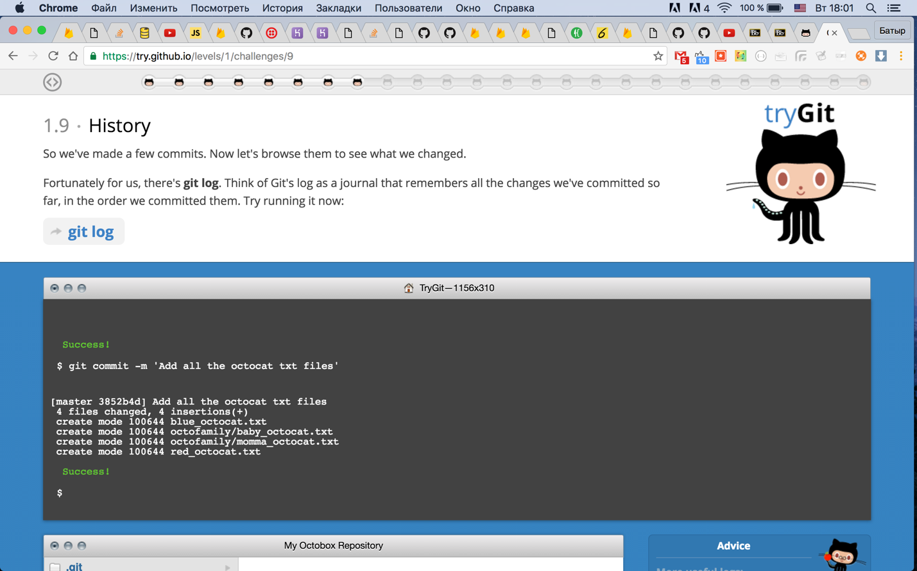

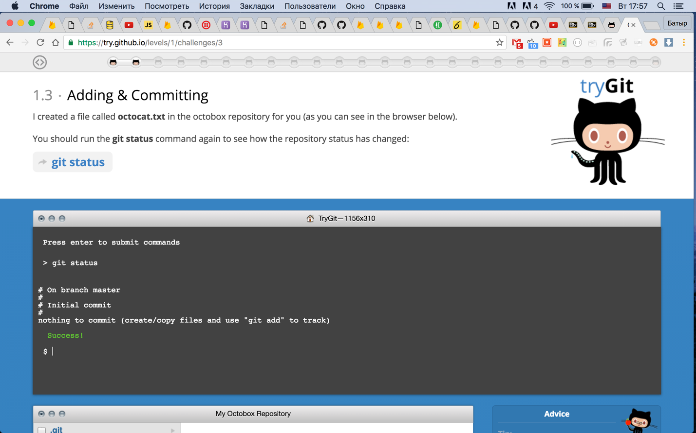

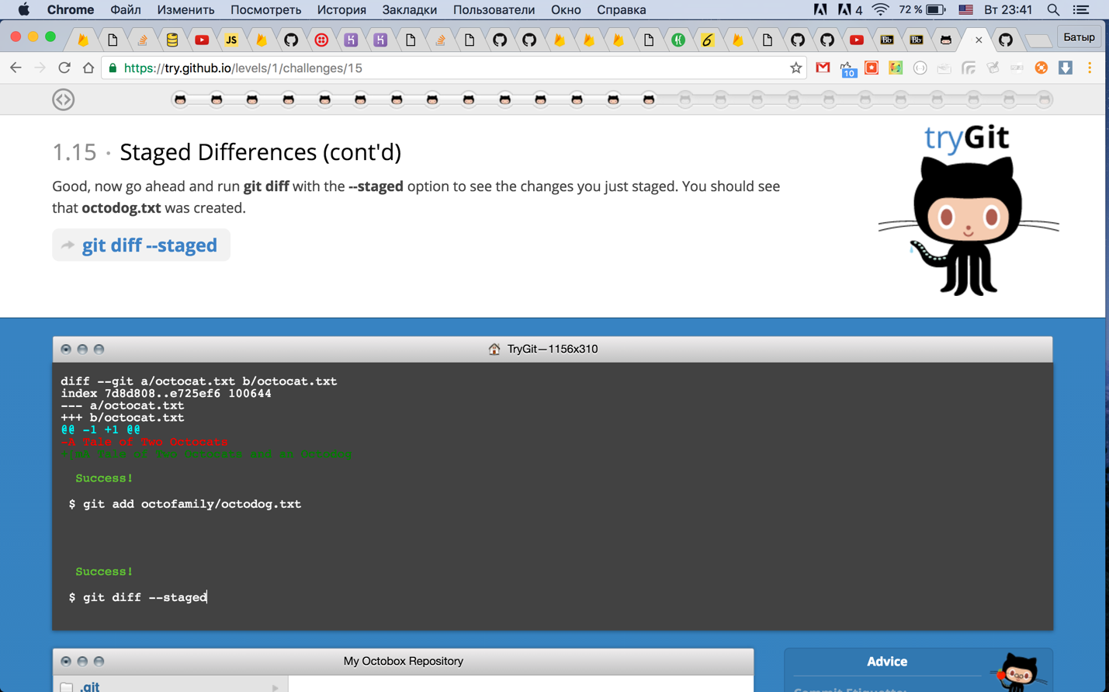

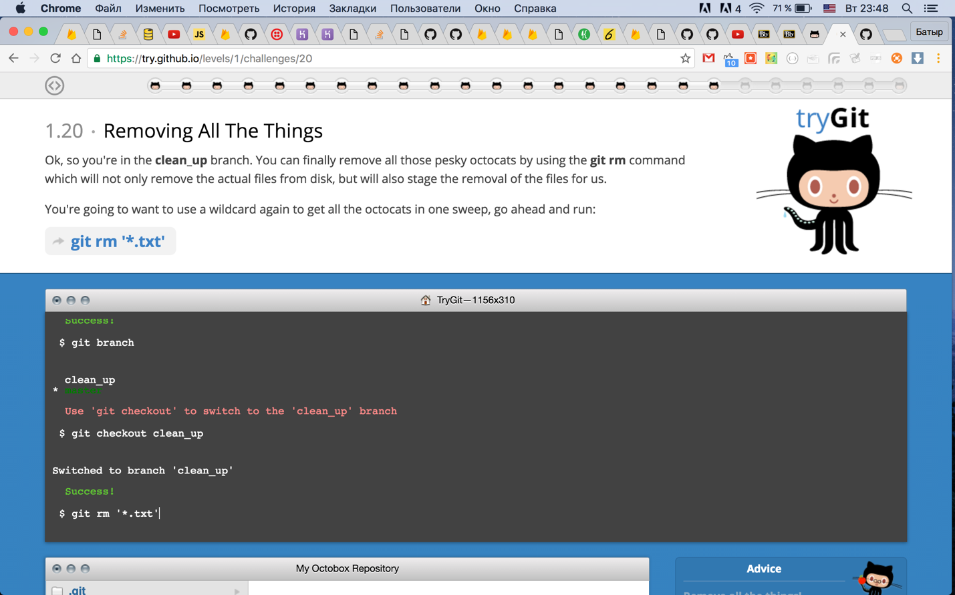

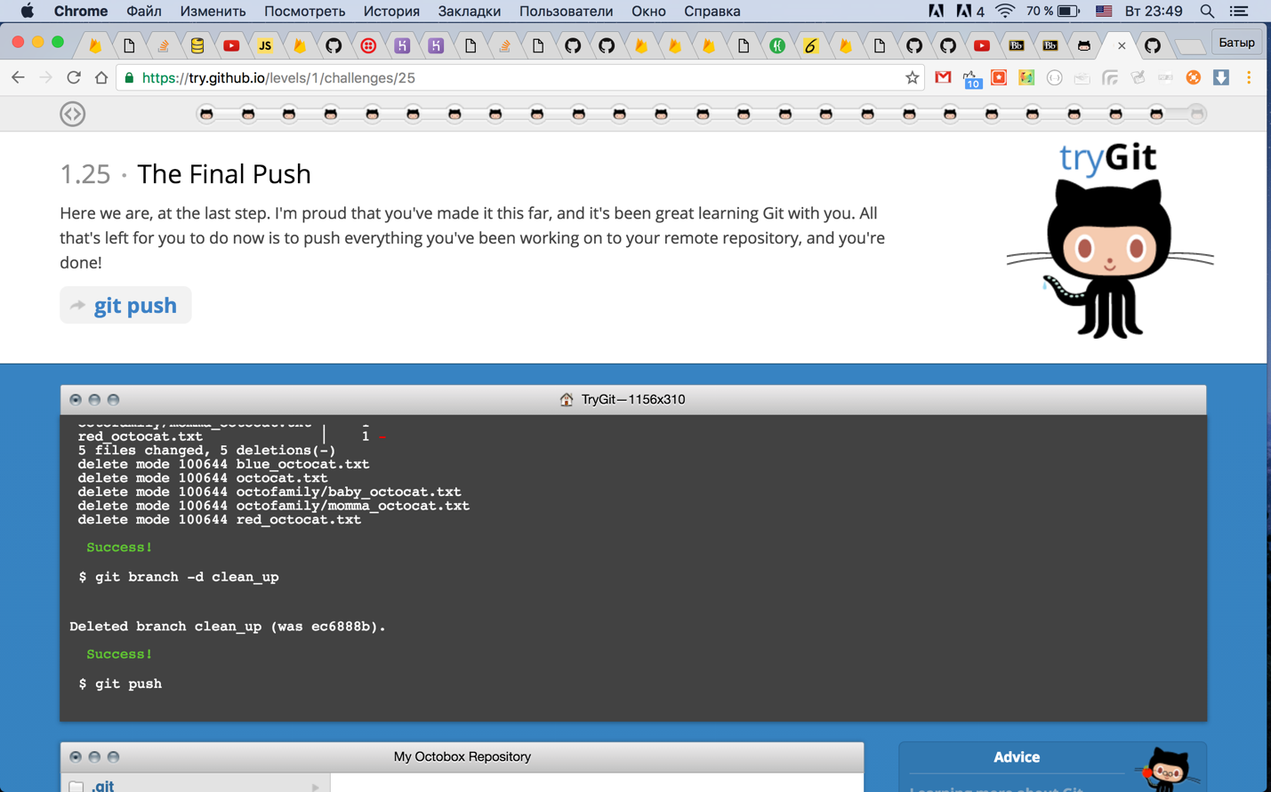

# Part 5 answers:

* Repository – is a project's folder that contains all of the project files and stores all changes which were commited.
* Commit – is an one-time change to a file.
* Push – is an action that sends your commited changes to a remote repository such as GitHub.
* Branch – is a parallel version of a repository (or a copy) that doesn't affect the primary branch.
* Fork – is a personal copy of another user's repository that is located on your account.
* Merge – is an action that takes changes from one repository and applies them into another.
* Clone – is a copy of a repository on your laptop instead of on a website's server.
* Pull – is an action that fetchs in changed and merges them.
* Pull request – is a proposed change to a repository submitted by a user and accepted or rejected by a repository's collaborators.