NV1 Design and Specification
NanoVision-1 (NV1) is a cross-platform, Qt-based, C++ application that displays structures and simulations especially those produced by NE1.
The dynamic companion document to this (mostly) static document is the following wiki page:
http://www.nanoengineer-1.net/mediawiki/index.php?title=NanoVision-1_Requirements_and_Specification
The wiki page is for aggregating links, project status, and a exploring new ideas.
Notes on Terminology
simulation - Used to refer to energy minimizations as well as simulations over time

User Interface
UI mockups are linked-to from the NV1 wiki page accessible via the URL above
Here is the UI panel hierarchy with class and member names from the NV1 code:

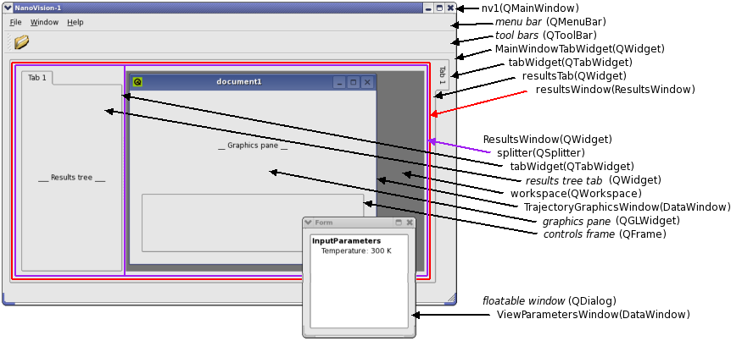
One NV1 process is started per simulation results viewed.
The simulation results data may include several components such as input parameters, input structures, trajectory data, and results summary data. Each of these components will be associated with a node in the results tree in the left channel. When nodes in the results tree are clicked, new windows appear (or existing windows are brought to the fore) showing the data associated with the node.
When an Input Parameters node, or a Results Summary node is clicked, a floating dialog appears with the information. Later, when we support data plots, these would also appear as floating dialogs which can then be configured on the screen for comparisons.
When an Input File, or Trajectory node is clicked, an MDI child window is created to show that data in the right pane of the ResultsWindow splitter.
The user conception for the two different types of data display windows is that textual and 2D/3D plot data is "lighter" and can be floated around for comparison with other such windows, whereas OpenGL-rendered 3D structures in space are "heavy" and live inside the NV1 application window. That said, for maximum flexibility for the user, we could make the "heavy" windows floatable for comparison too, but by default, they would appear as described above.
DataWindow is the base class for data-viewing windows. The class names below are the ones we'll use, not the (similar) ones shown in the screenshot above.
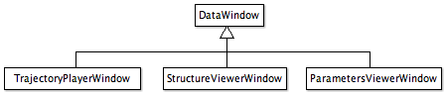

Results Tree
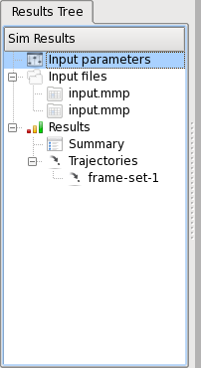 | UI Actions  - Input parameters:  - Double-clicking must open a text window showing this information  - If open, single- or double-clicking must bring it to the foreground  - Input Files:  - Double-clicking on an input-file item should create a StructureGraphicsWindow that inherits DataWindow and NXRenderer. This will render the molecule and allow user interaction.  - If the StructureGraphicsWindow already exists then single-clicks and double-clicks must bring it to the foreground.  - All parts in the input file must appear as a part-library sub-tree of the input files node  - Double-clicking on any of the parts should create a StructureGraphicsWindow with that part as the root molecule set  - If that StructureGraphicsWindow is already open, then single- or double-clicking must bring it to the foreground.  - Results:  - Summary:  - Double-clicking “Summary” must create a text window that displays summary information for the simulation.  - If open, single- or double-clicking must bring it to the foreground.  - Trajectories:  - All trajectories must appear as children of the “Trajectories” node  - Double-clicking a trajectory node must create a TrajectoryGraphicsPane and start playing the trajectory.  - If the TrajectoryGraphicsPane already exists then that instance must be brought to the foreground.

Plugin Architecture
Plugins will be used to add functionality flavors. For example an HDF5-based plugin will enable NV1 to read HDF5 data files while an Open Babel-based plugin will enable NV1 to read the various chemical structure formats. The following is an overview of the Rattlesnake NV1 plugin architecture:
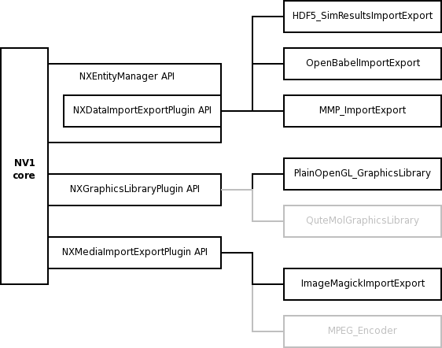
- Plugins are registered and configured in a NV1 startup configuration file.
- If there's time pre-FNANO, and if not, certainly later, we'll add an NXSimulationResultsPlugin that would provide for writing simulation results data. For example one implementation would be for writing POV-Ray scene descriptions, another would be for writing out per-step thermometer measurements in CSV format.
  - For now, we can just hard-code in a POV-Ray scene file writer.

NXMediaImportExportPlugin API
- Provides access to graphics buffers for the purposes of generating graphics files such as PNG and MPEG
- Provides ability to read images, video, or audio for viewing or composing scenes

NXGraphicsLibraryPlugin API
- Provides for drawing balls, sticks, and cones to the graphics window in various display styles (lines, tubes, ball-and-stick, and CPK)
- Add support for clouds (ESP data augmentation) and surfaces (macro display modes) as necessary
- May provide a "pass-through" functionality to enable the client to make OpenGL calls directly
- May incorporate a plugin pipeline to enable multiple plugins to contribute visualization specialty to the same scene (ala cascading style sheets)
- Incorporate a scene graph library such as OpenSceneGraph (others: Irrlicht, OGRE 3D, and OpenSG, NVIDIA Scenegraph) instead of implementing our own.

NXDataImportExportPlugin API
- An adaptor between the various file format libraries and the NXEntityManager data structures.
- NXDataStore
  - Stores info needed by the data tree discovery mechanism (explained later in this document)
  - Stores handles to out-of-memory data storage like trajectory files and most everything HDF5

NXEntityManager
- So instead of mimicking the Open Babel API, we'll just integrate Open Babel itself.
- Chemistry object model:

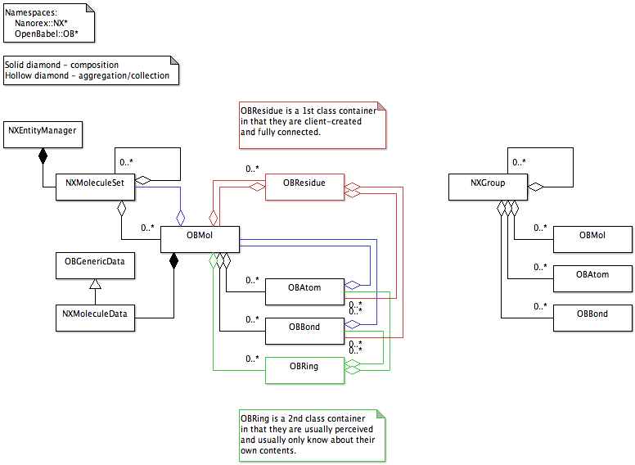
- Notes
  - OBMol is a stable group of at least two OBAtoms in some definite arrangement held together with OBBonds. An NXGroup object, however, may be thought of as a simple collection of zero or more OBMols, OBAtoms, and OBBonds with no implied chemistry.
  - NXMoleculeData is a container for storing whatever additional data we'll need. For now it just stores a molecule index. We may hang NXAtomData and NXBondData objects off of OBAtom and OBBond also if we need to.

Results Tree
- This appears in a tab in the left channel
- When a data file is loaded, it goes through a discovery phase where we determine what data the file offers (encapsulated in an NXDataStore object) to build the results tree
for each data tree node in a list of supported data tree nodes
if there is input data for it
add it to the tree model
Originally I thought storing the results tree structure in an external XML file that gets read upon NV1 startup would be a good idea, but I now think that's probably overkill. An example of it is listed here to help in the hardcoding of it.
<root image="foo.png">
<leafNode name="Journal" image="foo.png" type="journal" action="showTextEditor" />
<leafNode name="Input Parameters" image="foo.png" type="parameters" action="showParameters" />
<parentNode name="Input Files" image="foo.png" expanded="true" type="inputFiles">
<leafNode image="foo.png" type="mmpFile" action="showFrame" />
<leafNode image="bar.png" type="pdbFile" action="showFrame" />
</parentNode>
<parentNode name="Results" image="foo.png" expanded="true" type="results">
<leafNode name="Summary" image="foo.png" type="resultsSummary" action="showResultsSummary">
<parentNode name="Trajectories" image="foo.png" expanded="true">
<leafNode image="foo.png" type="trajectory" action="showTrajectory">
</parentNode>
</parentNode>
</root>

NV1 Graphics Component
This section expands on the graphics portions of the NV1 Rattlesnake Plugin Architecture diagram above.
There are three classes of graphics plugin implementation.
- Requests for object rendering returns NXSceneGraph nodes that are managed and rendered by a scenegraph layer
- Requests for object rendering returns renderer-specific scenegraph nodes, such as OpenGL display lists
- The plugin largely takes control of the full renderer context
For Rattlesnake we'll only have time to implement the class 2 implementation system. This section describes that system.
This is the graphics system class hierarchy with some example plugin implementations:
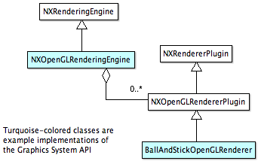
The diagram below shows an expanded view of the subcomponents of this system and how a plugin internally interacts with the NV1 core.

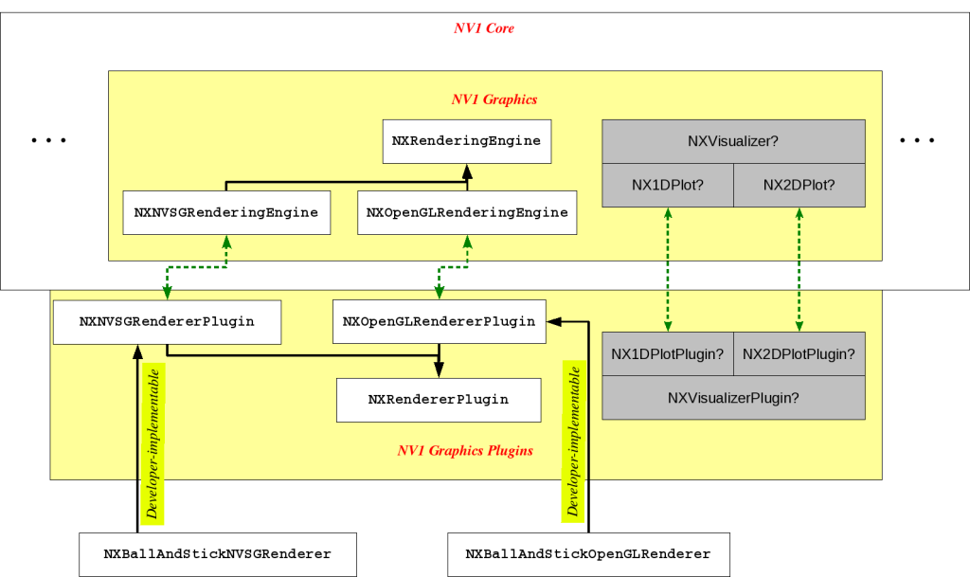

Fig. 5: Schematic view of the graphics system components in the NV1 Rattlesnake architecture. The black
arrows show class-inheritance. Developers may implement plugins by following paths similar to those
labelled "User-implementable hooks". The green arrows indicate collaboration.
Of the many extensible components in the NV1 Rattlesnake architecture, the graphics subsystem is one. This is indicated by the ellipsis in Fig. 5. This subsystem has the task of rendering the given molecule-set and of visualizing results in the form of trajectory animations and 1D, 2D plots etc. The gray components in Fig. 5 indicated placeholders for future components that need more planning, i.e., the "gray areas".
Example:
A developer wishing to render a molecule with the Ball-and-Stick style in OpenGL would first subclass NXOpenGLRendererPlugin, implement its virtual methods, build and test it, and copy the DLL to the correct NV1 plugins subdirectory. This process is shown with the "Developer-implementable hook" label. The user will have specified the OpenGL rendering engine at NV1 invocation time and NV1 scans for and recognizes the new plugin. This engine loads the NXOpenGLRenderer class which has an established protocol for communication with NXOpenGLRendererPlugin. While the "ball-and-stick" display style is standard and always available in NV1, if a developer created a plugin implementing a new display style, recognition of this plugin could result in the inclusion of a button in the display styles NV1 UI with an icon representing the new rendering style so that the user may click on it to enable rendering through it.

Rendering Engines
Fig. 5 uses OpenGL as an example of the rendering engine - the NXOpenGLRenderer class is shown to be derived from the abstract NXRenderer base-class. The graphics subsystem is designed to be extensible allowing the user to choose from a range of rendering engines, as shown in Fig. 6.

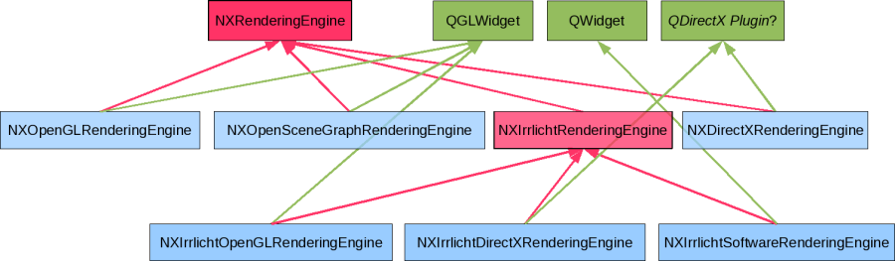
Fig. 6: Rendering-engine class hierarchy. Pink cells indicate abstract base-classes. Blue cells indicate instantiable leaf-subclasses. Green cells indicated Qt widget classes that leaf-subclasses implement to obtain a rendering surface. Each leaf-subclass therefore has two parents, one rendering-engine abstraction and one rendering surface. As of v4.3 Qt does not support DirectX because it is not cross-platform. Discussions about a plugin can be found on mailing lists.
The list of possible rendering engines shown above is not exhaustive. Others worth considering are OpenSG, OGRE-3D, and NVIDIA SceneGraph. Each engine offers a different mix of features and in designing NV1 for extensibility we are attempting to cater to a variety of interest groups.
NXOpenGLRenderer: This engine allows the developer to implement rendering using plain OpenGL. The developer must implement OpenGL calls as in a display-list. The rendering engine executes glNewList() and glCallList() at before and after calling the plugin's rendering methods. The plugin can initialize and maintain its own resources and must clean up in the destructor or otherwise.
NXOpenSceneGraphRenderer: OpenSceneGraph is a mature scenegraph library that allows for high-performance on recent graphics hardware. It is tightly coupled to a camera-like rendering mode where the screen is constantly refreshed and only the scenegraph nodes need be modified to induce animation etc. It supports import/export of a wide variety of 3D model file formats. This engine will permit the user to allow tools like 3D Studio and Maya to create representations for molecule substructures. This will also facilitate the exchange of these models between NE1/NV1 users. It implements mature algorithms for culling and optimizations and is now officially a part of the OpenGL SDK. OpenSceneGraph internally makes calls to OpenGL to perform the rendering and therefore inherits QGLWidget to obtain a rendering surface.
NXIrrlichtRenderer: Irrlicht is a cross-platform 3D rendering engine that offers common data structures for representing a scene but supports many display drivers to render the same scene depending on the hardware capabilities of the platform. It implements many fallback methods for rendering features not supported by the hardware and has very few dependencies. The Irrlicht engine will enable developers to customize rendering based on Irrlicht's capabilities and may enable adoption on a broader spectrum of hardware.
NXDirectXRenderer: DirectX is highly optimized for windows platforms and is supported by most graphics hardware manufacturers. This engine will permit the developer to optimize performance on MS Windows provided a Qt rendering surface becomes available.
NXNVSGRenderer: This engine is based on the NVIDIA SceneGraph SDK which is a freely available scenegraph library from NVIDIA. It could offer optimizations that exploit NVIDIA hardware.
NXOGRE3DRenderer: This engine will use the OGRE-3D cross-platform game-engine framework.
NXOpenSGRenderer: This engine will allow the use of the OpenSG cross-platform scenegraph library that compares well with OpenSceneGraph but offers a different capability-performance trade-off.

Rendering Plugins
Fig. 5 uses an OpenGL rendering plugin (NXOpenGLRenderer) as an example. Rendering plugins are specific to rendering engines - the name for the base class for a plugin is derived by concatenating "Plugin" to the correponding engine's class-name. A developer wishing to see molecules rendering using balls and sticks, for example, must implement a different body of code for each engine he/she wishes to use. Fig. 7 shows the class hierarchy for rendering plugins which extends Fig. 5.

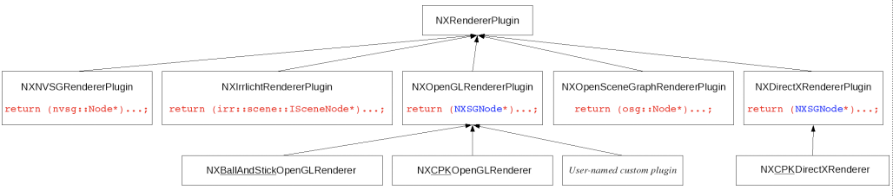

Fig. 7: Class hierarchy for the rendering plugin system. The top-level NXRendererPlugin base class forces a policy through pure virtual methods. Base-classes for plugins specific to each engine are shown in the second level and are available through the NV1 API - the type of return statement expected from the plugin is shown in red. NV1 internally assumes an engine-specific scenegraph structure for the molecule-set scene. Plugins for engines using NVIDIA SceneGraph (NVSG), OpenSceneGraph, Irrlicht. etc. can return the corresponding scenegraph node structures. For engines that directly use OpenGL or DirectX, NV1 offers its own basic scenegraph api which the developer must interact with, and must return an NXSGNode structure. OpenGL implementations of ball-and-stick and CPK rendering styles are exemplified by the eponymous classes in the third level. These follow the Nanorex nomenclature. Third-party plugins need not conform to this nomenclature but the
architecture still allows inclusion.

Deployment

Installed Directory Structure
Here's the directory structure of a unix file system install:
/usr/local/
bin/
nv1
include/
Nanorex/
Interface/
Utility/
Plugins/
RenderingEngines/
OpenGL/
NXOpenGLRenderer/
NXOpenGLRenderingEngine.h and supporting NXOpenGL-specifics
lib/
Nanorex/
libInterface.so
libUtility.so
Plugins/
HDF5_SimResultsImportExport.so
OpenBabelImportExport.so
RenderingEngines/
OpenGL/
NXOpenGLRenderer.dll
NXOpenGLRenderer/
<textures, what-not>
Renderers/
NXBallAndStickOpenGLRenderer.dll

Alternatively, we could lose the RenderingEngines/OpenGL/ directories and put Renderers/ under NXOpenGLRenderer/ so that it looks like:

lib/
Nanorex/
Plugins/
NXOpenGLRenderer.dll
NXOpenGLRenderer/
<textures, what-not>
Renderers/
NXBallAndStickOpenGLRenderer.dll

