Program Structure

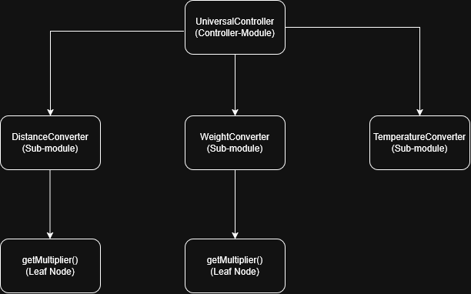
Top-down Integration
Unit under test | List of Stubs/Drivers | result | Stub’s return value | Expected results | Actual results | Pass/Fail/No run
UniversalConverter | Stub DistanceConverter  Stub WeightConverter  Stub TempConverter | convert(5.0, "Distance", "km", "m") | 5000.0 | 5000.0 | 5000.0 | Pass
UniversalConverter | Stub DistanceConverter  Stub WeightConverter  Stub TempConverter | convert(2.0, "Weight", "kg", "lbs") | 4.410 | 4.410 | 4.410 | Pass
UniversalConverter | Stub DistanceConverter  Stub WeightConverter  Stub TempConverter | convert(100.0, "Temperature", "C", "F") | 212.0 | 212.0 | 212.0 | Pass
UniversalConverter +  DistanceConverter | Stub WeightConverter  Stub TempConverter | convert(5.0, "Distance", "kilometer", "meter") | - | 5000.0 | 5000.0 | Pass
UniversalConverter +  DistanceConverter | Stub WeightConverter  Stub TempConverter | convert(1000.0, "Distance", "meter", "kilometer") | - | 1.0 | 1.0 | Pass
UniversalConverter +  WeightConverter | Stub DistanceConverter  Stub TempConverter | convert(2.0, "Weight", "kilogram", "gram") | - | 2000.0 | 0.002 | Fail
UniversalConverter +  WeightConverter | Stub DistanceConverter  Stub TempConverter | convert(1.0, "Weight", "kilogram", "lbs") | - | 2.205 | 2.205 | Pass
UniversalConverter +  TemperatureConverter | Stub DistanceConverter  Stub WeightConverter | convert(100.0, "Temperature", "C", "F") | - | 212.0 | 132.0 | Fail
UniversalConverter +  TemperatureConverter | Stub DistanceConverter  Stub WeightConverter | convert(212.0, "Temperature", "F", "C") | - | 100.0 | 0.0 | Fail
UniversalConverter +  TemperatureConverter | Stub DistanceConverter  Stub WeightConverter | convert(0.0, "Temperature", "C", "K") | - | 273.15 | 273.15 | Pass

Bottom-up Integration
Unit under test | List of Stubs/Drivers | result | Stub’s return value | Expected results | Actual results | Pass/Fail/No run
DistanceConverter.getMultiplier | Driver: TestDriver_Distance | getMultiplier("kilometer", "meter") | - | 1000.0 | 1000.0 | Pass
DistanceConverter.getMultiplier | Driver: TestDriver_Distance | getMultiplier("mile", "kilometer") | - | 1.609 | 1.609 | Pass
WeightConverter.getMultiplier | Driver: TestDriver_Weight | getMultiplier("kilogram", "gram") | - | 1000.0 | 0.001 | Fail
WeightConverter.getMultiplier | Driver: TestDriver_Weight | getMultiplier("lbs", "ounce") | - | 16.0 | 16.0 | Pass
DistanceConverter.convert | Driver: TestDriver_Distance | convert(10.0, "meter", "kilometer") | - | 0.01 | 0.01 | Pass
WeightConverter.convert | Driver: TestDriver_Weight | convert(2.0, "lbs", "ounce") | - | 32.0 | 32.0 | Pass
TemperatureConverter.convert | Driver: TestDriver_Temp | convert(100.0, "K", "C") | - | -173.15 | -173.15 | Pass
TemperatureConverter.convert | Driver: TestDriver_Temp | convert(100.0, "C", "F") | - | 212.0 | 132.0 | Fail
UniversalConverter.convert | Driver: TestDriver_Universal | convert(2.0, "Distance", "km", "mile") | - | 1.242 | 1.242 | Pass
UniversalConverter.convert | Driver: TestDriver_Universal | convert(10.0, "Weight", "lbs", "ounce") | - | 160.0 | 160.0 | Pass

