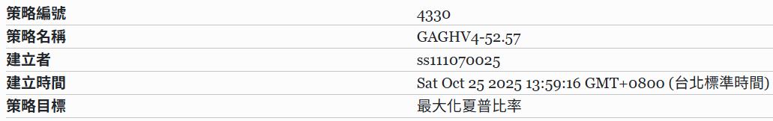
- Trial ID number : GAGHV4-52.57
- The total number of trials : 31
- Best Sharpe Ratio (SR) : 4.67
- Screenshot
資產比重
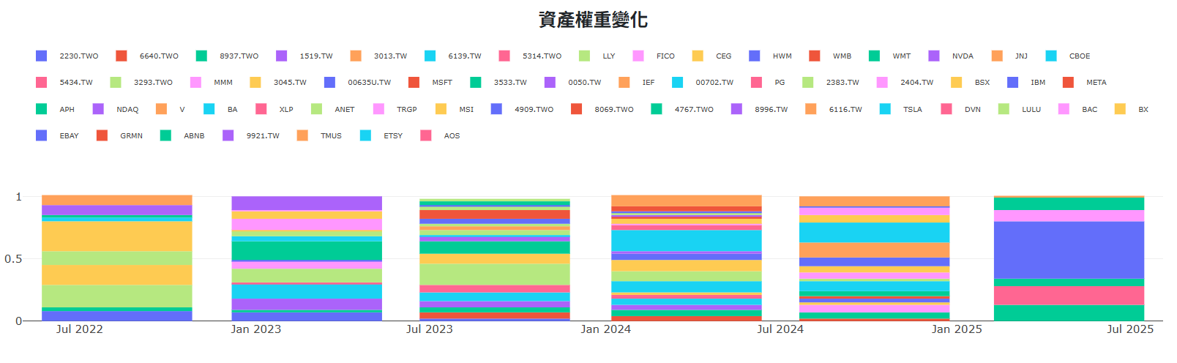
投組表現
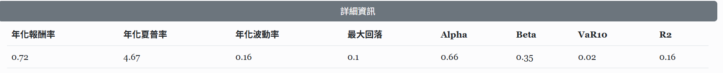
投資組合每季報酬率
