
ACLEDA UNIVERSITY OF BUSINESS

Subject : CS 219
Topic: Final Oracle

Introduce By Lecturer: Prepare By:
Mr. Morn PichKhemra Kao Meyly 7152
From Class : Banteay Samrea
Session : 11:00am - 2:00pm
Major : CSE

1. Create Table

+Create Table Courses_Offered

Create table Courses_Offered(
2 course_id number GENERATED By DEFAULT AS IDENTITY Primary key,
3 course_name varchar2(100) UNIQUE Not null
4 );
+Create Table Courses_Requested
CREATE TABLE Courses_Requested (
2 course_id NUMBER GENERATED BY DEFAULT AS IDENTITY PRIMARY KEY,
3 course_name VARCHAR2(100) UNIQUE NOT NULL
4 );
2. Insert Sample Data
INSERT INTO Courses_Offered (course_name) VALUES ('Web');
INSERT INTO Courses_Offered (course_name) VALUES ('API');
INSERT INTO Courses_Offered (course_name) VALUES ('Data Structure');
INSERT INTO Courses_Offered (course_name) VALUES ('PHP');

INSERT INTO Courses_Requested (course_name) VALUES ('C#');
INSERT INTO Courses_Requested (course_name) VALUES ('PowerBI');
INSERT INTO Courses_Requested (course_name) VALUES ('Oracle');
INSERT INTO Courses_Requested (course_name) VALUES ('Cybersecurity');
3. Set Operation Queries
3.1 All unique courses either Offered or Requested

SELECT course_name FROM Courses_Offered
2 UNION
3 SELECT course_name FROM Courses_Requested;
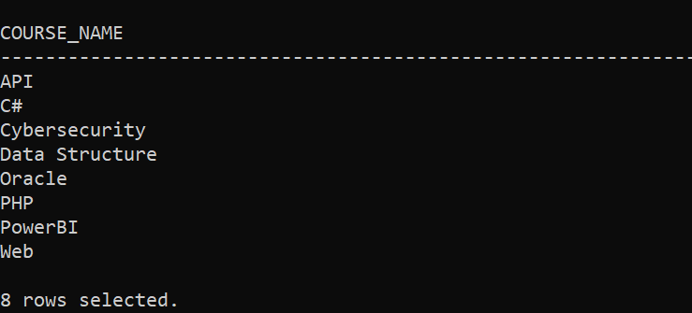

3.2. Courses both Offered and Requested

SELECT course_name FROM Courses_Offered
INTERSECT
SELECT course_name FROM Courses_Requested;
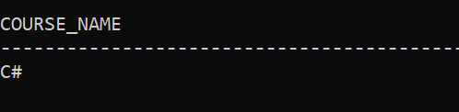

3.3 Courses Offered but not Requested

SELECT course_name FROM Courses_Offered
MINUS
SELECT course_name FROM Courses_Requested;
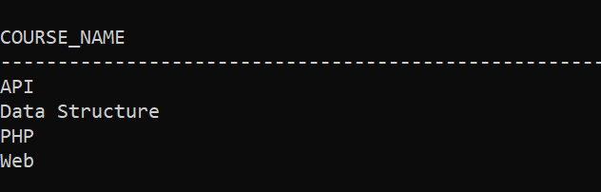

3.4 Courses either Offered or Requested, but not both

SELECT course_name FROM Courses_Offered
MINUS
SELECT course_name FROM Courses_Requested
UNION
SELECT course_name FROM Courses_Requested
MINUS
SELECT course_name FROM Courses_Offered;
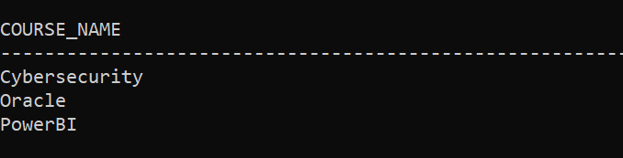
4. Create Procedure

CREATE OR REPLACE PROCEDURE Add_Course(
p_course_name IN VARCHAR2,
p_table_type IN VARCHAR2 -- 'OFFERED' or 'REQUESTED'
)
IS
BEGIN
IF UPPER(p_table_type) = 'OFFERED' THEN
INSERT INTO Courses_Offered(course_name) VALUES(p_course_name);
ELSIF UPPER(p_table_type) = 'REQUESTED' THEN
INSERT INTO Courses_Requested(course_name) VALUES(p_course_name);
ELSE
RAISE_APPLICATION_ERROR(-20001, 'Invalid table type. Use OFFERED or REQUESTED');
END IF;
COMMIT;
END;
/
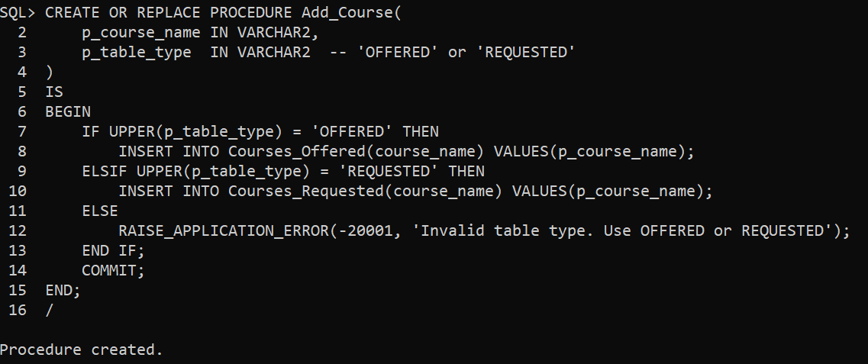

5. Create Function

CREATE OR REPLACE FUNCTION Is_Course_Both(p_course_name IN VARCHAR2)
RETURN VARCHAR2
IS
v_count_offered NUMBER;
v_count_requested NUMBER;
BEGIN
SELECT COUNT(*) INTO v_count_offered
FROM Courses_Offered WHERE UPPER(course_name) = UPPER(p_course_name);

SELECT COUNT(*) INTO v_count_requested
FROM Courses_Requested WHERE UPPER(course_name) = UPPER(p_course_name);

IF v_count_offered > 0 AND v_count_requested > 0 THEN
RETURN 'YES';
ELSE
RETURN 'NO';
END IF;
END;
/
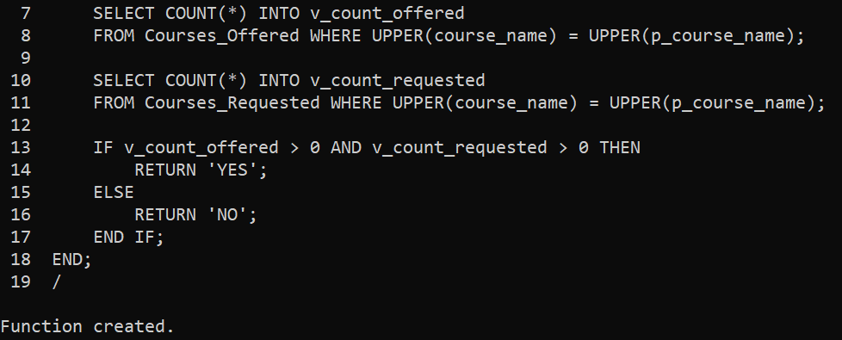

6. Test Procedure & Function

+Add new courses

EXEC Add_Course('Python', 'OFFERED');
EXEC Add_Course('SQL Server', 'REQUESTED');
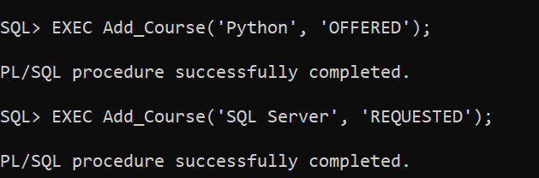

+Test function
