CMPT 365 – Programming Assignment 1

James Cam, 301562474, jca548@sfu.ca

Date: Oct. 3rd, 2025

Program Screenshots:
The following screenshots will show what each “.bmp” file looks like within the program before showcasing the functionality of the other features on the sample file “BIOS.bmp”.

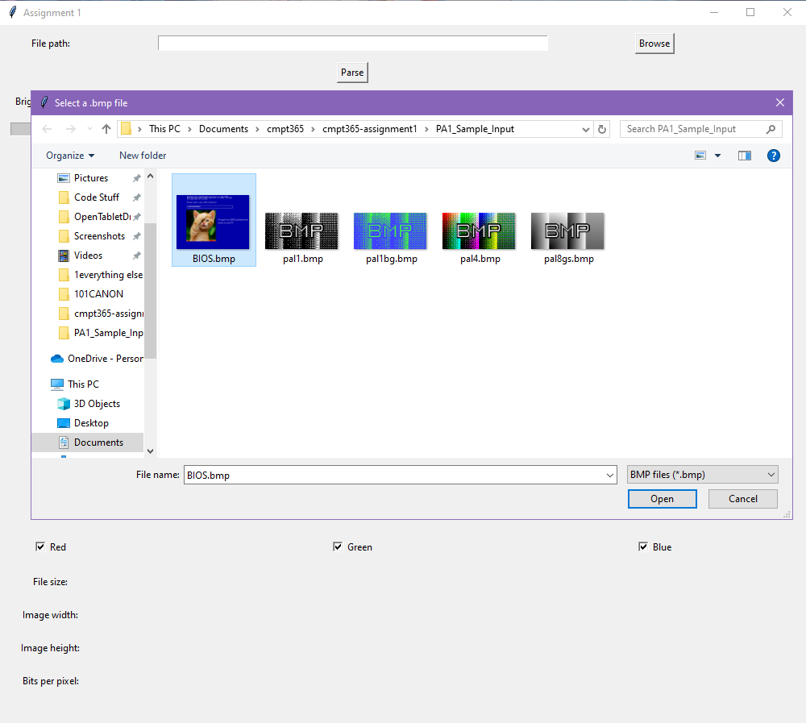
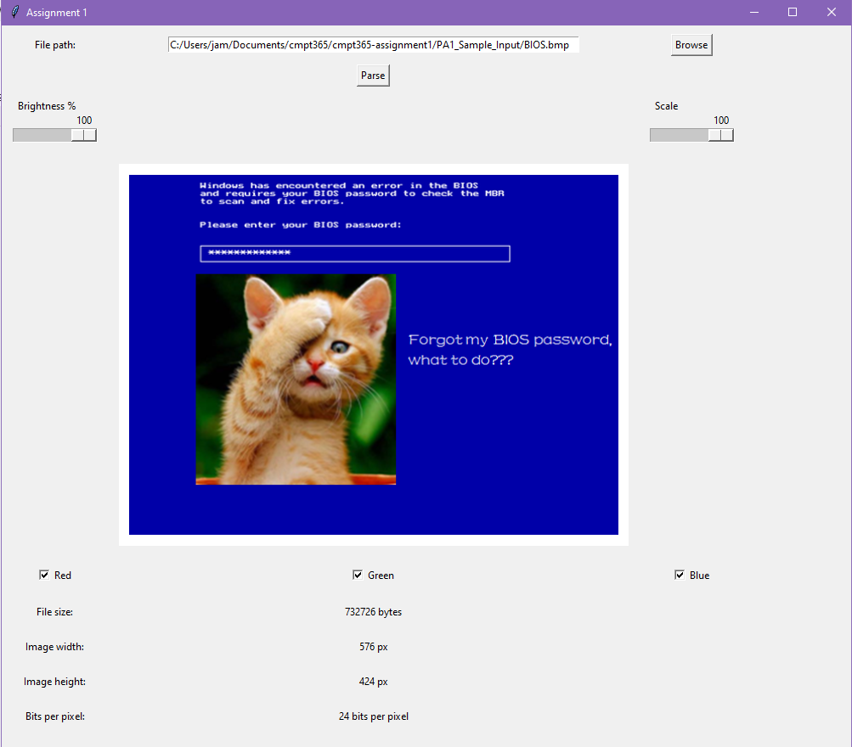

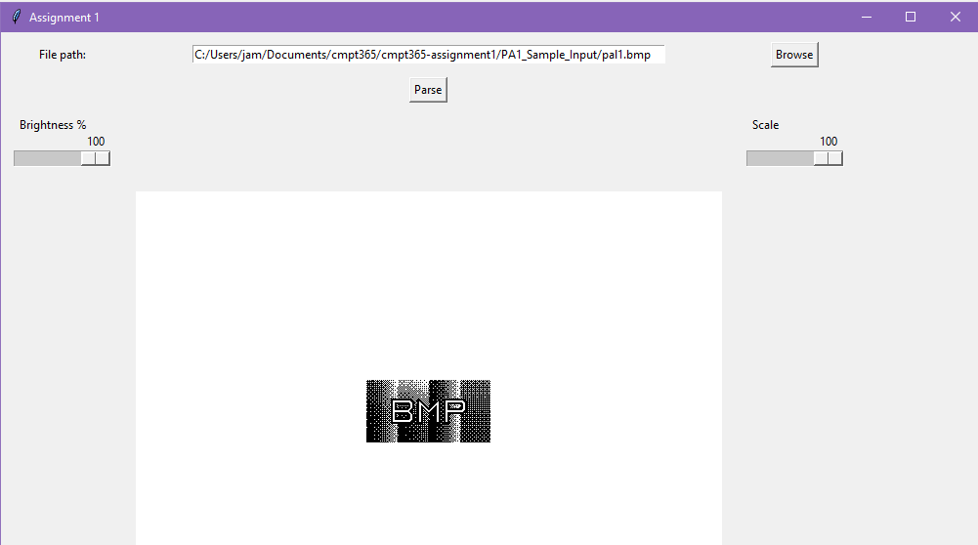
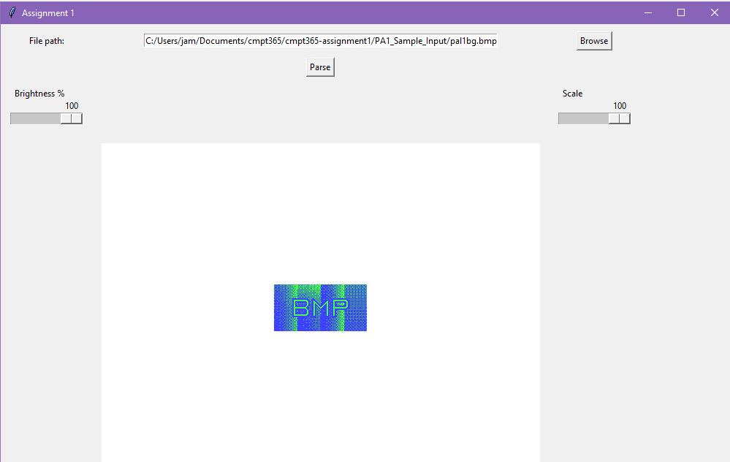
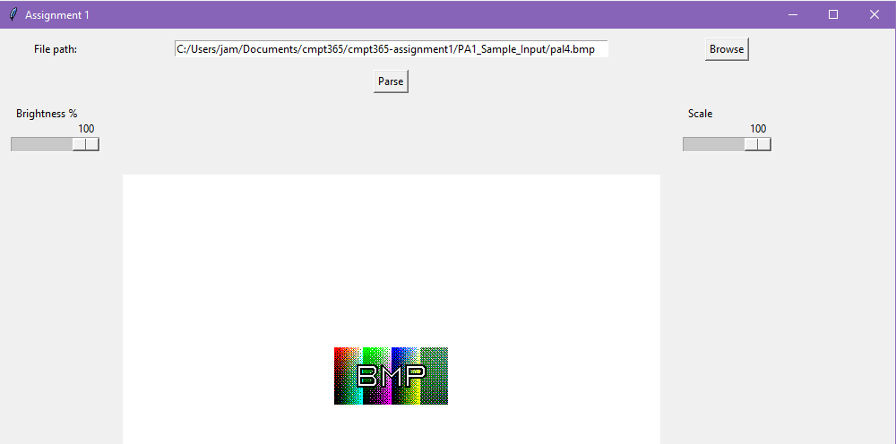
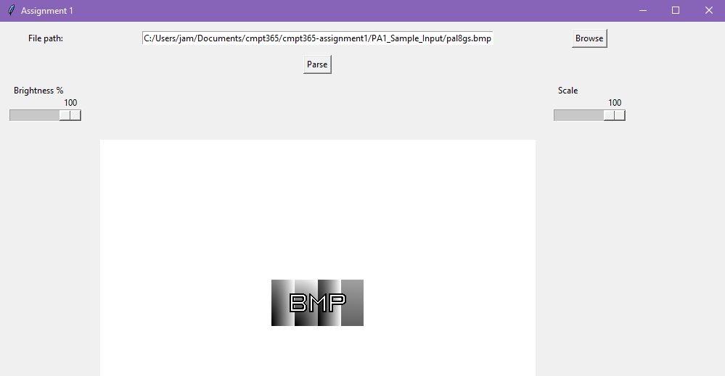

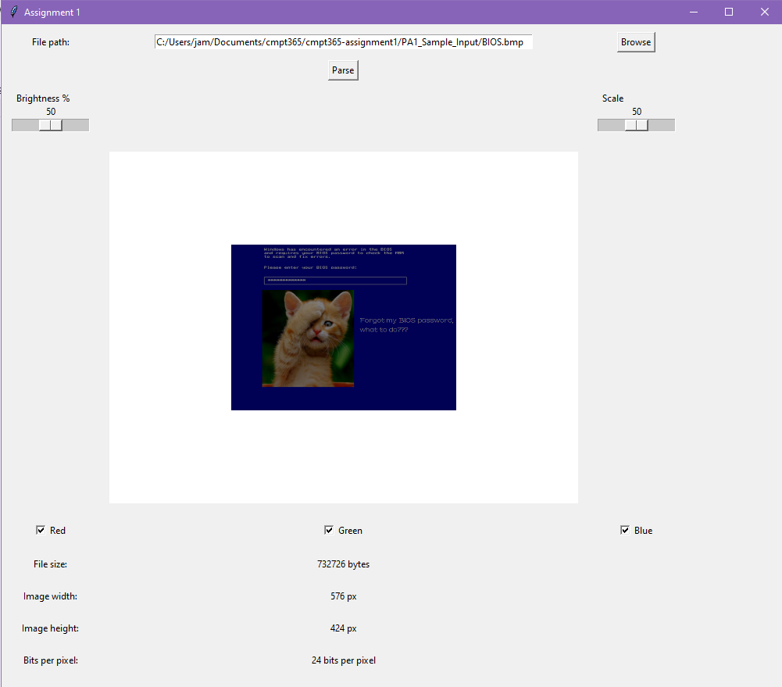
“BIOS.bmp” at 50% brightness and 50% scale.
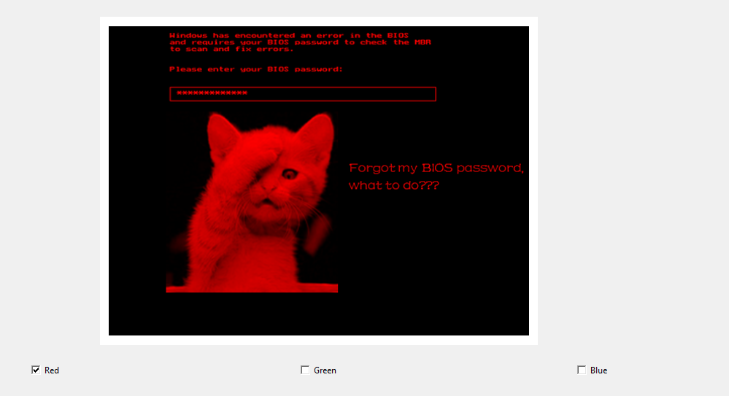
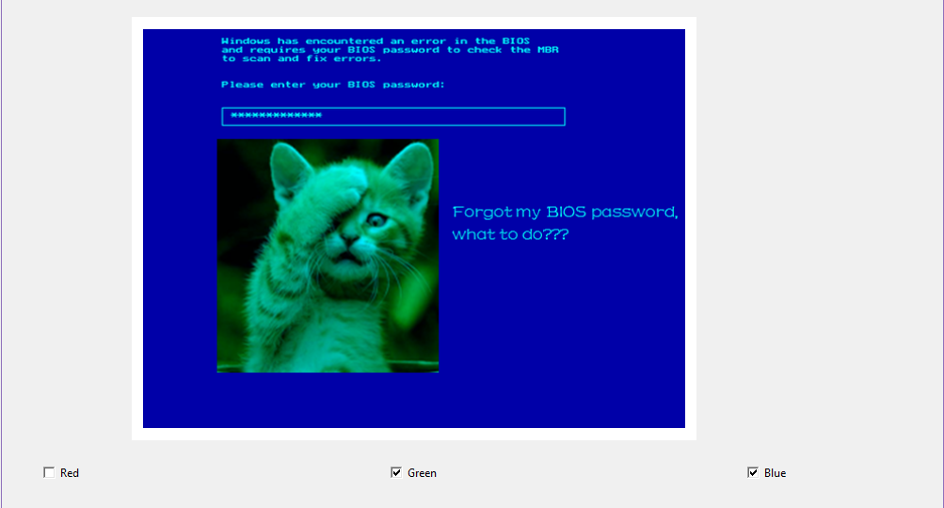
“BIOS.bmp” with different RGB channels enabled.

Essential Code Explanation:
This section will only explain parts of the code that are either not completely obvious, or complex enough to warrant an explanation. Simple functions, for example such as functions that get the value of something will not be explained.
get_color_table(bmp_bytes, bpp):
This function retrieves the color table of a “.bmp” file by parsing through the color table only if the bits per pixel (bpp) of the file is 1, 4, or 8 bpp. 24 bpp images do not store color on a color table hence it will return nothing if that’s the case.

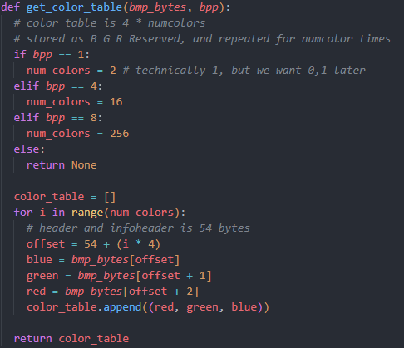

parse_bmp_file():
Parse_bmp_file first takes the given file path entered in the textbox and converts it into bytes. After getting the byte information which we will call “bmp_bytes”, it does a check on the first two bits to confirm whether it is a “.bmp” file and it will notify the user if it is not. If it is a “.bmp” file, it will parse the rest of the bytes to extract relevant information and call display_image to display the image using the extracted bytes.

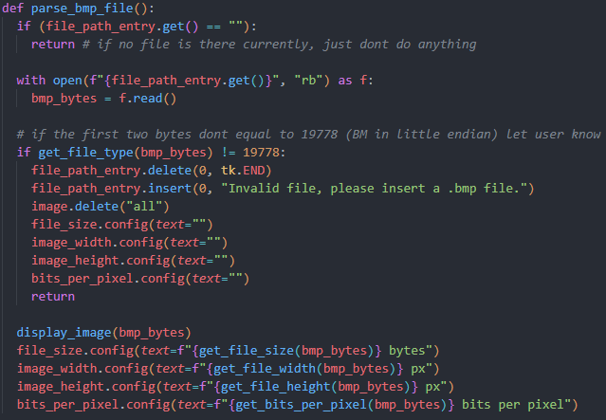

display_image(bmp_bytes):
The display_image function is very long and will be explained through multiple parts and screenshots.

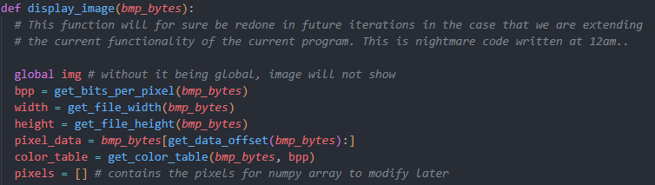

Besides initializing some variables, display_image first check if the bpp is either 1, 4, 8, or 24 . If the bpp does fall in one of these values, it will look to properly extract information from the pixel data section of the bmp_bytes and store it into an array to use later when displaying the final image.
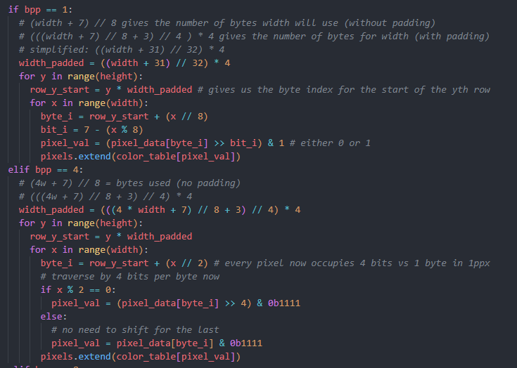
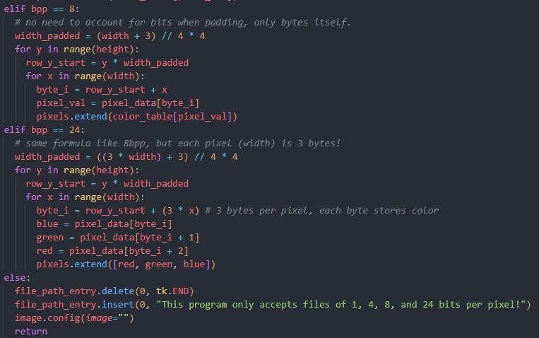

After extracting all the pixel values, display_image will look to modify the array of pixels based on both the brightness and scale slider, and the enabled/disabled color channels.
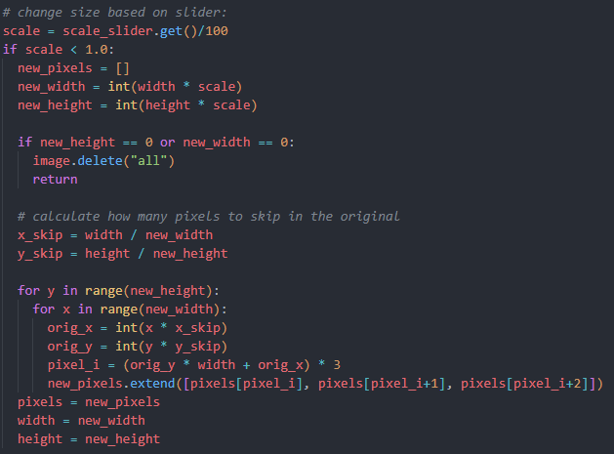
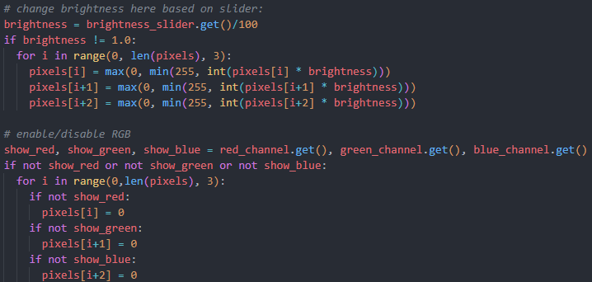

Once we modify the given array of pixels through scaling/resizing, brightness changes, or enabling or disabling different RGB channels, we can finally look to display the image. Using numpy, we can reshape the pixel array and flip the array to correctly orient the image before the image is finally created in the canvas.
