ASSIGNMENT 3 – ECE 656
NAME: Kaushik Bharathan
UW ID: 20412310
NAME: Keyur Hindocha
UW ID:
We have implemented the modules using a Postgres SQL database management system as the backend, Java Enterprise Edition to handle the web services and connect to the DBMS. Basic html forms were used at the front end to take input and display output.
We have included screenshots of the important steps. The code in it's entirety along with the the queries is printed out and submitted with this submission.

Github repository link to the source code:
https://github.com/kaosman/HotelManagementSystem

Below are screenshots of the various tables in the Database with their data before executing functionality of modules 1 to 4.

HOTEL:
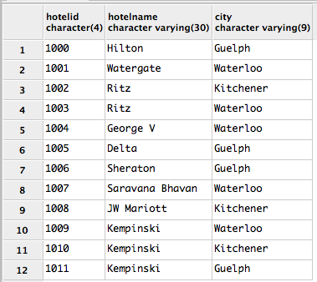

ROOM:
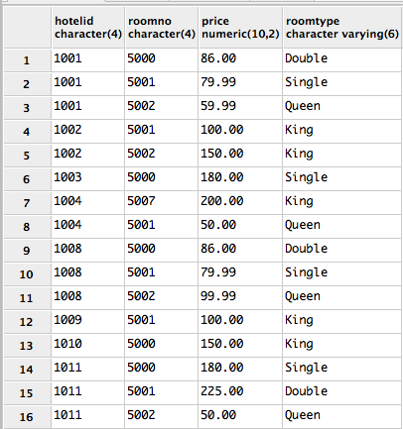
BOOKING:
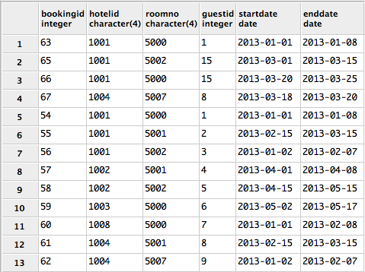

GUEST:
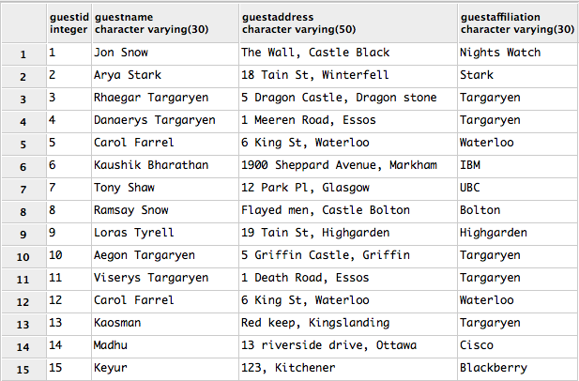
MODULE1: Guest Registration
Step1 – Booking agent enters guest information to register guest in the following form and presses submit.
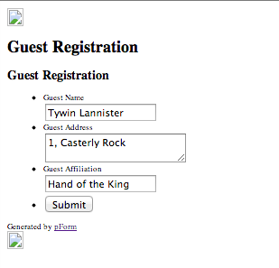

Step2 – The form input is taken in by the RegisterNewGuest servlet and the information is pushed into a “GUEST” object.
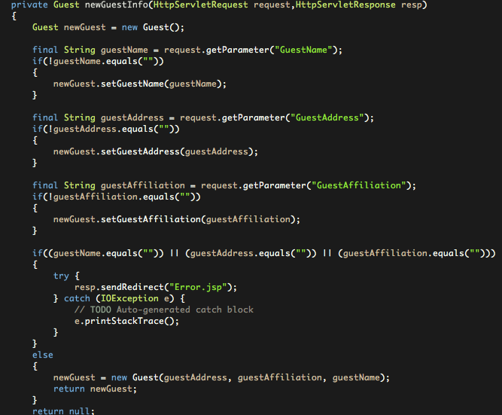
Step 3 – Insert query is formed and data is pushed into the Database
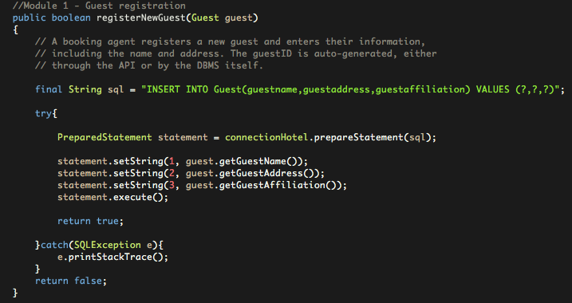

Step 4 – Guest table after insertion.
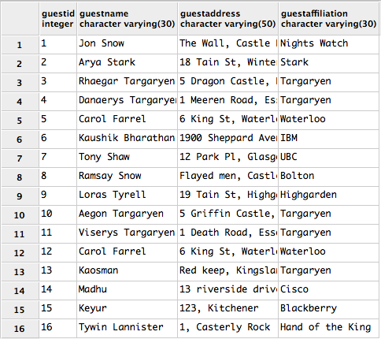
MODULE1: Guest Update
Step1 - Booking agent enters guest information to update guest in the following form and presses submit.
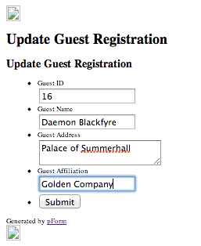

Step 2 - The form input is taken in by the UpdateGuest servlet and the information is pushed into a “ExisitingGuest” object to update information required.
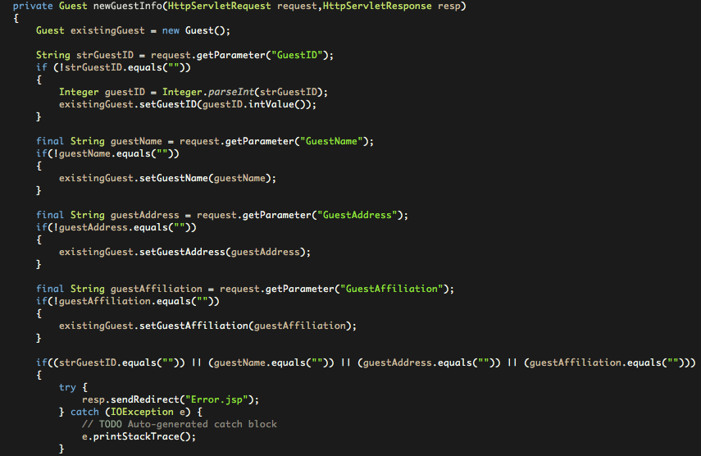
Step 3 – Update query is formed and data is pushed into the Database
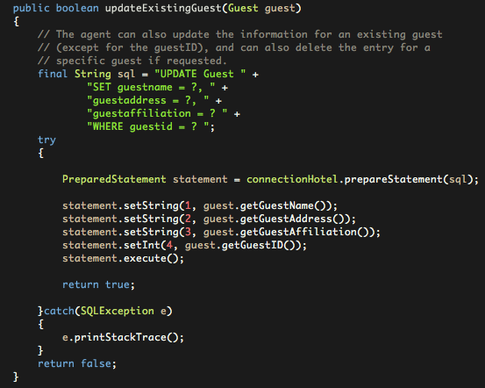
Step 4 - Guest table after updation
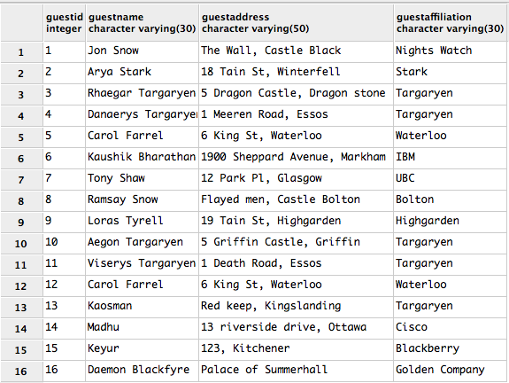
MODULE1: Guest Delete
Step1 - Booking agent enters guest id to delete guest in the following form and presses submit.
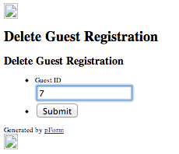

Step2 - The form input is taken in by the DeleteGuest servlet and passed on the Data Access object class handling queries.
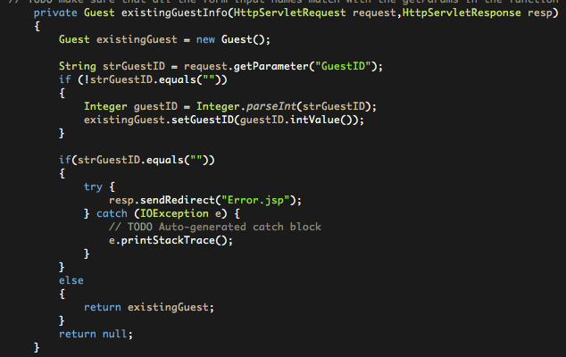
Step 3 – Delete query is formed and guest is deleted from the database. Note that when a guest is deleted, his bookings are also deleted to ensure integrity on the foreign key constraint between the Guest and Booking tables.
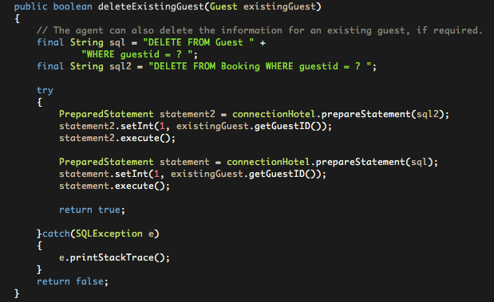

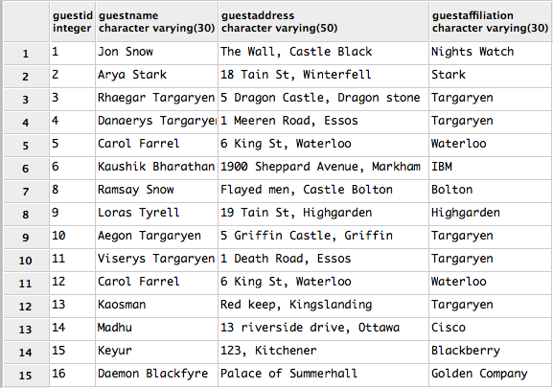
Step 4 - Guest table after deletion.

Step 5 – Booking table after deletion
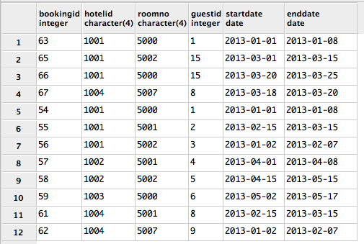

MODULE 2 : BOOKING QUERY
Step 1 – Agent queries for hotels with available rooms by entering information in the following form,
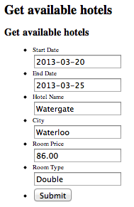
Step 2 - The form input is taken in by the GetAvailableHotels servlet and passed on the Data Access object class handling queries.
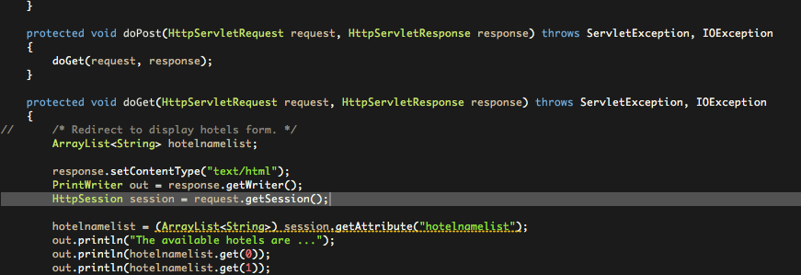
Step 3 – Select query is formed and available rooms are fetched from the database
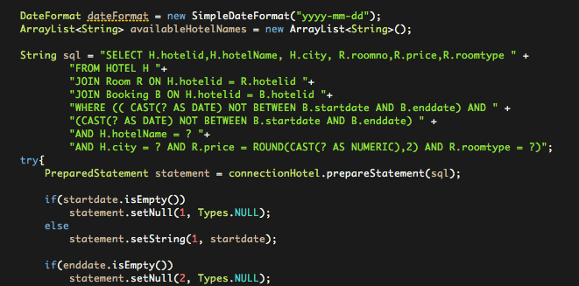
Step 4 – The available rooms are displayed in an HTML form to the agent querying
MODULE3: BOOKING REGISTRATION
Step 1 – Agent registers a new booking by entering information into the following form
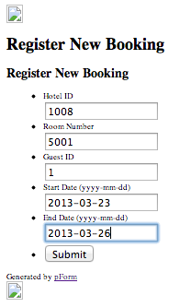

Step 2 - The form input is taken in by the RegisterNewBooking servlet and passed on the Data Access object class handling queries.
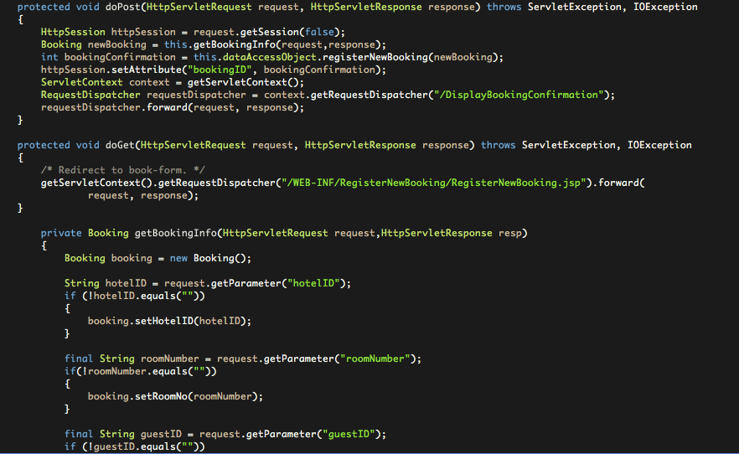
Step 3 – Insert query is formed a new booking is inserted into the database
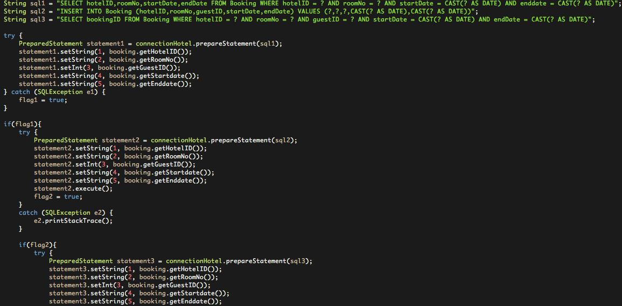

Step 4 – New booking is successfully inserted in the database as seen below (booking ID generated = 68)
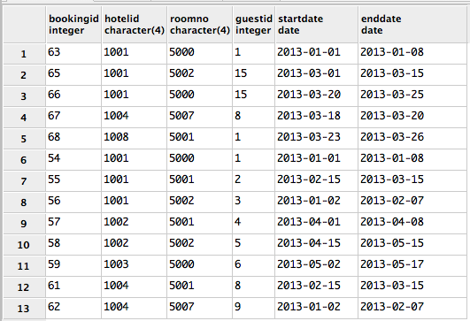
Step 5 – Agent gets a HTML form returned with new booking ID and successful booking message
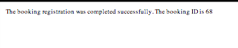
MODULE 4 : Room Maintenance and Billing – Get Arrivals
Step1 – Maintenance staff of a hotel enter their hotel ID to obtain all arrivals on that particular date in the following form
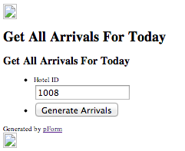

Step2 - The form input is taken in by the GetArrivalsForToday servlet and passed on the Data Access object class handling queries.
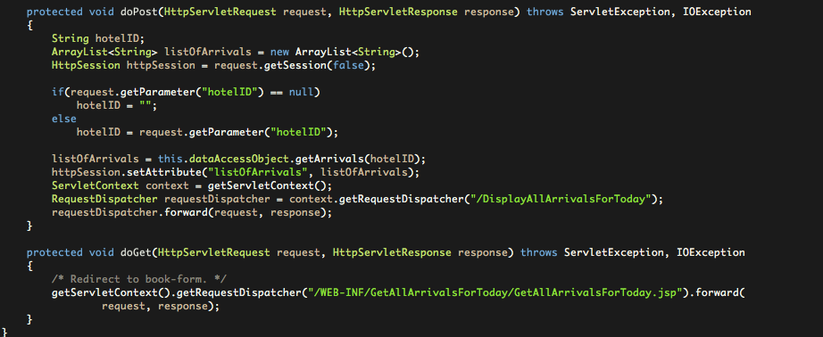
Step3 - Select query is formed and all arrivals on the day are displayed to the staff
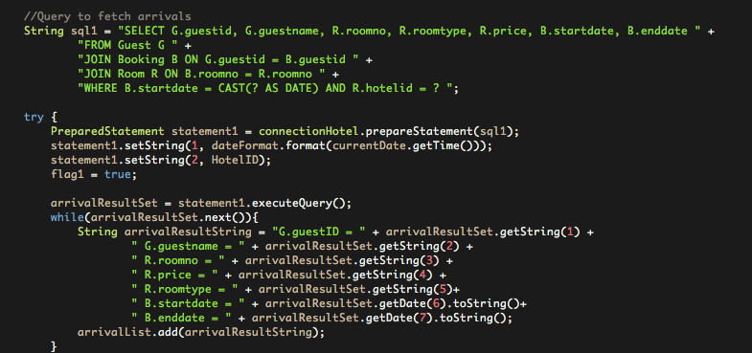

Step4 – Arrivals of the day are displayed in the form
MODULE 4 : Room Maintenance and Billing – Get Departures with billing log
Step1 - Maintenance staff of a hotel enter their hotel ID to obtain all departures and billing information on that particular date in the following form,
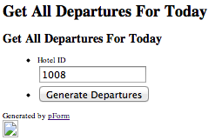
Step2 - The form input is taken in by the GetDeparturesForToday servlet and passed on the Data Access object class handling queries.
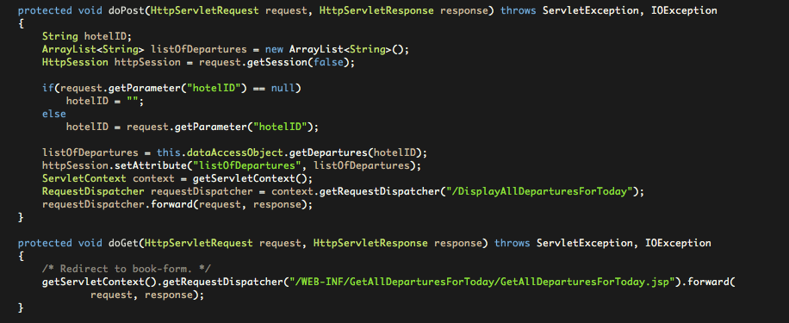

Step3 - Select query is formed and all departures on the day are displayed to the staff
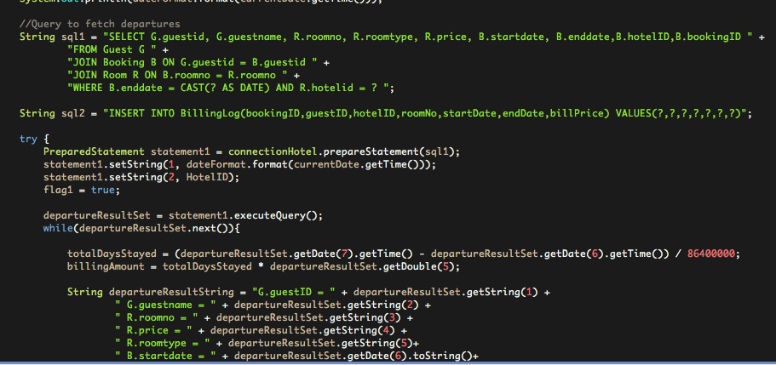
Step4 – Look at the billing log table
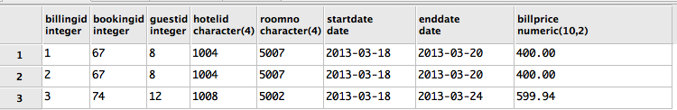
Step5 - Arrivals of the day are displayed in the form
