School of Computing
University of Teesside
Middlesbrough TS1 3BA

The Arbitor: A Peer to Peer solution for MMORPG dungeons

Submitted in partial requirements for the degree of MSc Computer Games Programming

Date: 21st September 2010

Bryn Stringer

Dr Anne-Gwenn Bosser

Acknowledgments

I'd like to thank my lecturer Dr Bosser for her guidance in this project, without which I would have been running around headless.
I'd also like to thank Jenny Draper for being my main test subject both for muliplayer testing and from a non technical point of view.
Finally i'd like to thank Blizzard for making an awesome game to inspire me and Zullin the level 80 troll priest for putting up with me being behind the controls through 2 expansion packs.

Abstract

The goal of this project is to explore the feasabilty of using the peer to peer architecture in augmenting the server client model used in mmorpgs.
Server client has been the backbone of the mmorpg market since its inception and the reasons for this have been well researched.
I aim to combat the weaknesses in the peer to peer model by using a hybrid peer to peer and server client model, using peer to peer for the main gameplay packets and the server client to add security and anti cheat measures to the mmorpg.
I have chosen to create instanced dungeons as these are self contained areas of the world in which usually 5 players interact. This simplfiys the peer to peer process as the clients involved are static.
I aim to show how creating a peer to peer hybrid mmorpg is an area that has potential use in the mmorpg market.

Table of contents

Chapter 1: Introduction Page
Chapter 2: Xna and the 2D engine Page
Chapter 3: Server – Client Page
Chapter 4: Arbitor Hooks Page
Chapter 5: The Arbitor Page
Chapter 6: Testing Page
Chapter 7: Conclusions Page

Chapter 1: Introduction

Massively Multiplayer Role Playing Games or MMORPG's for short are persistant game worlds in which a player may connect to and take of the role of an avatar. This avatar is the representation of the player in this game world and allows them to interact with both the world and other players connected to the world.
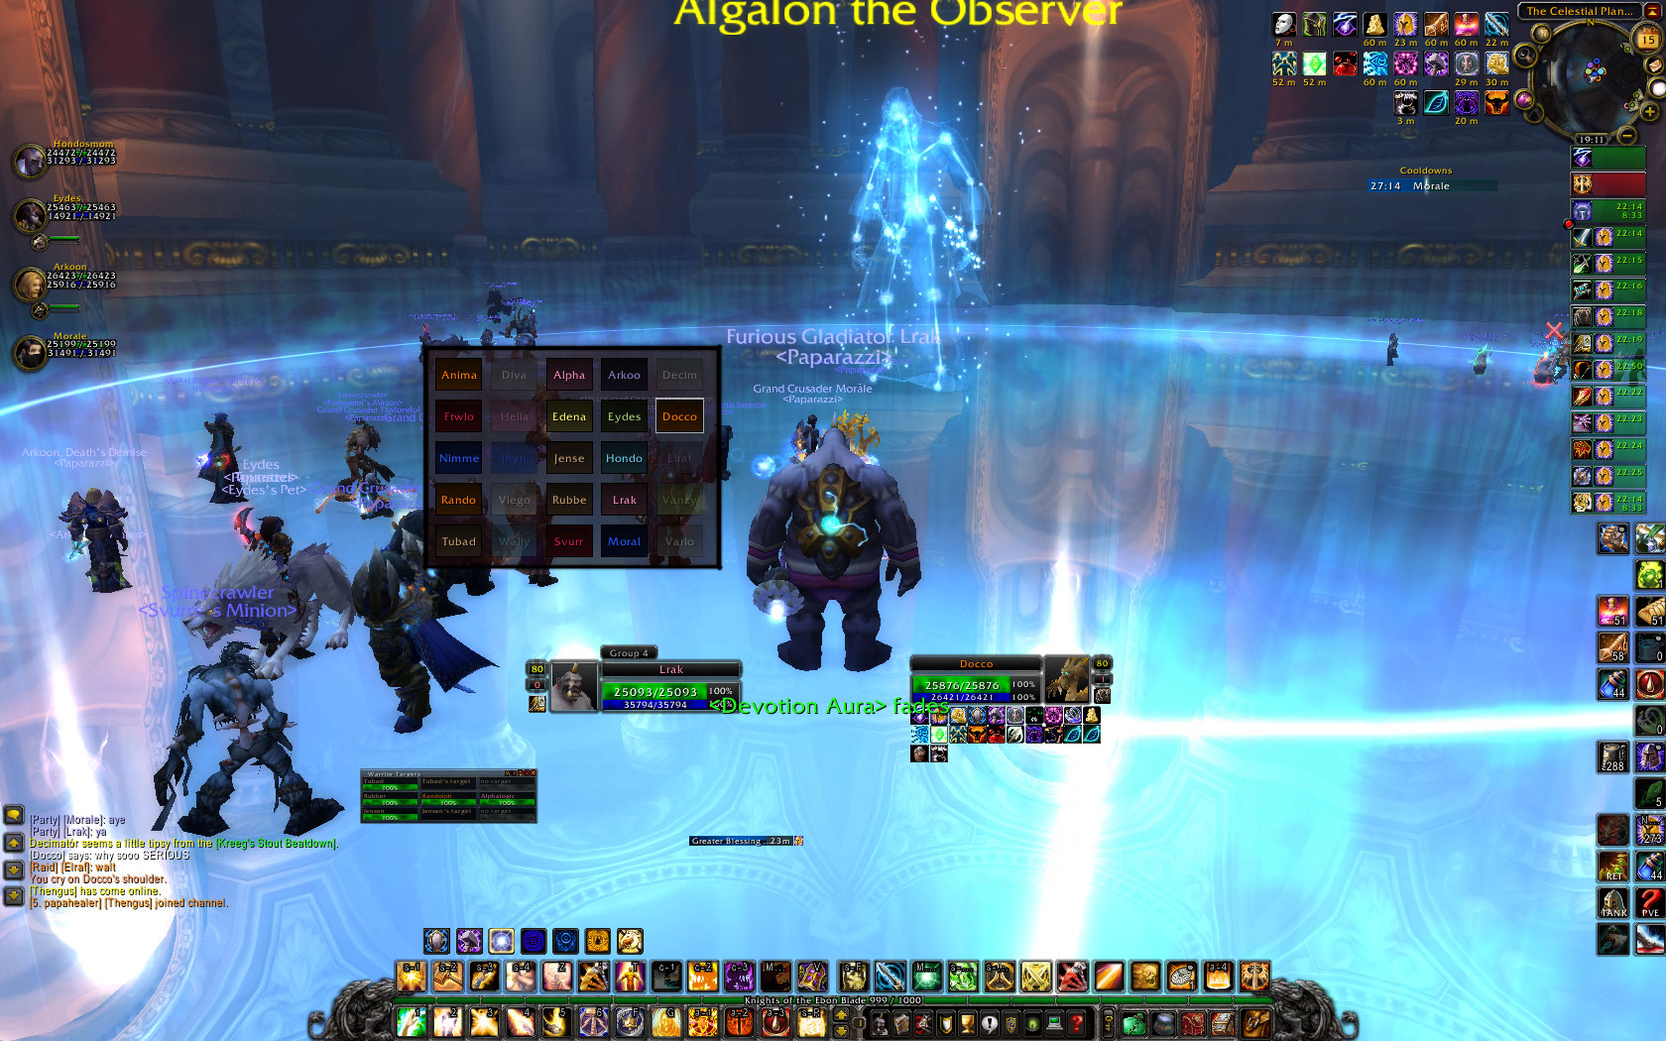
Fig 1.1 Screenshot from World Of Warcraft

The most common type of MMORPG is the fantasy genre, in these brave heros go on epic quests to slay powerful monsters, getting epic equipment and leveling up.
MMORPG's mainly use the server client model, this allows the company to handle all game interactions through there servers making for a much more secure and fair game service.
The server client model is also easy to implement, meaning less development time and less costs.
However as the number of players increases the cost of servers and bandwidth increases proportionatly. [Fan et al,2009]
These rising costs make a peer to peer alternative look promising, due to there scalable nature.
There are a few major drawbacks with a peer to peer MMORPG that have yet to be fully overcome, mainly making a secure and fast experence for the player.
Security in a peer to peer network is best described using the “The Byzantine Generals Problem”.
The Byzantine generals problem can be broken down into the communication between peers.
“We imagine that several divisions of the Byzantine army are camped outside an enemy city, each division commanded by its own general. The generals can communicate with one another only by messenger. After observing the enemy, they must decide upon a common plan of action. However, some of the generals may be traitors, trying to prevent the loyal generals from reaching agreement.”
[lamport et al, 1982].
This replecates the problems of a peer to peer network with either a faulty client or a client deliberatly cheating.
Combating this in a peer to peer fashion is a challage, as determining which client is faultly is difficult without something to compare it to.

A few attempts have been made at successfuly desiging a secure and fast peer to peer architecture,
such as PartyPeer [Liu et al. 2006] and [Knutsson et al, 2003]. These are solely peer to peer architectures which while functional have made no major attempt at secruitiy making them acedemic exercises as opposed to possible tools for creating a retail game.
Other attempts at a hybrid server client and peer to peer approach have been made such as VoroGame [Buyukkaya et al, 2009] and 'tisu [Aasen, 2009].
These mainly focus on spliting the responsibitly of the game world into sections to be handled either by a client or a server. The problem with this approach is that if the server is in charge of an area it may as well be the server client model and if a client holds the responsibity then cheating or the client disconnecting may affect the qualtiy of service.
This made me consider how you could use peer to peer in an mmorpg without running into major flaws yet still benefitting from the distrubed nature.

World of Warcraft is the most popular MMORPG currently on the market, leaps ahead of any of it's rivals.

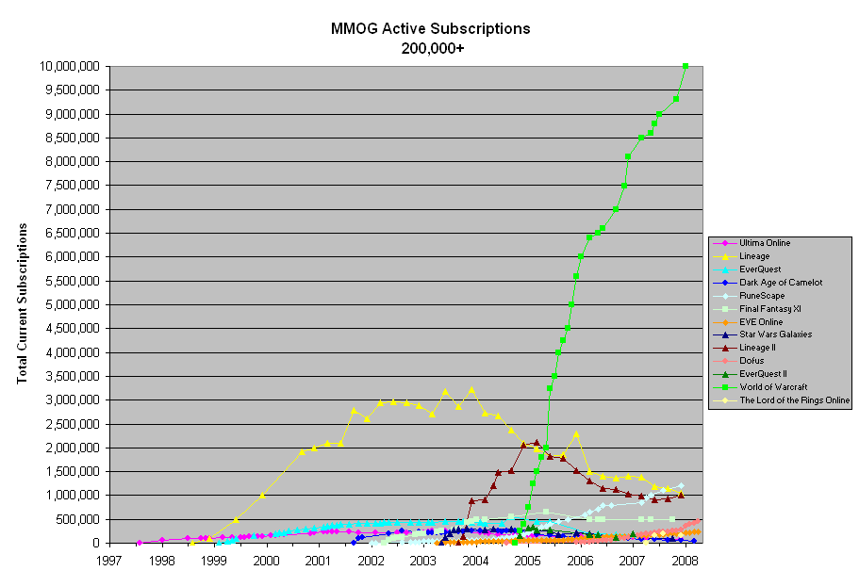
Fig 1.2 MMORPG subscriptions chart, Green line is World of Warcraft
[Chart from mmogchart.com]

In the World of Warcraft players can group together into parties of 5 people to enter dungeons which give more rewards than solo play.
Recently a tool for quickly finding groups of people to play with has been interoduced, this allows people playing on different servers to enter a dungeon together by having a seperate set of servers which solely handle this cross server interaction.
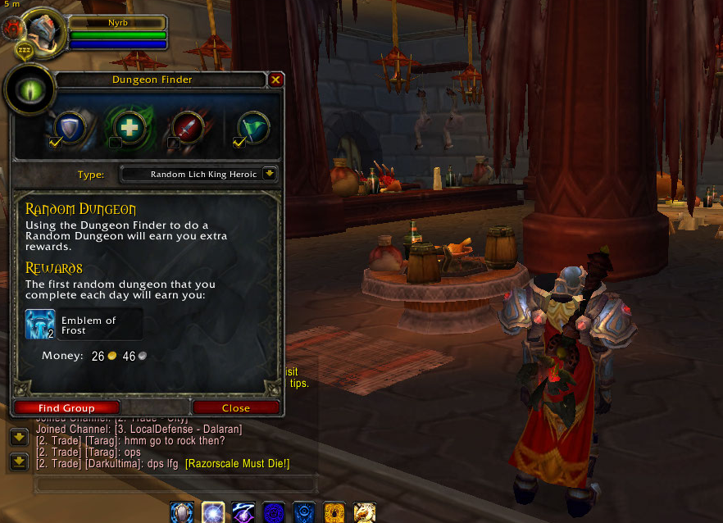
Fig 1.3 World of Warcrafts Looking For Group tool

It was this moving of players to a seperate server while retaining the server client model that made me think about the possible use of peer to peer networking in dungeons.

The dungeon is a self contained and clearly defined area of space, meaning there are no boundries to worry about. Also the layout of the dungeon is static, meaning that no information needs to be secret from the players.
The number of clients who are in the peer to peer network is known at all times, due to the grouping of players prior to the setup of the dungeon.
Finally due to the player vs enviroment aspect the players will only try and cheat the server, this can be anticipated and dealt with.
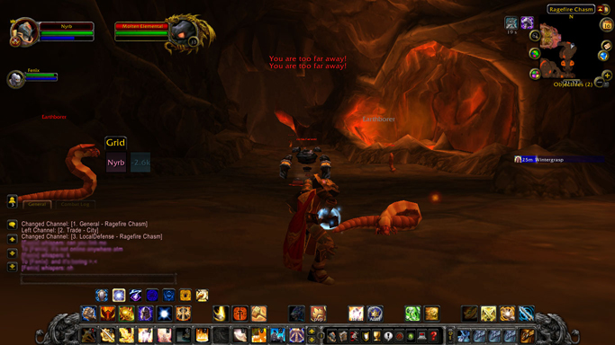
Fig 1.4 Ragefire Chasm a dungeon with a fixed layout in WoW
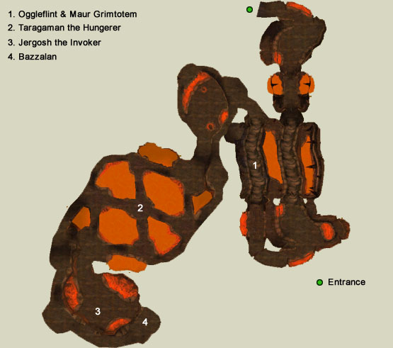
Fig 1.5 Map of Ragefire Chasm
All these aspects contain some of the major flaws in the peer to peer mmorpg concept, allowing for a hybrid peer to peer network to handle dungeons without major shifts in gameplay or server layout.

My project will atempt to create a simple MMORPG and implement hybrid server client and peer to peer dungeons.
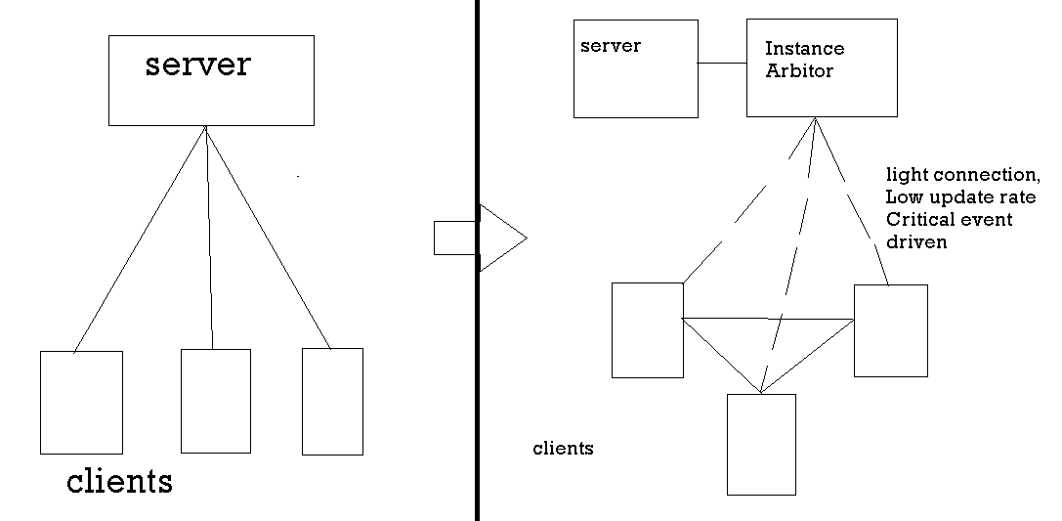
Fig 1.6 Initail design concept for the Arbitor system

The goal of the Arbitor system will be to handle the creation of a peer to peer network between clients and to monitor the progress of the players in the dungeon. It will act as the one true state, taking updates from the clients and monitoring for cheating and desynchronization of the clients.
To put this in the Byzantine generals metaphor the Arbitor would act like the king positioned outside of the battle sending his orders and judging on commands.
The update rate will be a lot lower than a server client model, allowing most of the crucial game packets to be handled in a peer to peer fashion with only occasional checks to the server.
Hopefully by limiting in this manner the Arbitor will be able to use less bandwidth and processing power on the server, allowing for more players on the same hardware with lower costs per player.

Chapter 2: Xna and the 2D engine
For this project I decided to use Microsoft's XNA for the creation of the 2D engine. XNA uses c# which also allows the use of .Net for my networking components, making it a logical choice to develop in.
I considered usings Direct X or Opengl along with the boost networking libaries however i've never used boost networking and felt that working in C# would speed up development allowing me to acomplise more in the time allowed.
I have previously used XNA for game creation and am quiet fluent in it, allowing me to work on developing the project as opposed to learning a new set of tools.
My project uses XNA version 3.1, which is the most widely used version. Version 4.0 has been released but it is still in beta testing and mainly focuses on add compatabily for the upcoming windows phone 7 OS.

The first step I took when creating this poject was to lay down the foundations of my 2D engine.
The engine handles the drawing of sprites onscreen, the loading of assets and the general flow control of the program.
In the Game1.cs file in the client we can see the creation of the 3 major parts of the program:
Graphics = new Graphics_Core(this);
Game = new GameState();
Logon = new LogonState();
The Graphics core is responsible for the loading, management and rendering of sprites. It has an update function which clears the screen and a draw function which draws all listed sprites.
The Game state is the main game loop which handles all gameplay and the logon state is in control of the main menu (First screen shown).

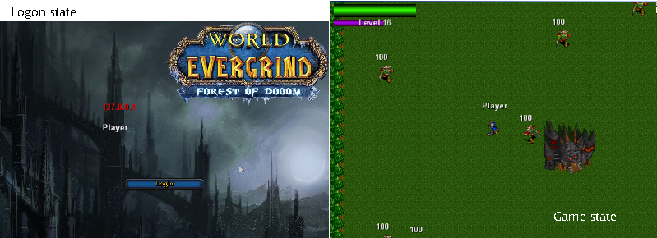
Fig 2.1 Logon and Game state

Both of these states talk to the Network Core, which handles network functionailty. I shall discuss the network core in more detail in a later chapter.

Each of these states is called from the main game loop, located in the Game1.cs file in the update function.
There the graphics core is updated then depending on the current active state the correct update function is called.

The server works on a similar system, however only having the abitly to render the console text.
Text is rendered in both the server and client using a sprite font, which converts a system font into a 2d image which can then be rendered simply by passing a string to the XNA function.
Functionailty like this is one of the major reasons I chose to use XNA for this project.
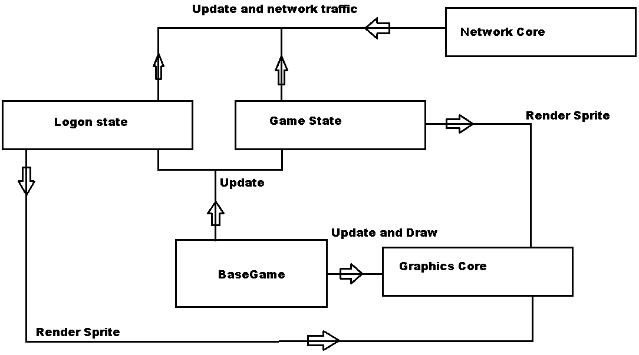
Fig 2.2 Basic module overview

In Fig 2.2 you can see how the modules interact with each other, with each frame starting at BaseGame.
This seperation of the modules allowed me to work on each part seperately, making for a much smoother workflow.

XNA uses something called the “Content Pipeline” to load files into the engine.
These are a range of custom importers which convert the files data into a standard format, allowing multiple file types to be treated in the same way.
For example textures can be Jpeg, Bitmap, Targa, Png or dds files and all will be treated the same once loaded.
To use the content pipeline you add the file to the project under the Content branch as show in Fig 2.3.

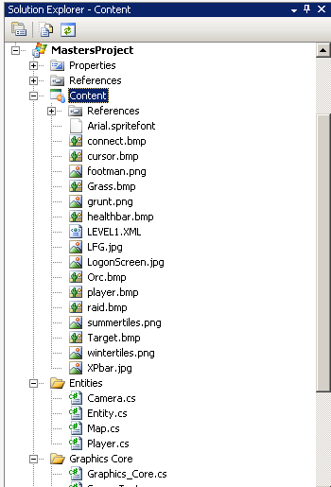
Fig 2.3 The content branch
As Fig 2.3 shows, multiple different file types are added to the content branch. These will be compiled into a standard format on build and included in the content folder of the build.
Two useful features of this are a built in XML loader and a color key tool for textures. The color key allows for a background colour in the texture to be replaced with alpha, meaning a seperate alpha channel is not nessicary (however it is still supported).

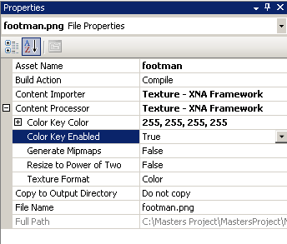
Fig 2.4 Content properties

Once the file has been added to the content branch it can be loaded into the game using the “Content Manager”. I have wrapped this functionaitly so that I can assign an integer identifier to a texture and render by simply passing the idenifier to the graphics core.

SpriteManager.LoadSprite(0, GameAccess.Content, "footman");

This line called in my graphics core load content function simply loads the file called “footman” from the content branch into a list of loaded sprites at index 0.
When I want to draw it I simply call RenderSprite from the sprite manager, adding in the index of the sprite and its location onscreen.
There are various overloads for RenderSprite such as render with rotation or render a subsection of the sprite (used when doing animation of sprite sheets).

The game world is a 2d scrolling tile map, created using a sprite map of tiles.
The layout of the world is held in a 2d integer array in the Map class, containing functionailty for loading an array from a file, saving the current map as a file, rendering the current map and getting collision information.
The map is stored in an XML file which contains a string of all the Tile Identifiers in a set order, these are loaded into the array at the beginning of the game.
Tile Identifiers work from the position of the tile on the tile sheet, reading right to left and top to bottom.
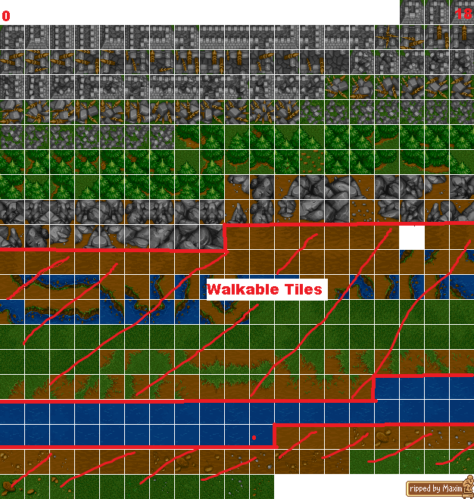
Fig 2.5 Basic Tile Map

These tile identifers are used for both rendering the tile and collision detection.
In the GetWalkable function the tiles with a value less than 189 (the top section containing rocks and trees) and the tiles between 314 and 351 (Water) are not walkable.

To allow the map and world to scroll around I created a simple camera system. The camera holds the centre point it is focusing in on and also a bounding rectangle representing the onscreen area. With this we can apply an offset to the map and other world sprites to draw them in the correct place.
This is a simple but effective way of scrolling the tile map.

Control of the local player is contained within the Player class. This class handles the control, animation and rendering of both the local player and the representations of other network players.
XNA contains it's own keyboard and mouse input system which allows for easy implmentation of controls.
The players movement is bound to the “wasd” keys, with a simple check to see if each key is pressed:
if (Keyboard.GetState().IsKeyDown(Keys.W))
{
TargetPosition.Y--;
moving = 1;
}
Next we interpolate the movement of both local and network players to smooth movement using a built in interpolator to get the new position.

Position = Vector2.SmoothStep(Position, TargetPosition, 0.15f);

The Animation of the local player is split into 8 cycles, one for moving in each direction and one for attacking in each direction.

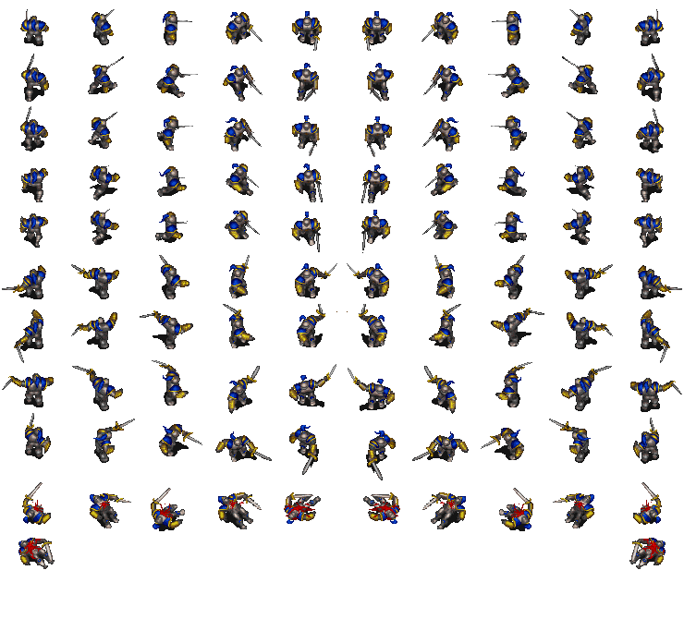
Fig 2.6 Player Animation file
The graphics core has a RenderSprite overload which takes a frame and animation parameter. These are linked to the row and column of the sprite sheet respectivly.
If the player is attacking a target then the frame is set to the lower attack animation.

The player can attack targets using either the mouse to select them or pressing the tab key to target the nearest enemy. When a left click is detected we compare all enemies position with the current mouse position and select any within a small radius. The target is then stored in the playertarget variable.
The Tab key uses a simple range check on all the enemies currently alive and selects the one closest.

The player has a timer embedded which is set every time he attacks a enemy. The interval is 1 second and allows for the animation to complete before another attack.
Every swing AttackCooldown is set to current time plus 1 second, this is then compared to the current time every frame and if the current time is greater then a range check is started to see if the player is in melee range of his target.

The final part of the player code is the implementation of the chat input. This checks to see if the enter key is pressed then stops all other keystrokes and listens to the players input. Sadly there is no simple way of taking the players input so a large collection of if statements cycles through each letter and checks if it has been pressed:

if (Keyboard.GetState().IsKeyDown(Keys.A)) { CurrentMessage += "a"; }

These are added to the CurrentMessage string, which is then passed to the network core when the enter key is pressed again.

All the world and player assets are from the game “Warcraft 2”. I chose this game as a homage to blizzards “World of Warcraft” and the assets are easily available and of high quality.
It also allowed me to make the joke that I was working on “World of Warcraft 2”.

Chapter 3: Server – Client

Most MMORPG's on the market use the Server Client model. It is understandable why as the idea of a player connecting to a world fits with the idea of a client connecting to a server.
For my implementation of the Server Client model I am using tcp and a multi threaded server.
By using a multi threaded server I can handle connections better and large amounts of clients.

My project is split into 2 main sections, the server and the client. This allowed me to keep the server and client very distinct and work on them seperatly.

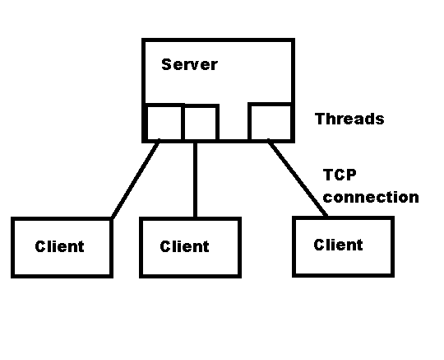
Fig 3.1 Diagram of Server Client model with threads
As you see in Fig 3.1 each client has a thread on the server. This thread handles communication to and from the server to the client.
Each thread in the server is an implementation of the TCPThread class. This class contains a thread, a TCPClient for sending and rechieving the messages and a class called “PlayerRepresentation” which holds all server side information about the player connected to this thread.

All information sent across the network is first packed into a class i've created called “Packet”.
These packets hold a select number of variables which are converted into a string before being sent.
Using a set number of variables allows for fixed length packets to be sent, however this is more costly on the bandwith.

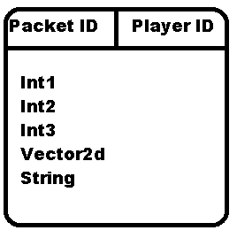
Fig 3.2 Contents of a packet

The packet's ID is a fixed number which identifies the information held within the packet.
The Player ID is the unique player identifer that the server has assigned the player, this is given to them the first time they log on with a new name.
The Packet class also implements two functions for converting a packet to a string and creating a packet from a string.
These functions work by having a fixed order for the values in the string which are then split with “|”. Finally a “@” is placed at the end of the string to mark the end of the packet.
An example packet is the Packet ID 0. This packet uses the string as the name of the player and the vector for there desired position. The server checks on it's map if the tile is walkable and either ignores or accepts the change.
The map is loaded by the server as well as the client for the purpose of collision dectection.
If the change is ignored the player will be returned to where they last had an accepted move during the refresh cycle of the server.
The refresh cycle sends the state of the game world to all clients, including the information on all clients.

When a client wishes to connect to a server they enter the IP address of the server into the logon screen. This is required because there is no static ip address for the server, if this was a commercial product the server would have a static ip address that could be hard coded into the program.
When they push the Logon button the network core's connect function is called with the selected IP.
This atempts to make a tcp connection with the server. If it fails the function returns a cooldown for displaying a “Could not connect” message on the logon screen.
If the connection is a success the network core sends the sever a packet containing the name of the player and the default packet id and player id.
The server during this creates a new thread for this connecting player and when it rechieves this name packet it checks it's record of players using the name and returns the unique player id if the player has connected before or returns the next available player id not yet used.
This id is then passed into the GetPlayer function of the database and returns the data.
If the GetPlayer function cannot find the player then it creates a new entry for the player with the new identifier. This new player is then returned to the thread and the thread does an update sending the players id and all information to the client.
This packet is marked with the id 3 which tells the client that this data is the servers copy of the player which then sets the players id and position to the correct values.
The client then returns a setup complete message that the server rechieves and flags the user as connected.

The storage of player information is a key part of an mmorpg, as the players character is expected to be there everytime they connect to the server. This persistance is one of the major parts of an mmorpg and storing the game data is crucial. Normally a database is used for the storing of the players information however the creation of such systems is a project in itself, instead I chose to use a simple system that had drawbacks but was easier to implement.
The player database class handles the save and loading of the list of all known players. The list is a text file stored with the server program which is read at load time and written to on shut down.

Example of data stored:

Player|814,946|0|100|1560
Playerssd|752,792|0|-176|0
Playerwrwqr|500,500|0|100|0
Playerqweqew|793,609|0|100|20

This information represents the players name, there position at log out in the game world, there level, there current health and total XP gained.
The ordering of the player information determines there unique ID, however due to the fact that the players name is used as the unique identifier as long as the names aren't changed the server will still function normally.
On load time the server reads in the text file and stores each line as a player in the PlayerDatabaseList which is a large list containing the players information.
This would be a problem spot if there was any large number of players stored in the database as the server has to look through each entry whenever a client connects and do a string comparision.
However for the needs of this project it surfices, there is never expected to be more than 10 records stored in the database.
In game chat is another important area of mmorpgs, as without having a way to communicate there would be no social aspect to the game.
In my engine the player can enter chat mode by pressing enter, this halts movement and allows for typing. When the message is sent by pressing enter again the string is passed to the send chat function of the network core and a packet is sent to the server with the packet id 1.
When the server rechieves the packet it attaches the players name to the front of the string and broadcasts it to all connected client using the broadcast packet function.
This simply sends the packet to all connected clients. On rechieving the broadcast the clients display the message on the chat console, a list of strings and timeouts stored in the game state.
The timeouts are used to remove messages from the chat window ingame after a set time, which prevents overcrowding the chat window.

Chapter 4: Arbitor Hooks

Having created a functioning client server mmorpg I turned my attention to adding the elements required for the peer to peer functionailty.
To clearly seperate the peer to peer section from the main client I created two library projects which contain most of the functionailty of the peer to peer system.
The first stage was to implement a queing system for creating groups of players looking to join a party.

Queing
I decided to have a fortress placed in the middle of the game world which when clicked would put you in the que for the duegeon.
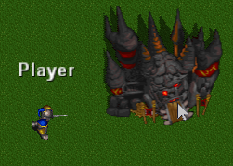
Fig 4.1 The fortress

This is implemented client side using a simple render call in the main game state loop and a mouse click check in the player loop.
The player has a boolean called “qued” which is used for showing when the queing process has begun.

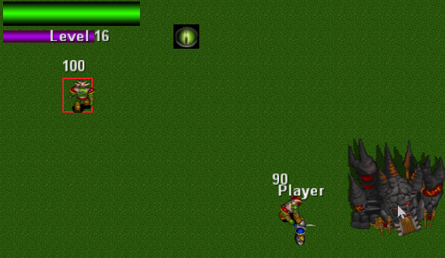
Fig 4.2 The green eye marks the player that he is queing

When the fortress is clicked the player sends the server a que packet with the packet id 66, and also informs the arbitor core to connect to the servers arbitor core.
When the main server rechieves the packet id 66 it adds the player to the LFG list in the arbitor core, adding it's unique player id to the list of currently waiting players.
It also marks the boolean “Instance” as true, preventing anymore updates from the main server from being sent.

The arbitor core's need some additional information from the client and server before loading.
On the client side the arbitor core is passed the ip address of the server when the first successful connection is made on the logon screen. This is in the connect function of the network core:
Arbitor_Core.IP = IP;
This is due to the arbitor server running at the same ip address of the main server.

Also an update function fr the arbitor core's is called on both server and client. This is to allow the arbitor to update its state.

With these hooks in place I was able to create a list of clients wishing to join a duegeon and so had the list of clients for my peer to peer network.

Chapter 5: The Arbitor

The Arbitor kicks in when there is a set number of players in the que, this is the number of clients to create a peer to peer network out of. The number is changeable as it is defined in the Arbitor cores update function. Currently the number is set to 2 however the code is designed so that any number of clients can be used.

When the Arbitor cores update function finds enough players waiting in the que it calls the CreateArbitor function which takes the Looking For Group list and adds a new Arbitor to the Arbitor list. This Arbitor class represents a single duengon and peer to peer network, the system is designed to handle multiple seperate duengons and peer to peer networks at any one time.

When a player joins que for the duengon he also estabilshes a tcp connection to the arbitor core which is used by the client to communicate with the servers Arbitor Core.
Once the Arbitor is created it waits for all the players to connect via tcp, this is nessicary as the last player to join the que may not have connected via tcp for a short interval due to the handshaking involved.

Each client connected to the arbitors via tcp has a thread to handle the communications. These threads have two identifers attached to them. First is the players unique identifer which is aquired from the player on initial connection and the second is the Raid identifer. The Raid identifer is linked to the Arbitor class that is handling the peer to peer network that the player is connected to.
This is important as the player will send updates via tcp and the Arbitor core needs to pass these messages to the correct Arbitor.

The players id is requested using a Id request packet with the packet id 100. This packet when rechieved by the client causes the client to send back a packet with the id 100 and also there player id.

When all players have sent there player ids to the arbitor core the creation of the peer to peer network can begin.
We then look at each client in the looking for group list passed to the arbitor and compare the player id to the ids of the clients connected via tcp.
For each matched id we take the clients ip address and send it via tcp to each of the other clients connected via tcp.

This ip address is attached to a packet with the packet id 101, when the arbitor core on the client rechieves this packet we add a new udpplayer containing the string of the address to the list of players in the peer to peer network.

During the setup stage we also set the raid id of the threads connected to the arbitor to the number of the instance which is it's position in the arbitor list in the arbitor core.

Now that all the players have the ip addresses of one another we are able to send udp messages using the SendDatagram function of the arbitor core.
This takes a string of data and the target player and uses a socket to send string to the player.

This is then wrapped again in the SendUdp function which takes the packet class and broadcasts it to all the other players on the peer to peer network. This allows the client to use the same set of packets in both the standard client server and peer to peer connection.

When a udp packet is rechieved by the arbitor core on the client it is passed via a delegate to the network core of the client.
The delegate allows the client to tell the arbitor core define which function handles incoming packets. This allows for flexiblity and all packets to be handled in the same place.
Player packets with the id of 0 use the same code for both peer to peer and client server connections.
There are some exceptions, for example the attacking packets rechieved by the client are only for the enemy attacking the player thus a new packet type was created for when a remote player attacks an enemy during peer to peer mode.

Allowing the players to send messages via udp is only one half of the Arbitors responsibity.
Each player also sends a complete update of there game state to the Arbitor core via tcp.
This contains all entity positions and health, all player positions and details of the local player.
The arbitor stores a copy of the details on each entity and player in the game per player, allowing it to compare the game states and make judgements on what the state should be.
Each player represention includes the identifer of the player, there name and a list containing the reported positions and health.
Entity's include there entity identifer and along with there position, health and there attack target.

The code for the collection of this data is rather confusing at first glance:
case 22:
//A player update packet
bool FoundClient = false;
for (int i = 0; i < ClientReps.Count; i++)
{
if (ClientReps[i].PlayerID == p.PlayerID)
{
FoundClient = true;
ClientReps[i].Updated = true;
//Set the reported vector for the player
bool SetVector = false;
for (int j = 0; j < ClientReps[i].VectorFeedbacks.Count; j++)
{
if (ClientReps[i].VectorFeedbacks[j].PlayerID == p.Int2)
{
ClientReps[i].VectorFeedbacks[j].Vector = p.Vector;
SetVector = true;
}
}
//Vector not reported before, create
if (!SetVector)
{
Vector2_PlayerLink NewVec = new Vector2_PlayerLink();
NewVec.PlayerID = p.Int2;
NewVec.Vector = p.Vector;
ClientReps[i].VectorFeedbacks.Add(NewVec);
}
//Set the reported health value
bool SetHealth = false;
for (int j = 0; j < ClientReps[i].HealthFeedbacks.Count; j++)
{
if (ClientReps[i].HealthFeedbacks[j].PlayerID == p.Int2)
{
ClientReps[i].HealthFeedbacks[j].Int = p.Int1;
SetHealth = true;
}
}
if (!SetHealth)
{
Int_PlayerLink NewInt = new Int_PlayerLink();
NewInt.PlayerID = p.Int2;
NewInt.Int = p.Int1;
ClientReps[i].HealthFeedbacks.Add(NewInt);
}
}
}
if (!FoundClient)
{
Arbitor_Player_Rep NewPlayer = new Arbitor_Player_Rep();
NewPlayer.Name = p.String1;
NewPlayer.PlayerID = p.PlayerID;

Vector2_PlayerLink NewVec = new Vector2_PlayerLink();
NewVec.PlayerID = p.Int2;
NewVec.Vector = p.Vector;
NewPlayer.VectorFeedbacks.Add(NewVec);

Int_PlayerLink NewInt = new Int_PlayerLink();
NewInt.PlayerID = p.Int2;
NewInt.Int = p.Int1;
NewPlayer.HealthFeedbacks.Add(NewInt);

ClientReps.Add(NewPlayer);
}
break;

This takes the packet and sorts it into the right player representation as shown.

Find if we have a player representation for this player
if we have then check if the player reporting has told us of this player before
if they have then update the information
if not then add a new entry
If we don't have a player representation for this player add a new one

The entity data collection works in the same fashion, except it collects the target of the entity as well.

When the server has rechieved updates for all players it looks at all the data collected and broadcasts the new state to all the players.
This is handled in the update function of the Arbitor.
The positions and health of the players are averaged for all reported values and the values sent via tcp back to the players where they overwrite the players values, this keeps all players in sync with one another.
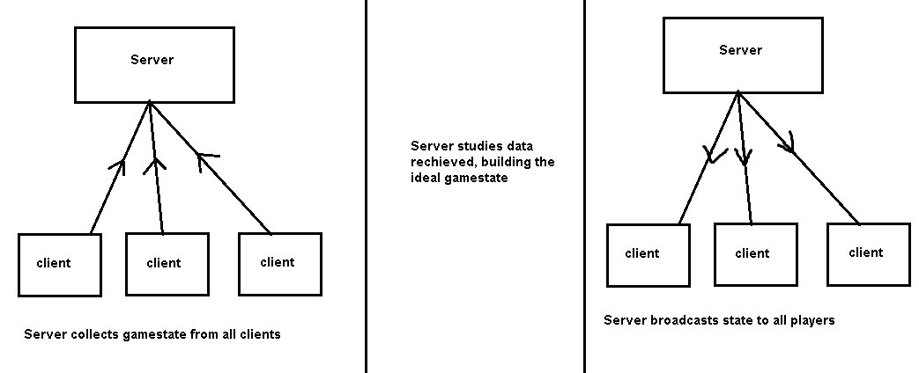
Fig 5.1 Collection and Broadcast
Having the updates from all the players allows the arbitor to act as the judge of decisions and gamestate, hence it's name “Arbitor” based on the word “arbiter” meaning “One who has the power to judge or ordain at will”.

Chapter 6: Testing

Testing an MMORPG is a difficult process, mainly due to the amount of computer required to do any stress testing. Many companies preform a pre release stress test to fans so that they can gauge how much stress the servers will be put under.
My tests can be broken into two types, the small scale testing using one or two machines and the testing using multiple machines in the computer labs.
During development most of the testing was done in the small scale form, allowing me to testing during development.
However there are limitations to testing a large scale multiplayer game on one or two machines so I was careful to testing frequently on a larger scale.

While developing the server client model most of the testing was done on a single machine. Due to the loopback functionailty of tcp my client and server were able to function normally on a single machine.
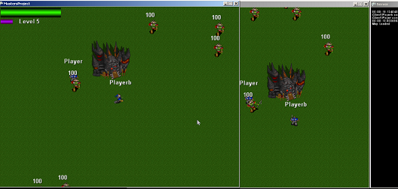
Fig 6.1 Two clients and the server running on a single machine
While not ideal this was enough for me to develop the server client without any difficulty.
I was able to test around 5 clients and the server before my machine started to slow down.
This was enough for me to be sure that the server client model was functional.
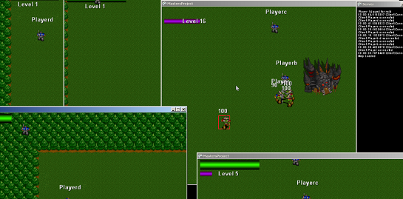
Fig 6.2 Five clients and the server running on a single machine
However as I implmented udp into my arbitor I found that the udp began clashing. This was due to one of the clients rechieving the all of the udp packets, starving the other client running on the machine.
This lead to one client rechieving all of the updates and functioning normally but the other client not updating the others state.
When the arbitor broadcasts were implemented this was repaired slighty due to the updates being tcp. This causes the client to only update on the infrequent broadcasts from the servers arbitor.

However this only is in effect when there is two clients running on a single machine, the problem is not apparent during network testing.

In order to test my project on a larger scale I took my work into one of the computer labs and took over 11 machines to test if the server could handle 10 clients at once.
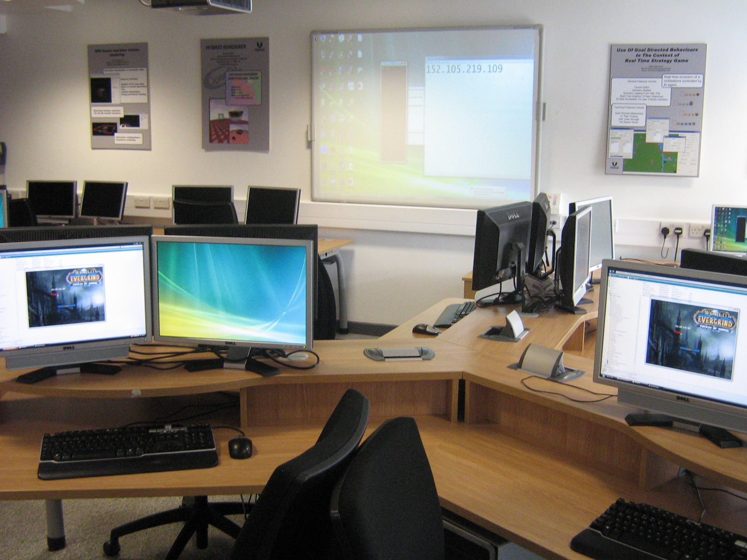
Fig 6.3 Lab testing, 11 machines (10 clients, 1 server)

After connecting all my clients to the server I tested movement and combat for the normal server client mode, all of which functioned correctly.
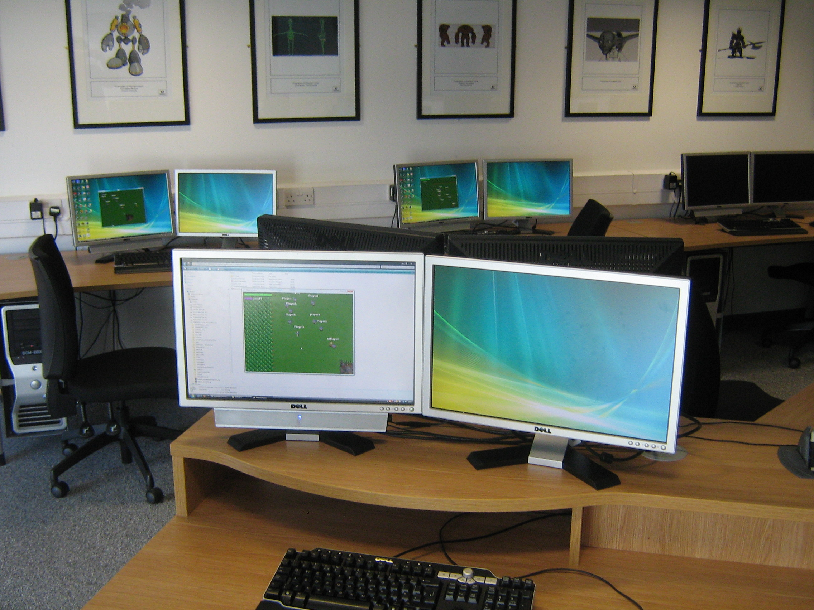
Fig 6.4 Shot of clients running in server client mode
Both the server and clients ran without any noticable faults.
For the next test I grouped the clients into pairs and created 5 running Arbitor dungeons, all being controlled from the same server.
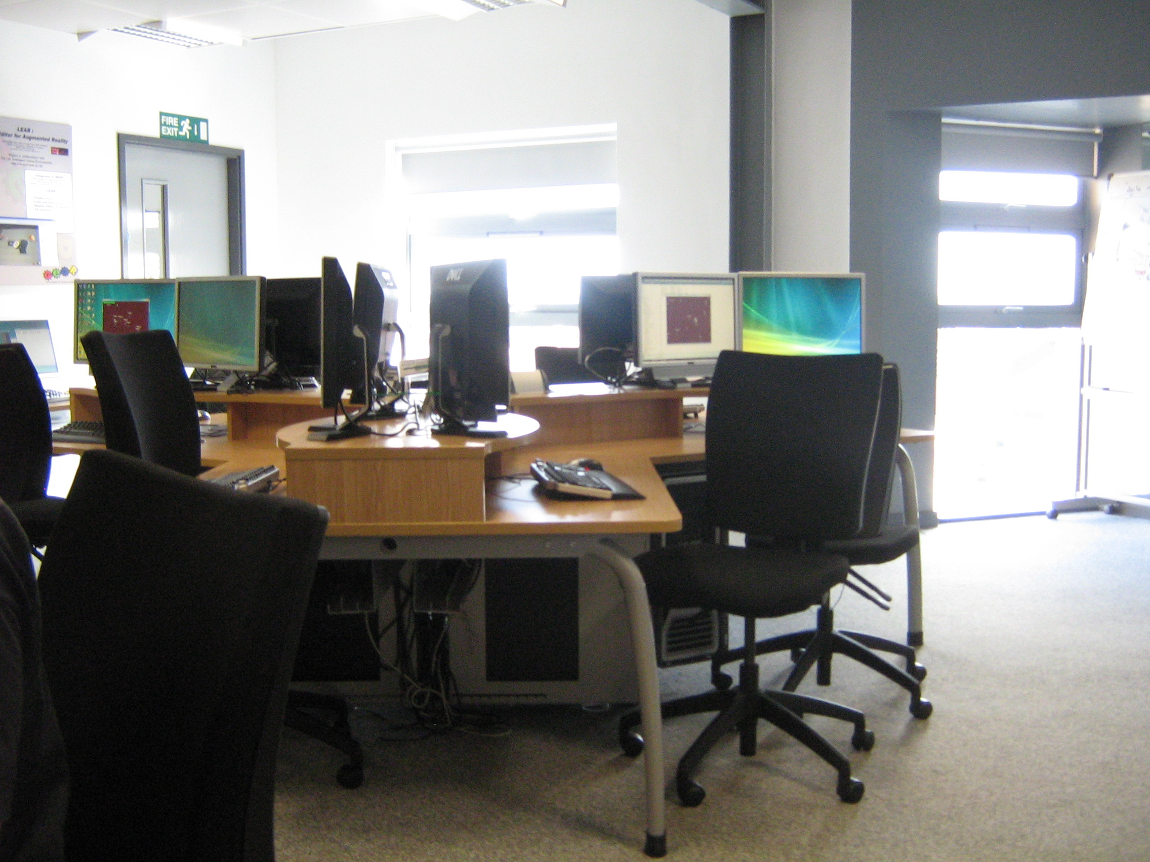
Fig 6.5 Shot of clients connected in peer to peer mode. (Red screen means dungeon)
The clients connected into peer to peer mode and entered there own instances. Players in the server client mode or another instance did not rechieve updates from these players or send updates to them.
One problem that was apperant was that all non connected clients were not cleared from the screen, simply standing there without any updates.
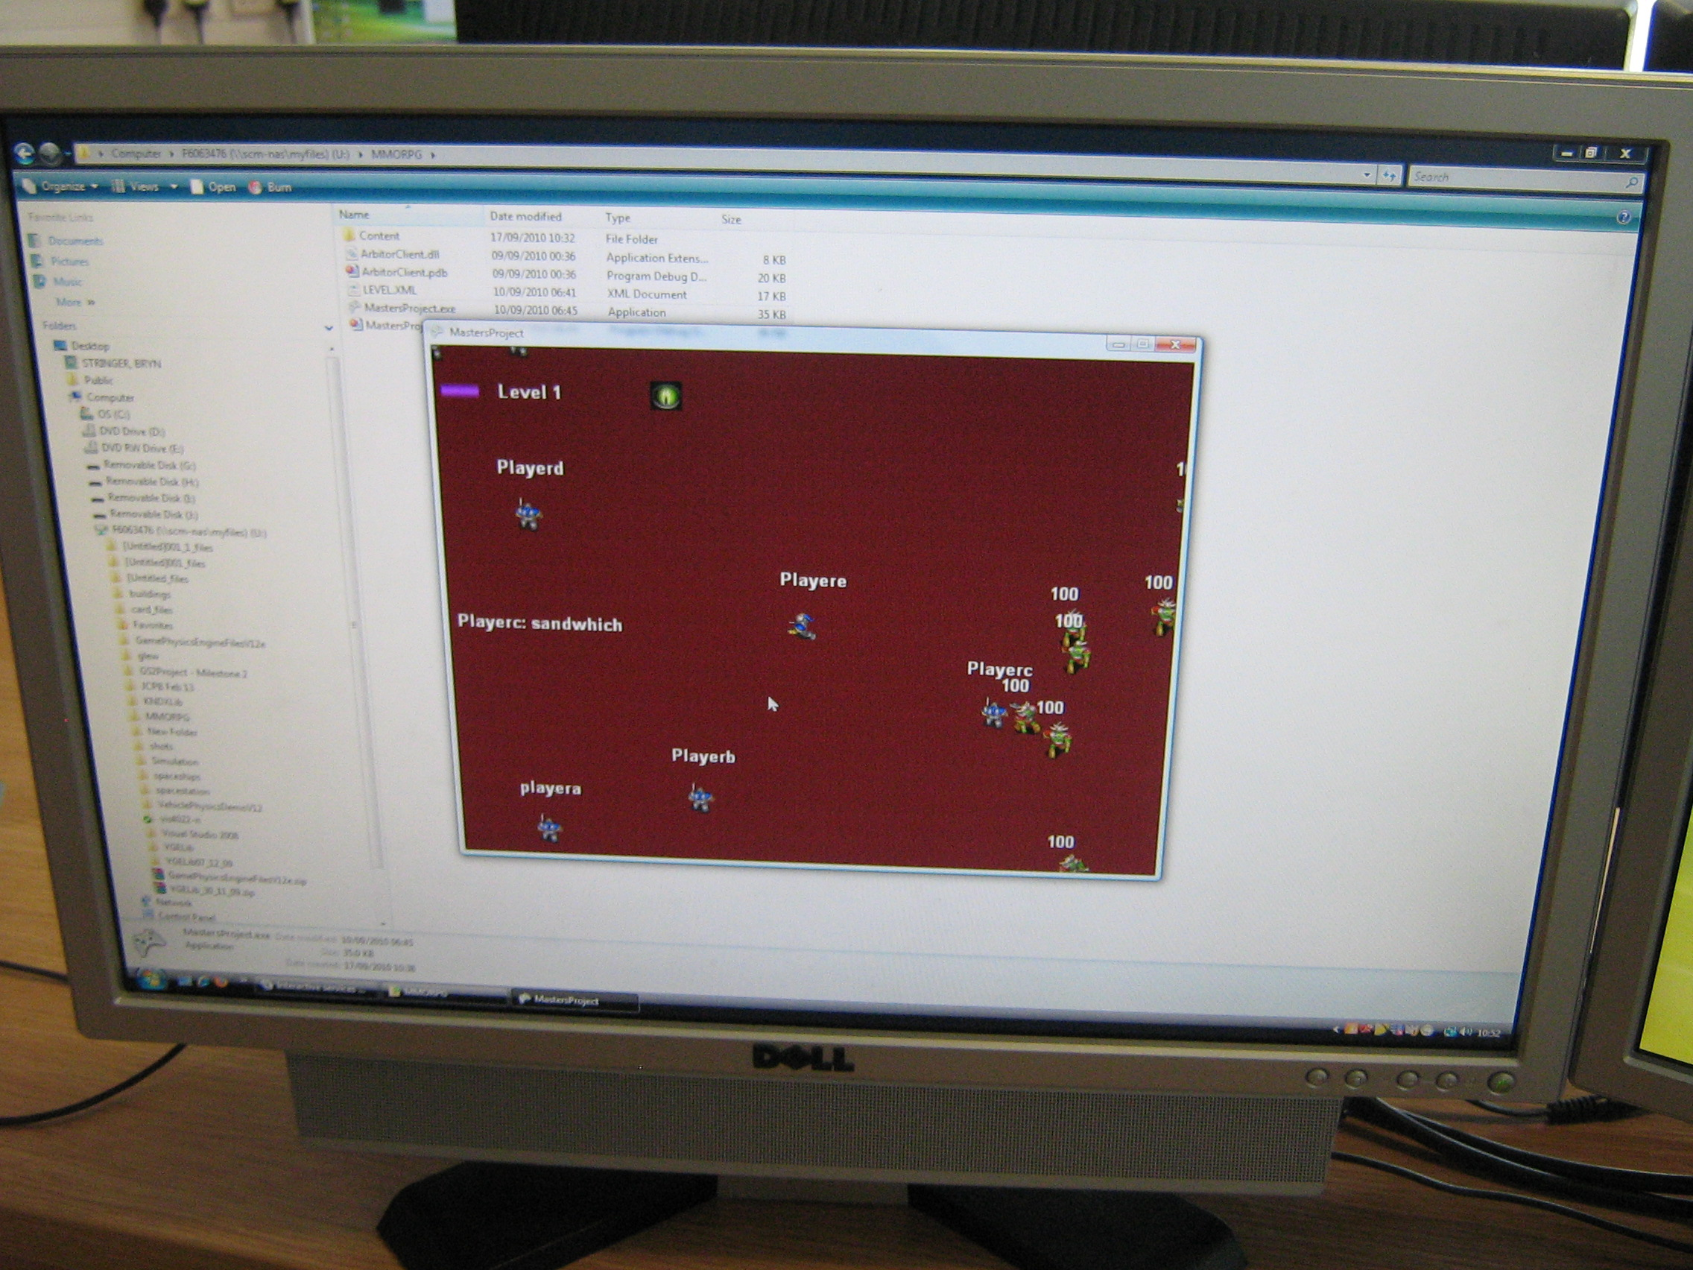
Fig 6.6 Client in Peer to Peer mode, showing non active players
This could be fixed simply by clearing the player list on entering a arbitor dungeon.
The final test I preformed was to kill the server while the 5 arbitor cores were active.
This was to test how the peer to peer network could handle losing the arbitor server.

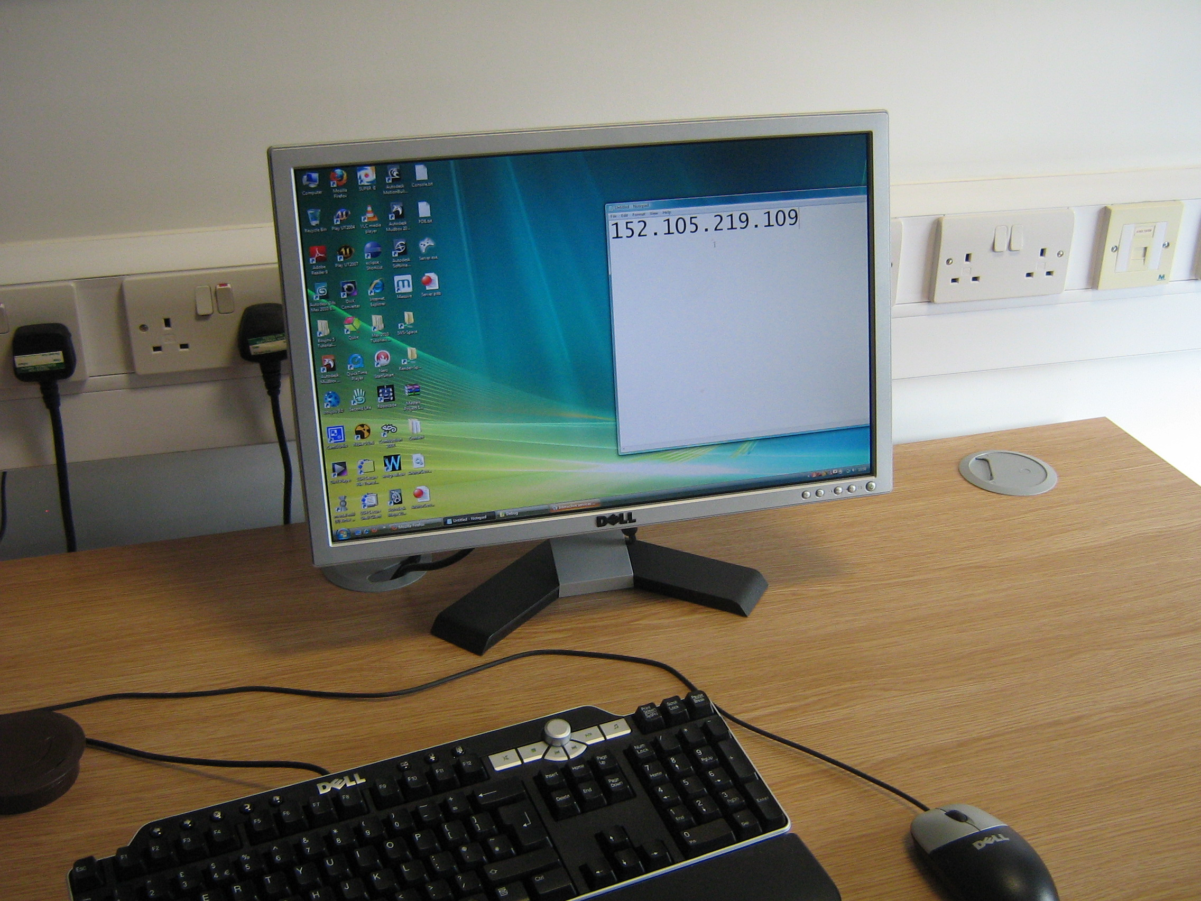
Fig 6.7 Server no longer running
To my surprise all the clients connected continued to send player updates without fail, however the enemy health state was not updated. The enemy health state is handled by the arbitor so this is no major surprise.
All in all the testing went well, there was no faults found and the project seemed to handle 10 clients without any trouble.
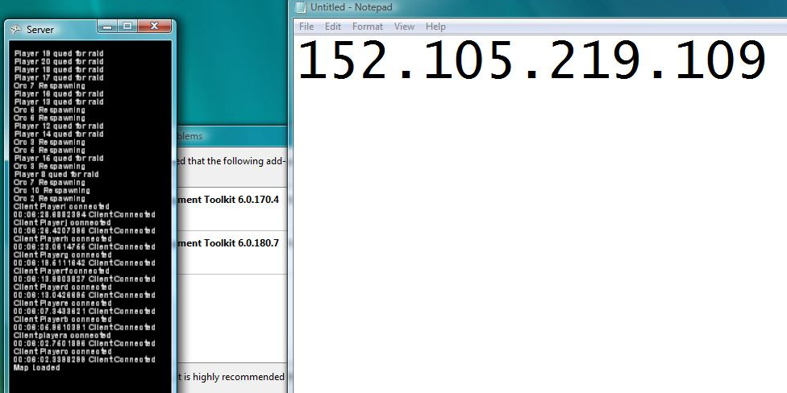
Fig 6.8 Shot of the server showing client connects and queing

Chapter 7: Conclusions
I started this project having only made simple multiplayer games and I feel very proud that i've come out the other end with a functioning MMORPG.

The graphics engine functioned perfectly, however i've worked on many similar things before hand so this came as no large surprise. While I chose to work on a 2d game I feel that extending it to 3d would not be much of a problem.
I'm glad that I kept the design of the game simple as it allowed me to concentrate more on the networking aspect of the game.

The server and client mode works very well, once I had it up and running I was surprised by how simple each individual part of it is. There is a lot of small parts that make up the server client connection but when broken down into small sections it is easy to implement.

The Arbitor took a lot of deep thought into how all the clients would connect and share there data. While working on the server client model my mind was always looking ahead planning how I was to implement the Arbitor. I feel that i've managed to implement something with potential use however I can see that the Arbitor could be a lot more than what it is in it's current state.
The fairness checks currently implemented are fairly basic and the Arbitor has no understanding of the rules of the game. Various interesting addtions to the Arbitor could be made, such as monitoring movement for speed hacks and calculating if the speed that enemies lose health is within normal levels.
The data collection of the Arbitor works well however I feel that more tweaking of the interval of complete updates would find the perfect update rate.
This rate will probably be effected by the speed of gameplay, the faster things can change the more updates will be needed. More turn based combat games would be happier with slower updates.
Getting the update rate as low as possible would be ideal as it would maximise the benefits of the Arbitor.
It would be interesting to look into dynamically changing the update rate depending on gameplay etc, as with a more dynamic system you may get better results.
The dungeons currently are set for 2 players however this is a simple number defined in the arbitor core and is easy to change.

The testing went very well, it would have been nice to see how far I could push my mmorpg however even setting it up on 10 clients took a while. In theory only the network and computer hardware effect the limit of players however due to no area of interest management in the server client mode it would break before it reached them.

All in all I feel that the project was a success, i've demonstrated that a hybrid peer to peer architecture can be used for mmorpg dungeons. I feel that the project could be easily be extended to provide more security to the peer to peer network which could possibly make the arbitor system a viable idea for use in mmorpgs.
One of the main things I would work on would be to make the arbitor more generic, taking out game spefic functionality and replacing it with scripts. These scripts could contain various portions of the Arbitors code for example what data the complete update contains. This would allow the arbitor to function as a middleware, allowing it to be used in any mmorpg style.
Another interesting element to add is to split the arbitor into its own seperate program, allowing it to be run on it's on server or even multiple servers. You could have a server for the Arbitor core and then a cluster of servers which the Arbitors themselves run on. With some tweaking of how the arbitor core and the arbitors interact this could allow for a much larger scale system.
I found this project very interesting to work on, as it's scope was vast and rooted in multiple different fields. Networking played a large part in the use of a hybrid network however there was the possiblity of using AI in the Arbitor to make judgements on the game state. I feel the arbitor has a lot of promise and with a longer development period it could be a useful tool for the development of MMORPGs.

References

[Fan et al,2009] Design Issues for Peer-to-Peer Massively Multiplayer Online Games, Lu Fan, Phil Trinder, and Hamish Taylor. Heriot-Watt University 2009

[lamport et al, 1982] The Byzantine Generals Problem, Leslie Lamport, Robert Shostak and Marshall Pease. SRI International. 1982

[Liu et al. 2006] PartyPeer: a P2P Massively Multiplayer Online Game, Leslie S. Liu, Roger Zimmermann, Baoxuan Xiao and Jon Christen. University of Southern California. 2006

[Knutsson et al, 2003] Peer-to-Peer Support for Massively Multiplayer Games, Bj¨orn Knutsson, Honghui Lu, Wei Xu, Bryan Hopkins, University of Pennsylvania. 2003

[Buyukkaya et al, 2009] VoroGame : A Hybrid P2P Architecture for Massively Multiplayer Games,
Eliya Buyukkaya, Maha Abdallah, Romain Cavagna, Université Paris, 2009

[Aasen, 2009] Hybrid Peer-to-Peer Solution for MMORPGs, Frode Voll Aasen, Tom- Christian Bjørlo Johannessen. Norwegian University of Science and Technology. 2009

Appendix

Packet ID's List
Packet ID | Packet Data
0 | Player updates
1 | Chat messages
2 | Entity updates
3 | Logon handshaking
4 | Attack Packets
5 | Arbitor Entity updates
6 | Arbitor Attack Packets
22 | Arbitor Player Refresh
23 | Arbitor Entity Refresh
66 | Que for dungeon
100 | Arbitor Handshaking
101 | Peer to Peer client information

