**Scatter**

Scatter symbols, or ‘Scatters’, may trigger a Bonus Game, multiply the total bet, or activate Free Spin rounds giving you anything from 1-50 free spins. The number of Scatters needed to trigger a bonus or Free Spin round differs from slot to slot, check the payout table to see how many you need, and Scatters can appear anywhere on the reels, not just in a payline.

In our case we get next level or play chest mini game (3x5bonus scene)

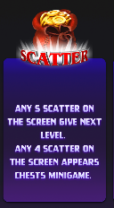

**How it work:**

Select your scatter symbol

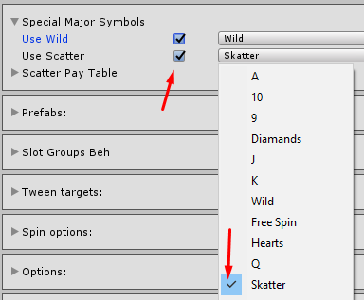

Create scatter paytable (we have only 1 win combo – 5 scatters)

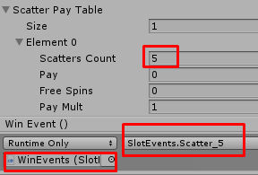

Add event for scatter win (or use existing GameObject)

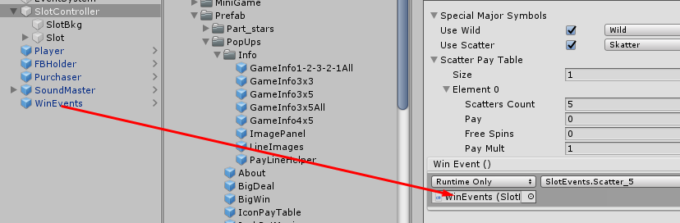

Change event method for another result (SlotEvents.cs).

