Accounting information system
Functional guide
For the UX expert and the delivery manager
v001
UX Expert  Understand data flows  to design the interfaces | Delivery Manager  Understand the business rules  to steer development

Use case: Sterling Union — VTC driver cooperative
4 reference diagrams + associated definitions
Diagram 1 — The basics: one ride, one entry
Before looking at the complete system, let's start with a simple example. Dupont completes a £100 ride via Uber. This single event illustrates the fundamental principle of all accounting.

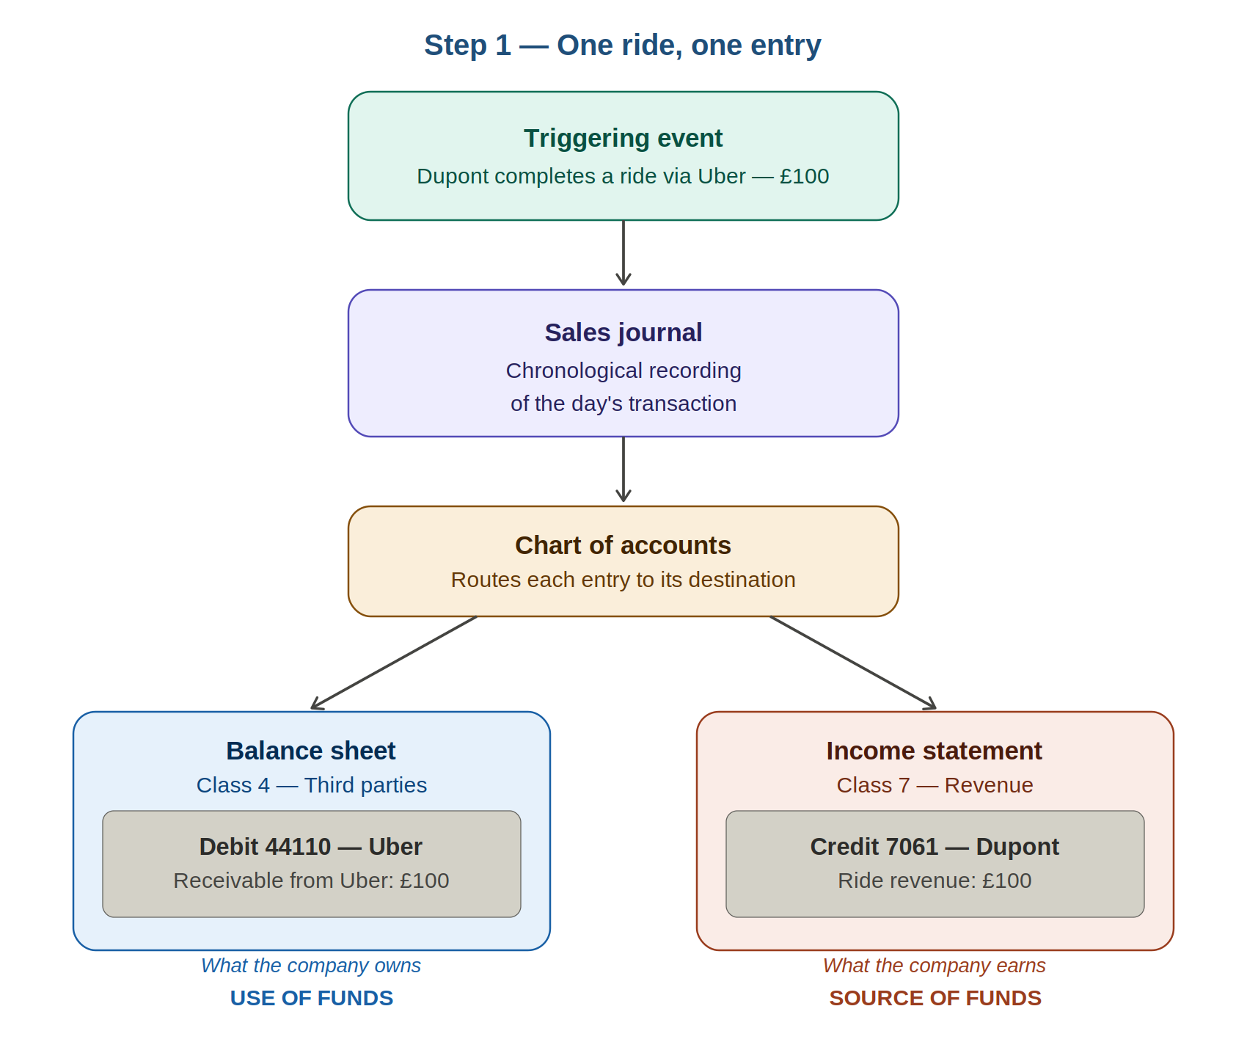
Diagram 1 — A £100 ride simultaneously generates revenue (Cl. 7) and a receivable from the platform (Cl. 4).

Triggering event | The economic event that initiates the accounting entry. Here: the completed ride. This opens the entry in the sales journal.
Use of funds (Debit) | What the money is used for. Here: the receivable from Uber (44110) — Sterling Union is waiting to be paid.
Source of funds (Credit) | Where the money comes from. Here: the driver's revenue (7061 Dupont) — the wealth generated by the ride.
Double-entry | Golden rule: every transaction is recorded twice — debit and credit — for an equal amount. Debit ≠ Credit = blocking error.
Chart of accounts | Automatic routing: Cl. 4 → Balance sheet (Uber receivable). Cl. 7 → Income statement (Dupont revenue). Same transaction, two destinations.

Diagram 2 — The complete accounting system
The system revolves around two fundamental documents with distinct but complementary roles, continuously fed by the journal. They are linked through the net profit figure.

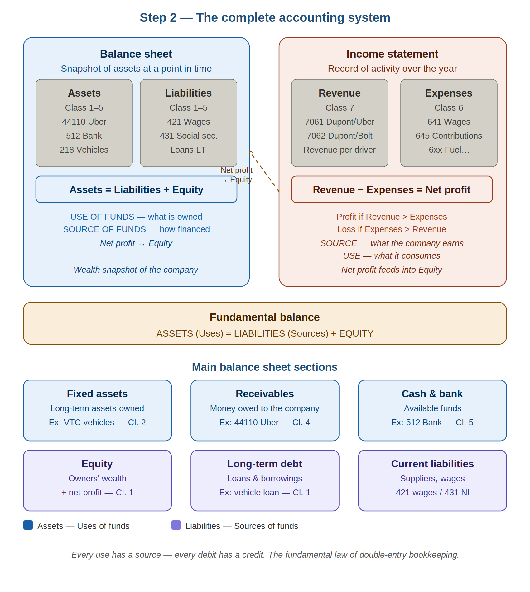
Diagram 2 — Balance sheet (Cl. 1–5) on the left. Income statement (Cl. 6 & 7) on the right. Net profit feeds into equity.

Income statement | Record of activity over the year. Answers: did the company make money? Formula: Revenue (Cl. 7) − Expenses (Cl. 6) = Net profit.
Balance sheet | Snapshot of assets at a point in time. Answers: what does the company own and owe? Formula: Assets = Liabilities + Equity.
Assets — Uses | What the company owns and uses: fixed assets (vehicles), receivables (44110 Uber), cash (512 Bank).
Liabilities — Sources | How the company is funded: equity (contributions + profit), long-term loans, current liabilities (421 wages, 431 NI).
Profit → Balance sheet | Net profit (or loss) is added to equity in the balance sheet. The year's economic performance changes the company's net worth.

Diagram 3 — The 7 classes of the chart of accounts
The chart of accounts is the central routing rule. It organises all accounts into 7 classes and determines which document each entry is posted to.

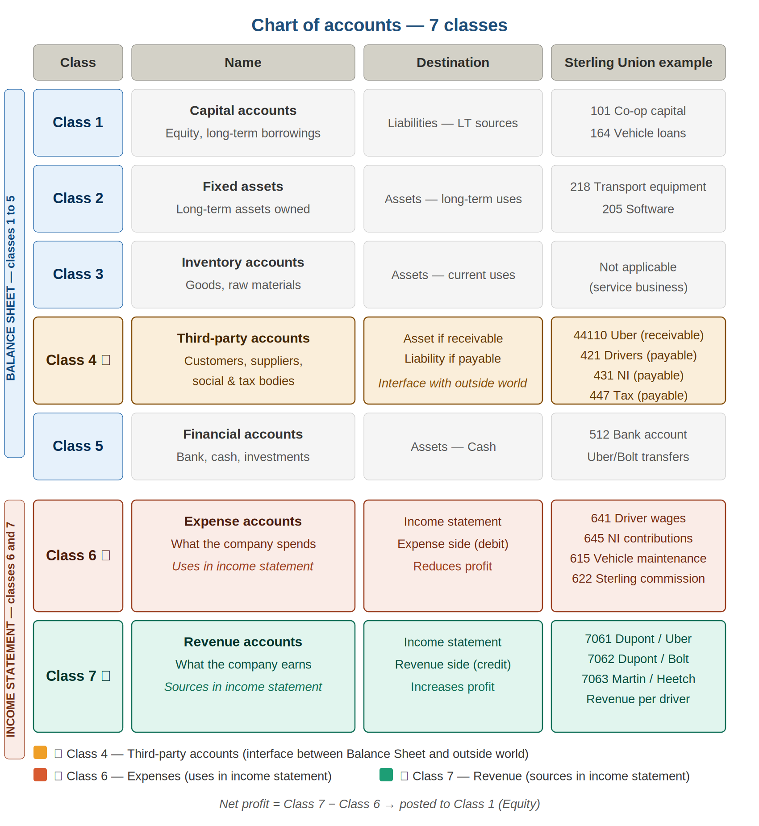
Diagram 3 — Classes 1 to 5 → Balance sheet. Classes 6 and 7 → Income statement. Class 4 ★ is the interface with the outside world.

Class 1 — Capital | Long-term financing of the company. Liability side of the balance sheet. Ex: 101 Co-op capital, 164 Vehicle loans.
Class 2 — Fixed assets | Long-term assets owned by the company. Asset side. Ex: 218 Transport equipment, 205 Software.
Class 4 — Third parties ★ | Interface with external partners. Bidirectional: asset if receivable (Uber owes), liability if payable (Sterling owes). Ex: 44110 Uber, 421 Drivers, 431 NI.
Class 6 — Expenses ★ | What the company spends. Uses in the income statement. Reduces profit. Ex: 641 Wages, 622 Sterling commission.
Class 7 — Revenue ★ | What the company earns. Sources in the income statement. Increases profit. Ex: 7061 Dupont/Uber, 7062 Dupont/Bolt.

Diagram 4 — Sterling Union complete system
Sterling Union is a VTC cooperative acting as an intermediary between platforms and self-employed drivers. Its accounting architecture is specific to this model.

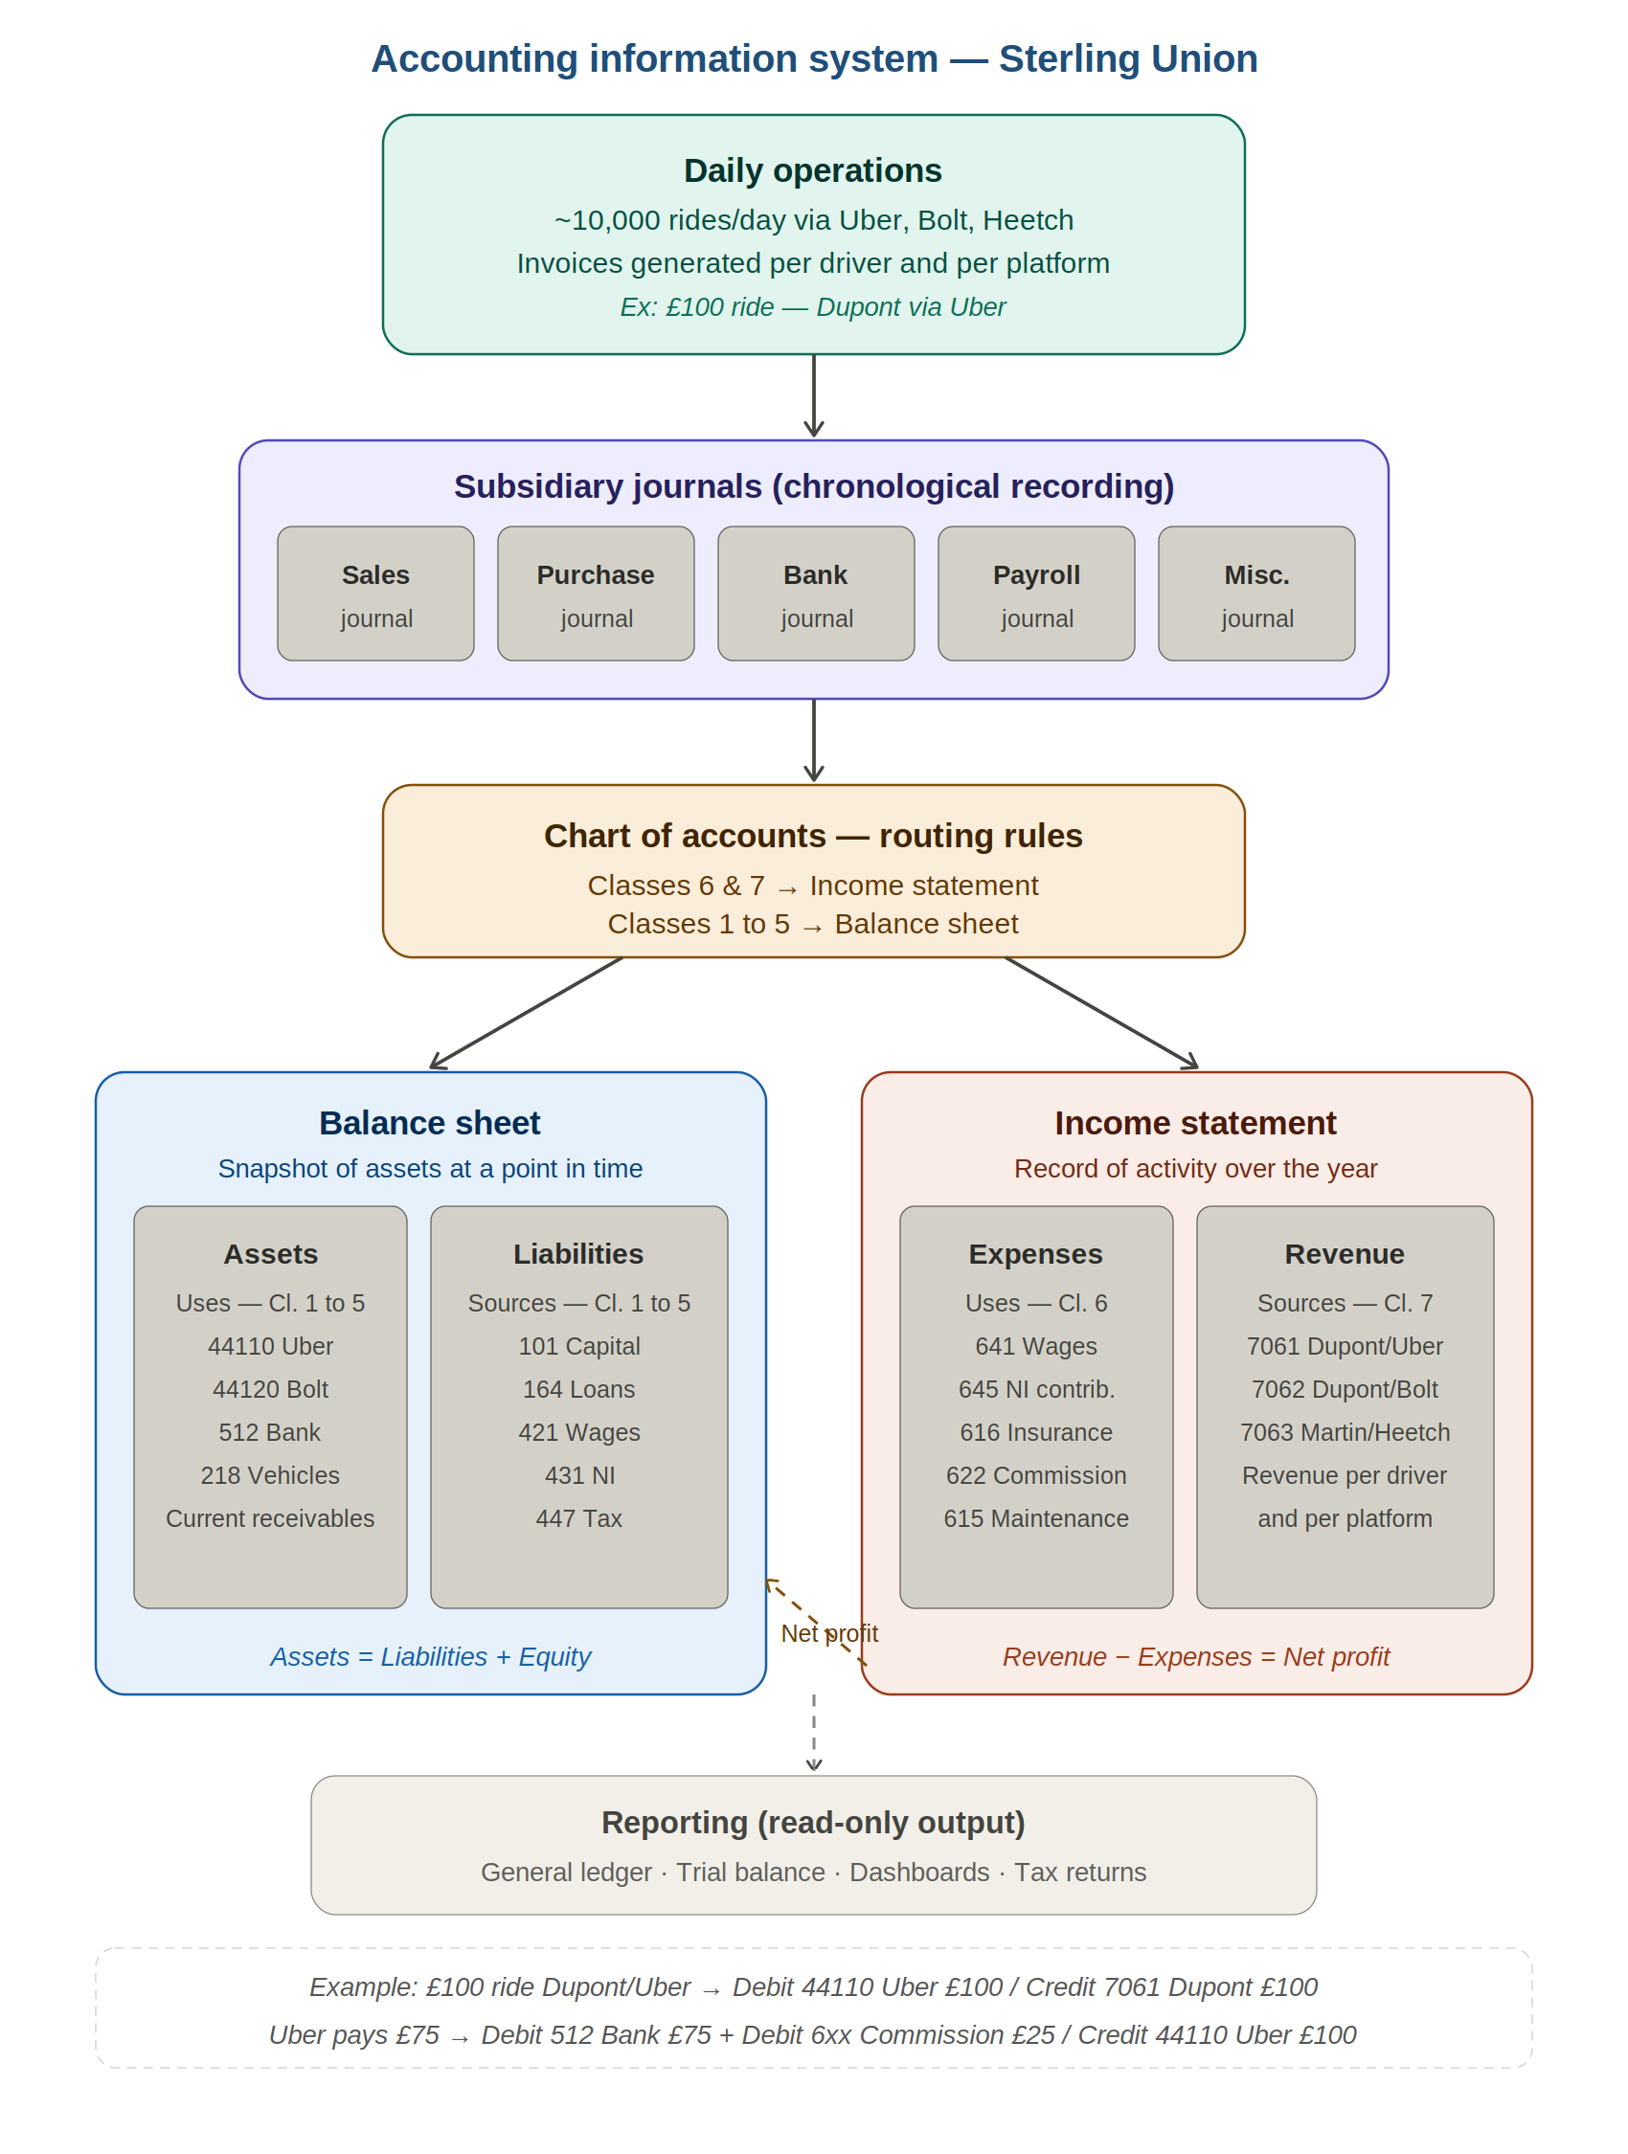
Diagram 4 — From ~10,000 daily rides to the summary documents. The chart of accounts is the central routing engine.

Subsidiary journals | 5 specialist journals: sales, purchases, bank, payroll, misc. Every entry passes through here chronologically before being routed.
Sub-ledger coding 706.x | Revenue account individualised per driver AND per platform. 7061 Dupont/Uber, 7062 Dupont/Bolt. Allows instant extraction of revenue by driver, by platform, or overall.
44110 Uber (receivable) | When Uber pays £75 (£100 − 25% commission): Debit 512 Bank £75 + Debit 6xx Commission £25 / Credit 44110 Uber £100. Receivable is cleared.
Driver net pay | Gross revenue £100 − Uber commission £25 − fuel £15 − rental £20 − insurance £8 − Sterling commission £7 = net pay £20 posted to 421.
Reporting | General ledger, trial balance, dashboards = read-only views on journal data. Not a processing step — never entered manually.

Key points by profile

For the UX expert — interface implications

- Each input automatically routes to the correct account. The chart of accounts is the business rule — the interface encapsulates it, does not expose it.
- One ride generates two simultaneous entries (Cl. 7 income statement + Cl. 4 balance sheet). Visualisation screens must allow users to trace this link.
- Third-party accounts (Cl. 4) are bidirectional. Clearly distinguish receivables (money expected) from payables (money to be paid).
- The journal is the single source of truth. No flow may feed the balance sheet or income statement directly without passing through it — non-negotiable architectural invariant.
- General ledger and trial balance are read-only views. They are generated automatically, never entered manually.
- Sub-ledger coding is transparent to the user: new driver or new platform → sub-accounts created automatically.

For the delivery manager — development implications

- The routing engine (chart of accounts) is the central business rule. It must be configurable — adding a new platform = configuration only, no development.
- ~10,000 invoices/day → robust batch processing: error handling, duplicate detection, retry on failure.
- Debit = credit balance is checked on every entry. Unbalanced entry = blocking error, never accepted by the system.
- Reconciliation between platform payments and recorded invoices = critical process to automate with supervised alerts.
- Balance sheet, income statement, trial balance = generated on demand from the journal. Never calculated separately or stored as duplicates.

Glossary

Term | Definition
Double-entry bookkeeping | Every transaction is recorded twice — debit and credit — for an identical amount. The fundamental law of accounting.
Journal | Chronological log of all transactions. The single source of truth. No flow bypasses it.
Balance sheet | Document presenting the company's net worth at a point in time. Assets = Uses. Liabilities = Sources.
Income statement | Document presenting revenue and expenses for the period. Revenue − Expenses = Net profit.
Third-party accounts (Cl. 4) | Relationships with external partners. Bidirectional: asset if receivable, liability if payable.
Sub-ledger coding | Breaking down a collective account into individual sub-accounts. Ex: 411 Customers → 44110 Uber.
Chart of accounts | Nomenclature of accounts in 7 classes. Routing rules for accounting flows. Must be configurable.
General ledger | All entries grouped by account. Read-only reporting output — not a processing step.
Trial balance | Summary table verifying the balance: total debits = total credits for each account.
Use / Source | Use = how funds are employed (debit). Source = origin of financing (credit).

— Document produced as part of the Sterling Union project —

