STAIRLING SOFTWARE
Stairling Enterprise — Electronic invoicing platform
DEVELOPER GUIDE
Electronic invoicing
From Peppol to issuing and receiving invoices via SuperPDP

Document | Developer Guide — Electronic Invoicing
Scope | Stairling Enterprise — electronic invoicing module (SuperPDP PA) · pa-gateway reference implementation (Go)
Version | v001 — draft
Date | September 2026
Status | Proposal — to be approved by the engineering team
Classification | Confidential

Contents
How to read this guide 4
Minimal glossary 4
1. Why and what: the French reform 5
1.1 The timeline 5
1.2 Three flows not to confuse 5
1.3 What changes for a developer 5
2. The infrastructure: who carries the invoice 6
2.1 The four-corner model 6
2.2 How a platform finds the recipient 6
2.3 The recipient’s electronic address 6
2.4 What SuperPDP does for us 7
3. Enrolment: attaching a customer to the platform 8
3.1 Two enrolment models, only one for us 8
3.2 Blocking prerequisites 8
3.3 The flow 9
3.4 The state machine 10
3.5 The trap: connected does not mean transmitting 10
3.6 Token management 10
4. The invoice as a structured document: content and compliance 12
4.1 The EN 16931 model 12
4.2 The data to know 12
4.3 France-specific mentions 13
4.4 Rule families 14
4.5 Calculations that must add up 14
4.6 Rejections actually encountered 14
4.7 Validate before sending 14
5. Issuing an invoice 15
5.1 Three invariants never to break 15
5.2 The flow 15
5.3 API calls 16
5.4 The send job (Go excerpt) 16
5.5 Catch-up 16
6. After sending: lifecycle and errors 18
6.1 The statuses 18
6.2 Refused is not Rejected 19
6.3 Tracking by polling 19
6.4 Cashing: the only status we issue 20
6.5 Failure natures before deposit 20
6.6 Quick reference by code 20
7. Receiving an invoice 21
7.1 Three objects not to merge 21
7.2 Collection: four cursor-based passes 21
7.3 Turning reception off 21
7.4 Processing: three gates 22
7.5 Fraud vigilance 23
7.6 What is still missing 23
8. Operating: logs, sandbox, deployment 24
8.1 Logs 24
8.2 The sandbox 24
8.3 Jobs and scheduling 24
8.4 Per-environment configuration 25
8.5 Developer checklist 25
8.6 Reference documents 25
9. Reference implementation in Go: pa-gateway 27
9.1 The principle: a gateway between the application and the platform 27
9.2 Where each chapter lives in the code 27
9.3 The internal API 27
9.4 The job queue: three possible outcomes 28
9.5 The three most sensitive pieces of code 28
9.6 What the tests guarantee 29
9.7 What remains to align with the SuperPDP spec 29

How to read this guide
This guide is for a developer who has to implement electronic invoicing without any prior knowledge of the domain. It moves from context to code, in the order in which problems actually show up.
The order matters. Content compliance (chapter 4) comes before sending (chapter 5), because most production rejections concern the content of the invoice, not its transport. The lifecycle after sending (chapter 6) has its own chapter, because that is where the business decisions are concentrated.
Each chapter ends with a What this means for the code box. The rest explains the business. Chapter 9 presents a reference implementation in Go, pa-gateway: each box points to the Go package where the rule is implemented.
The code examples are in Go: they come from pa-gateway, the reference implementation described in chapter 9.

Minimal glossary
Term | Short definition
E-invoice | An invoice issued, transmitted and received as structured data. A PDF sent by email is not one.
PA (formerly PDP) | Plateforme agréée: a platform approved by the French tax administration. The only authorised channel to issue and receive. Here: SuperPDP.
PPF | Portail public de facturation: the public invoicing portal. It maintains the central directory and collects data for the administration.
Directory | Registry that states, for each company (SIREN/SIRET), on which PA it receives its invoices.
Peppol | International network for exchanging documents between access points, with shared rules.
EN 16931 | European standard defining the semantic model of an invoice: which data, with which meaning.
BT / BG | Business Term (one data item, e.g. BT-1 invoice number) / Business Group (a group, e.g. BG-4 seller).
UBL, CII | XML syntaxes that carry the EN 16931 model.
Factur-X | Readable PDF with an embedded CII XML. A hybrid format, readable by both humans and machines.
Schematron | Rule language used to validate an invoice. Produces the BR-* codes found in rejections.
Lifecycle status | Standardised code (XP Z12-012 standard) stating where the invoice stands: deposited, rejected, refused, cashed…
Enrolment | Attaching a company to a PA, with verification of its identity (KYB).
KYB | Know Your Business: the PA checks that the company exists and that the requester represents it.
Tenant | A client company in our multi-company application (Stairling Enterprise).
SIREN / SIRET | French identifier of the company (9 digits) / of the establishment (14 digits).

1. Why and what: the French reform
In France, invoices between VAT-registered businesses must go through an approved platform, as structured data. The goal is twofold: fight VAT fraud and pre-fill tax returns.

1.1 The timeline
Date | Obligation
1 September 2026 | All companies must be able to receive. Large companies and mid-caps (ETI) must issue.
1 September 2027 | SMEs and micro-businesses must also issue.

Consequence for us: reception is mandatory for all our tenants, while issuing depends on their size. This is why issuing is enabled per company, from a given date (see chapter 3).

1.2 Three flows not to confuse
Flow | Scope | Channel
E-invoicing | B2B invoice between two VAT-registered businesses established in France | The invoice itself, via the PAs
Transaction e-reporting | B2C, international sales and purchases | Transaction data, not the invoice
Payment e-reporting | Collection of payments for services | Payment data

This guide covers e-invoicing. E-reporting exists alongside it: a purchase from a foreign supplier does not arrive through the PA but must still be declared.

1.3 What changes for a developer
Before, an invoice was a PDF. The software generated it, then sent it by email. Now the invoice is data: it is validated by automatic rules, it can be rejected, and it has a lifecycle with statuses that the customer and the administration can see.
What this means for the code. The invoice becomes an object with an external state (its status on the PA) in addition to its internal state. Both must be modelled separately, and you must never assume that a “sent” invoice has been received.

2. The infrastructure: who carries the invoice
Our application never talks directly to the recipient customer, nor to the Peppol network. It hands each invoice to an approved platform (SuperPDP) through a REST API, and the platform routes it.

2.1 The four-corner model
Peppol rests on a simple principle: each company goes through its own provider, called an access point. Providers talk to each other. It is the telephone model: one operator each, not one per correspondent.
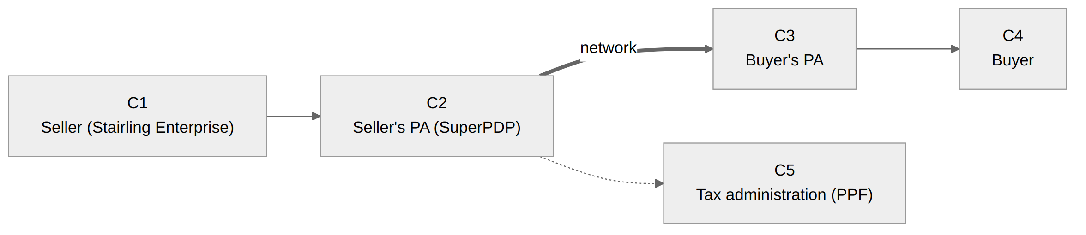
Corner | Who | Role
C1 | The seller, through our software | Produces the invoice
C2 | Its approved platform | Checks the invoice, finds the recipient, transmits it
C3 | The buyer’s platform | Receives, checks, delivers to the buyer
C4 | The buyer | Integrates the invoice, then replies with statuses
C5 | The tax administration | Receives the invoice’s tax data and key statuses

France adds the fifth corner: the administration receives the data of every invoice. This is why people speak of a “5-corner” model.

2.2 How a platform finds the recipient
In pure Peppol, the address is found through two technical directories: the SML (a central DNS) says which SMP knows the buyer, then the SMP gives the address and certificate of its platform. Transport uses AS4 (HTTPS, signed, encrypted, with a signed receipt).
France is different. Routing relies on the national directory maintained by the PPF. It states, for each SIREN, SIRET or department, on which approved platform the company receives its invoices. Peppol is only one of the ways platforms connect to each other. Having a Peppol identifier is therefore not enough to know where to send a French invoice.

2.3 The recipient’s electronic address
The routing address has the form scheme:identifier. In France, the scheme is 0225:
Address | Designates
0225:SIREN | the company
0225:SIREN_SIRET | an establishment
0225:SIREN_SIRET_CODE | a department

This address is not computed, it is read from the directory. If the directory publishes several addresses for a customer, one must be chosen. If the customer is not registered, the invoice cannot be sent.

2.4 What SuperPDP does for us
Function | Who handles it
Produce the invoice (business data) | Stairling Enterprise
Local check before sending | Stairling Enterprise
Conversion EN 16931 JSON → Factur-X | SuperPDP (convert API)
Schematron validation (EN 16931, French rules, Peppol) | SuperPDP
Recipient lookup, transport, delivery | SuperPDP
Transmission of data to the administration | SuperPDP
Status tracking | Stairling Enterprise polls SuperPDP every hour (no webhook)
Archiving an evidential copy | Stairling Enterprise

What this means for the code. We implement neither AS4, nor SML/SMP, nor Peppol certificates: that is the platform’s job. We implement a REST HTTP client authenticated with OAuth, a local content check, and a polling mechanism to track statuses. To go further on Peppol: the Fiche_explicative_Peppol_et_la_facturation_électronique.md sheet.

3. Enrolment: attaching a customer to the platform
Before issuing any invoice, each client company must be enrolled with the approved platform: it has an account there, its identity is verified (KYB), and it authorises our application to act on its behalf. Only the connected state allows issuing.

3.1 Two enrolment models, only one for us
Model | Who enrols | Mechanism | Our case?
Chartered accountant | The firm, for its clients | API route POST /v1.beta/companies + formal agreement PDF, then X-Impersonate-Company header | No: route forbidden to multi-tenant platforms
Multi-tenant platform | The company itself, on the SuperPDP portal | OAuth 2.1 Authorization Code + PKCE, one token set per tenant | Yes

In our model, we trigger the flow and read its result. The enrolment itself (account, manager details, KYB documents) happens at SuperPDP. We hold neither the formal agreement nor the documents.

3.2 Blocking prerequisites
The “Connect SuperPDP” button stays disabled until the company record has:
- a valid SIRET (14 digits), from which the SIREN is derived;
- the SuperPDP login email (login_email): the manager’s or legal representative’s, not the company’s generic email.
The server repeats the check in authorize: never rely on the disabled button alone.

3.3 The flow
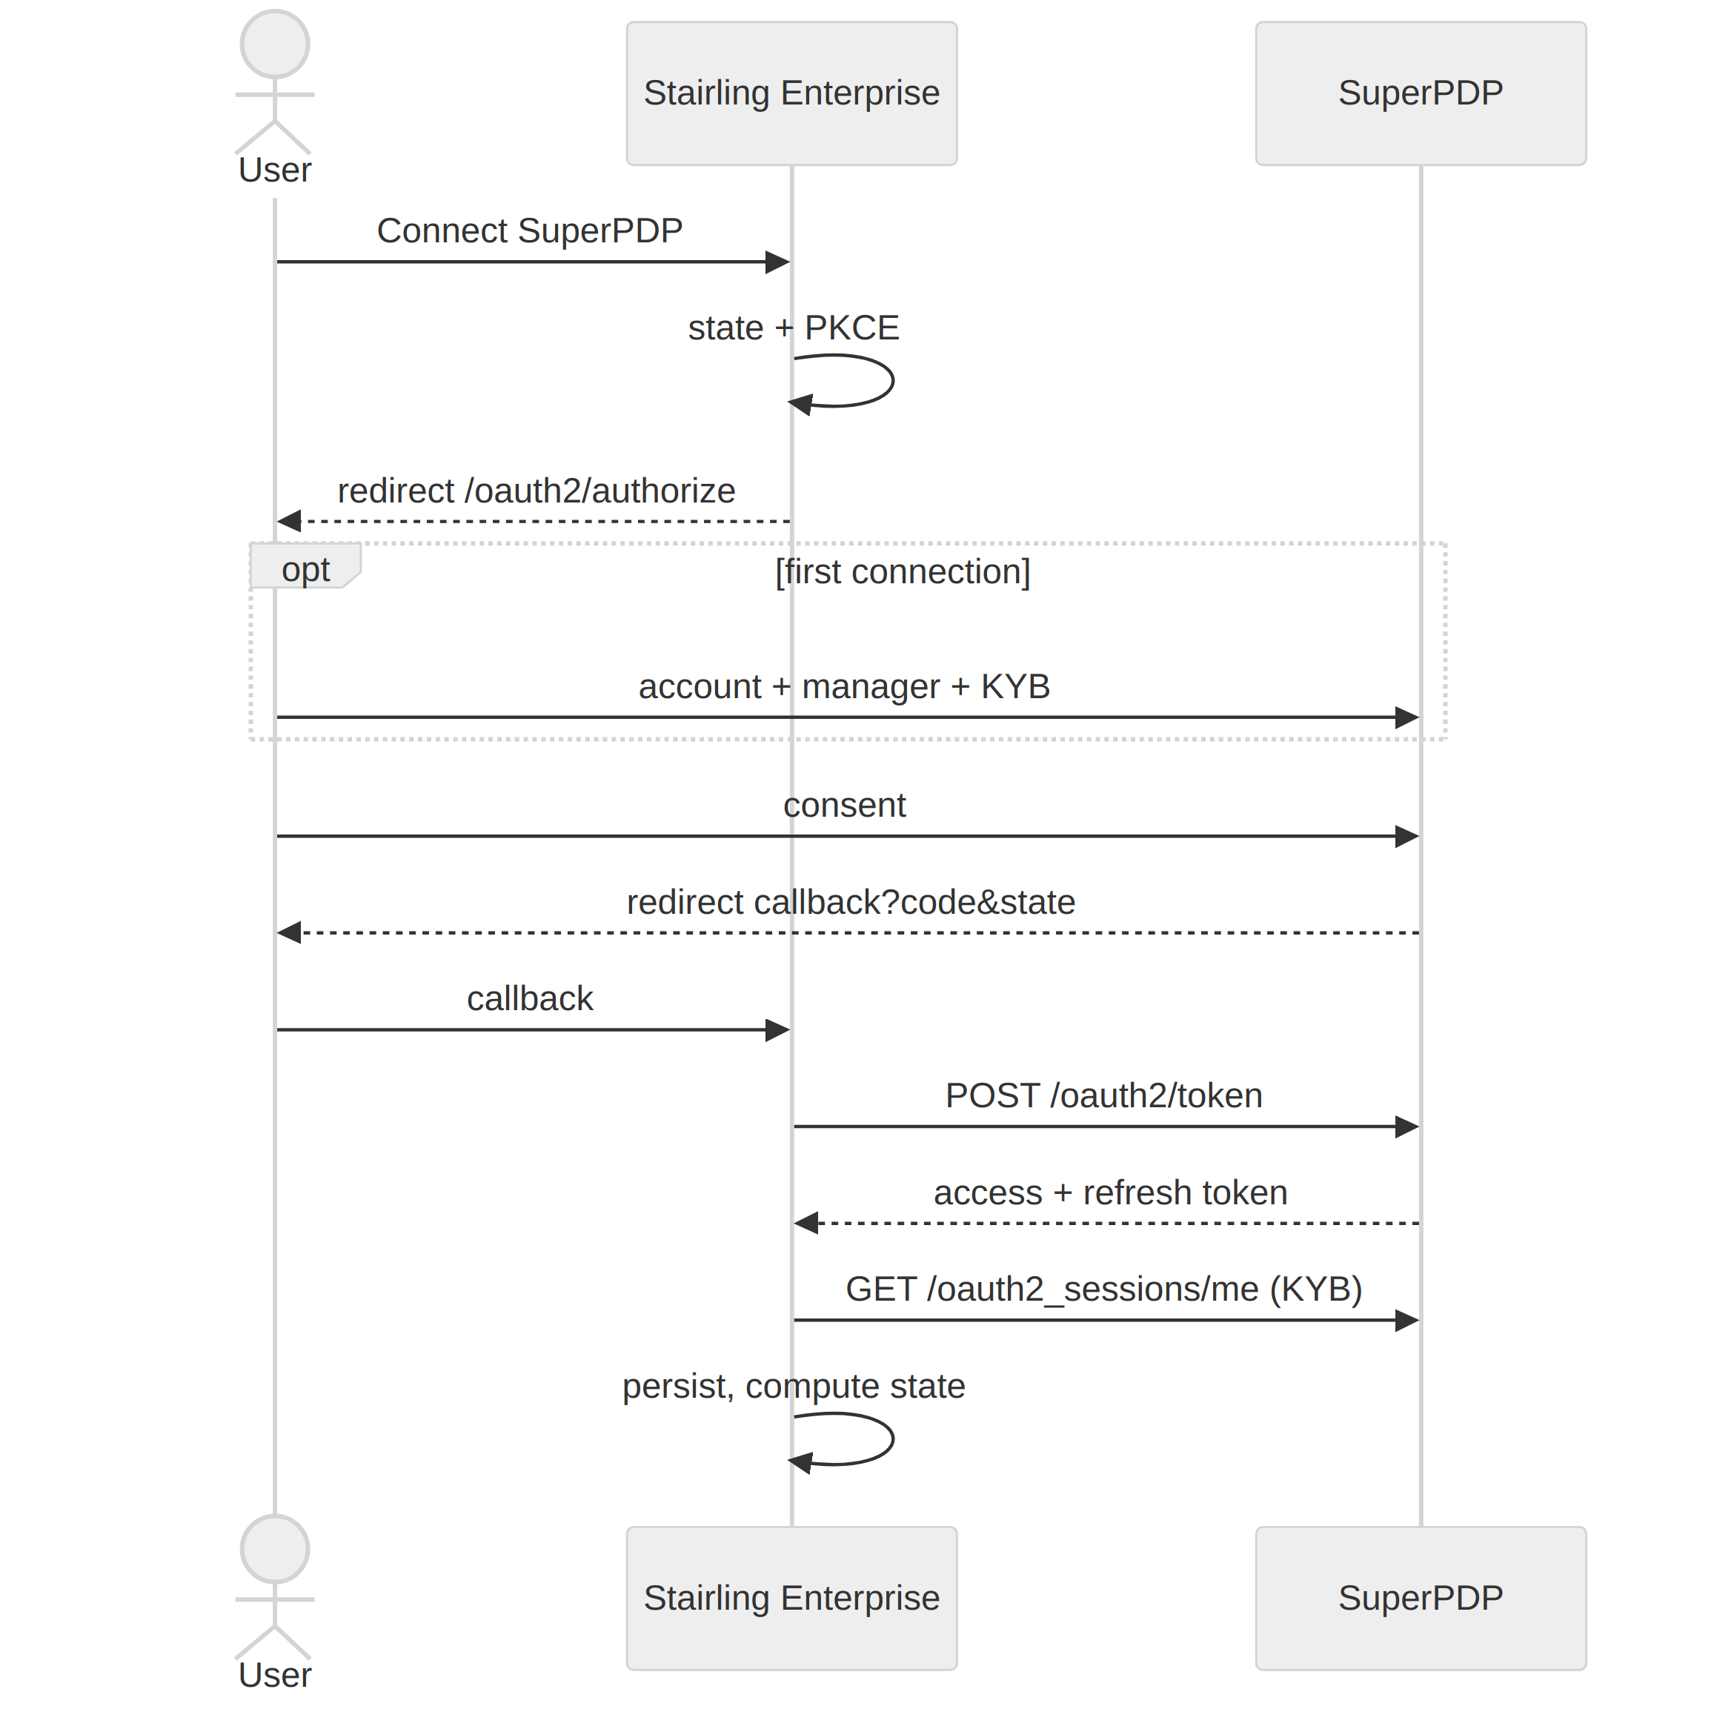
- Launch. We generate a state (anti-CSRF, single use) and a PKCE pair (code_verifier / code_challenge S256). We persist the request, with the verifier encrypted, then redirect to /oauth2/authorize with the SIREN and email pre-filled.
- Onboarding (first time). The company creates its SuperPDP account and uploads its documents. All of this happens outside our application.
- Consent. The user authorises Stairling Enterprise. This is an access authorisation, not a document upload.
- Callback. We check and consume the state, exchange the code for tokens, read the KYB status (/oauth2_sessions/me) and the company_id (/companies/me). Tokens are stored encrypted.
- KYB verification. SuperPDP decides: verified, needs_review or failed. We only mirror it, re-read by the “Re-check” button and before each issue.

3.4 The state machine
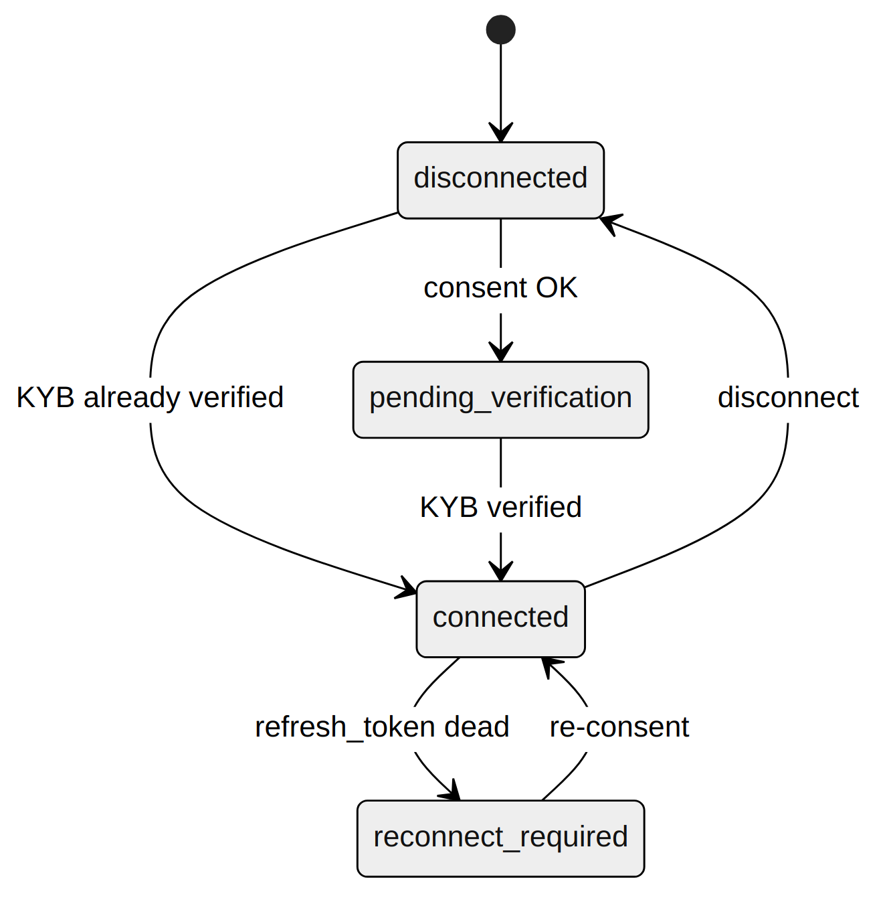
State | Issuing | Way out
disconnected | blocked | start the flow
pending_verification | blocked (403) | wait for KYB; failed → SuperPDP support
connected | allowed | —
reconnect_required | blocked | full re-consent, the only way out

3.5 The trap: connected does not mean transmitting
The connected state grants the right to issue, not issuing itself. Three conditions must be met for an invoice to leave:
- the company is connected;
- the service is enabled: a date is set in emission_enabled_from;
- the invoice is dated on or after that opening: its issue date (BT-2) is equal to or later than emission_enabled_from.
An invoice dated before activation is never caught up: it was never in scope. Turning issuing off is a scope decision, not a pause.

3.6 Token management
- The access_token lives about 30 minutes. It is refreshed proactively, 60 s before expiry.
- Refreshing rotates the refresh_token: the old one becomes invalid. Two workers refreshing at the same time break the connection. Hence a per-tenant lock (pg_advisory_xact_lock) and a re-read after locking.
- The application credentials (client_id / client_secret) are unique and global. Tokens, on the other hand, are per tenant.
What this means for the code. Model the connection state per tenant, encrypt the tokens, serialise the refresh, and check the state before each issue (errors tokens.ErrPendingVerification, tokens.ErrReconnectRequired or tokens.ErrNotConnected). Required configuration: SUPERPDP_CLIENT_ID, SUPERPDP_CLIENT_SECRET, SUPERPDP_REDIRECT_URI (registered at SuperPDP), SUPERPDP_TOKEN_ENC_KEY. Details: ENROLEMENT_TENANT_PDP.md and SPEC_PDP_OAUTH_AUTHORIZATION_CODE.md. In Go: internal/enrollment, internal/oauth and internal/tokens (chapter 9).

4. The invoice as a structured document: content and compliance
An invoice is valid if it complies with three layers of rules: the European EN 16931 standard, the French rules, and the Peppol rules. They are checked automatically by the platform; a single violation is enough to reject the invoice.

4.1 The EN 16931 model
The standard describes the invoice as a tree of named data items. Each data item is a BT (Business Term), each group a BG (Business Group). These codes are stable: they are what rejection messages cite.
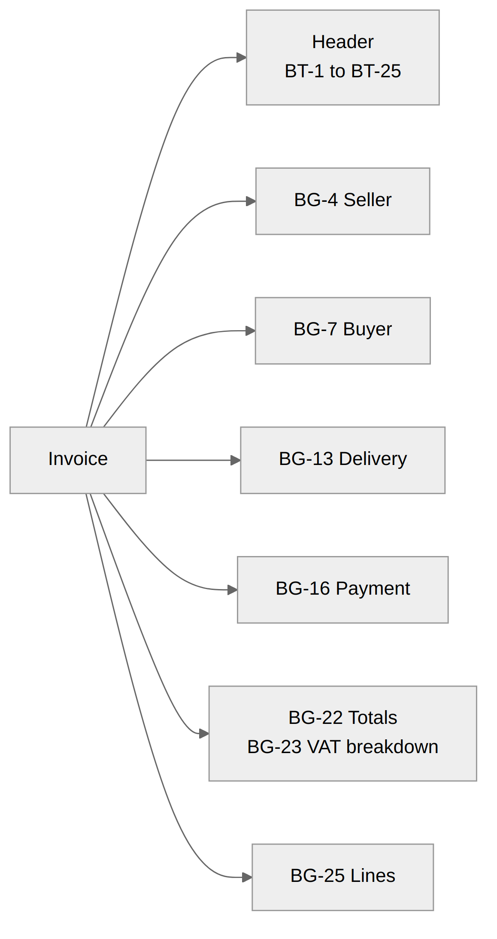
The content is independent of the format. The same model is written in UBL, CII or Factur-X (PDF + CII). We send a JSON that follows this model, and SuperPDP converts it to Factur-X.

4.2 The data to know
Group | Data | Code | Note
Header | Invoice number | BT-1 | Unique, continuous chronological sequence, never reused
Header | Issue date | BT-2
Header | Document type | BT-3 | 380 invoice, 381 credit note, 384 corrective, 386 prepayment
Header | Currency | BT-5 | EUR
Header | Due date | BT-9 | Or payment terms (BT-20)
Header | Purchase order reference | BT-13 | Optional, but key to matching on the buyer’s side
Header | Notes | BT-22 | Carries the French legal mentions (see below)
Header | Business process | BT-23 | Mandatory in France: B1 goods, S1 services, M1 mixed…
Header | Preceding invoice | BT-25 | Mandatory on a credit note or corrective invoice
Seller | Legal name | BT-27
Seller | SIREN | BT-30 | Scheme 0002
Seller | Intra-EU VAT number | BT-31
Seller | Electronic address | BT-34 | Scheme 0225
Buyer | Legal name | BT-44
Buyer | SIREN | BT-47 | New mandatory mention under the reform
Buyer | Electronic address | BT-49 | Read from the directory, never computed
Delivery | Delivery date and address | BT-72, BG-15 | Address mandatory if different from the buyer’s
Payment | Payment means, IBAN | BT-81, BT-84
Totals | Total excl. VAT, VAT, incl. VAT, amount due | BT-109, BT-110, BT-112, BT-115 | Must be consistent to the cent
VAT | Base, amount, category, rate | BT-116 to BT-119 | One breakdown per category / rate pair
VAT | Exemption reason | BT-120 | Mandatory for categories E, AE, K, G, O
Line | Quantity, unit, net price, amount | BT-129, BT-130, BT-146, BT-131
Line | Item name | BT-153
Line | VAT category and rate | BT-151, BT-152

4.3 France-specific mentions
The French Commercial Code requires mentions that the European standard does not know. In a structured invoice, they go into the notes (BT-22), each with its subject code (BT-21):
Mention | Subject code | Rule if missing
Late-payment penalty rate | PMD | BR-FR-05
Fixed recovery fee (€40) | PMT | BR-FR-05
Early-payment discount terms (or “no discount”) | AAB | BR-FR-05

The reform adds four mentions: the buyer’s SIREN, the delivery address if different, the nature of the transaction (goods, services or mixed), and the option for VAT on debits where applicable. In our system, the nature of the transaction and the option for VAT on debits are configured per company.

4.4 Rule families
Family | Example | What it checks | Who fixes it
[BR-NN] | BR-16 | Presence of EN 16931 data | Invoice entry
[BR-CO-NN] | BR-CO-10, BR-CO-13 | Consistency of calculations and totals | Calculation engine
[BR-S-NN], [BR-E-NN], [BR-Z-NN] | BR-S-08 | Rules per VAT category | VAT settings
[BR-FR-NN] | BR-FR-05, BR-FR-08 | French rules | Company settings
PEPPOL-EN16931-RNNN | R008 | Structure required by Peppol | Document construction

4.5 Calculations that must add up
Consistency rules check totals to the cent. The most frequent:
- sum of line amounts (BT-131) = sum of lines (BT-106);
- total excl. VAT (BT-109) = sum of lines − allowances + charges;
- total incl. VAT (BT-112) = total excl. VAT + total VAT (BT-110);
- each VAT breakdown amount = base × rate, rounded to 2 decimals.
Rounding per line then summing, or summing then rounding, does not give the same result. You must follow the standard’s method and apply it everywhere, otherwise cent differences trigger BR-CO rejections.

4.6 Rejections actually encountered
Rule | Data | Cause | Fix
BR-FR-05 (×3) | BT-22 | The three mentions PMD, PMT, AAB were missing | Configured per company, issued as notes
BR-FR-08 | BT-23 | Empty business process | List restricted to accepted codes; S1 for a service
PEPPOL-EN16931-R008 | BG-13 | Empty delivery block produced by the converter | BG-13 always issued, invoice date by default

Two lessons. First, the “(still status warning)” label next to R008 is misleading: the rule rejects. Second, rejections are discovered in layers: a refusal on the buyer’s address was hiding these three rules. Fixing one barrier reveals the next.

4.7 Validate before sending
The invoice is validated locally, before any network call. Two levels:
- blocking (red): the invoice does not leave, the record shows “To be completed before transmission”;
- rejection risk (orange): the invoice leaves, but a rule may reject it.
Local validation does not replace the platform’s: it avoids round trips on known causes.
What this means for the code. Build the invoice from the BTs, not from the PDF. Centralise VAT and rounding calculations. Configure the French mentions and the business process per company. Maintain a local validator that cites the same BT and BR codes as the platform. Code details: CODES_ERREUR_PA_SUPERPDP.md. In Go: internal/eninvoice — model by BT, validator (validate.go), amounts in exact decimal, never float64 (chapter 9).

5. Issuing an invoice
Issuing is triggered when the invoice moves to “Sent”: the application submits it to the gateway (POST /v1/tenants/{id}/invoices), then everything runs asynchronously: local check, fresh token, conversion to Factur-X by SuperPDP, deposit, and recording of the first status 200 Deposited.

5.1 Three invariants never to break
Invariant | Why | How
Per tenant | Each company has its own connection and its own tokens | All PA state is attached to the tenant (tenant_id)
Idempotent | An invoice sent twice is a tax duplicate | An invoice that has a platform identifier never leaves again
Traceable | Proof of transmission is an obligation | Each status change adds a dated row to pa_status_history, with the raw response

5.2 The flow
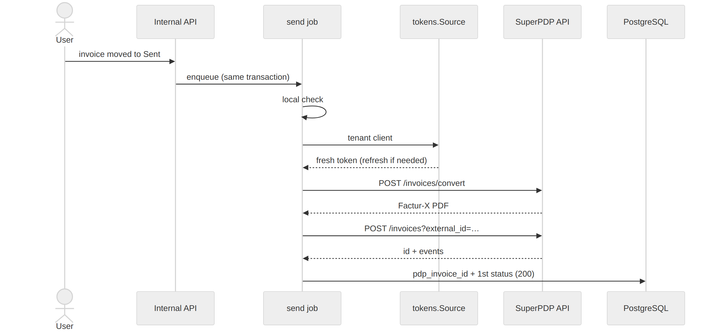
# | Step | Possible failure | Failure nature
1 | Submission: invoice not yet transmitted, dated within the open scope | Out of scope or already transmitted → immediate refusal (409) | —
2 | Enqueue the send job, in the same transaction | — | —
3 | Local compliance check | Missing data | invalid
4 | Resolve PA client + fresh token | Not connected, KYB pending, reconnection required | blocked
5 | Build the EN 16931 JSON | — | —
6 | Conversion to Factur-X (convert) | 400 response | refused
7 | File deposit (upload) | 400 BR-* rules, recipient missing from the directory | refused
8 | Network, timeout, 5xx | Transient outage | failed
9 | Persistence: pdp_invoice_id + first status, in one transaction | — | —

5.3 API calls
Call | Role
POST /oauth2/token (grant_type=refresh_token) | Refresh the tenant’s token
POST /v1.beta/invoices/convert?from=en16931&to=factur-x | Turn the EN 16931 JSON into a Factur-X PDF
POST /v1.beta/invoices?external_id=… | Deposit the file; returns id and events[]
GET /v1.beta/invoices/{id} | Read an invoice’s events (tracking)
POST /v1.beta/invoice_events | Send a status, e.g. fr:212 Cashed

All requests carry Authorization: Bearer <tenant access_token>. The external_id is our invoice identifier: it lets us find an invoice on the platform side.

5.4 The send job (Go excerpt)
Simplified excerpt from internal/emission/emission.go (pa-gateway, chapter 9):
func (s *Service) HandleSend(ctx context.Context, job *queue.Job) error {
out, _ := store.GetOutbound(ctx, s.DB, args.OutboundID)
if out.PDPInvoiceID.Valid {
return nil // idempotence: already transmitted
}
if fs := eninvoice.Validate(&inv); eninvoice.HasBlocking(fs) {
return s.deterministic(ctx, log, out, "invalid", msg, false)
}
// error if not connected / KYB pending / reconnection required
api, _, err := s.Tokens.Client(ctx, out.TenantID)
if err != nil {
return s.classify(ctx, log, out, err) // blocked
}
enJSON, _ := eninvoice.ToSuperPDP(&inv) // EN 16931 JSON
pdf, err := api.Convert(ctx, enJSON) // Factur-X produced by SuperPDP
if err != nil {
return s.classify(ctx, log, out, err)
}
created, err := api.Upload(ctx, pdf, "application/pdf", out.ExternalID)
if err != nil {
return s.classify(ctx, log, out, err) // refused, failed or blocked
}
// pdp_invoice_id + status 200 + raw response, in one transaction
return s.persist(ctx, out, created)
}
The excerpt shows the order of the steps and the classification of errors; the full code also handles logging and the case of a successful deposit whose database write fails.

5.5 Catch-up
There is no separate catch-up task: the job queue handles retries. The budget depends on the nature of the failure: a network outage is postponed without limit, a content rejection is retried at most 5 times (details in chapter 6).
What this means for the code. Always issue asynchronously. Classify each failure into a nature (invalid, blocked, refused, failed) as soon as it occurs, because it decides the catch-up and the message shown. Store the raw response of each call. Details: PROCESSUS_EMISSION_FACTURE_PDP.md. In Go: internal/emission (send and payment jobs) and internal/queue (chapter 9).

6. After sending: lifecycle and errors
A deposited invoice is not a received invoice. It goes through standardised statuses (XP Z12-012 standard) up to a final status, and each final status calls for a different action. This is the chapter where the business decisions are concentrated.

6.1 The statuses
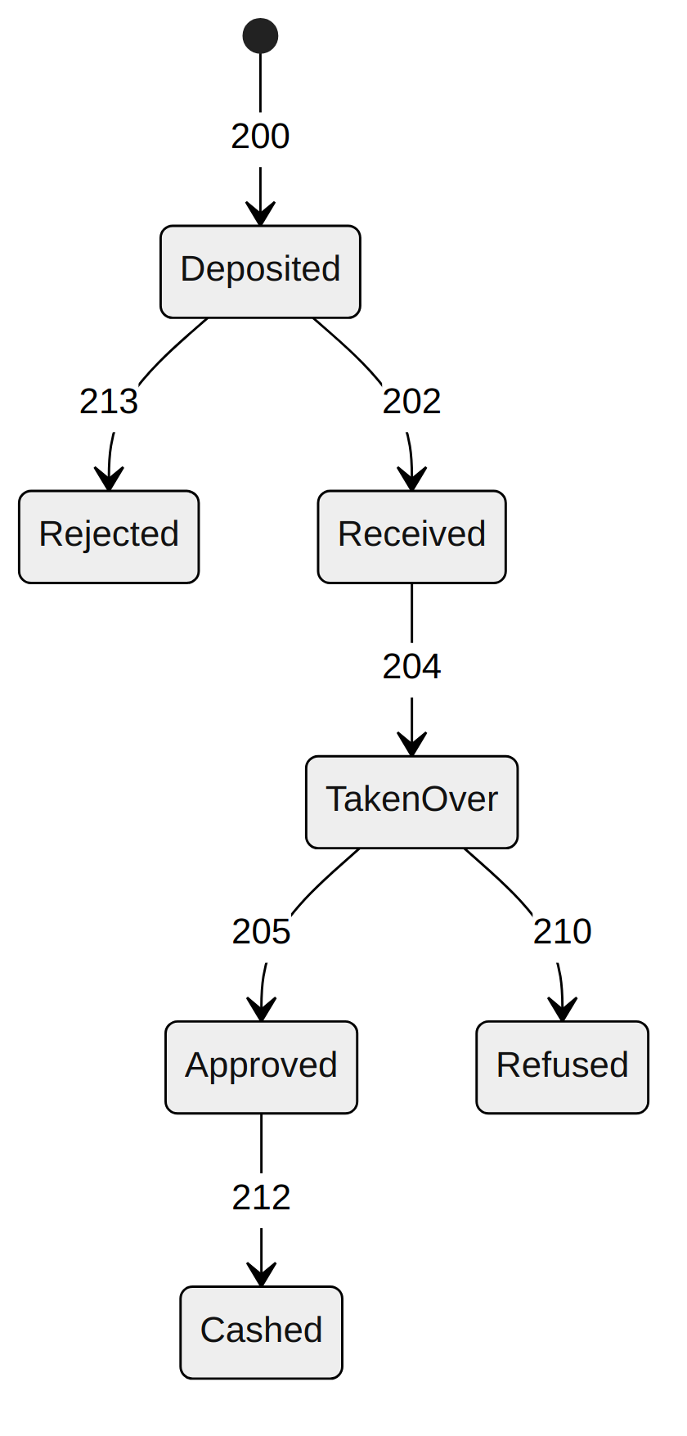
Code | Status (French label) | Produced by | Final | Action
200 | Deposited (Déposée) | Issuing platform | no | tracking ongoing
201 | Issued by the platform (Émise) | Issuing platform | no | tracking ongoing
202 | Received by the customer’s platform (Reçue) | Customer’s platform | no | tracking ongoing
203 | Made available (Mise à disposition) | Customer’s platform | no | tracking ongoing
204 | Taken over (Prise en charge) | Customer | no | tracking ongoing
205 | Approved (Approuvée) | Customer | no | wait for payment
206 | Partially approved (Approuvée partiellement) | Customer (reason) | no | business handling
207 | Disputed (En litige) | Customer (reason) | no | business handling
208 | Suspended (Suspendue) | Customer (reason) | no | complete, then tracking continues
209 | Completed (Complétée) | Seller | no | tracking ongoing
210 | Refused (Refusée) | Customer (reason) | yes | credit note, new invoice or negotiation; re-sending blocked
211 | Payment transmitted (Paiement transmis) | Customer | no | tracking ongoing
212 | Cashed (Encaissée) | Us, on payment | yes | normal end
213 | Rejected (Rejetée) | A platform (format, address) | yes | fix and re-send the same invoice, no credit note

The four statuses in bold are mandatory and transmitted to the administration.

6.2 Refused is not Rejected
This is the most important distinction in the chapter.
- 213 Rejected is a technical error: the invoice reached nobody. You fix it and re-send it, without a credit note.
- 210 Refused is a commercial disagreement: the customer received the invoice and disputes it. It exists for tax purposes; you do not re-send it, you issue a credit note or a new invoice.
To check: PROCESSUS_EMISSION_FACTURE_PDP.md §5 still states that a 213 requires a new invoice, whereas CODES_ERREUR_PA_SUPERPDP.md and the Peppol sheet describe re-sending the same invoice. The two documents must be aligned.

6.3 Tracking by polling
SuperPDP does not send webhooks. Each tenant’s sync job reads new events every hour, then re-reads every “in-flight” invoice: platform identifier present, status not final.
- GET /v1.beta/invoices/{id} returns events[]; the latest status_code is translated into an XP Z12-012 code.
- If the status has changed, a dated row is added to pa_status_history.
- At the final status, the invoice is no longer polled.
- A failure on one invoice does not block the batch.
SuperPDP code | XP Z12-012 code
fr:NNN | NNN directly
api:uploaded, api:validated, api:sent | 200
api:received | 202
api:acknowledged | 204
api:accepted | 205
api:rejected, api:invalid, ppf:rejected | 213
ppf:refused | 210
ppf:payment-received | 212

An unknown code is kept raw for audit and does not overwrite the current status.

6.4 Cashing: the only status we issue
For services subject to VAT on receipts, the seller must declare the collection. When the payment is settled, we send POST /v1.beta/invoice_events with status_code: fr:212.
- Conditions: invoice transmitted, provision of services, VAT due on receipt (no option for debits), full payment.
- The application declares the payment (POST …/payment); the payment job sends fr:212. It is idempotent: replaying it is safe.

6.5 Failure natures before deposit
Nature | Title shown | Origin | Who fixes it | Counts toward the cap of 5?
invalid | Non-compliant invoice | Local check | Whoever enters the invoice | yes
blocked | Transmission impossible | 401, 403, invalid_grant, configuration | Whoever manages the connection | no
refused | Refused by the platform | 400, 422 + BR-* rules | The invoice or the directory | yes
failed | Transmission failed | 5xx, timeout, TLS | Nobody, catch-up is enough | no
exhausted | Transmission abandoned | Cap reached | Manual action required | —

The principle: the cap only penalises deterministic failures. A content rejection will happen again identically; a network outage will not. The counter never resets by itself: to leave exhausted, the corrected invoice must be resubmitted, which resets the counter.

6.6 Quick reference by code
Code | Action
401 | Reconnect SuperPDP (banner on the company record)
403 | Wait for KYB; if it fails, SuperPDP support
invalid_grant | Full OAuth re-consent
400 + BR-* / BR-FR-* / PEPPOL-* | Fix the invoice or the company settings
400 recipient missing | Check the customer’s registration in the directory
5xx, timeout | Nothing, the next tick retries

What this means for the code. Store statuses as integers, with dated history. Separate the failure nature from the status. Never offer “re-send” on a 210. Make sending fr:212 idempotent and replayable. Details: CODES_ERREUR_PA_SUPERPDP.md. In Go: MapStatus in internal/superpdp/types.go, tracking in internal/tracking (chapter 9).

7. Receiving an invoice
Suppliers have nothing to ask us: the company’s address in the directory points to SuperPDP, which receives and keeps the invoice. We check this mailbox every hour, then the user decides, links and books.

7.1 Three objects not to merge
Object | Origin | Editable | Role
Received document | The platform | No | Evidence, archived as is
Incoming invoice | Reading of the document | Yes | Working object, enriched by the user
Purchase invoice | Booking | No (corrected by credit note) | Accounting entry, supplier debt

Never copy the content of the received file directly into the purchase invoice table. The received document remains the truth; the rest is derived from it.

7.2 Collection: four cursor-based passes
The same hourly sync job runs four reception passes. The scope is that of the tenant’s OAuth token: SuperPDP partitions by company.
Pass | Call | Result
Invoices | GET /invoices?direction=in&order=asc&starting_after_id={cursor}&limit=100&expand[]=en_invoice&expand[]=events | One row per invoice in pa_inbound, raw JSON kept
Events | GET /invoice_events?starting_after_id={cursor}&limit=1000 | Status history, in both directions
Detail | GET /invoices/{id} | Complete invoice (the list returns a truncated version)
Native file | GET /invoices/{id}/download | Factur-X or XML stored in the S3 vault, with integrity check

Four robustness rules:
- The cursor only advances after persistence. A crash between the two causes a new fetch, absorbed without duplicates.
- Double anti-duplicate protection: the cursor for efficiency, a unique index on pdp_invoice_id for correctness.
- Cursor trap: if the identifier is stored as a string, MAX() becomes lexicographic ("9" > "1000") and freezes the cursor silently. Platform identifiers are 64-bit integers: BIGINT in the database, int64 in the code.
- Without expand[], the list contains neither amounts nor events: the invoice looks status-less.
Events sometimes arrive before their invoice. They are stored without a foreign key; the join closes on the next pass.

7.3 Turning reception off
The switch (reception_enabled_from) turns off the invoices, detail and native file passes. The events pass never stops: it also carries the refusals and rejections of our issued invoices. Turning reception off is lossless: on reactivation, the backlog is caught up.

7.4 Processing: three gates
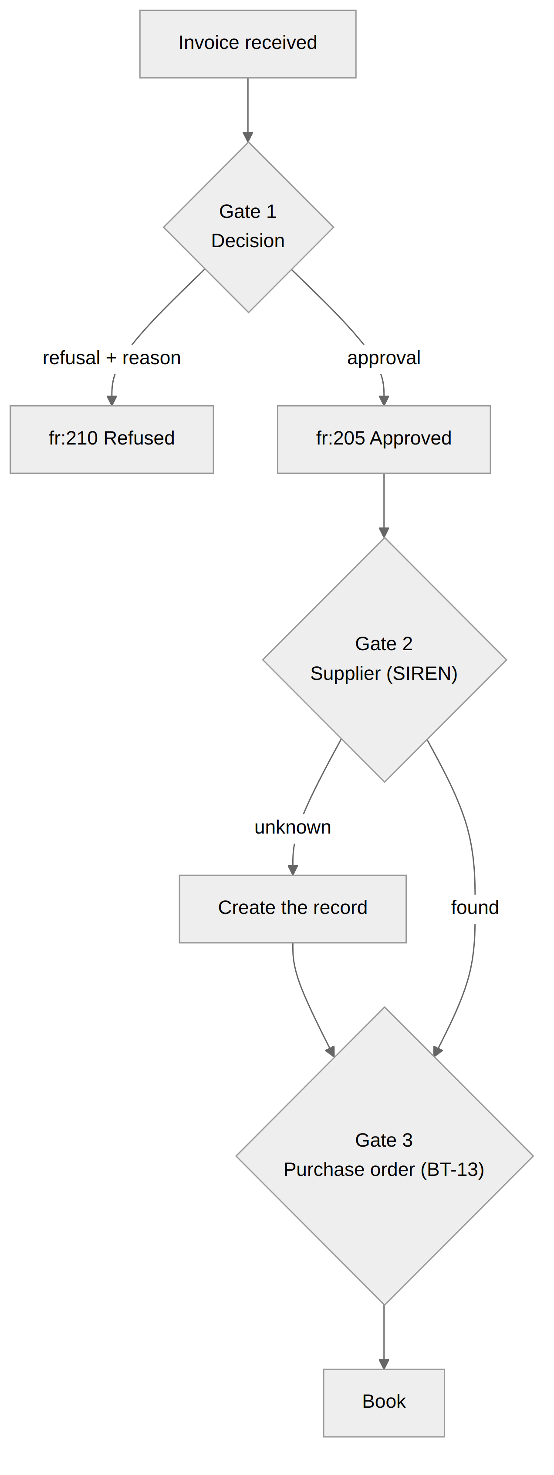
- The decision. The user approves (fr:205) or refuses (fr:210, standardised reason mandatory, irreversible). The decision goes to the platform and the supplier receives it.
- The supplier. Matching is by SIREN, not SIRET: a branch that invoices remains the same company as its head office. If unknown, we offer to create the record, pre-filled from the invoice.
- The purchase order. If the invoice cites a reference (BT-13), we look for the order with this supplier. This gate never blocks: it only decides in which deal the purchase invoice is created.
Gate 3 outcome | Situation | Consequence
MATCHED | One order, right supplier, deal free | Purchase invoice in the order’s deal
TAKEN | The deal already holds a purchase invoice | Separate deal
AMBIGUOUS | Several orders with the same reference | Separate deal
FOREIGN | The reference designates another supplier’s order | Anomaly to report
UNKNOWN | No order carries this reference | Separate deal
ABSENT | No reference | Separate deal; most frequent case, compliant

Booking without having approved is refused by the server.

7.5 Fraud vigilance
An invoice arriving through the official channel is technically authenticated, not commercially. A fraudster registered on a platform with a valid SIREN can send a perfectly compliant invoice. Checks to maintain: SIREN consistency with the usual supplier, IBAN change, unusual amount, first invoice from an unknown issuer, duplicate number + SIREN.

7.6 What is still missing
- Statuses 204 “Taken over” and “Payment in progress” are not sent back to the supplier.
- Business checks (duplicates, fraud, quantity and price matching) remain to be built.
What this means for the code. Treat reception as an idempotent cursor-based flow. Keep the raw JSON and the native file as evidence. Separate received document, incoming invoice and purchase invoice. Never stop ingesting events. Details: SPEC_INTEGRATION_PA_MODULE_ACHAT.md, processus_collecte_factures_recues.html, scenarios_reception_facture_recue.html. In Go: internal/reception and internal/vault (chapter 9).

8. Operating: logs, sandbox, deployment
A tax flow must be explainable after the fact: who sent what, when, with which response. This relies on redacted logs, a sandbox for risk-free testing, and per-environment configuration that leaks no secret.

8.1 Logs
All logging goes through internal/logx: a slog logger in single-line key=value format. The flow key identifies the flow, the event key the step.
level=INFO msg=send flow=send event=send.upload outcome=ok tenant_id=42
outbound_id=1812 pdp_invoice_id=88505 status_code=200 dur_ms=640
Flow | flow | Example events
Enrolment | enroll | authorize.start, callback.denied, token.exchange.ko
KYB verification | verify | status re-read (kyb_status, state)
Issuing | send | send.validate.ko, send.upload, send.refused, send.blocked, send.exhausted
Tracking | track | track.status, sync.partial
Reception | receive | receive.invoices, receive.invoices.skipped, decision.sent

Blocking rule: never log access_token, refresh_token, the authorisation code, code_verifier, code_challenge, client_secret, the Authorization header, the state, PDF bytes, or full response bodies. logx applies an allow-list: an unknown field comes out as [FILTERED]. The logger must never make the business flow fail.

8.2 The sandbox
Two levels of testing, with no risk to production:
# unit + integration tests (PostgreSQL + fake SuperPDP)
TEST_DATABASE_URL=postgres://… go test -race -p 1 ./...
# real service against the SuperPDP sandbox
SUPERPDP_COMPANY_NUMBER_SCHEME=sandbox go run ./cmd/pa-gateway
Against the real sandbox, connect a test tenant through the internal API, open issuing, then submit an invoice and track its status with GET /v1/tenants/{id}/invoices/{external_id}.
Trap to know: the platform deduplicates on content, not on external_id. Re-sending the same invoice (same number) returns 400 La facture est déjà existante (“invoice already exists”), even with another external_id. In testing, change the number.

8.3 Jobs and scheduling
Item | Role
send job | Issuing an invoice
payment job | Declaring collection (fr:212)
sync job, per tenant | Events, tracking, reception; reschedules itself every hour, scheduled as soon as the tenant is connected
decision job | Sending the buyer’s decision (fr:205 / fr:210)
Watchdog (every 5 min) | Recreates a connected tenant’s sync chain if it has broken

8.4 Per-environment configuration
Variable | Role | Note
SUPERPDP_BASE_URL | API host | Same host in sandbox and production; the account is what changes
SUPERPDP_CLIENT_ID / SUPERPDP_CLIENT_SECRET | The application’s OAuth client | The secret never leaves the server
SUPERPDP_REDIRECT_URI | OAuth callback | Registered at SuperPDP character for character, no trailing slash
SUPERPDP_COMPANY_NUMBER_SCHEME | Company number scheme | sandbox in test, fr_siren in production
SUPERPDP_TOKEN_ENC_KEY | AES-256-GCM key for tokens | Stable over time: changing it makes all tokens unreadable
PA_INTERNAL_API_TOKEN | Secret shared with Stairling Enterprise | Required on every /v1/ route
PA_VAULT_DIR (dev); S3 bucket (production) | Evidence vault | Versioning enabled on the bucket

Three rules:
- Tokens do not travel from dev to production. In production, each tenant runs “Connect SuperPDP” again.
- No secret in a file tracked by git. Unversioned environment file, injected by the orchestrator or a secrets manager.
- Enable bucket versioning before storing evidence in it: a PUT on an existing key overwrites without a trace.

8.5 Developer checklist
☐ I have read chapters 1 to 4 before writing sending code.
☐ The tests pass (go test -race ./...) and my sandbox account connects a test tenant.
☐ I have deposited and tracked a test invoice up to 202.
☐ My local validator cites the same BT / BR rules as the platform.
☐ Every failure is classified into a nature (invalid, blocked, refused, failed).
☐ No token or secret appears in the logs.
☐ Platform identifiers are int64 / BIGINT everywhere.
What this means for the code. Instrument from the first call, not after the first incident. Details: PROCEDURE_LOGS_PDP.md, DEPLOIEMENT_PROD_PDP.md. In Go: internal/logx (allow-list logging: any unknown key comes out as [FILTERED]) and the project’s .env.example (chapter 9).

8.6 Reference documents
Topic | Project document (in French)
Peppol and network | Fiche_explicative_Peppol_et_la_facturation_électronique.md
Enrolment | ENROLEMENT_TENANT_PDP.md, SPEC_PDP_OAUTH_AUTHORIZATION_CODE.md, GUIDE_SUPERPDP_OAUTH.md
Issuing and statuses | PROCESSUS_EMISSION_FACTURE_PDP.md
Error codes | CODES_ERREUR_PA_SUPERPDP.md
Reception and purchasing | SPEC_INTEGRATION_PA_MODULE_ACHAT.md, processus_collecte_factures_recues.html
Logs | PROCEDURE_LOGS_PDP.md
Deployment | DEPLOIEMENT_PROD_PDP.md
Open questions | QUESTIONS_SUPERPDP_OAUTH.md
Reference Go implementation | pa-gateway.zip and its README.md (chapter 9)

9. Reference implementation in Go: pa-gateway
Chapters 3 to 8 describe the business. This chapter shows how it translates into code, in a standalone Go service: pa-gateway, delivered with this guide (pa-gateway.zip, README included). It serves as a reference: every rule from the previous chapters has its place there and, for the most sensitive ones, its test.

9.1 The principle: a gateway between the application and the platform
Stairling Enterprise never calls SuperPDP directly. It talks to the gateway through an internal API; the gateway handles tokens, the job queue, retries and evidence.
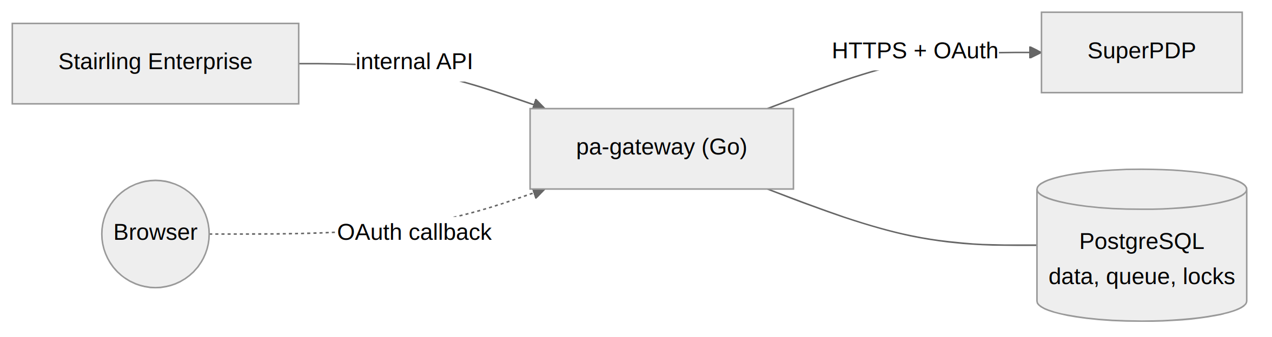
A single binary carries the HTTP API, the workers and the scheduling watchdog. PostgreSQL holds the data, the job queue and the locks: no Redis, no broker. Dependencies: the Go standard library (1.22 or later) and a PostgreSQL driver, since the code only uses database/sql.

9.2 Where each chapter lives in the code
Guide chapter | Go package | What it implements
2. Infrastructure | internal/superpdp | REST HTTP client: typed errors, rate limiter (20 calls/s), no automatic retry on a POST
3. Enrolment | internal/enrollment, internal/oauth | PKCE S256, single-use state, callback, KYB reading, state machine
3. Tokens | internal/tokens, internal/secret | Proactive refresh at 60 s, serialised per tenant, rotation persisted; AES-256-GCM
4. Compliance | internal/eninvoice | EN 16931 model by BT, local validator (BR, BR-CO, BR-FR), translation to SuperPDP
5. Issuing | internal/emission | send (deposit) and payment (fr:212) jobs
6. Lifecycle | internal/superpdp/types.go, internal/tracking | Code translation to XP Z12-012, tracking of in-flight invoices
7. Reception | internal/reception, internal/vault | Four cursor-based passes, native-file vault, fr:205 / fr:210 decisions
8. Operations | internal/logx, internal/queue, migrations/ | Allow-list logging, job queue, SQL schema

9.3 The internal API
Call | Role
POST /v1/tenants/{id}/connection/authorize | Returns the consent URL (SIRET and email checked server-side)
GET /oauth/callback | Public SuperPDP return; redirects to Stairling Enterprise with the result
POST /v1/tenants/{id}/connection/verify | “Re-check” button: re-reads the KYB
PUT /v1/tenants/{id}/connection/enablement | Opening dates for issuing and reception
POST /v1/tenants/{id}/invoices | Submits an invoice; 202 with the local check result
GET /v1/tenants/{id}/invoices/{external_id} | Status, failure nature, dated history
POST /v1/tenants/{id}/invoices/{external_id}/payment | Declares the collection (fr:212)
GET /v1/tenants/{id}/inbound?after= | Received invoices, cursor-based
POST /v1/tenants/{id}/inbound/{pdp_id}/decision | Approve, or refuse with a mandatory reason

All /v1/ routes require the Authorization: Bearer <PA_INTERNAL_API_TOKEN> header.

9.4 The job queue: three possible outcomes
Everything that talks to SuperPDP goes through a job. A handler ends in one of three ways, which is how the failure natures of chapter 6 are expressed:
Outcome | Effect | Used for
error | retry with backoff, counts an attempt | refused
queue.Snooze(d, err) | postponed, does not count | blocked, failed
queue.Cancel(err) | permanent abandonment | invalid, exhausted, out of scope

Enqueuing happens in the same transaction as the business data. A uniqueness key guarantees a single active job per invoice or per tenant. The queue is written in PostgreSQL (SELECT … FOR UPDATE SKIP LOCKED); riverqueue/river offers the same semantics and can replace it without touching the handlers.
Job | Triggered by | Role
send | invoice submission | local check, conversion, deposit, first status
payment | payment declaration | sends fr:212, idempotent
sync | connection, then every hour | events, tracking, reception; reschedules itself
decision | buyer’s decision | sends fr:205 or fr:210, replayed until success

9.5 The three most sensitive pieces of code
Token refresh (internal/tokens). The refresh token rotates on every call: two workers refreshing at the same time break the connection. The code takes a PostgreSQL advisory lock specific to the tenant, re-reads the row after the lock, then refreshes and persists in the same transaction. An invalid_grant moves the tenant to reconnect_required.
err = store.WithTx(ctx, s.DB, func(tx *sql.Tx) error {
store.LockTenantTokens(ctx, tx, tenantID) // pg_advisory_xact_lock
conn, _ := store.GetConnectionForUpdate(ctx, tx, tenantID)
if tok, ok, _ := s.usable(conn); ok { // already refreshed
access = tok
return nil
}
t, err := s.API.Refresh(ctx, refresh)
if errors.Is(err, superpdp.ErrInvalidGrant) {
return store.SetState(ctx, tx, tenantID,
"reconnect_required", nil)
}
return s.Save(ctx, tx, tenantID, t) // new pair, encrypted
})
Failure classification (internal/emission). Every client error is typed; the job only sorts:
switch {
case errors.Is(err, tokens.ErrPendingVerification),
errors.Is(err, superpdp.ErrForbidden) /* … */:
return queue.Snooze(time.Hour, err) // blocked
case errors.As(err, &rej):
return s.deterministic(ctx, log, out,
"refused", msg, true) // counts, cap 5
case errors.As(err, &tr):
return queue.Snooze(
queue.DefaultBackoff(1+out.Attempts), err) // failed
}
The reception cursor (internal/reception). It is typed int64 end to end, only advances after commit, in the same transaction as the inserted rows, and never goes back (GREATEST). The lexicographic MAX() trap from chapter 7 cannot occur.

9.6 What the tests guarantee
The tests run against a real PostgreSQL and a fake SuperPDP (internal/fakepdp) that reproduces refresh-token rotation, the 403 until KYB is verified, cursor pagination and BR-* rejections.
Test | Guide rule verified
TestEnrollment, TestEnrollmentPendingThenVerified | State machine, single-use state, sync scheduled on connection (ch. 3)
TestRefreshIsSerializedAndRotationPersisted | 10 concurrent workers, a single refresh; invalid_grant → reconnect_required (ch. 3)
TestEmissionHappyPathAndIdempotence | Out of scope refused; a transmitted invoice never leaves again (ch. 3 and 5)
TestEmissionFailureNatures | refused counts, failed does not, cap 5 → exhausted, resubmission restarts (ch. 6)
TestInvalidInvoiceIsHeldUntilCorrected | A non-compliant invoice does not leave (ch. 4)
TestSyncReceptionAndTracking | Cursors with identifiers 9, 10 and 100; fr:212 status; unknown code recorded without overwriting (ch. 6 and 7)
TestReceptionOffStillIngestsEvents | Reception off: refusals of our invoices still arrive (ch. 7)
TestPaymentAndDecision | fr:212 sent; refusal without reason rejected (ch. 6 and 7)

Run: TEST_DATABASE_URL=postgres://… go test -race -p 1 ./....

9.7 What remains to align with the SuperPDP spec
The code was validated against a fake SuperPDP. Before production, it must be checked against the official OpenAPI (v1.beta), ideally by generating the types with oapi-codegen:
- The field names of the invoice JSON sent to the platform. They are all in internal/eninvoice/mapping.go, the only file to touch; validate with a round trip in the sandbox.
- The shape of list responses. The code assumes {"data": [...]}.
- The body of POST /invoice_events: amount for fr:212, reason code for fr:210.
- The fr:220 status, introduced in API version 1.33.0. It is already accepted and recorded; confirm whether it is final, then add it to the chapter 6 table.
- Webhooks, absent from the API contract to date. If they arrive, a handler can simply enqueue an immediate sync job for the tenant concerned.
What this means for the code. Nothing to reinvent: start from pa-gateway, align mapping.go with the spec, plug a versioned S3 vault in place of the file vault, and keep the tests green with every change to the SuperPDP API. Details: the project’s README.md.

