Download Doxygen

Function Documentation

/**

* Description of function

*

* @param parameter1name parameter1description

*

* @return variableReturned returnedVariableDescription

*/

Class Documentation

/**

*Class Description

*

*@author AuthorName

*/

Link to list of doxygen tags

<http://www.stack.nl/~dimitri/doxygen/manual/commands.html\>

Doxygen Project Configuration (click next after entering info):

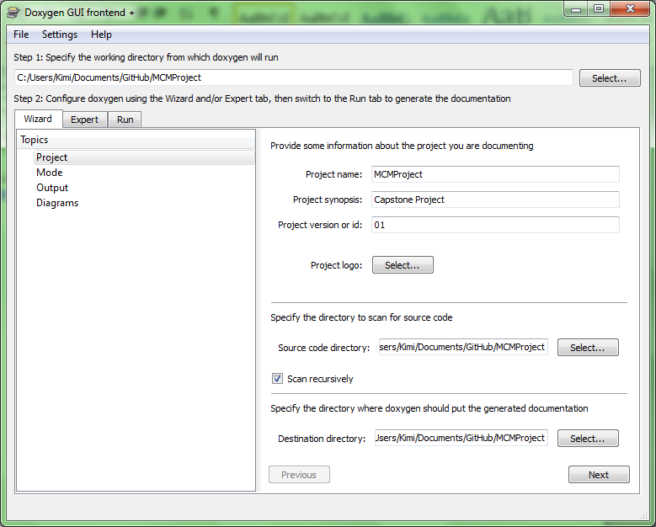

Mode settings:

**Click Documented entities only**

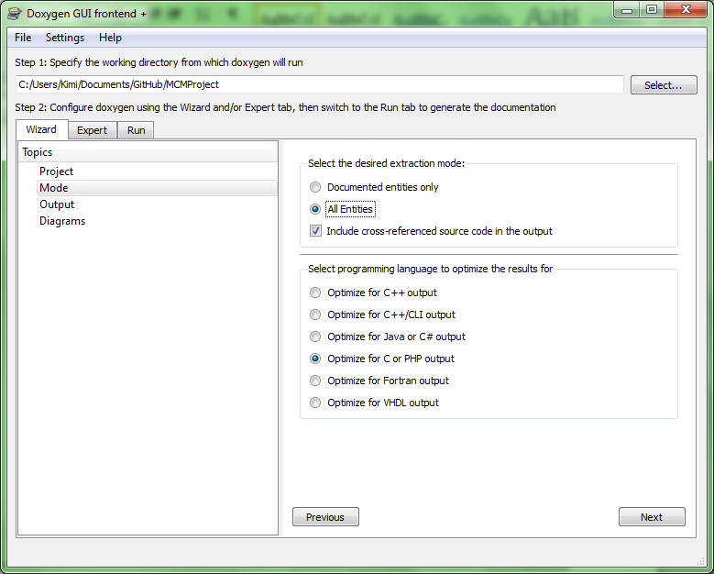

Diagrams (go to the run tab):

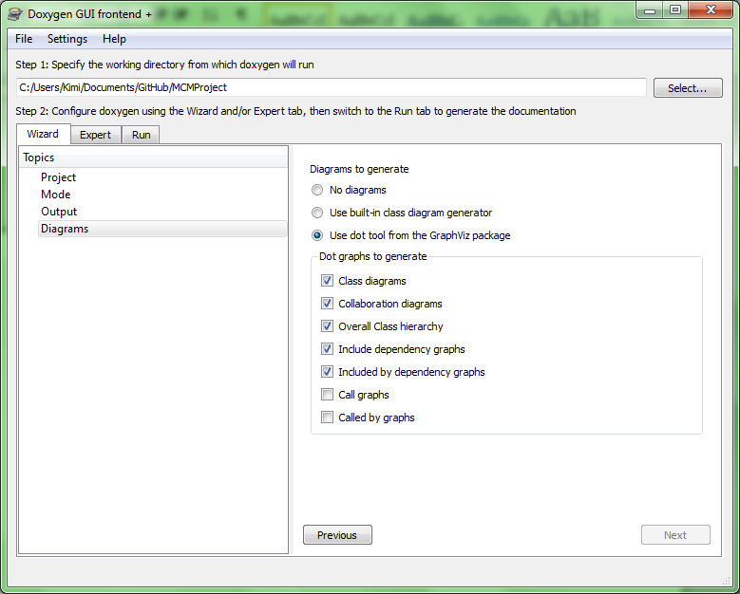

Run (click Run doxygen):

