**Obtaining your Google API Debug Key**

Source: <http://stackoverflow.com/questions/2997348/cant-find-the-android-keytool>

1. Find your JDK that you are using.

It should be under “C:\Program Files\ Java”

1. Find the location of the keytool (keytool.exe), which is located in the JDK.

It should be under “C:\Program Files\Java\<your jdk version>\bin”

1. Find the debug.keystore location on your Eclipse Android SDK.

To find this in Eclipse, go to Window 🡪 Preferences 🡪 Android 🡪 Build 🡪 Default debug keystore.

Mine was “C:\Users\.android\debug.keystore”

1. In the command prompt, cd to the directory containing the keytool executable. Type in:

keytool –list –keystore “<keystore location>”

1. When prompted for a password, press enter. This should bring up your MD5 for the debug key.
2. Go to Google API key signup:

<https://developers.google.com/maps/documentation/android/maps-api-signup>

and enter the MD5 fingerprint obtained from the command line.

1. Generate the API key and use it as the apiKey for the applications.

My exact commands in cmd were:

cd “C:\Program Files\Java\jdk1.6.0_22\bin”

keytool –list keystore “C:\Users\Chihiro\.android\debug.keystore”

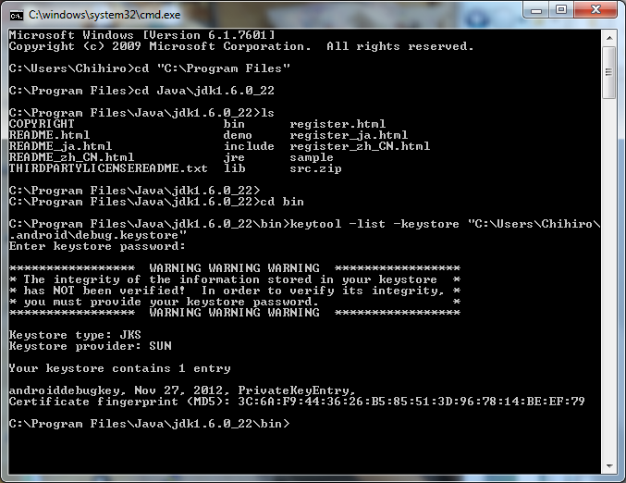

**Debug Key:**

0X1GgLjbBZ9vhft0CaWFF8fgBzrikwnldWcsWFg

Obtained from MD5 signature:

3C:6A:F9:44:36:26:B5:85:51:3D:96:78:14:BE:EF:79