Assignment Sheet - II

Department: Department of Computer Engineering & Applications
Course: Year/Semester: Session: 2014-15
Subject Name & Code: Soft Computing Max. Marks: 50 Time allowed: 7(days)
Note/Instruction (If any) Solve all the questions on A4 size sheets.

Q1. Discuss in details the leaning algo used in back propagation network.
Q2.What is the activation function used in back propagation. Write a short note on a choice of parameter used in a BPN.
Q3.Why sigmoid activation are used in BPN? Why it is advantages over step function?
Q4.What is the advantage of using momentum factor in a back propagation net.
Q5.What is feed forward network? Explain the architecture of back propagation network.
Q6.Try a training pass for the following example. Target=1, Learning rate=1:

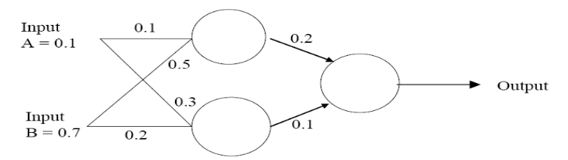

Q7. Derive the generalized delta learning model?
Q8. Consider the simple network below:

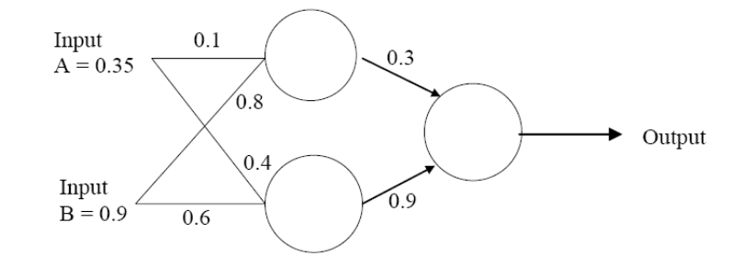

Assume that the neurons have a Sigmoid activation function and
(i) Perform a forward pass on the network.
(ii) Perform a reverse pass (training) once (target = 0.5).
(iii) Perform a further forward pass and comment on the result.

Q9. Explain how an auto – correlator results in the refinement of the pattern or removal of noise to retrieve the closest matching stored patterns.
Q10. Define Associative memory and write down its applications.

