Ask Your Query
(Learning is social)

Report – I

Date:12-03-2015

Priya Soni (121500110)
Prashant Verma (121500101)

Table of Contents

1. Introduction 1
1.1 Purpose 1
1.2 Scope 1
1.3 Definitions, Acronyms, and Abbreviations 2
1.4 References 2
1.5 Overview 2
2. General Description 3
2.1 Product Perspective 3
2.2 Product Functions 3
2.3 User Characteristics 3
2.4 General Constraints 3
2.5 Assumptions and Dependencies 4
3. Specific Requirements 4
3.1 External Interface Requirements 4
3.1.1 User Interfaces 4
3.1.2 Hardware Interfaces 4
3.1.3 Software Interfaces 4
3.1.4 Communications Interfaces 4
3.2 Functional Requirements 5
3.2.1 Use Case Diagram 5
3.2.1 Data flow Diagram 6
3.3 Other Requirements 7
4. Analysis Models 8
4.1 Flow Chart 8
4.3 Module Description 9

Introduction
From time immemorial it has been observed that there is large communication gap between students and teachers in order to convey information. The project “Ask Your Query” is not only limited to attracting and encouraging students to take work at College but it also aims to provide information about institute keeping in mind that the person visiting this website wants a basic knowledge of the college.

Website is aimed toward students who are perusing their studies. This project is developed in PHP programming language. The main aim of this project is to develop a website that covers all the area of interactions among the students. The proposed website will also reduce the cumbersome paper work, manual labor as well as communication cost.

1.1 Purpose
- This project is to share information of the college among the students. The various modules in the project provides platform where students can share their study materials, assignments, achievements and ideas. The senior students can even share their projects and experience. This project involves faculty members too who can guide the students in their work. Thus the project would result in a healthy interaction system where circulation of information would be easier, faster and beneficial.

- This application will be web based (Browser Based). There will be separate panel for students, faculty and admin. They can create their own profile and post question and answers or any other related news.

1.2 Scope
The Project is useful for effective communication among students and lessens the gap between students and faculty members as well as the gap between seniors and juniors too.
Other areas are:-

1. To provide extra reading practice for students.
2. As online student learner journals that can be read by their peers.
3. To guide students to online resources appropriate for their level.
4. To increase the sense of community in a class.
5. To encourage shy students to participate.
6. To stimulate out-of-discussions.
7. To encourage a process writing approach.
8. As an online portfolio of student written work.
9. To help build a closer relationship between students in large classes.
Page 1

1.3 Definitions, Acronyms, and Abbreviations
  - HTML (Hyper Text Markup Language): It is used to create static web pages.

  - CSS (Cascading Style Sheets): It is a style sheet language used for describing the look and formatting of document written in markup language.

• PHP: Hypertext Preprocessor.

- X (any operating system) A for Apache M for My SQL P for PHP P for Perl.

1.4 References
- http://www.w3schools.com/php/
- http://stackoverflow.com/
- http://www.raymondware.com/blog/7-php-books-for-beginners/
- PHP 5 / MySQL Programming for the Absolute Beginner

1.5 Overview

- Online “Ask Your Query” is a web application built in PHP. It provides the candidates a platform to register, share and spread knowledge and excellence among each others. On the other hand involvement of faculties allows a systematic and responsible approach towards the objective of this website.
- Admin can add or remove the student’s questions and answers. Main aim of this website is to make a good web application that can make this interaction system easy and accessible to everyone who is interested. Page 2

2. General Description
2.1 Product Perspective

The “Ask Your Query” Website to be developed benefits greatly the members. The website provides a interaction system for all the students to share their work. The Admin can keep the track of the questions updated all the time so that the students get the updated information all the time.

The main users are users: Admin, student and Faculty members.

2.2 Product Functions

The “Ask Your Query” website provides online real time information various achievements about the students, their excellence in some domain, the answers to some queries and other important information regarding the college.

The functions of the system include

- The member should be provided with the updated information about the students and college.

- The admin can get the information about the members as well as update the questions

- User Characteristics

  - The users of the system are students, faculty members and the admin who maintain the system.
  - The student or the faculty member must be associated with a particular college.
  - The members are assumed to have basic knowledge of the computers and Internet browsing.

- General Constraints

The users access the “Ask Your Query” from any computer that has Internet browsing

capability and an Internet connection.

Page 3

- Assumptions and Dependencies

- The user should have sufficient knowledge about computers.
- Admin can update the news content but cannot delete it.
- The users know the English language, as the interface will be provided in English.
- The computer should have internet connection and Internet server capabilities.

3. Specific Requirements

3.1 External Interface Requirements

3.1.1 User Interfaces

The user interface for the software shall be compatible to any browser such as Internet Explorer, Mozilla or Netscape Navigator by which user can access to the system.

Sreen Shots

3.1.2 Hardware Interfaces

The system should have these hardware requirements:

- The processor should be Pentium 4, 3.2GH

- The processor speed should be greater than 400 MHz

- The video device should support graphics.

- Ram should be Minimum (512 MB) Maximum (1 GB)

3.1.3 Software Interfaces

The software requires the support of the following soft ware’s for the database and other requirements:

- Komodo Edit 6.1 (php editor)
- My sql, Apache.(Database)
3.1.4 Communications Interfaces

- Local intranet and internet protocols.

- Supports all HTTPS, SMTPS and POP3 services.
Page 4

3.2 Functional Requirements
3.2.1 Use Case Diagram

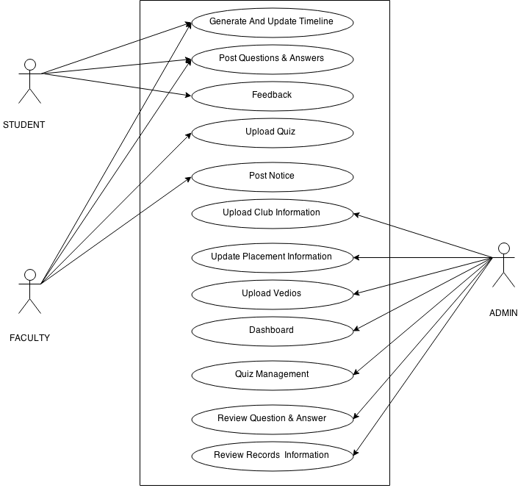

Page 5

3.2.2 Data Flow Diagram
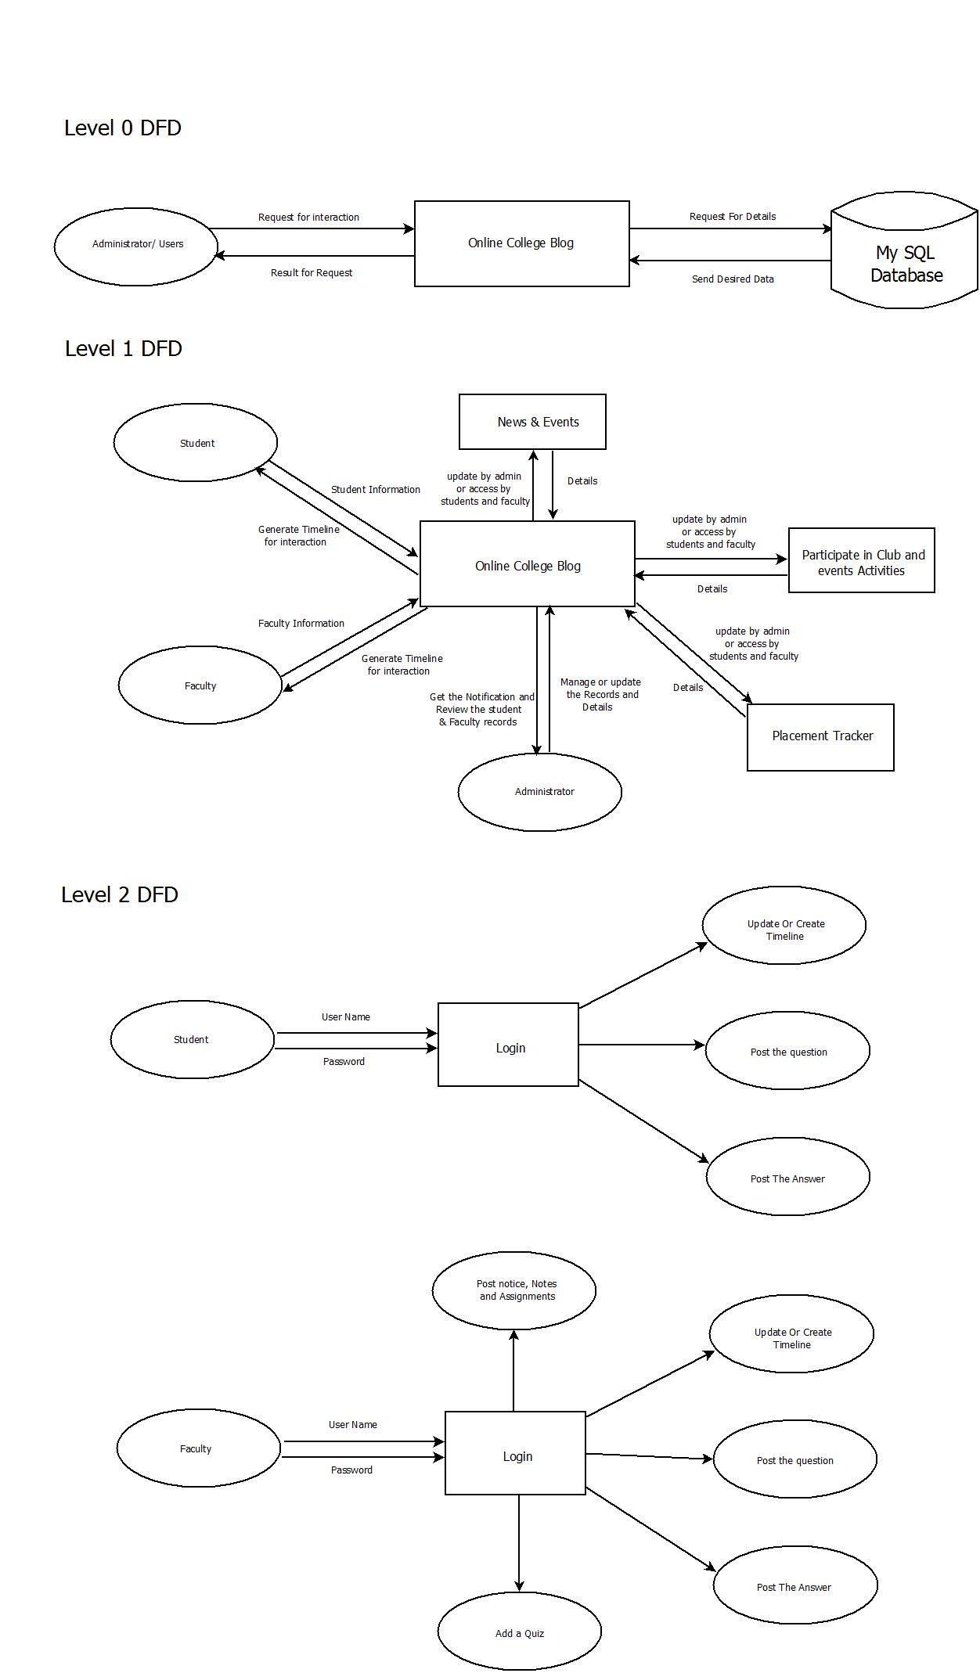
Page 6

3.4 Other Requirements
The user must be agreed with all the terms and conditions that are provided by the System Administrator, local authority and should obey to all the International standards and Protocols.

Applicable Standards

- The IEEE guidelines for the documentation of computer based application systems will be followed.

Page 7
4. Module Analysis

4.1 Flowchart

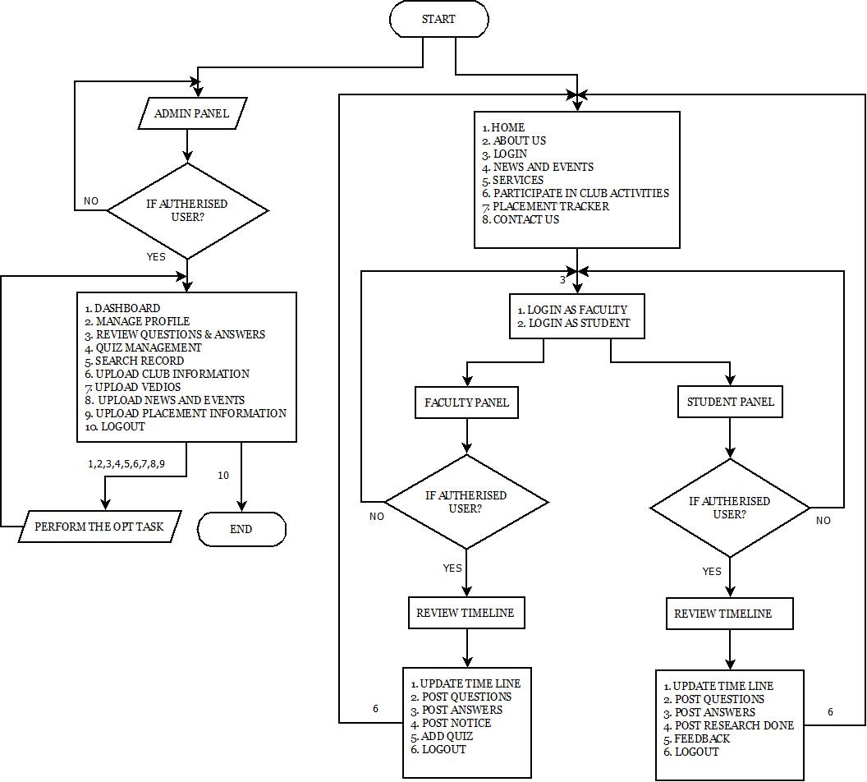
Page 8

4.2. Module Description
Module Layout:-

- Home
- About Us
- Login & Register
- News & Events
- Services
- Participate in Club activities
- Contact us
- Placement Tracker
- Login

- Student Login
- Faculty Login
- Admin Login
- Registration (in case student /faculty is not able to login successfully )

- Student Login
    - Generate Dynamic Timeline
    - Post the Questions
    - Post the answer (Study materials, Important files and Documents)
    - Update the Timeline
    - Post Some innovative talent & Research
    - Student Help Center (Knowledge About some Interesting Topics)
    - Feedback
    - Log out Page 9
- Faculty Login
    - Generate Dynamic Timeline
    - Post the question
    - Add quiz
    - Answer the Question (Study materials, Assignments & Notes)
    - Update the Timeline
    - Post the Notice
    - Log out
- Admin login
    - Update News & Events
    - Update the Club information
    - Update the Placement Records
    - Review the Question
    - Student Records and Faculty records
    - Answer the enquired questions
    - Review the answers
    - Dashboard
    - Search any records or information
    - Quiz management
    - Upload videos on interested topics
    - Manage profile
    - Log out

- Placement Tracker
    - Know about the Company Profile & placement Criteria
    - Placement Information
    - Share the Experience & Efforts by the students Page 10

