DOCUMENTATION FROM THE ABOVE GUIDANCE

1. Installation of OS (window 11)

Step-by-step installation

>> Download Rufus of Power ISO for creation of Bootable (window image bootable) me I chose Rufus for creating window image bootable as per the below screenshot

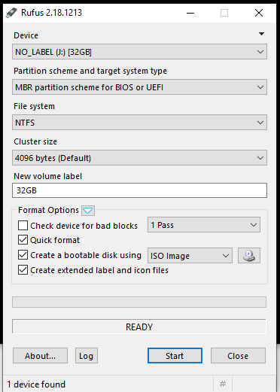

After creating the bootable from the above then I removed my USB flash to the machine that I wanted to install the window image as per instructions.

>>After inserting the USB flash into my HP machine then I rebooted the window by pressing F9 thereafter to navigate down and up using the down and up row to choose to install the window using a USB flash next step

>> After choosing the USB flash then I will pop up to choose the language you wish for my side I chose English as per the below screenshot after that press next

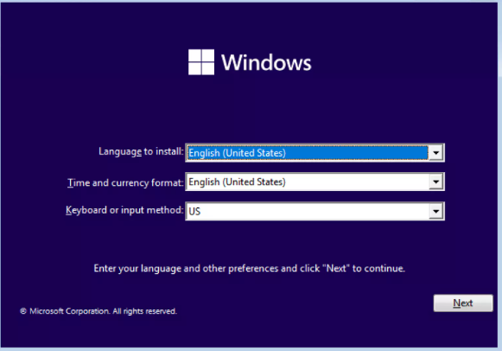

>> Now it is time to select the window edition you want to install, for my case I chose window 11 Pro to install into my machine as per the below screenshot then enter next

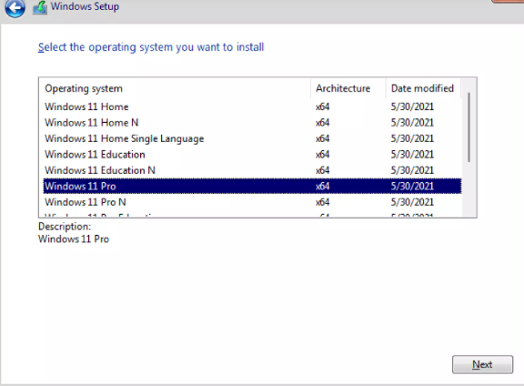

>>After hitting next It will pop up the installation type of installation then you will choose whether you want to upgrade the current window or to custom the new one for my side I choose custom then it will go to the next step as per the below screenshot

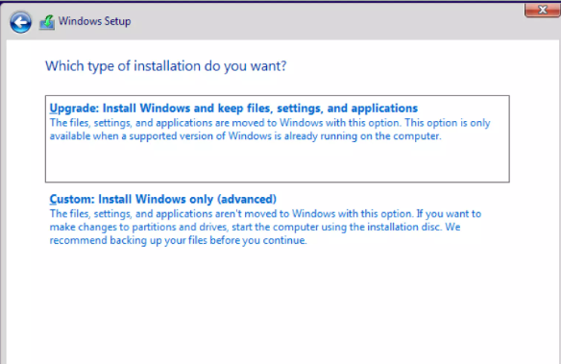

>> It will give you room to choose where you want to install the window in which drive as per the below screenshot then press the next button it will start installing the window

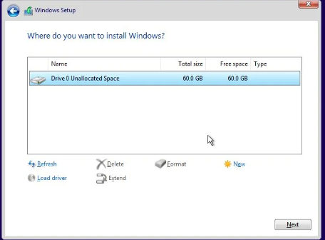

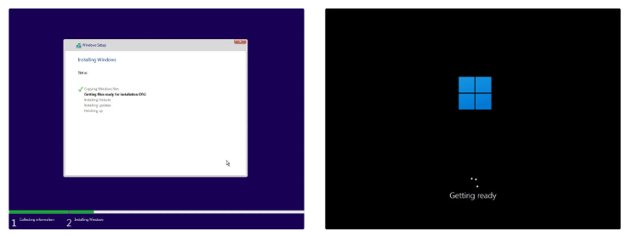

Now it will start instating the window into your machine until the time that will complete installation then it will pop up the room for you to set up the account (how is going to use the machine

ALL OTHER PROGRAM WAS INSTALLED SUCCESSFUL WITHOUT ANY STACK