**Comprehensive Analysis of an IoT-Enabled Vehicle Tracking System: Architecture, Implementation, and Technology Stack**

**Abstract**

The proliferation of Internet of Things (IoT) technologies has revolutionized location tracking and fleet management systems. This project presents a comprehensive IoT-based vehicle tracking solution that integrates hardware, software, and cloud technologies to deliver real-time location monitoring capabilities. By leveraging an intricate combination of microcontroller technology, cellular communication, GPS positioning, and cloud-based infrastructure, the proposed system demonstrates a robust approach to mobile asset tracking.

1. **Introduction**

The contemporary landscape of transportation and logistics demands sophisticated tracking solutions that provide real-time, accurate, and secure location monitoring. Traditional tracking systems often suffered from limitations in real-time data transmission, scalability, and user experience. This project addresses these challenges by developing an integrated system that combines advanced hardware components with cloud-native software architecture.

The primary objectives of the research included:

* Designing a compact and efficient IoT device for location tracking
* Implementing a scalable cloud infrastructure for data management
* Creating a user-friendly mobile application for comprehensive tracking
* Ensuring secure and reliable data transmission

1. **Hardware Architecture**

**2.1 Microcontroller ESP32-S3**

The ESP32-S3 microcontroller was strategically selected as the core processing unit due to its exceptional characteristics. This microcontroller represents a significant advancement in IoT device design, offering a compelling combination of computational power, low energy consumption, and integrated communication capabilities.

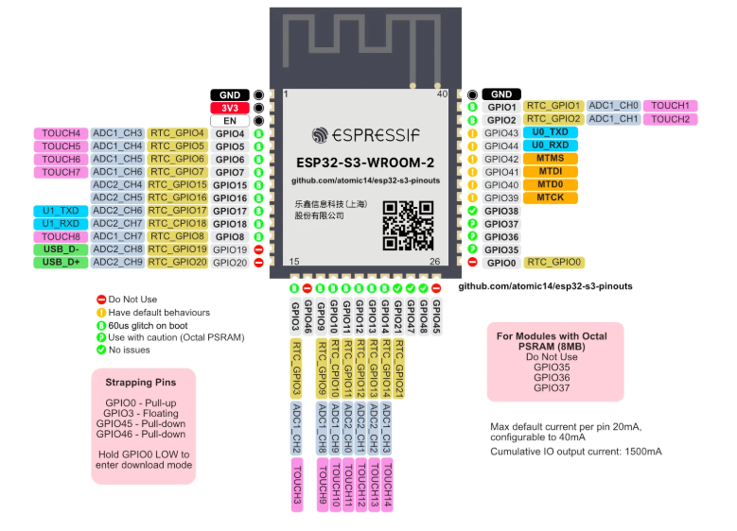

Figure: ESP32S3 Pinouts

The ESP32-S3 provides several advantages:

* Dual-core processor with clock speeds up to 240 MHz
* Integrated Wi-Fi and Bluetooth Low Energy (BLE) connectivity
* Advanced low-power management modes
* Sufficient GPIO pins for modular sensor integration
* Strong security features including secure boot and flash encryption

**2.2 Module L80**

The L80 GPS module was chosen for its precision and reliability in geographical positioning. Unlike traditional GPS modules, the L80 offers,

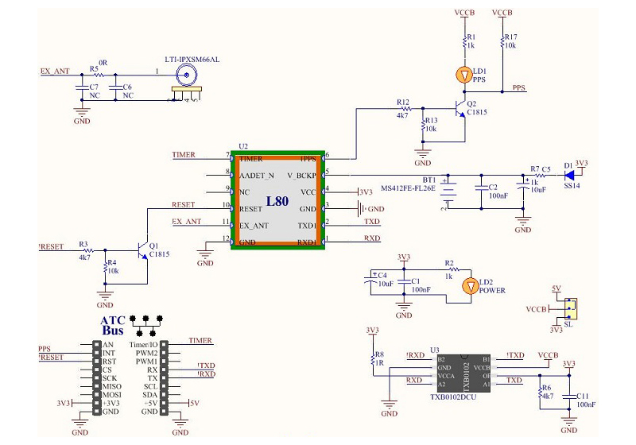

* High sensitivity (-167 dBm tracking sensitivity)
* Support for multiple global navigation satellite systems (GNSS)
* Low power consumption (approximately 20 mA during tracking)
* Compact form factor suitable for mobile applications

**2.3 GSM Module SIM800L**

Communication reliability is paramount in tracking systems. The SIM800L GSM/GPRS module was selected to provide robust cellular network connectivity. Its key features include,

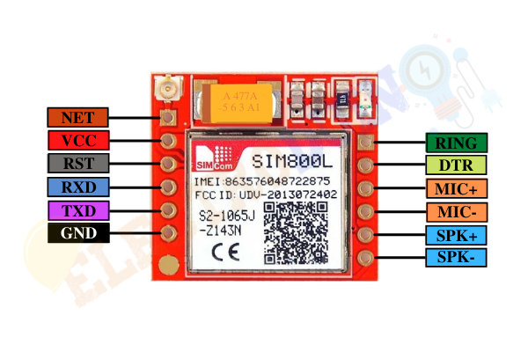

* Quad-band GSM/GPRS functionality
* Support for multiple communication protocols
* Low voltage operation
* Compact design
* AT command compatibility for flexible programming

1. **Backend Infrastructure**

**3.1 Node.js and Render**

Node.js was selected as the primary server-side runtime environment due to its event-driven, non-blocking I/O model, which is particularly advantageous for real-time applications. The asynchronous nature of Node.js enables efficient handling of multiple concurrent connections, a critical requirement for IoT tracking systems.

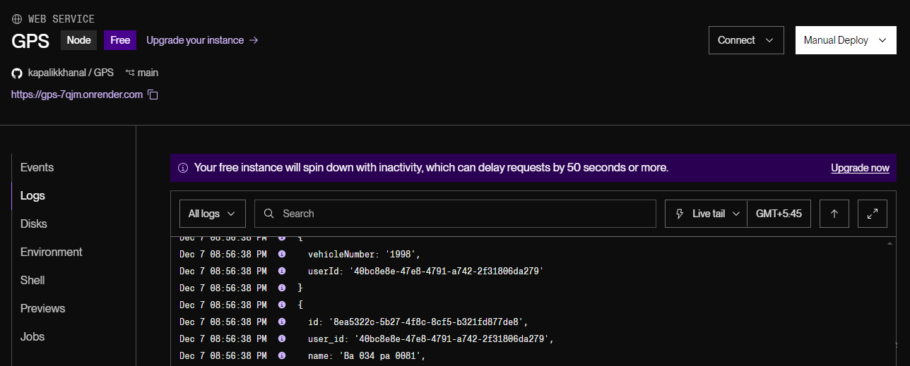

Render was chosen as the deployment platform for its,

* Seamless continuous deployment capabilities
* Automatic SSL certification
* Scalable infrastructure
* Simplified DevOps processes
* Free usage

**3.2 Ably Broker**

Real-time data transmission represents a critical component of modern tracking systems. Ably was selected as the message broker due to its,

* Global real-time infrastructure
* Guaranteed message delivery
* Web-Socket support
* Pub/Sub messaging architecture
* Low-latency communication channels

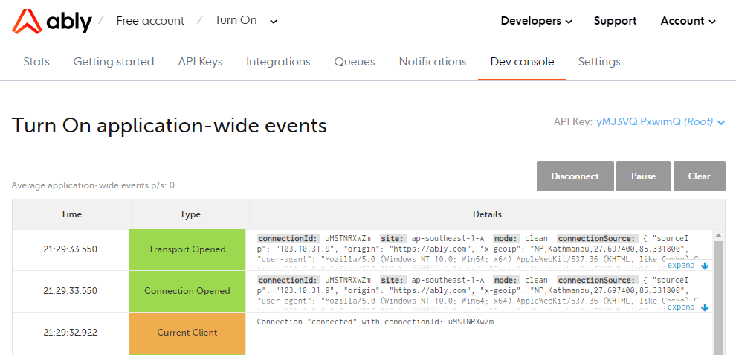

The publish-subscribe model implemented through Ably ensures that location updates are instantaneously propagated across the system, maintaining near-real-time tracking capabilities.

**3.3 Database and Authentication using Supabase**

Supabase, an open-source Firebase alternative, was strategically chosen for database management and authentication. Its PostgreSQL-based infrastructure provides,

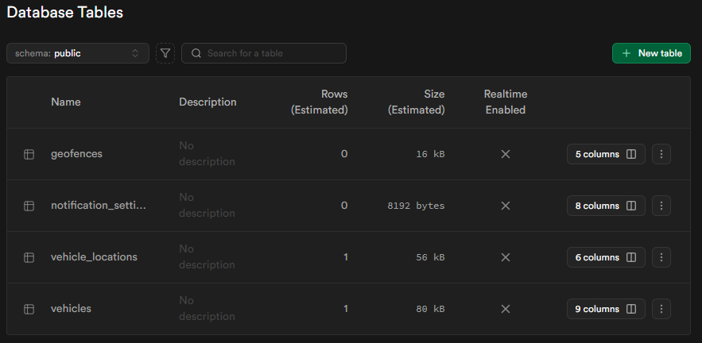

* Robust row-level security mechanisms
* Real-time database subscriptions
* Integrated authentication services
* Comprehensive user management
* Scalable cloud database solutions

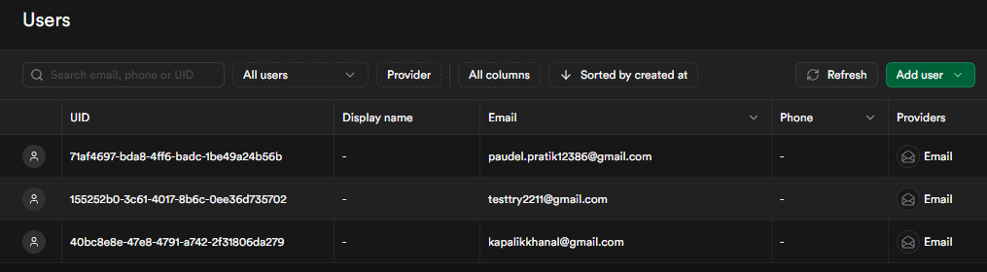

The selection of Supabase facilitates secure, efficient data storage and retrieval while maintaining flexible authentication protocols.

**4. Mobile Application Development**

**4.1 React Native Framework**

React Native emerged as the optimal framework for cross-platform mobile application development. Its key advantages include,

* Native performance rendering
* Code reusability across iOS and Android platforms
* Large community and extensive library ecosystem
* Hot reloading for rapid development
* Consistent user interface across different devices

**4.2 Leaflet Open Maps**

Leaflet was selected as the mapping library due to its,

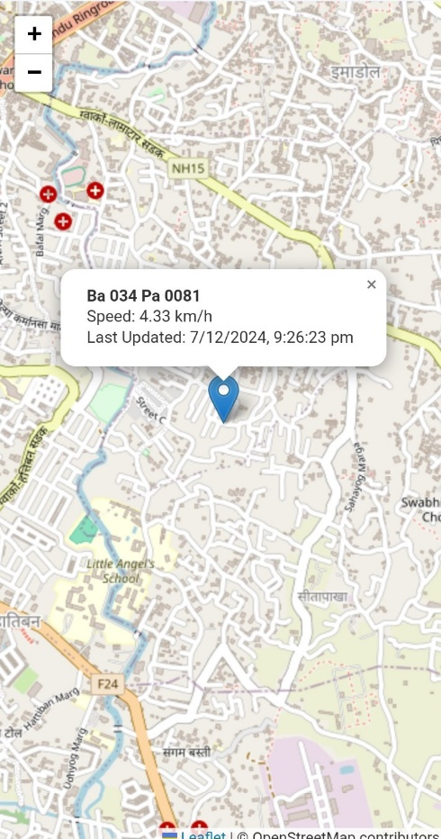

* Open-source licensing
* Lightweight implementation
* Cross-browser compatibility
* Extensive customization options
* Support for various map tile providers
* Efficient handling of geographical data

**5. System Architecture and Data Flow**

The system architecture follows a microservices-oriented approach, ensuring modularity and scalability. The data flow is structured as follows,

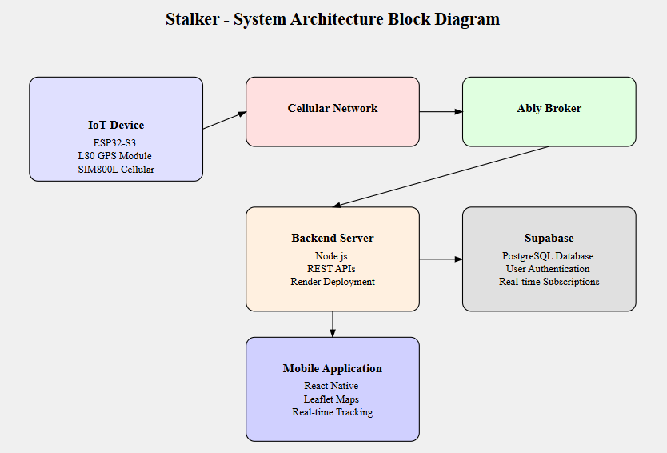

1. IoT device captures GPS coordinates
2. Data transmitted via cellular network to cloud infrastructure
3. Ably broker facilitates real-time message distribution
4. Backend services process and store location data
5. Mobile application retrieves and displays real-time locations

**6. Security Considerations**

Security was integrated at multiple architectural layers:

* Hardware-level secure boot on ESP32-S3
* End-to-end encryption for data transmission
* Token-based authentication by Supabase
* Role-based access control
* Regular security audits and vulnerability assessments

**7. Technological Justification**

The selected technology stack represents a deliberate approach to addressing complex tracking system requirements. Each component was chosen after comprehensive evaluation of performance, scalability, and integration capabilities. The synergy between ESP32-S3's computational capabilities, L80 GPS's precision, SIM800L's communication reliability, Node.js's server-side efficiency, Ably's real-time infrastructure, Supabase's database management, React Native's cross-platform development, and Leaflet's mapping capabilities creates a holistic solution to mobile asset tracking.

**8. Conclusion**

This project successfully demonstrated the potential of integrated IoT technologies in developing sophisticated tracking systems. By leveraging modern cloud-native architectures and advanced hardware components, we created a scalable, efficient, and user-friendly vehicle tracking solution.

Future research directions include,

* Machine learning-enhanced predictive tracking
* Enhanced energy efficiency algorithms
* Advanced anomaly detection in location data
* Expanded sensor integration capabilities