# Assignment 2

Kasperi Palkama, 356440

## Exercise 1/5

The CIE 1931 color spaces were the first defined quantitative links between physical pure colors (i.e. wavelengths) in the electromagnetic visible spectrum, and physiological perceived colors in human color vision. A color space maps a range of physically produced colors to an objective description of color sensations registered in the eye, typically in terms of tristimulus values. The tristimulus values associated with a color space can be conceptualized as amounts of three [primary colors](https://en.wikipedia.org/wiki/Primary_color) in a tri-chromatic [additive](https://en.wikipedia.org/wiki/Additive_color) [color model](https://en.wikipedia.org/wiki/Color_model). The CIE XYZ color space encompasses all color sensations that an average person can experience. Due to the distribution of cones in the eye, the tristimulus values depend on the observer's [field of view](https://en.wikipedia.org/wiki/Field_of_view). To eliminate this variable, the CIE defined a color-mapping function called the standard observer, to represent an average human's chromatic response within a 2° arc inside the [fovea](https://en.wikipedia.org/wiki/Fovea_centralis). The CIE's color matching functions {\displaystyle {\overline {x}}(\lambda )} {\displaystyle {\overline {z}}(\lambda )}are the numerical description of the chromatic response of the observer. They can be thought of as the spectral sensitivity curves of three linear light detectors yielding the CIE tristimulus values X, Y and Z. Collectively, these three functions are known as the CIE standard observer.

Chromaticity xy-coordinates of figure 1 can be transformed into XYZ tristimulus values flowingly:

X = Yx / y, Y = luminance, Z = (1- x-y)Y/y. The spectrum locus is the set of chromaticity coordinates of pure monochromatic (single-wavelength) lights. The purple boundary is the straight line connecting the chromaticity coordinates of the longest visible wavelength of red light (about 700 nm) to the chromaticity coordinates of the shortest visible wavelength of blue (about 400 nm).

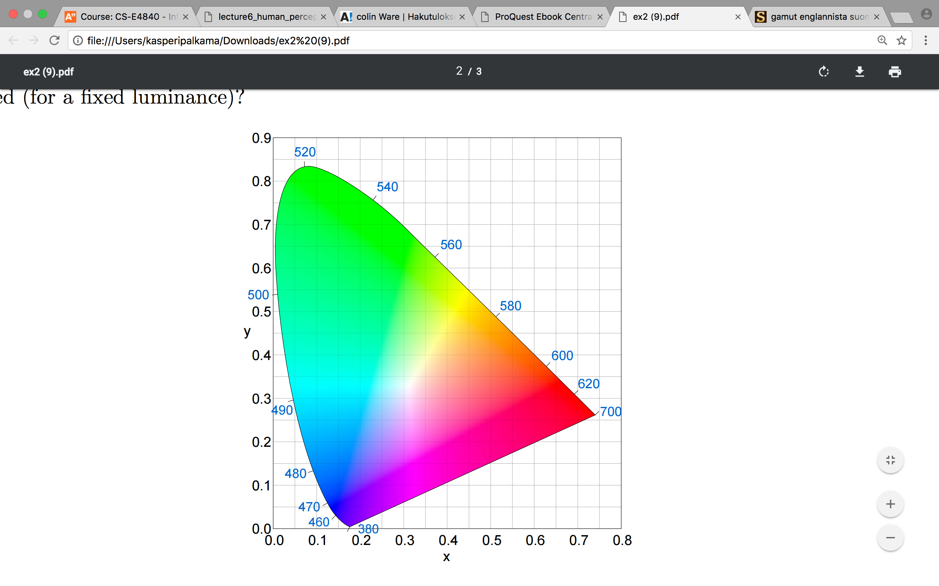

The purple line is the straight boundary

Spectrum locus is the curved boundary

The chromaticity diagram represents all range of colors a naked human eye can see. Therefore, it is shape is not a triangle. A RGB monitor cannot produce colors outside of the formed triangle when its primaries are connected with straight lines. Therefore, the gamut has the shape of a triangle.

## Exercise 2/5

In [colorimetry](https://en.wikipedia.org/wiki/Colorimetry), CIE LUV is a [color space](https://en.wikipedia.org/wiki/Color_space) adopted by the International Commission on Illumination (CIE) in 1976, as a simple-to-compute transformation of the 1931 [CIE XYZ color space](https://en.wikipedia.org/wiki/CIE_1931_color_space), but which attempted [perceptual uniformity](https://en.wikipedia.org/wiki/Color_difference#Tolerance). It is extensively used for applications such as computer graphics which deal with colored lights. CIE LUV was created to correct for the CIE XYZ distortion by distributing colors roughly proportional to their perceived color difference. A region that is twice as large in UV will therefore also appear to have twice the color diversity — making it far more useful for visualizing and comparing different color spaces.

To have uniform color sequence ∆E must be constant between sequential colors 🡪When L,U and V variables are increased by 30 after every color, ∆E is constant 51.9615 and the respective RGB values are:

First LUV = L:0, U:0, V:0 🡪 RGB: R: 0, G: 0, B:0

Second LUV = L:30, U:30, V:30 🡪 RGB: R: 100.7301107362861, G: 62.40505837223183, B: 0

Third LUV = L:60, U:60, V:60 🡪 RGB: R: 200.9271221602317, G: 129.13902239980374, B: 0

Fourth LUV = L:90, U:90, V:90 🡪 RGB: R: 255, G: 202.96975332400476, B: 0

Following figure shows a data map of US airports using the selected colors:

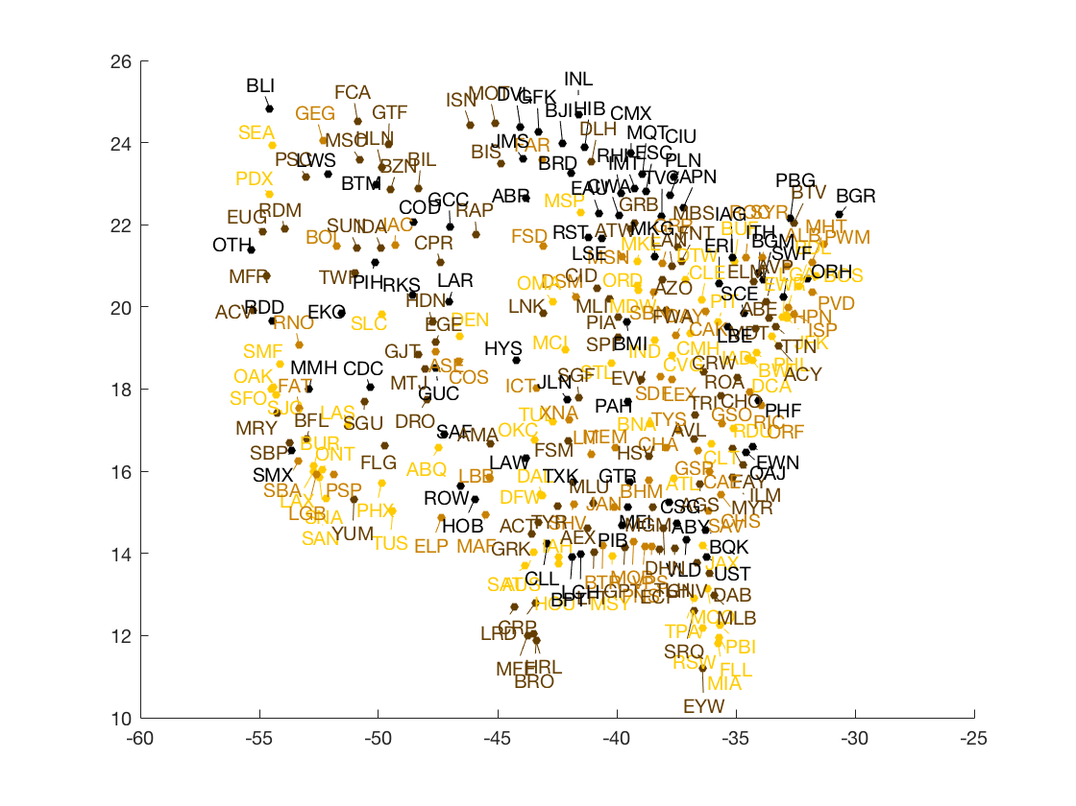

## Exercise 3/5

Images from different sources of light have a different ‘color’ or temperature to them. Humans don’t generally notice this difference in temperature because our eyes adjust automatically for it. So, unless the temperature of the light is very extreme a white sheet of paper will generally look white to us. However, a digital camera doesn’t have the smarts to make these adjustments automatically and sometimes will need us to tell it how to treat different light. For example, for a cooler light you must adjust the camera to warm things up and in warm light, you must tell it to cool down. If you don’t do this, pictures taken outdoor appear blue in indoor setting and picture taken indoor appear red in outdoor settings.

### Exercise 4/5

Continuity: Two white shapes form a rectangle

Symmetry: The dots in line seem to create a U-shape form

Closure: dots seem to create a rectangle event the rectangle is overlapping it

Figure and Ground: There’s no figure since the blue area is in the foreground

When applying each law separately they contradict each other as explained above.

## Exercise 5/5

Preattentive visual channels: Color of the shape, Radius of the shape, The orientation of the shape. All dimensions are separable and if we can distinguish at most 4 different values, then 4*4*4 =64 combination can be represented with this design. There are not integral dimensions in the glyph since color, orientation and radius are perceived independent of each other and are thus separable dimensions.