# Assignment 3

## 1/4.

The network was visualized, see appendix A.

## 3/4.

PCA was applied and scatter plot was constructed, see figure 1.

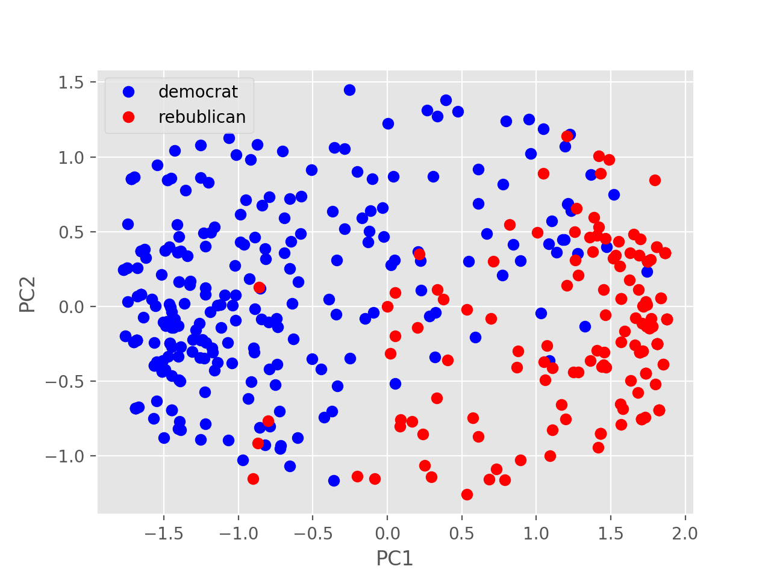

*Figure 1. Visualization of the US congress voting after dimension reduction into 2D applying PCA.*

## 4/4.

Metric MDS and Sammon mapping were computed and plotted, see figure 2. Shepard plots were computed for these methods, see figure 3 and 4. MMDS seem to predict better distances between 50-80. Otherwise the prediction seem to be equally good.

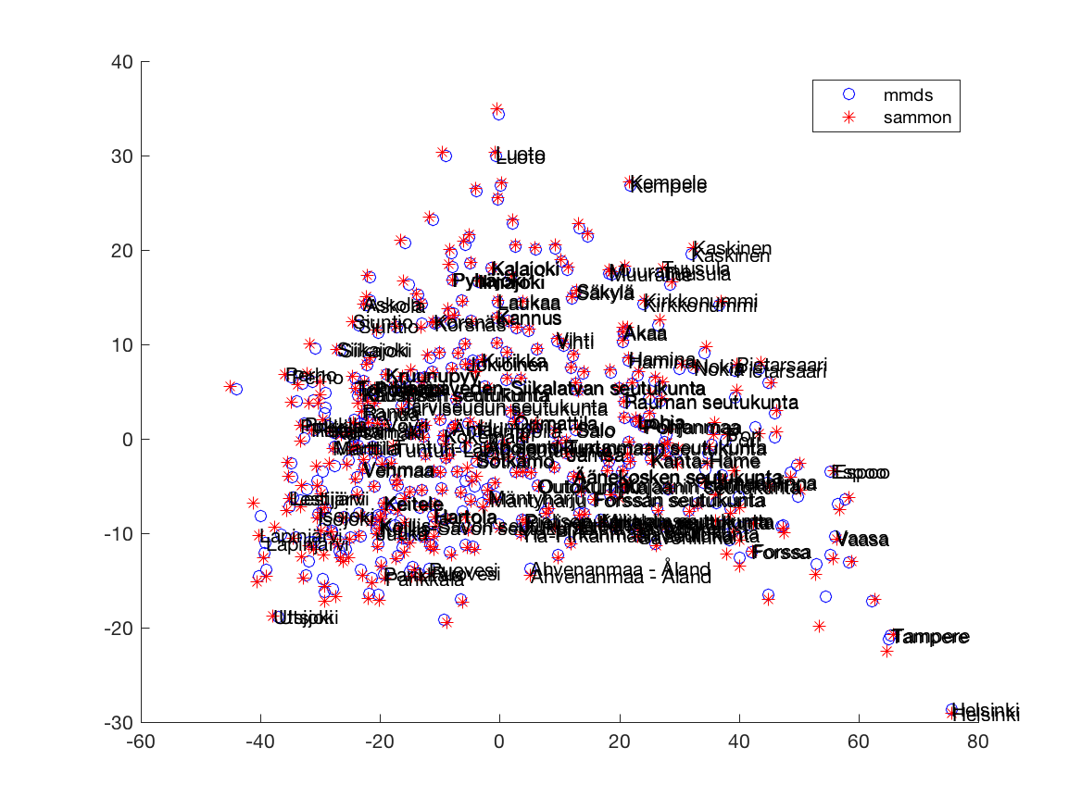

*Figure 2. Visualization of the statistics of Finnish municipalities* *after applying MMDS and Sammon mapping.*

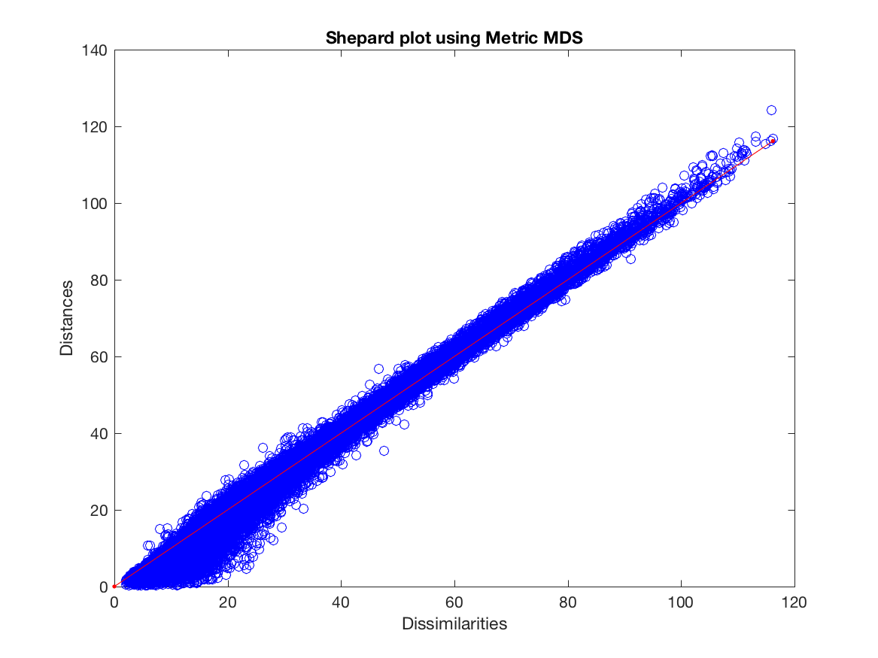

*Figure 3. Shepard plot the statistics of Finnish municipalities* *after applying MMDS*

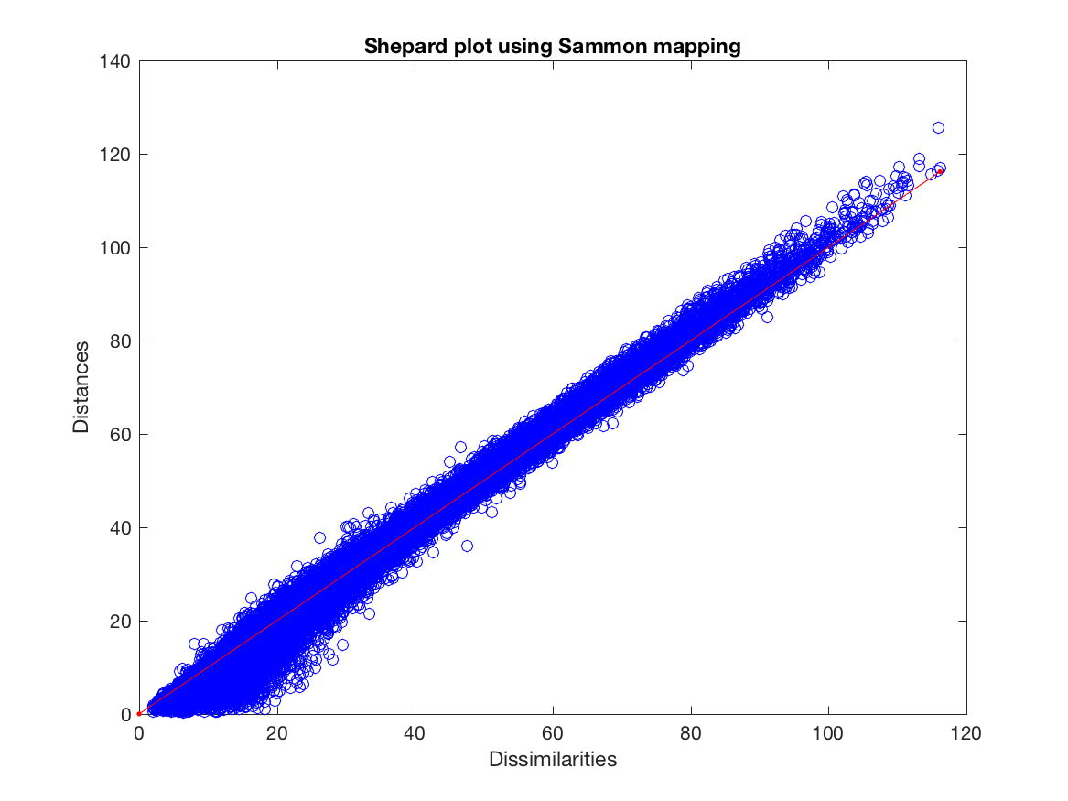

*Figure 4. Shepard plot the statistics of Finnish municipalities* *after applying Sammon mapping.*